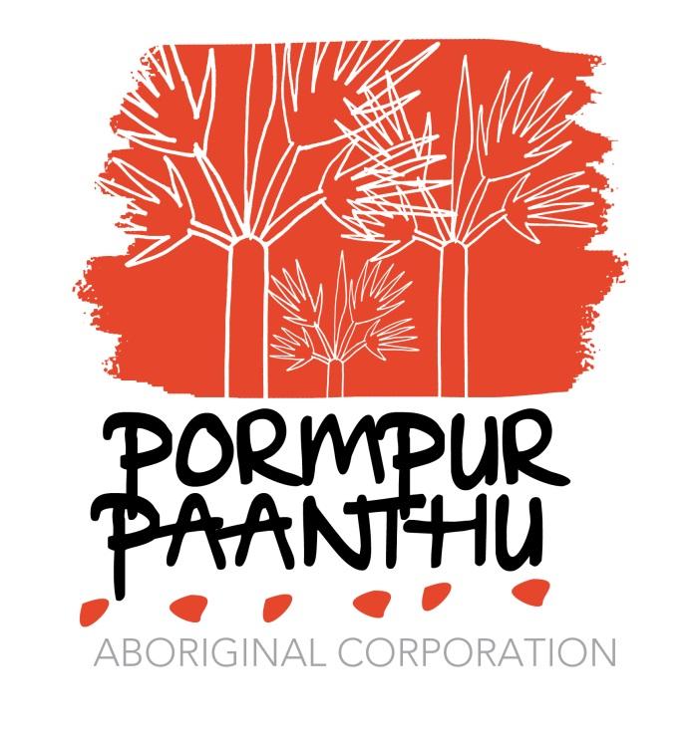

Information Package for Job Applicants

Pormpur Paanthu Aboriginal Corporation

CONTENT OF APPLICATION KIT

- Brief overview of Pormpur Paanthu
- Introduction to community
- Recruitment Process
- Structure
- Copy of Job Description

COMMUNITY ENVIRONMENT
Pormpuraaw, formerly Edward River Mission until 1987 is a very remote, diverse and dynamic Aboriginal community located on the western coast of Cape York Peninsula.
It remained Edward River Mission until 1967 when the Anglican Church handed the administration of the Community to the Queensland Government. In 1986 the elected Pormpuraaw Community Council assumed Local Government responsibilities and acquired title over the Trust area which encompasses 466,198 hectares by way of Deed of Grant in Trust (DoGiT). In 1987 the Community changed its name to Pormpuraaw, taken from the local dreamtime story about a burnt hut or Pormpur in the Kuuk Thaayorre language of the traditional owners.
Pormpuraaw is home to the Thaayorre and Mungkan Aboriginal peoples. The Thaayorre people who are traditionally from Pormpuraaw and the areas to the east and south towards Kowanyama and including the Coleman River; and the Mungkan are traditionally from the North including areas along the Edward and Holroyd Rivers.
Pormpuraaw has over 679 inhabitants. Pormpuraaw people take pride in continuing practice of their cultures and traditions and maintain an active cultural life where oral tradition, gathering bush tucker, traditional cultural practices, art and custom are actively passed onto the younger generations by the Elders of both Clan groups and historical families living there.
Culture
Pormpuraaw people are rightly proud of the strength of their language and culture. Unlike many other Aboriginal Communities many Pormpuraaw children speak a local Aboriginal language as their first language. The Thaayorre people from the south mainly speak Kuuk Thaayorre and related dialects, with some speaking Kuuk Yak or languages from further south. The Mungkan people from the north speak a variety of Kugu or Wik languages, including Kugu Muminh, Kugu Mu'inh, Kugu Ugbanh, Olkolo, Wik Mungkan, Pakanh, Wik Iyenh, Kugu Uwanh and Kugu Yi'anh.
Traditional "Dreamtime" stories are still told - for example about the rainbow serpent that created the landscape and the epic fight between the freshwater and saltwater crocodiles. Stories are associated with "story places" - the land where the events in a story happened. Many stories have songs and dances associated with them that are performed at ceremonies.
1. 2 Pormpur Paanthu Aboriginal Corporation

Pormpur Paanthu is an Aboriginal Community Controlled Organisation that was originally established in 1991 as means for providing a resource to women and children of Pormpuraaw community experiencing Domestic Violence and to provide adequate support service as means for safety and protection. It focuses on family wellbeing and on health promotion to deal with issues such as substance misuse, and those risk factors which impacts on families, women and children. It was also established to advocate on behalf of health issues for Aboriginal families in Pormpuraaw.
Services focus on quality, evidence based services that are appropriate in meeting the needs of Aboriginal and Torres Strait Islander men, women, youth, children and families in the Pormpuraaw community.
Services have a coordinated and holistic community approach that includes:
- Child Care, After School and Vacation Care
- Healing Family and Support Services
- Domestic and Family Violence Women’s Shelter
- Domestic and Family Violence Counselling Services
- Alcohol and Other Drugs Counselling Services
Finance and Human Resource

Pormpur Paanthu Aboriginal Corporation (PPAC) receives Commonwealth and State funding to provide support programs to the families of Pormpuraaw. The Finance and Human Resource functional work area manages overall finance, administration, human resource and capital works, infrastructure and asset and file systems management

The Child Care and child support

The functional work area comprises of the Child Care Centre, Play Group, Positive Parenting, Healthy Lifestyle Programs, and After School - Vacation Care.

Restorative Justice and Healing, Alcohol and Other Drug counselling, and homeless and temporary accommodation: women’s shelter and child safety.

The Alcohol and Other Drugs Service Area has been established for families, and community members who wish to remove themselves from the harmful effects of alcohol on adults and their children. It works through a consumer-centred approach in a recovery model, and coordinates local and external services to support the recovery model.

PPAC provides a range of services for residents including the healing centre where counselling service are provided.

Pormpuraaw endures a significantly high incidence of domestic violence and interpersonal conflicts, and has implemented counselling and various support services for families and individuals as well as the alcohol management plan. Clients may be referred from a number of sources and include women, men and children of various ages.

Currently, the Pormpuraaw Healing Centre employs local Counsellors as part of PPAC’s commitment to address the area of family violence and provide support for victims of crime. The Healing Service works towards holistic community healing that respect community cultural practice.

RECRUITMENT PROCESS

As an applicant you should be careful to read the attached Job Description currently advertised, and supplied with the Application Kit, which outlines the roles, responsibilities and selection criteria.

Please email to liz.pearson@ppac.org.au
Phone: 07 40604295

You should supply a cover letter addressed:-

- ‘CONFIDENTIAL’ to the CEO, Pormpur Paanthu Aboriginal Corporation C/- Pormpuraaw Post Office Pormpuraaw QLD 4871
  - and information relevant to the applicant:-
- The title of position the applicant is applying for
- A current Curriculum Vitae (Resume) that includes your name, and contact details including return address for correspondence, educational background and work history, any other relevant and supporting documentation to support your application.
- The name and contact details of at least two referees who are familiar with your recent employment performance and achievements in relation to the selection criteria and relevant to these areas. Including current supervisor.
- Your typed response to EACH Criterion identified in the job description with supporting evidence of skills, knowledge and outcomes against work previously undertaken.
SELECTION PROCESS

After the Closing Dates for Applications, each application submitted will be reviewed by a Selection Panel coordinated by the Centre manager and comprising of:-

- Board members
- Independent Member/service manager
- CEO
All applicants will be contacted ad advised of the outcomes in writing/phone/fax/email.

Shortlist

Each shortlist applicant will receive in writing or phone/fax notification of their success and a suitable date and time nominated for the short list interview. If applicants live outside the community an appropriate telephone link up will be established with the Interview Panel.

Steps

- The appointed Chair of the Selection Panel will prepare a shortlist of all suitable applicants for interviews
- A table of questions will be designed for all applicants to weight and score each applicant on merit based on equity:-
  - suitability for the position in light of the selection criteria, and
  - And responses by applicant
  - Any other questions/responses for further clarification to identify skills and knowledge
- The tally of scores by all selection panel members will be tallied up
- Reference checks will be made against the highest scoring applicant
- If the highest scored applicant proves to have negative references then the process will continue to the next position or a discussion and decision will be left with the Executive Board with transparency a priority.
- If all of the above is completed and successful then the Chair will recommend to the Executive Board the successful application
- The Executive Board will endorse the successful applicant
- The Successful applicant will be notified in writing/phone /fax and commencement date and contract details negotiated
- All unsuccessful applicants will be contacted after endorsement by the Board
- On acceptance, and contact signature a three month probationary period will commence; followed by the offer of a contract.
Other

If successful applicant does not accept the position and there are no suitable applicants the position will be readvertised.
All feedback can be provided by the Chairperson of the Selection Panel, or appointed representative.

EMPLOYMENT

All external staff members receive 4 weeks annual leave with leave loading; 1 week remote leave without loading

Rental deductions are applicable. Weekly rental agreement with the Pormpuraaw Aboriginal Shire Council $120.00 for a 2-bedroom duplex with appropriate kitchen and bedding supplies.

Staff share accommodation may apply if housing is not available. The levy is $80.00 per week.

No pets allowed.

No smoking allowed indoors in PPAC Housing

Accommodation and Housing has been made available to PPAC by the Shire Council and rent will be deducted from fortnightly wages.

$20.00 power cards are at own expense, and purchased from Post Office or coffee shop

Gas bottles at a cost to tenant with gas stoves

Gross salary is inclusive of leave loading, tax deductions, super etc

Discuss salary sacrifice with CEO

On employment identification is required, license is a MUST.

Registration, degree, appropriate qualification certificates must be scanned and attached.

Blue Card/ or application to be within 1 month of probationary employment

Police check applicable

Leave is not applicable until after the first 3 months of employment

TRANSPORTATION

Skytrans flights from Cairns to Edward River Cairns on Monday and Thursday mornings; and Tuesday and Friday afternoons.

