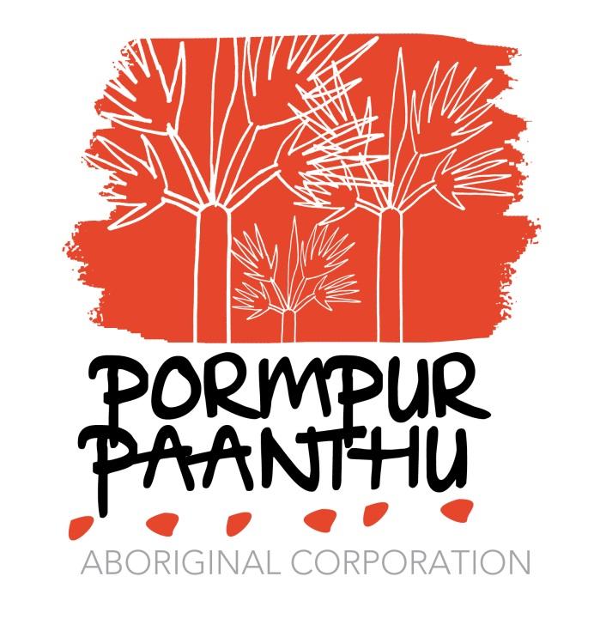
POSITION DESCRIPTION
___________________________________________________________________
- Position Title Domestic Violence Counsellor
- Classification SACS 6.1 +Locality
- Employment Status Permanent / Contract Based
- Organisational Environment
Pormpur Paanth is an Aboriginal Community Controlled Organisation that was originally established in 1991 as means for providing a resource to women and children of Pormpuraaw community experiencing Domestic Violence and to provide adequate support service as means for safety and protection. It focuses on family wellbeing and on health promotion to deal with issues such as substance misuse, and those risk factors which impacts on families, women and children. It was also established to advocate on behalf of health issues for Aboriginal families in Pormpuraaw.
There are four (5) Service areas within Pormpur Paanth Aboriginal Corporation
- Executive
- Administration
- Early Childhood Learning
- Integrated Healing Services (women’s shelter, Men’s Healing Services, Family and Child therapies, and AOD therapeutic services)
- Child and Youth Development
- Purpose of Position
Provide support and counselling services to men and families who have experienced domestic and family violence; and may be perpetrators. Assist clients with information, safety plans and referral pathways so they can make informed decisions about their lives and the environment in which they live. Build relationships and establish Men’s and Youth Groups; and Men’s Recovery Support Groups with a focus on change behaviour.
- Reporting Relationships
Integrated Healing Service Manager
- Direct Reports

NIL

- Key Duties

- Team lead the development of Men’s Groups and Men’s Recovery Groups as well as the coordination and management of coordinated care model that is client centred.
- Oversee the safety of clients by establishing Safety and Staying Strong Plans
- Implement outcome measures by using the GEM Tool as part of assessment and intake.
- Ensure all clients presenting receive a risk assessment and appropriate support
- Case manage clients through a safety plan, support and referrals
- Attend Joint case management meetings with PPAC AOD counsellors and Family Therapists
- Liaise with the FIFO Mental Health Clinicians, and RFDS SEWB team member
- Work as a team member of Pormpur Paanth Aboriginal Corporation Healing Services to enhance the wellbeing of men and young people in the community of Pormpuraaw
- Work collaboratively with other agencies in providing referral pathways, support and assistance to those men and young people exposed to domestic or family violence
- Provide timely reports to the Department of Communities and statistics on clients seeking help, incidences and trends regarding domestic or family violence.
- Maintain records and data relating to clients, their family and domestic / family violence within the community.
- Liaise with Police, DV Connect and the Health Centre regarding referrals, health checks and the safety of a client and their families as part of risk management
- Promote Education and Awareness of domestic and family violence including activities for Domestic and Family Violence Month, Child Protection Month, NAIDOC, International Men’s Health Day (19th November)
- Ensure the workplace, health and safety, maintenance and hygiene guidelines are managed appropriately
- Participate in all Quality and continuous improvement frameworks being established at Pormpur Paanthu
- Maintain confidentiality at all times ensuring work is conducted in a professional manner and in keeping with best practices and Pormpur Paanthu Policies and Procedures.
- Report any suspected child abuse or neglect where a child is exposed to, or at risk of, domestic or family violence.
- Submit quarterly performance reports to the CEO and Integrated Healing Service Manager using the Department of Communities proforma supplied to Pormpur Paanthu.
- Attend and participate in training, workshops, forums, and meetings on behalf of Pormpur Paanthu Aboriginal Corporation in relation to the Domestic Violence service.
- Develop networks with other community service providers and support networks to address and provide awareness of, domestic and family violence.
- Provide counselling and crisis intervention related support services to client referred to the Healing Services.
- Liaise with fellow staff members and contribute as a team member within Pormpur Paanthu to coordinate, deliver, and improve services and practices.
- Maintain and collect relevant client statistical data utilising existing state and national data collection systems
- Network with relevant agencies in providing coordinated, appropriate services that meet community needs.
- Attend staff meetings and contribute to the quality improvement of the organisation and its aims and objectives.
- Facilitate and participate in support groups within the community that enhances lifestyles and wellness using holistic healing.
- Actively promote Pormpur Paanthu Services, professionally representing the service at meetings and forums.

JOB SPECIFICATION
___________________________________________________________________
Personal Requirement
- Person of indigenous descent, or someone who has worked with indigenous communities and is knowledgeable about indigenous cultures
- A shared vision and commitment to Pormpur Paanth aims and objectives
- The ability to work effectively as a member of the senior management team and contribute to a supportive peer work environment
- Good work ethic and ability to work effectively without supervision
- The ability to communicate effectively with community members and agencies, government departments either verbally or in written form
- A commitment to Pormpur Paanth values, equal opportunity, cultural diversity, industrial democracy and safety of workers.
- The ability to travel and willingness to participate in development opportunities
- Current Driver’s Licence
- Current Blue card

Education

- Qualifications in Family Violence/ Ending Family Violence and/or Anger Management or relevant tertiary degree and evidence that demonstrates equivalent skills, working in Aboriginal and Torres Strait Islander communities and/or with Aboriginal and Torres Strait Islander people.

Essential Experience

- Knowledge of Indigenous cultures and experience working in Aboriginal and Torres Strait Islander communities and/or with Aboriginal and Torres Strait Islander people.

- A high level of oral and written communication skills
- An understanding of health legislation, evidence based practices, compliance, quality assurance and grant funding requirements
- Demonstrated experience in working in a integrated, multi funded, multi-function operation
- High organisational and time management skills
- Demonstrated previous experience in working effectively with a management team.
- Demonstrated ability to conduct research and analyse best practices, relevant legislation and models of health care.
SELECTION CRITERIA
___________________________________________________________

SC 1 Demonstrated ability to communicate effectively and sensitively with Aboriginal and Torres strait Islander people, including a high level of knowledge and understanding of their culture and societies from a historical perspective and the issues which impact upon them in a contemporary society.
SC 2 Demonstrated ability to actively participate in a working environment supporting policies, procedures and practices including employment equity, anti-discrimination, occupational health and safety and ethical behaviour.
SC 3 Demonstrate capacity; evidence of knowledge and literature: National Standards, Frameworks and Legislation published on Domestic Violence, Child Protection; Clinical Guidelines; Best Practice, and Scope of Practice.
SC 4 Demonstrated ability to function effectively without supervision and to meet responsibilities regards to workplace health and safety.
SC 5 Sound communication skills, and the ability to establish a collaborative, supportive and trusting relationship with clients.
SC 6 Demonstrated experience in working in a team member and the ability to contribute to a supportive peer work environment.

