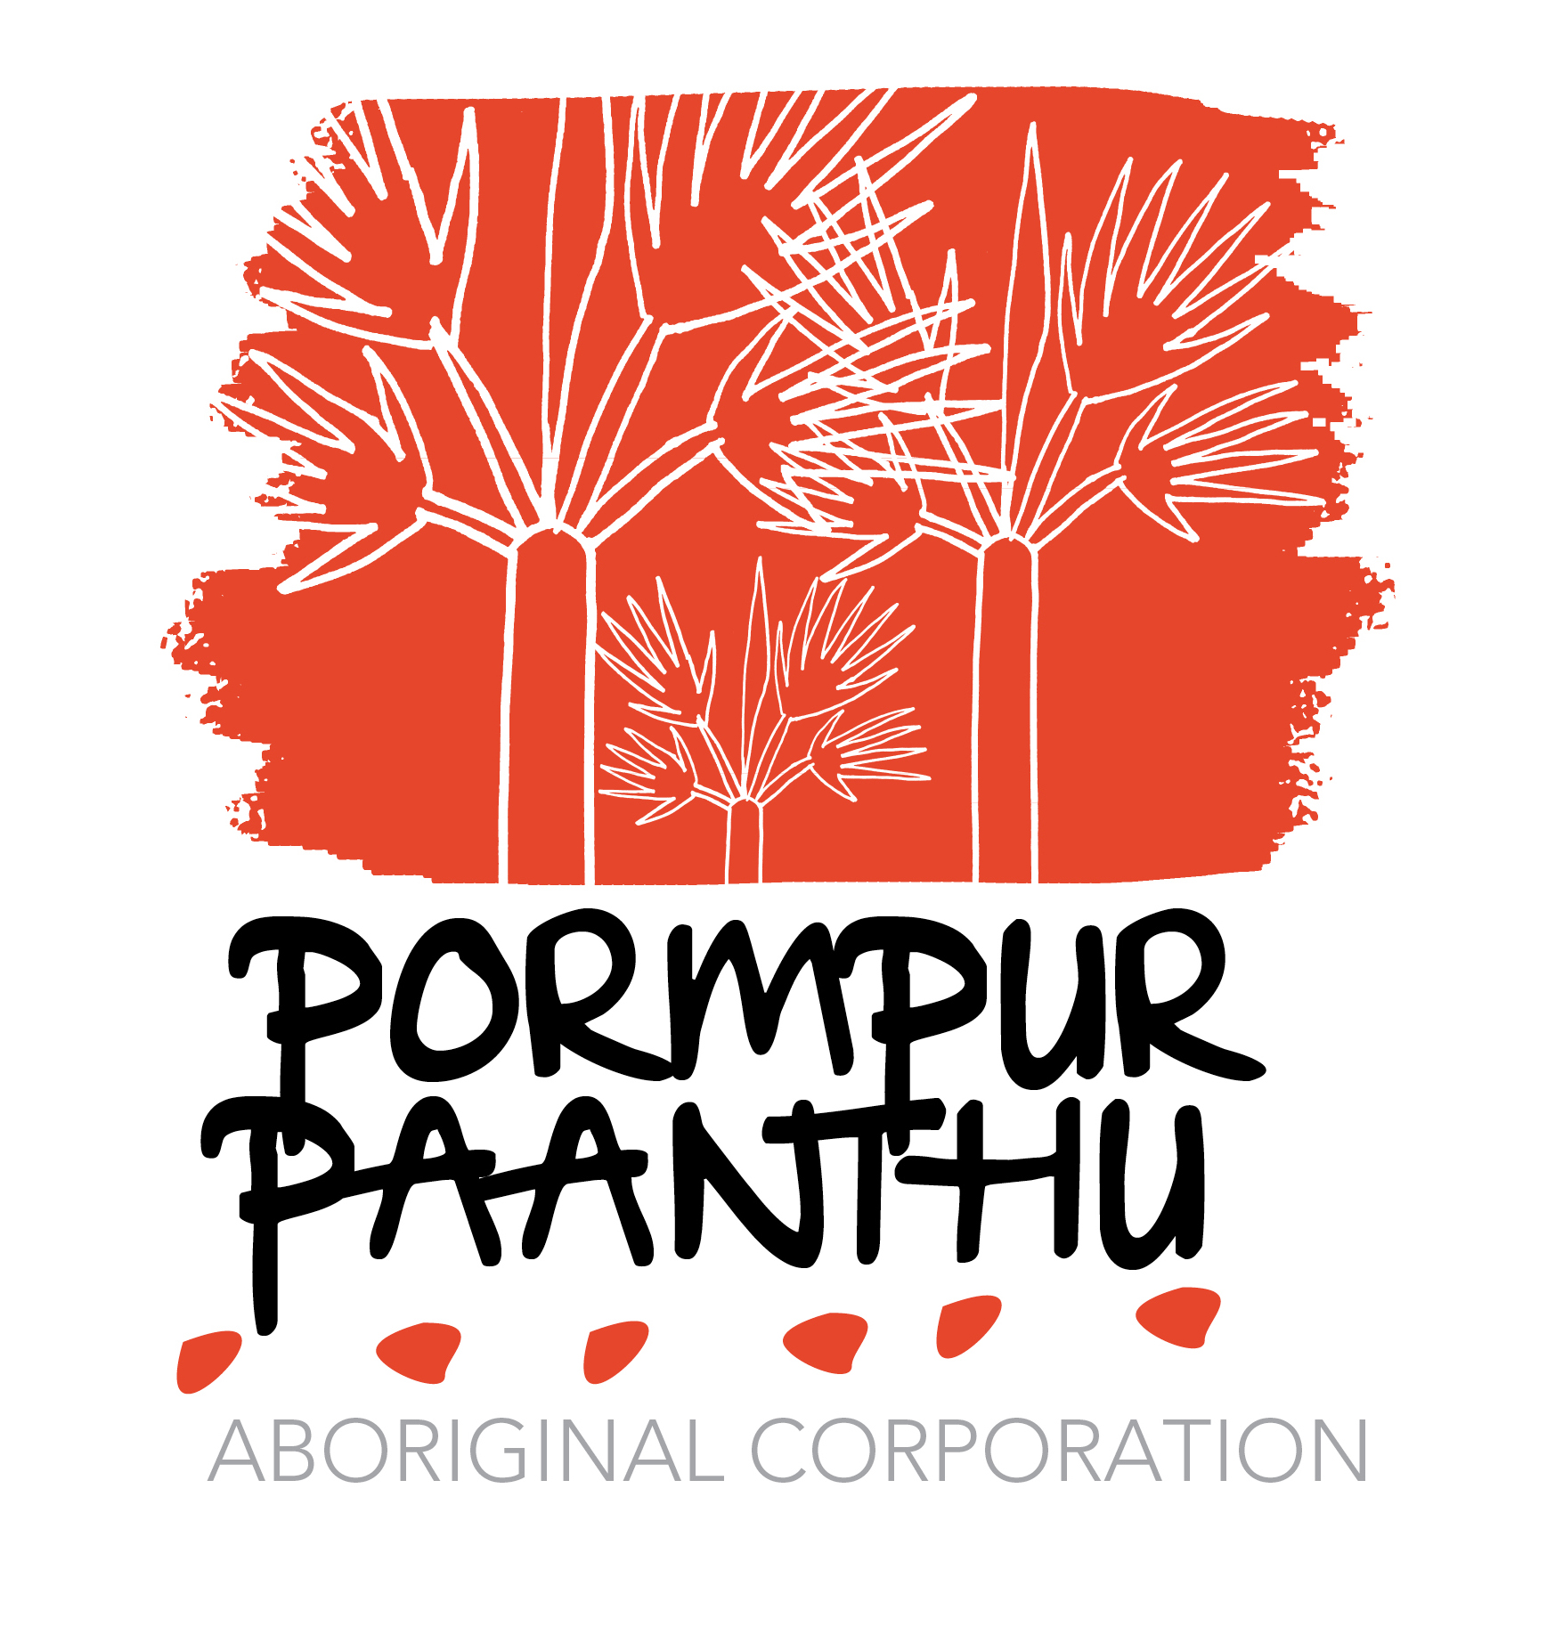

POSITION DESCRIPTION

- Position Title Alcohol and other Drugs Counsellor
- Position Number PD 002
- Classification 3021.76 f/n
4 Issue Date 8 April 2014

5 Organisational Environment
Pormpur Paanthu Aboriginal Corporation is a non government community controlled organisation originally established in 1991 to provide protection and support to women experiencing domestic / family violence. The organisation has expanded to include a suitable learning environment for children as well as family wellbeing and health support for those exposed to substance misuse, mental health domestic/family violence.
Services focus on quality, evidence based services that are appropriate in meeting the needs of Aboriginal and Torres Strait Islander men, women, children and families in the Pormpuraaw community.
Services have a coordinated and holistic community approach that includes:
- Executive
- Administration
- Early Childhood Learning
- Integrated Healing Services (women’s shelter, Men’s Healing Services, Family and Child therapies, and AOD therapeutic services)
- Child and Youth Development
6. The Role
To provide an holistic, culturally appropriate alcohol and other drug service that includes the delivery of an alcohol and other drug program; the use of screening, assessment, early intervention and care planning Tools; as well as bereavement, trauma, crisis, family violence, and financial counselling. The role will also provide case management, crisis intervention and relapse management; attend Unit, Staff, Practice, and Risk Management Meetings that supports individuals, groups and families where alcohol or other drug use is a concern. Through assessment you may need to refer individuals and families to other services. At times you may be called upon to perform in the role of on call counsellor for the Women’s Shelter. As part of compliance and reporting you will be expected to complete online reporting at the discretion of your Manager.
PPAC is committed to providing quality services and all staff are required to participate in continuous quality improvement activities and mandatory training required to support the quality management system.
7. Reporting Relationships
Services Integration Manager
8. Direct Reports
N/A
9. Key Duties

- Work with the Service Integration Manager to develop appropriate service delivery models and tools for Social Emotional Wellbeing and Mental Health; Alcohol and Other Drug, Therapeutic programs with specialist outreach services that support a family or consumer-centred approach suited to the needs of the community

- Actively contribute to the effective functioning and development of the service/program by participating in operational planning, implementation, reporting and evaluation of program development activities

- Facilitate activities or programs to enhance the delivery of alcohol and other drug services in the community, in alignment with Australian National Drug Strategy Framework, the National Strategic Framework for Social Emotional Wellbeing and Mental Health; and World Health Organisation policies of demand, supply and harm reduction, and harm minimisation

- Comply with Clinical Governance and best practices in the delivery of counselling and Group work

- Implement Crisis Intervention Plans, Staying Safe and Recovery Plans (Stay Strong Plan); including Family Support Plans for perpetrators, partners and family members

- Work with the Service Integration Manager to lead Practice Meetings, Risk Management and case reviews

- Provide counselling and health awareness education to community members and groups that is evidence based, holistic and culturally appropriate using best practice counselling models

- Implement the GEM Tool as the evidence-based outcome measure

- Contribute to the coordination of community initiatives related to addressing alcohol and other drug use and strengthen the level of access for groups and individuals to the Integrated Healing services.

- Develop and maintain strong collaborative partnership approaches with key stakeholders and service providers (such as Child Safety, Justice, Courts and Police; as well as Mental Health, Community Council, RJCP) which have an interest in addressing alcohol and other drug misuse.

- Participate in performance appraisal and professional development processes; and formal clinical supervision

- Deliver timely reports and statistics on the delivery of services, in compliance with funding agreements

- Contribute to the development, collection and analysis of research and data to identify community trends, gaps, needs and issues in addressing alcohol and other drug misuse.

- Work with the evaluation frameworks that monitor, assess and review the implementation and delivery of the alcohol and other drugs’ counselling service.

- Ensure all policies and procedures of Pormpur Paanthu Aboriginal Corporation are adhered to

- Participate in any meetings as directed by the Service Integration Manager and/or Chief Executive Officer
JOB SPECIFICATIONS

Personal Qualities
- Person of indigenous descent, or someone who has worked with indigenous communities and is knowledgeable about indigenous cultures
- Ability to work effectively and independently with minimal supervision and as part of a multi-disciplinary and multi-cultural team, in a supportive work environment
- Demonstrated ability to provide support and training to health and social welfare professionals and staff.
- The ability to travel and willingness to camp as required
- A commitment to the aims and objectives, policies and procedures of Pormpur Paanth Aboriginal Corporation and workplace health and safety.
Qualifications / Professional registration
- Minimum of a Certificate IV-6 AODs/DV; tertiary degree qualification (or equivalent) in the discipline/profession of Psychology, Social Work or Occupational Therapy.
- Recognised training in Dual Diagnosis and co-morbidity (optional)
- Registration with APS, AASW, ACWA or AHPRA registration.

Other requirements
- Possess a current driver’s licence.
- Possession of a Blue Card, or “Working with vulnerable people”
- Police Check
- Recognised qualifications related to the drug and alcohol field and willingness to undertake further professional development in this field

Knowledge
- Demonstrated knowledge of, evidence based and quality practice counselling models and tools and frameworks including narrative, group and family therapy, and their application in addressing alcohol and other drug misuse in an Aboriginal and Torres Strait Islander setting
- An understanding of the cross cultural work environment, including cultural safety, a knowledge of indigenous culture, social structures and health determinants.
- An understanding of the National Drugs Strategy Framework, guidelines and best practices, including the National Minimum Data Set; and National Strategic Framework for SEWB and MH
- Demonstrated well developed written, IT and oral communication skills and interpersonal skills particularly in regards to community consultation and conflict resolution.
- Demonstrated ability to work independently and in a multi-disciplinary team in a cross-cultural environment.
- Demonstrated knowledge of the drug and alcohol field as it applies to Indigenous people, including knowledge of the current policy, framework and strategies for improving Indigenous health, and social emotional well being.

Experience
- Applying best practice counselling including individual assessment, family therapy, group work and community development in addressing alcohol and other drug misuse
- Group and family facilitation and the development of support networks
- Experience in working with Aboriginal and Torres Strait Islander people
- Experience in case management, its coordination and the development of referral pathways.
- Experience in conflict resolution and mediation
- Report & submission writing skills

SELECTION CRITERIA

SC 1. Demonstrated ability to work effectively and sensitively with Aboriginal and Torres Strait Islander people, including a high level of knowledge and understanding of their culture and the socio economic determinants that impact on their health and well being.

SC 2. High level interpersonal and communication skills with demonstrated experience in the facilitation of AOD programs for groups.

SC 3. Alcohol and other drug counselling experience working with individuals who are disadvantaged and have complex issues.

SC4. Experience in drug and alcohol counselling, the application of best practices, clinical guidelines and tools and (including case and project management) for addressing substance misuse and domestic/family violence amongst Aboriginal and Torres Strait Islander people.

SC 5. Demonstrated experience of developing strategic links and partnerships with community–based service providers, external service providers and community members

SC 6. Demonstrated ability to collect, analyse and maintain client data.

