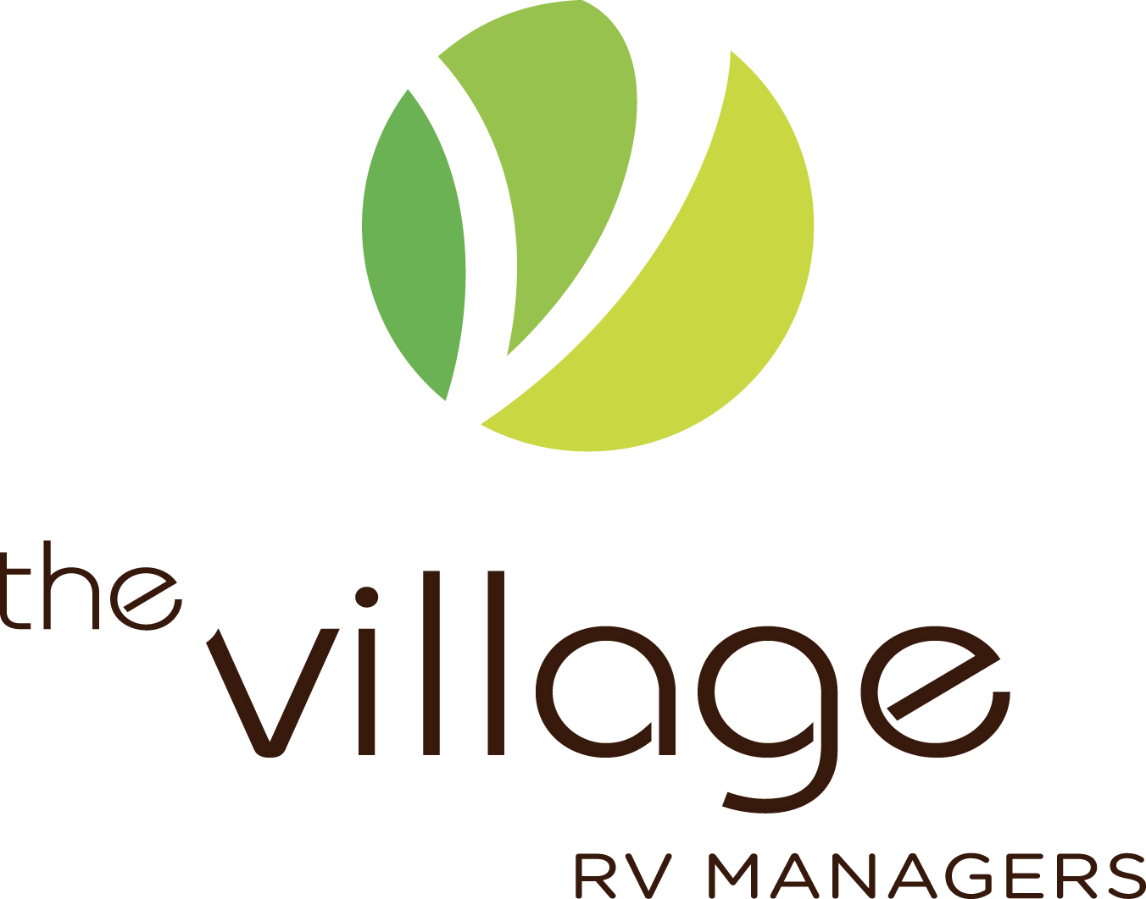

POSITION DESCRIPTION – Village Manager

POSITION DETAILS
Position Title | VILLAGE MANAGER
Date | July 2018
Location | The Village Taigum
Reports To | Chief Executive Officer

POSITION SUMMARY
The Village Manager is responsible for the efficient, effective and professional management of the delivery of services to the residents and the operation of the village, ensuring that the needs and expectations of the residents are appropriately met and maintained. The Village Manager develops and maintains good relationships with residents that indicate an understanding and empathy of their needs. The position ensures that the administrative functions are properly managed in accordance with The Village policies and procedures and that the applicable legislative requirements are met. The Village Manager further ensures that the assets of the village are properly managed and maintained within agreed budgets.

POSITION DIMENSIONS
Direct Reports | $ | Unit Operating Budget | $
Expenditure Limit - Capital | $ | Expenditure Limit - Operating | $ per month

MOST FREQUENT CONTACTS
Contact | Nature or Purpose of Contact
Chief Executive Officer | Line Manager
Assistant Village Manager | Daily tasks
Administration Assistant | Daily tasks
Sales Team | Liaising in relation to incoming and outgoing residents

 | KEY PERFORMANCE INDICATORS
 |  | KEY AREAS |  | ACCOUNTABILITIES |  | PERFORMANCE OBJECTIVES
 |  | Leadership |  | - Develop the Village in a professional and strategic and structured manner that involves and develops commitment of our people to the business. |  | - Demonstrates a leadership style that facilitates the commitment of the staff to the Village.  - Actively communicates the Corporate vision and values.  - Challenges and appropriately deals with behaviors that do not positively contribute to the success of the Village or the Company.
 |  |  | - Demonstrate a management style that engenders respect while facilitating operational efficiency, profitability and appropriate people and management practices. |  | - Leads in a way that engenders respect and demonstrates consistency of business practice.  - Is not afraid to make tough but fair decisions.
 |  |  | - Maintain effective communication standards with residents and staff which facilitates teamwork. |  | - Conducts day to day business showing an awareness and practice of appropriate and proactive communication methods that are appropriate for the Village.  - Relationships with staff are proactively maintained using appropriate communication methods, both written and verbal, including regular and documented staff meetings.  - Encourages and facilitates all staff to actively participate in team meetings.  - Facilitates positive and productive working relationships among the team to promote team spirit and a supportive working environment.
 |  |  | - Works cooperatively with the CEO and the Corporate Support Team to implement company strategies for the Village. |  | - Demonstrates to staff, residents and the Company an active commitment to the role as a member of the management team supporting implementation of practices which provide improve operational performance.
 |  |  | - Continuously reviews the Village’s business and operational performance and introduces appropriate strategies for improvement when necessary. |  | - Implements new and improved practices.
Operational and Quality Management |  |  | - Consistently facilitates the efficient management of business systems and processes and drives quality improvements and strives to ensure that all management systems are properly documented and comply with the requirements of the RVA and Retirement Villages Act. |  | - Corporate policies and procedures are adhered to.  - Village policies and procedures are developed and monitored.  - Village systems are reviewed, and improvements implemented on a regular basis to ensure ongoing efficiencies are achieved.  - The complaints policy and procedures are complied with and followed.
 |  |  | - Ensures that the Village is profitable and successful. |  | - Achieves or exceeds all budgets and financial targets.  - Actively participates and takes ownership of the budget process.  - Ensures that all Corporate and Village financial management standards are adhered to and within delegated authorities.  - Ensures best practice occurs at the best cost.  - Ensures that all resources are used appropriately in a cost-effective manner and that appropriate procedures and controls are in place.  - Ensures that staff rosters are managed in an appropriate and cost-effective manner.  - Ensures resident billing and supplier payments are accurate.  - Completion of Management Reporting to the required level and within required timeframes.
 |  |  | - Full responsibility for ensuring the operational efficiency of the Village and delivering all operational requirements. |  | - All Village operational areas are managed proactively.  - Staff are trained to take responsibility within delegated authorities and notify the Manager of any operational issues that require action.  - Staff are trained in the Corporate and Village Policies and Procedures.  - All business practices are maintained to a high standard in keeping with the needs of the Village.
 |  |  | - Conducts business practices that actively work towards maximising resident satisfaction. |  | - Resident feedback is sought and reviewed in order to maximise resident satisfaction.
 |  |  | - Contributes to the ongoing implementation, review and maintenance of the appropriate audit programmes. |  | - Audits completed, evaluated and recommendations are implemented as required.
 |  |  | - Asset preservation and management. |  | - Ensures that the village’s presentation is of a high standard creating a positive first impression for visitors.  - Manage compliance with legislative and Local Authority requirements.  - Manages and implements the village’s general and long-term maintenance plans.
Public Relations (including resident) |  |  | - Maintains appropriate and effective levels of communication and consultation with residents reflective of their role as customer and stakeholder. |  | - Conducts day to day business with residents showing an awareness and practice of appropriate and proactive communication methods relevant for the Village, including participation at regular resident meetings when requested.
 |  |  | - Demonstrates a thorough understanding of the role of the resident as a customer and stakeholder and the possible tensions that may arise by managing expectations and utilising effective conflict resolution strategies to protect the Village and Corporate image and reputation. |  | - Effectively using a consultative approach in managing relationships with residents while retaining an appropriate focus on the business objectives.  - Manages conflict in a positive and proactive way, always seeking to achieve the best possible outcome for the Village and resident(s).  - Is not afraid to stand ground and/or seek advice and support where appropriate.  - Carefully manages resident expectations by clearly communicating Village policy and procedures and contractual obligations and tactfully but firmly addressing difficulties raised due to unrealistic expectations.
 |  |  | - Seeks to develop relationships and maintain contact with appropriate external groups. |  | - Demonstrates proactivity and initiative in seeking out appropriate external groups and developing ongoing relationships that will add value to the Village.  - Consistently assesses these relationships and the way in which they are conducted for their effectiveness.
Sales |  |  | - Is proactively involved in the sales process in order to facilitate the sale and resale of units within the Village. |  | - Ensures that all enquiries are handled appropriately, using the standard sales process and that all enquiries are captured on a database.  - Demonstrates a good understanding of the sales process, the required level of participation and the documentation involved.
 |  |  | - Is actively involved and contributes to the marketing activities for the Village. |  | - In conjunction with the Corporate Support Team takes responsibility for the marketing of the Village.  - Actively participates in Open days when required and ensures that the Village is well presented.  - Actively supports and participates at marketing and sponsorship events that benefit both the Village and Corporate brand e.g. bowls sponsorships.
 |  |  | - Takes responsibility for the post sales process for new residents. |  | - Manages each new resident’s orientation into the Village including identifying additional service requirements.  - Ensures that resident occupation always occurs in line with Village and Corporate procedure.
Strategic Planning |  |  | - Takes responsibility for the Village’s business planning and actively implements initiatives which support business plan outcomes. |  | - Works with the Corporate Support Team to complete and implement the Village’s business plan.  - Operational management is conducted and reviewed in line with the business plan objectives.
Risk Management |  |  | - Ensures that risks to the Village and Corporate are identified proactively and the exposure is minimised. |  | - Seeks to identify and document any business risks.  - Risks are either minimised or alternative methods sought to eliminate.  - CEO is formally notified of any significant business risk.
Services |  |  | - Demonstrates a holistic approach to service delivery and the development of services which meets the needs and expectations of Village residents. |  | - Integrates service initiatives into the Village operation.  - Implements innovative business practices.  - Works effectively with staff and the corporate support team to identify further service opportunities.  - Service standards are resourced and delivered to a standard in keeping with the needs of residents within the Village while maintaining profitability.  - Ensures high standards of care practice are implemented and best practice is delivered.  - Any service standards that are unable to be met are to be communicated to the CEO.  - Coordinates the services appropriate to meet the personal needs of residents.  - Coordinates and encourages a range of social activities for residents with input from residents and the social committee.  - Produces a regular calendar of events and Village newsletter.  - Manage the effective operation of the emergency call system.
 |  |  | - Ensures that residents are aware of their rights and responsibilities and that these are maintained. |  | - Staff training includes resident’s rights, and staff are aware of and follow the policy requirements in this area.
 |  |  | - Acts as an advocate for the residents and their families. |  | - Staff training includes advocacy and staff are aware of and follow the policy requirements in this area.
Human Resource Management |  |  | - Ensures that best employment practices are maintained in line with Delegated Authorities and Corporate and Village policy. |  | - Conducts all employment relationships by demonstrating good practice in leadership, communication and HR practice and in line with policy and procedure.  - Maintains open and clear communication with the support team on HR issues and asks for assistance where appropriate.  - Takes full responsibility for the entire recruitment process for the Village within delegated authorities.  - Ensures that the appropriate induction procedures are followed by all staff.
 |  |  | - Takes full responsibility and accountability for the employment and employment relationships for all staff employed at the Village. |  | - Maintains strong performance management and development standards for all staff within delegated authorities.
 |  |  | - Ensures that all staff are appropriately supported, coached, trained and developed in order to take full responsibility and accountability for the requirements of their roles. |  | - Ensures that those staff who have supervisory responsibilities are coached, trained and developed to take appropriate levels of HR responsibility.  - Ensures that all staff are trained and supported in an appropriate manner to equip them to perform the requirements of their roles.  - Conducts annual performance reviews for all staff.  - Facilitates appropriate training when and where required.
Professional Standards and Development |  |  | - Deliver a consistently high standard of customer service at all times. |  | - Works actively to ensure that high standards of customer service, presentation and vision are maintained at all times.  - Actively initiates and contributes towards developing innovative, efficient and effective ways of meeting customer satisfaction.
 |  |  | - Personal presentation to always be of a high standard in keeping with the Village. |  | - Ensures that personal presentation is impeccable and appropriate at all times in line with any relevant Corporate policies.
 |  |  | - Maintains the highest level of confidentiality. |  | - Maintains secure village, staff and resident records and appropriate verbal communication to ensure that residents, staff and business confidentiality is maintained at all times.
 |  |  | - Takes responsibility for active participation in own professional development. |  | - Seeks, attends, actively participates in and implements learning from suitable ongoing training as agreed with the CEO.
Health & Safety Management |  |  | - Takes responsibility for Health & Safety in line with the requirement of the Health & Safety Act and Corporate policy and guidelines. |  | - The Company Health & Safety manual is read and signed off.  - Ensures that all Health & Safety practices are consistently maintained in line with the Health & Safety Manual.  - Actively participates in training and workshops regarding health and safety issues relevant to the role.
 |  |  | - Health & Safety responsibilities are managed and completed in line with the Policies and Procedures. |  | - All standards listed in the Health & Safety policy are adhered to.
 |  |  | - All work processes are carried out in an appropriate manner in order to maximise safety and in line with all Corporate Health & Safety guidelines, instructions and standards. |  | - Takes responsibility for wearing and maintaining all protective clothing and apparatus appropriate for the work performed and ensures staff take equal responsibility.  - Records using the appropriate documentation, all accidents or near misses and ensures that all staff are trained and supported in the use of the documentation.  - Actively participates in rehabilitation or retraining, as and when necessary after suffering an accident or injury.
Projects |  |  | - Contributes to Village or company wide initiatives where appropriate. |  | - Completes all agreed projects to a high standard and within agreed time frames.
 |  |  | - Maintains a high standard of teamwork and initiative within project teams. |  | - Actively participates as a team member in management and functional team meetings.  - Maintain positive and productive working relationships with all functional team members.
General |  |  | - Adheres to duties as specified and outlined in the document “Managers Duties”.  - Perform other general duties as required by the Director |  | - Be prepared to carry out duties as required in a pleasant manner and to the levels as required, and within set time frames.

QUALIFICATIONS AND LICENCES
- Qualifications in related field (Hospitality, Facilities Management, Aged Care)
- Current First Aid Certificate with CPR
- Current Police Check – National Criminal History Check

SKILLS AND COMPETENCIES
Knowledge and/or experience:
- Prior management experience
- Experience working in a service environment
- Demonstrated understanding of the needs of older people
- Experience in office administration
- Excellent interpersonal communications skills
- Proven ability to work in a team environment
- Commitment to quality management & practices
- Demonstrated ability to manage, train & development employees
- Conflict resolution and time management skills

Technical and business skills:
- Working knowledge of legislation affecting retirement villages
- Prior experience in the management of WH&S systems
- Computer literate with strong working knowledge of Microsoft Suite

Personal attributes:
- High ethical standard, is trustworthy and confidential
- Works well individually and as a team member
- Has consideration and respect for others and their views
- Adapts to changing environments and demands
- Enthusiastic, energetic, projects a positive image
- Good attention to detail, efficiency and effectiveness

SIGNATORIES
_______________________________ _______________________________
Employee’s Name Manager’s Name

_______________________________ _______________________________
Employee’s Signature Manager’s Signature

___________ ___________
Date Signed Date Signed

