General Manager

Position Description
This is an Aboriginal and/or Torres Strait Islander identified position.

The role
Reporting to the Board, the General Manager will have overall strategic and operational responsibility for staff, projects, stakeholder engagement, member services and industry advocacy and development as well as execution of the First Nations Media Australia strategic plan.

Where the role fits

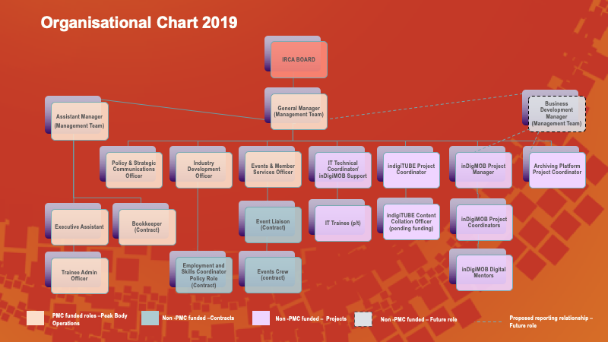

Key Responsibilities
1. | Peak Body Planning and Governance
Work with Board, members and stakeholders to develop and update the Strategic Plan.
Provide regular written and/or verbal reports to Board.
Seek relevant legal or expert advice for the Board where needed.
2. | Operational Management
Administer the operations of the organisation in line with the Constitution and Strategic and Operational Plans and organisational values.
Initiate and manage projects in line with the Strategic Plan and ensure the sustainability of the organisation.
Ensure organisational compliance with ORIC and other legal requirements.
Ensure policies and procedures are up to date and consistent with best practice.
3. | Financial Management
Manage and administer all budgets and ensure funding and contractual obligations are met.
Oversee the development and implementation of a fundraising strategy to increase non-government funding streams in order to increase organisational capacity and sustainability.
Identify funding opportunities for events, activities and industry development activities.
4. | Member Services and Stakeholder Engagement
Oversee the development and resourcing of a list of member services and capacity building activities.
Develop and maintain relationship with key government stakeholders and members.
Collaborate with stakeholder organisations to help achieve organisational outcomes, share resources and build sector capacity.
Develop relationships with and between member organisations by facilitating face to face and virtual meetings on a regular basis.
Keep Board and stakeholders informed and aware of pertinent information relevant to the sector and provide opportunities for consultation and input where appropriate.
Promote organisational role within the sector and wider community.
5. | Policy Development and Advocacy
Submit peak body Policy Positions to Government in response to relevant Reviews or Discussion Papers in consultation with sector (with Research & Policy Officer).
Develop and maintain strong relationships with relevant government agencies in order to support the development of the sector.
Participate in broader policy development and representation of the interests and goals of First Nations media organisations and practitioners.
Advocate for new opportunities that increase impact, income and capacity of media and communications for members.
Actively engage in all relevant forums and policy discussions to represent the outcomes and development needs of the sector.
6. | Staffing and HR (with Assistant Manager)
Recruit and supervise staff and contractors to meet human resourcing, strategic and operational objectives.
Manage the development of a succession planning and professional development strategy for all staff roles to support career pathways and Increased Indigenous employment in the organisation.
7. | Industry Development
Support the industry development of sector engagement through advisory groups in the areas of:
- Employment and skills development
- Governance and leadership
- Business development and fundraising
- Technology change
- Content creation and sharing
- Archiving.

Oversee the coordination of events, including annual National Conference and Remote Indigenous Media Festival.

Other duties which may be undertaken: Specific projects as directed by the board.

