POSITION DESCRIPTION
Occupational Therapist

Reports to: | Aged and Disability Operations Manager
Division: | Family and Community Services
Award: | Health Professionals and Support Services Award 2020
Classification: | Health Professionals Employee Level 3, Pay Point 1
Approved by: | Chief Executive Officer
Date approved: | 29 March 2023

ORGANISATIONAL CONTEXT
The Broome Regional Aboriginal Medical Service (BRAMS) is an Aboriginal Community Controlled Health Service which has been caring for the Broome community for more than 40 years. When we first opened our doors in 1978, BRAMS was the first remote Aboriginal Medical Service in Western Australia.
BRAMS provides comprehensive, holistic and culturally responsive primary health care, social and emotional wellbeing services, and NDIS support to Aboriginal people living in Broome. BRAMS delivers more than 40,000 of occasions of service each year. BRAMS delivers services in accordance with our Model of Care.
Our Vision
Healthy People – Strong Community – Bright Future
Our Mission
Provide holistic and culturally responsive health and wellbeing services for Aboriginal and Torres Strait Islander People. That means making our Mob healthy.

POSITION PURPOSE
This position will lead the provision of flexible and timely occupational therapy services to consumers of BRAMS’ Aged and Disability services. The focus will be on optimising independence for consumers and enhancing health, wellbeing and quality of life for Aboriginal and Torres Strait Islander consumers in accordance with the BRAMS Model of Care.

KEY RESULT AREAS | MAIN DUTIES
Service Delivery | Provide occupational services to aged and disability consumers including but not limited to:  - Provide services in accordance with the BRAMS Model of Care.  - Provide a quality occupational therapy (OT) service to consumers that includes assessment, therapeutic/enablement interventions and education. The purpose of OT interventions is to enhance self-care, mobility, independence and quality of life.  - Work with consumers to establish goals and provide information to support informed decision making in regard to activities of daily living.  - Work collaboratively as part of a multidisciplinary team to meet the goals of consumers.  - Accurately record data and case notes as required by BRAMS which comply with privacy policies.  - Act as a resource and referral base for assessment and provision of aids and equipment as necessary.  - Liaise with internal and external service providers, relevant networks and key stakeholders to ensure appropriate referrals of services.  - Where relevant undertake the monitoring, purchasing, storage and maintenance of supplies and equipment.  - Liaise with BRAMS staff, consumers, carers and other relevant service providers or health professionals about OT assessment outcomes and recommendations.  - Accept referrals from the Intake and Assessment Officer, organise and monitor appointment schedules and bookings ensuring the service is responsive.  - Attend service meetings, staff meetings and other organisational meetings as required.  - Undertake any reasonable tasks as directed by BRAMS.
Professional Leadership | Maintain ongoing professional knowledge and skills including but not limited to:  - Apply the principles of evidence based practice via professional training and professional development.  - Contribute to staff professional development by sharing knowledge and educating staff in areas relevant to OT.  - Manage OT student placement planning, supervision and feedback.  - Ensure OT policies and procedures are evidenced based and up to date with professional clinical practice.  - Comply with all relevant sector and profession recommended/approved risk assessment or diagnostic tools.
Quality and Risk | Practice complies with delegated scope of practice including but not limited to:  - Ensure compliance with all relevant legislation, funding guidelines, service standards and contractual obligations.  - Liaise with the Aged and Disability Operations Manager and the Senior Medical Officer on any clinical issues.  - Report areas of serious risk to the Aged and Disability Operations Manager and work together to mitigate those risks.
Personal Accountability | Compliance with BRAMS’ values, code of conduct, policies and procedures and relevant government legislation and standards including but not limited to:  - Work collaboratively with BRAMS employees and external stakeholders in accordance with BRAMS’ values and professional standards of behaviour.  - Actively participate in initiatives to maintain, build upon and promote a positive and collaborative workplace.  - Identify opportunities to integrate and work collaboratively across teams.  - Promote a positive safety culture by contributing to health and safety consultation and communication.
The duties outlined in this Position Description are not exhaustive and are only an indication of the work of the role. BRAMS reserves the right to vary the Position Description.

KEY PERFORMANCE INDICATORS
The employee will be required to participate in the development of an individual workplan which will include key result areas associated with their position and a requirement to demonstrate appropriate behaviours which reflect a commitment to BRAMS values and strategic directions.

KEY RELATIONSHIPS
Internal
BRAMS CEO | The CEO may make day to day requests for support and information from the Occupational Therapist.
Aged and Disability Operations Manager | The Aged and Disability Operations Manager is the first point of contact for the overall direction of work and will provide support and supervision to the Occupational Therapist.
Family and Community Services General Manager | The Occupational Therapist may receive guidance and direction from the Family and Community Services General Manager.
BRAMS Employees | The Occupational Therapist will interact closely with Employees to develop and maintain effective working relationships, collaborate on matters, exchange information and provide advice and feedback in order to meet organisational goals.
External
External Stakeholders | The Occupational Therapist will develop and maintain strong links with external stakeholders in the delivery of the Aged and Disability Program.
BRAMS Consumers | The Occupational Therapist will develop and maintain positive relationships with BRAMS Consumers.

WORKFORCE CAPABILITY FRAMEWORK
BRAMS is operating in a rapidly changing environment which requires our workforce to build capabilities and quality to enable - and drive - sector reforms, particularly the Closing the Gap initiative. These stages of work can be thought of as ‘domains’, and are intended to be consistent with BRAMS’ Model of Care. Each domain comprises several capabilities that enable BRAMS staff to achieve the objectives of that stage of work. These domains and capabilities combine to form the capability framework for BRAMS.
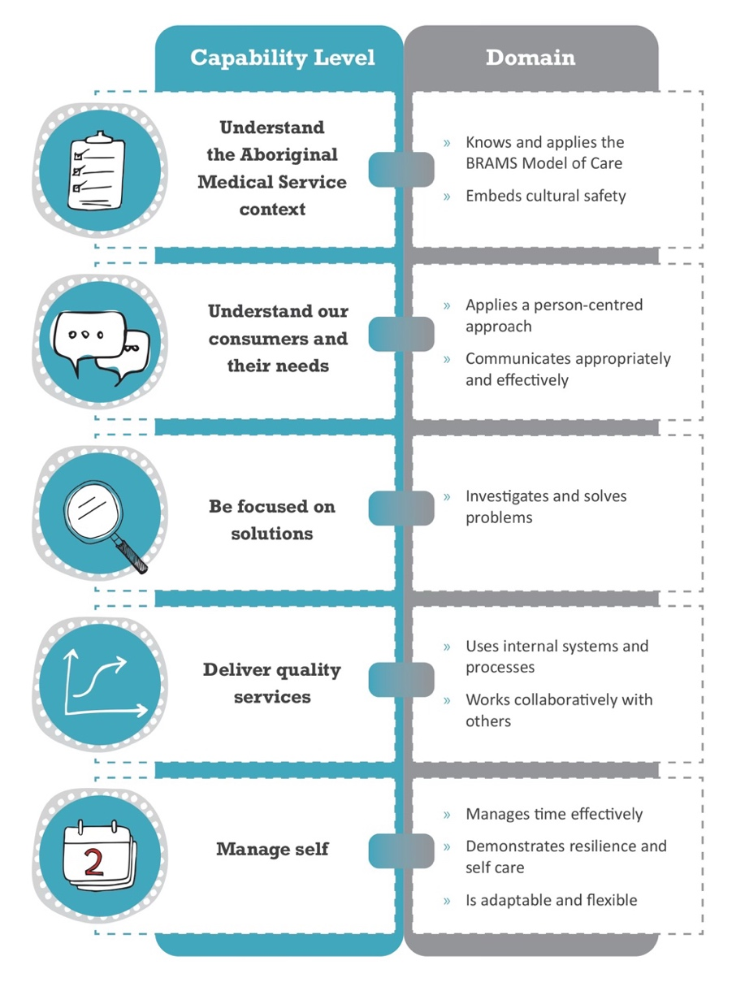

CAPABILITY LEVELS FOR THE POSITION
Capability levels for the position are as follows and reflect a progressive increase in complexity and skill:
Foundational > Established > Leading
CAPABILITY |  | DOMAIN | LEVEL
 | Understand the Aboriginal Medical Service context | Knows and applies the BRAMS Model of Care | ESTABLISHED
 |  | Embeds cultural safety | ESTABLISHED
 | Understands our consumers and their needs | Applies a person-centred approach | ESTABLISHED
 |  | Communicates appropriately and effectively | ESTABLISHED
 | Be focused on solutions | Investigates and solves problems | ESTABLISHED
 | Deliver quality service | Uses internal systems and processes | ESTABLISHED
 |  | Works collaboratively with others | ESTABLISHED
 | Manage self | Manages time effectively | ESTABLISHED
 |  | Demonstrates resilience and self-care | ESTABLISHED
 |  | Is adaptable and flexible | ESTABLISHED

BRAMS MODEL OF CARE
The BRAMS Model of Care is an expression of our collective goals of delivering high quality comprehensive health and wellbeing for Aboriginal people. Our Model of Care is defined in the figure below.
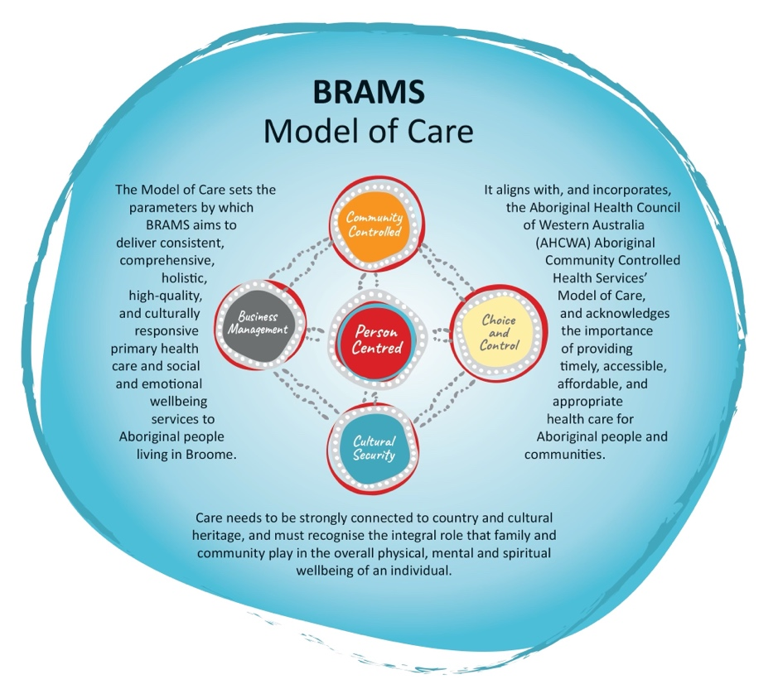

VALUES
The values of BRAMS are used to indicate the type of conduct required by our employees and the conduct that our consumers can expect from our service:
- Respect: Treat one another and others with respect.
- Integrity: Be truthful, honest and ethical in our dealing with one another and others.
- Accountability: Take responsibility for what we do and the decisions we make.
- Quality: Provide high quality services that meet the expectations of our clients and the community.

EMPLOYMENT SCREENING
Employees are required to demonstrate that they have undergone appropriate employment screening in accordance with BRAMS Employment Screening Policy. The following checks will be required for this role:
 | National Police Check |  | Pre-Employment Medical Assessment
 | Working with Children Check |  | National Disability Insurance Service Check
 | AHPRA Verification Check |  | Drivers Licence Verification Check
 | Passenger Transport Driver Check |  | COVID-19 Vaccination

SELECTION CRITERIA
Candidates for the position of Occupational Therapist must address the following selection criteria:
Essential Criteria
- The possession of a recognised tertiary qualification in Occupational Therapy and current registration with the Australian Health Practitioner Regulation Agency (AHPRA) as an Occupational Therapist.

Desirable
- Sound understanding of the Aboriginal Medical Service Model of Care.
- Previous experience within an Aboriginal and Torres Strait Islander Community Controlled Health Service.
- Demonstrated skills in working within a community setting, in particular the ability to work as part of a multidisciplinary team.
- Experience working in the disability or aged care sector.
- Excellent understanding of the disability and aged care sector and the care and support needs of Aboriginal and Torres Strait Islander consumers.
- Demonstrated ability to develop and sustain productive professional relationships with relevant stakeholders.
- Demonstrated ability to independently manage a workload.
- Strong computer skills and experience with clinical management systems.

ROLE ACCEPTANCE
I have read and understood the responsibilities associated with this role the organisational context and the values of BRAMS as outlined within this document.
Employee Signature: | Date:

