POSITION DESCRIPTION
Psychosocial Social Worker

Reports to: | Psychosocial Team Leader
Division: | Family and Community Services
Award: | Health Professionals and Support Services Award 2020
Classification: | Health Professionals Employee Level 1 - 3
Approved by: | Chief Executive Officer
Date approved: | 29 March 2023

ORGANISATIONAL CONTEXT
The Broome Regional Aboriginal Medical Service (BRAMS) is an Aboriginal Community Controlled Health Service which has been caring for the Broome community for more than 40 years. When we first opened our doors in 1978, BRAMS was the first remote Aboriginal Medical Service in Western Australia.
BRAMS provides comprehensive, holistic and culturally responsive primary health care, social and emotional wellbeing services, and NDIS support to Aboriginal people living in Broome. BRAMS delivers more than 40,000 of occasions of service each year. BRAMS delivers services in accordance with our Model of Care.
Our Vision
Healthy People – Strong Community – Bright Future
Our Mission
Provide holistic and culturally responsive health and wellbeing services for Aboriginal and Torres Strait Islander People. That means making our Mob healthy.

POSITION PURPOSE
The Social Worker provides social work using a person centered approach to provide support to Aboriginal and Torres Strait Islander consumers who access services through BRAMS. The role forms part of a multidisciplinary team approach and works closely with internal and other service providers to improve the health outcomes for our Aboriginal community. The social worker supports the delivery of groups within the Psychosocial team including to Aboriginal and Torres Strait Islander participants of NDIS, Aged Care and SEWB.

KEY RESULT AREAS | MAIN DUTIES
Service Delivery | Provide quality service provision to consumers, understanding the issues and support needs, and ensuring appropriate services are arranged and delivered to consumers including but not limited to:  - Provide group based support services to meet a range of consumer needs.  - Provide case management to a small case load of consumers as allocated and deliver number of hours and agreed outcomes.  - Provide necessary support for each consumer according to health status, personal strengths and weakness emotional state and additional factors.  - Contribute to provision of community groups, health promotion events and staff team building activities.  - Work creatively to develop group activities that seek to build on individual skills and capacity whilst fostering a non-judgemental, person-centred approach and creating a safe, nurturing environment for participation.  - Maintains appropriate case notes and other relevant documentation on consumer records.  - Gather regular statistical data including feedback from group participants and ensure this is recorded on LOGIQC.
Professional Leadership | Maintain ongoing professional knowledge and skills including but not limited to:  - Apply the principles of evidence based practice via professional training and professional development.  - Attend relevant training as required and participate in regular professional development activities.  - Provide advice and support to staff members regarding effective ways to address mental health and social and emotional wellbeing needs of consumers.  - Contribute to the design, development and evaluation of BRAMS’ Aged and Disability programs and services.
Personal Accountability | Compliance with BRAMS’ values, code of conduct, policies and procedures and relevant government legislation and standards including but not limited to:  - Work collaboratively with BRAMS employees and external stakeholders in accordance with BRAMS’ values and professional standards of behaviour.  - Actively participate in initiatives to maintain, build upon and promote a positive and collaborative workplace.  - Identify opportunities to integrate and work collaboratively across teams.  - Promote a positive safety culture by contributing to health and safety consultation and communication.
Quality and Risk | Practice complies with delegated scope of practice including but not limited to:  - Ensure compliance with all relevant legislation, funding guidelines, service standards and contractual obligations.  - Comply with all BRAMS Policies and Procedures.  - Liaise with the Aged and Disability Operations Manager and the Senior Medical Officer on any clinical issues.  - Report areas of serious risk to the Aged and Disability Operations Manager and work together to mitigate those risks.
The duties outlined in this Position Description are not exhaustive and are only an indication of the work of the role. BRAMS reserves the right to vary the Position Description.

KEY PERFORMANCE INDICATORS
The employee will be required to participate in the development of an individual workplan which will include key result areas associated with their position and a requirement to demonstrate appropriate behaviours which reflect a commitment to BRAMS values and strategic directions.

KEY RELATIONSHIPS
Internal
CEO | The CEO may make day to day requests for support and information from the Social Worker.
Psychosocial Team Leader | The Psychosocial Services Team Leader is the first point of contact for the overall direction of work and will provide support and supervision to the Psychosocial Social Worker.
Family and Community Services General Manager | The Psychosocial Social Worker may receive guidance and direction from the Family and Community Services General Manager.
Consumers | The Psychosocial Social Worker will develop and maintain caring, supportive, professional relationships with consumers ensuring professional boundaries are established and maintained.
External
External Stakeholders | The Psychosocial Social Worker will develop and maintain strong links with external stakeholders in the delivery of the Aged and Disability Program.

WORKFORCE CAPABILITY FRAMEWORK
BRAMS is operating in a rapidly changing environment which requires our workforce to build capabilities and quality to enable - and drive - sector reforms, particularly the Closing the Gap initiative. These stages of work can be thought of as ‘domains’, and are intended to be consistent with BRAMS’ Model of Care. Each domain comprises several capabilities that enable BRAMS staff to achieve the objectives of that stage of work. These domains and capabilities combine to form the capability framework for BRAMS.
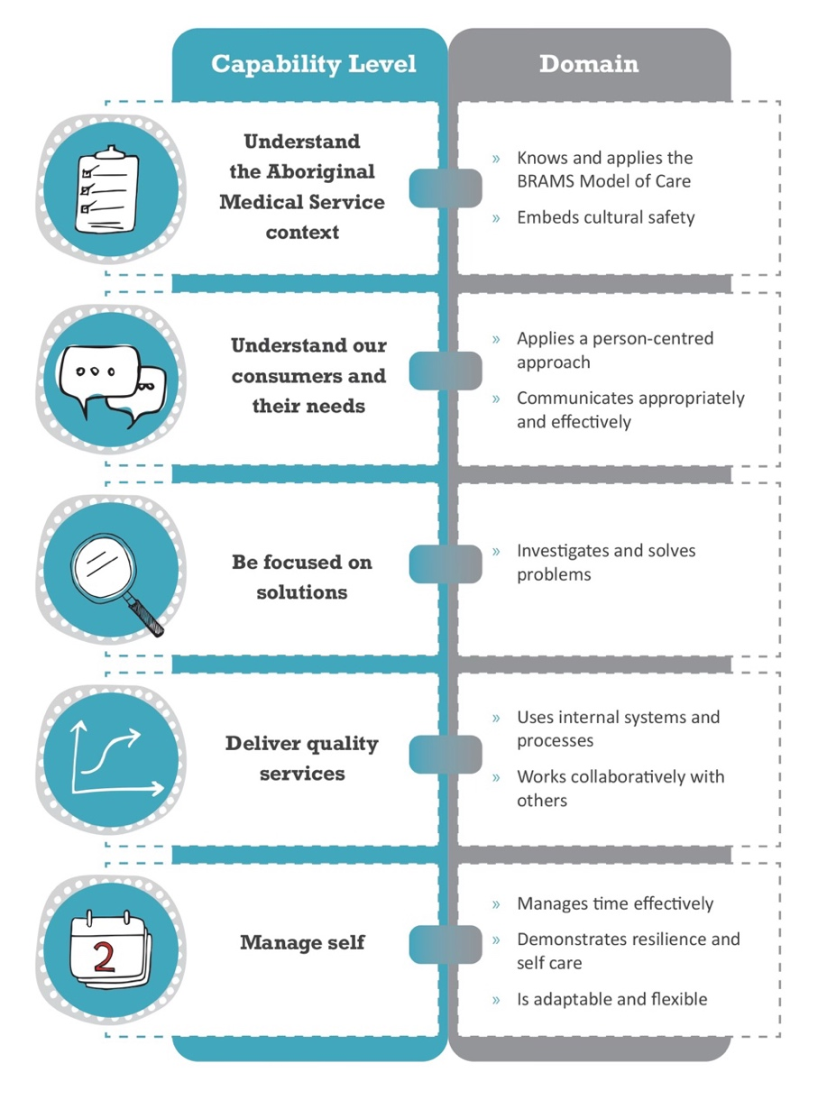

CAPABILITY LEVELS FOR THE POSITION
Capability levels for the position are as follows and reflect a progressive increase in complexity and skill:
Foundational > Established > Leading
CAPABILITY |  | DOMAIN | LEVEL
 | Understand the Aboriginal Medical Service context | Knows and applies the BRAMS Model of Care | ESTABLISHED
 |  | Embeds cultural safety | ESTABLISHED
 | Understands our consumers and their needs | Applies a person-centred approach | ESTABLISHED
 |  | Communicates appropriately and effectively | ESTABLISHED
 | Be focused on solutions | Investigates and solves problems | ESTABLISHED
 | Deliver quality service | Uses internal systems and processes | ESTABLISHED
 |  | Works collaboratively with others | ESTABLISHED
 | Manage self | Manages time effectively | ESTABLISHED
 |  | Demonstrates resilience and self-care | ESTABLISHED
 |  | Is adaptable and flexible | ESTABLISHED

BRAMS MODEL OF CARE
The BRAMS Model of Care is an expression of our collective goals of delivering high quality comprehensive health and wellbeing for Aboriginal people. Our Model of Care is defined in the figure below.
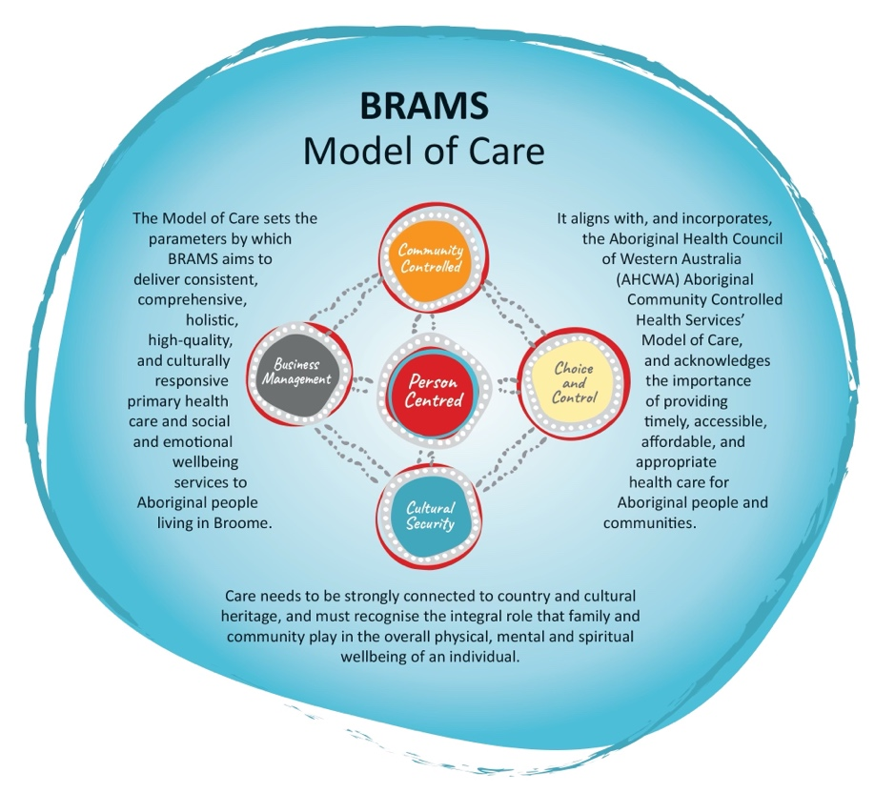

VALUES
The values of BRAMS are used to indicate the type of conduct required by our employees and the conduct that our consumers can expect from our service:
- Respect: Treat one another and others with respect.
- Integrity: Be truthful, honest and ethical in our dealing with one another and others.
- Accountability: Take responsibility for what we do and the decisions we make.
- Quality: Provide high quality services that meet the expectations of our clients and the community.

EMPLOYMENT SCREENING
Employees are required to demonstrate that they have undergone appropriate employment screening in accordance with BRAMS Employment Screening Policy. The following checks will be required for this role:
 | National Police Check |  | Pre-Employment Medical Assessment
 | Working with Children Check |  | National Disability Insurance Service Check
 | AHPRA Verification Check |  | Drivers Licence Verification Check
 | Passenger Transport Driver Check |  | COVID-19 Vaccination

SELECTION CRITERIA
Candidates for the position of Psychosocial Social Worker must address the following selection criteria:
Essential Criteria
- Bachelor’s Degree in Social Work, plus minimum 1 year clinical work experience.
- Registration or eligibility for registration with AASW.

Desirable
- Demonstrated knowledge of current issues, standards and trends in the delivery of mental health and social and emotional wellbeing services to Aboriginal people.
- Demonstrated experience or understanding of health and wellbeing issues affecting Aboriginal and Torres Strait Islander people, including a demonstrated awareness of and sensitivity to Aboriginal culture and history.
- Excellent interpersonal skills with the ability to work with a broad range of people from a variety of backgrounds and experiences as well as highly developed verbal and written communication.
- Demonstrated ability to maintain absolute confidentiality regarding patient and practice information.
- Demonstrated computer proficiency, including the use of Microsoft Office applications, clinical record and data management systems and software, as well as proficiency in report writing and demonstrated ability to develop, organise and maintain records and reports in a timely manner.

ROLE ACCEPTANCE
I have read and understood the responsibilities associated with this role the organisational context and the values of BRAMS as outlined within this document.
Employee Signature: | Date:

