Reports to: | Family and Domestic Violence Coordinator
Division: | Family and Community Services
Award: | Health Professionals and Support Services Award 2020
Classification: | Health Professionals Employee Level 1 - 3
Approved by: | Chief Executive Officer
Date approved: | 27 January 2023
POSITION DESCRIPTION
Family and Domestic Violence Social Worker

ORGANISATIONAL CONTEXT
The Broome Regional Aboriginal Medical Service (BRAMS) is an Aboriginal Community Controlled Health Service which has been caring for the Broome community for more than 40 years. When we first opened our doors in 1978, BRAMS was the first remote Aboriginal Medical Service in Western Australia.
BRAMS provides comprehensive, holistic and culturally responsive primary health care, social and emotional wellbeing services, and NDIS support to Aboriginal people living in Broome. BRAMS delivers more than 40,000 of occasions of service each year. BRAMS delivers services in accordance with our Model of Care.
Our Vision
Healthy People – Strong Community – Bright Future
Our Mission
Provide holistic and culturally responsive health and wellbeing services for Aboriginal and Torres Strait Islander People. That means making our Mob healthy.

POSITION PURPOSE
Reporting to the Family and Domestic Violence Coordinator, the Family and Domestic Violence Social Worker has a multidisciplinary focus that includes intake (in person and by phone) and short term crisis interventions which may involve managing a small case load. Using evidence based frameworks and the BRAMS Model of Care, the Social Worker will conduct risk and needs assessments, create individualised safety plans and develop case plans with Aboriginal women and families who are seeking support.

KEY RESULT AREAS | MAIN DUTIES
Service Delivery | Perform person centred assessments and planning in accordance with BRAMS policies and procedures including but not limited to:  - Greeting new people who present by phone or in person at BRAMS seeking family violence support.  - Complete risk assessment and safety action planning with women and their children in accordance with the Western Australian Family and Domestic Violence Common Risk Assessment and Risk Management Framework.  - Organising and supporting emergency accommodation plans including the use of appropriate brokerage.  - Provide short term responses to Aboriginal women and children – including emotional and practical support, referrals to external and/or internal services, material aid and other brokerage needs.  - Providing intermediate and longer term case management responses.  - Providing advocacy and psychoeducation.  - Working in collaboration with the Family and Domestic Violence team to ensure the best pathway of support is provided to Aboriginal women and children.  - Provide families affected by family and domestic violence with information on all of the options available to them and their children, providing them with referral and assistance with their chosen option and advocate on their behalf where requested.  - Record and maintain comprehensive case files and data collection for all clients.
Communication and Collaboration | Communicate in a professional and respectful manner including but not limited to:  - Maintain client confidentiality.  - Participate in decision making and joint problem solving.  - Actively participate in monthly documented support and supervision sessions.  - Attend relevant meetings. Be punctual, prepared and ready to participate.  - Build positive partnerships, both internally and externally.
Continuous Quality Improvement | Actively participate in organisational continuous quality improvement initiatives including but not limited to:  - Actively participate in the implementation of outcomes from program quality audits.  - Ensure that you are familiar with BRAMS’ program accreditations and your obligation to uphold these in your day-to-day role.  - Contribute to the collection of data and report on requirements for the program and services.  - Comply with all BRAMS Policies and Procedures.
The duties outlined in this Position Description are not exhaustive and are only an indication of the work of the role. BRAMS reserves the right to vary the Position Description.

KEY PERFORMANCE INDICATORS
The employee will be required to participate in the development of an individual workplan which will include key result areas associated with their position and a requirement to demonstrate appropriate behaviours which reflect a commitment to BRAMS values and strategic directions.

KEY RELATIONSHIPS
BRAMS CEO | The CEO may make day to day requests for support and information from the Family and Domestic Violence Case Worker.
Family and Community Services General Manager | The Family and Domestic Violence Social Worker may receive guidance and direction from the Family and Community Services General Manager.
Family and Domestic Violence Program Coordinator | The Family and Domestic Violence Program Coordinator is the first point of contact for the overall direction of work and will provide support to the Family and Domestic Violence Social Worker.
BRAMS Employees | The Family and Domestic Violence Social Worker will interact closely with BRAMS Employees to develop and maintain effective working relationships, collaborate on matters, exchange information and provide advice and feedback.
Clients | The Family and Domestic Violence Social Worker will develop and maintain caring, supportive, professional relationships with clients ensuring professional boundaries are established and maintained.
External Stakeholders | The Family and Domestic Violence Social Worker will develop and maintain strong connections with external stakeholders and other agencies in the local area.

WORKFORCE CAPABILITY FRAMEWORK
BRAMS is operating in a rapidly changing environment which requires our workforce to build capabilities and quality to enable - and drive - sector reforms, particularly the Closing the Gap initiative. These stages of work can be thought of as ‘domains’, and are intended to be consistent with BRAMS’ Model of Care. Each domain comprises several capabilities that enable BRAMS staff to achieve the objectives of that stage of work. These domains and capabilities combine to form the capability framework for BRAMS.
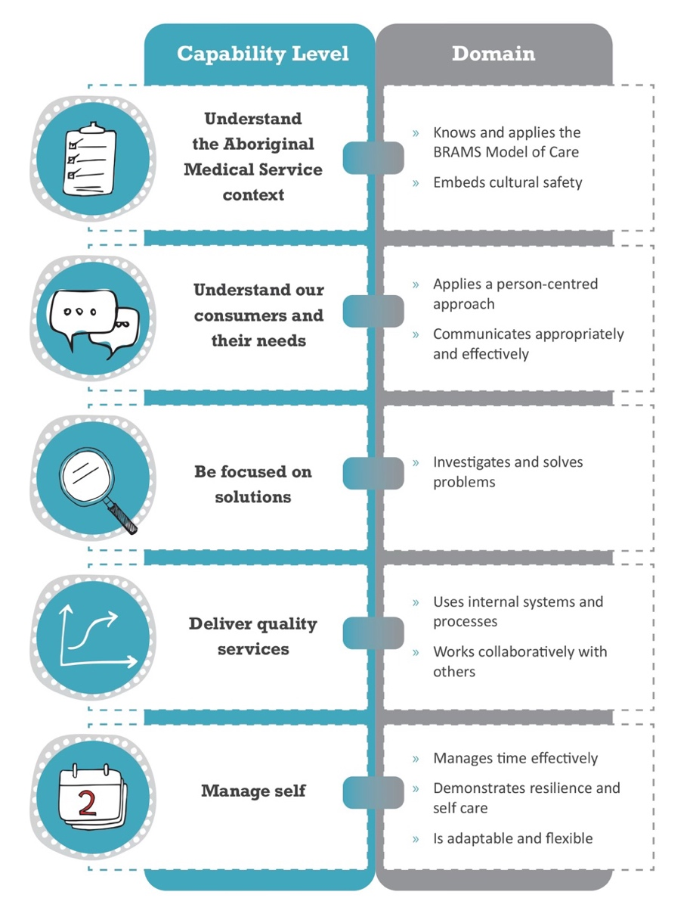

CAPABILITY LEVELS FOR THE POSITION
Capability levels for the position are as follows and reflect a progressive increase in complexity and skill:
Foundational > Established > Leading
CAPABILITY |  | DOMAIN | LEVEL
 | Understand the Aboriginal Medical Service context | Knows and applies the BRAMS Model of Care | ESTABLISHED
 |  | Embeds cultural safety | ESTABLISHED
 | Understands our consumers and their needs | Applies a person-centred approach | ESTABLISHED
 |  | Communicates appropriately and effectively | ESTABLISHED
 | Be focused on solutions | Investigates and solves problems | ESTABLISHED
 | Deliver quality service | Uses internal systems and processes | ESTABLISHED
 |  | Works collaboratively with others | ESTABLISHED
 | Manage self | Manages time effectively | ESTABLISHED
 |  | Demonstrates resilience and self-care | ESTABLISHED
 |  | Is adaptable and flexible | ESTABLISHED

BRAMS MODEL OF CARE
The BRAMS Model of Care is an expression of our collective goals of delivering high quality comprehensive health and wellbeing for Aboriginal people. Our Model of Care is defined in the figure below.
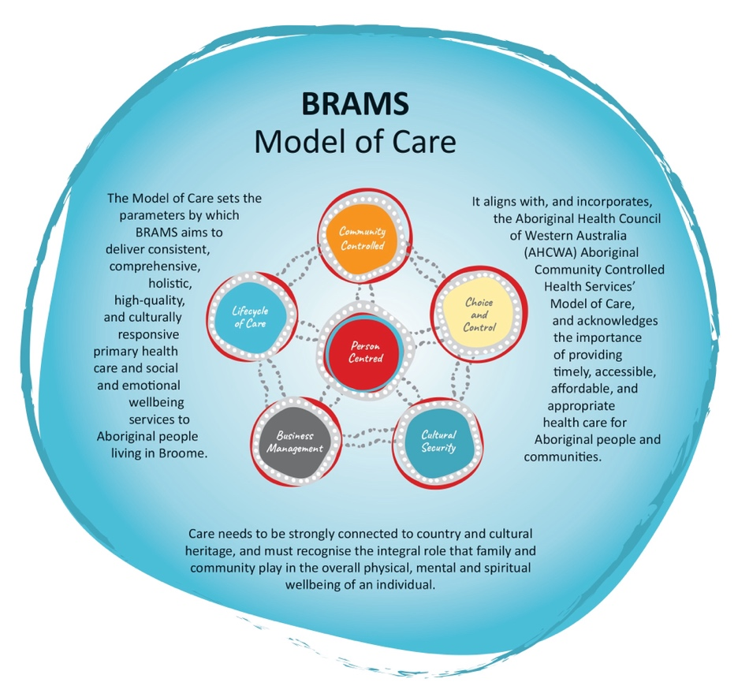

VALUES
The values of BRAMS are used to indicate the type of conduct required by our employees and the conduct that our consumers can expect from our service:
- Respect: Treat one another and others with respect.
- Integrity: Be truthful, honest and ethical in our dealing with one another and others.
- Accountability: Take responsibility for what we do and the decisions we make.
- Quality: Provide high quality services that meet the expectations of our clients and the community.

EMPLOYMENT SCREENING
Employees are required to demonstrate that they have undergone appropriate employment screening in accordance with BRAMS Employment Screening Policy. The following checks will be required for this role:
 | National Police Check |  | Pre-Employment Medical Assessment
 | Working with Children Check |  | National Disability Insurance Service Check
 | AHPRA Verification Check |  | Drivers Licence Verification Check
 | Passenger Transport Driver Check |  | COVID-19 Vaccination

SELECTION CRITERIA
Candidates for the position of Family and Domestic Violence Social Worker must address the following selection criteria:
Essential Criteria
- Appropriate tertiary qualification in Social Work.

Desirable
- Demonstrated knowledge and understanding of the issues affecting Aboriginal communities, families and children – specifically Aboriginal women and children who are experiencing family and domestic violence.
- A minimum of twelve months prior experience in a family violence focused role.
- Demonstrated capacity to work autonomously in developing and managing detailed, effective family violence safety plans for multiple families simultaneously.
- Demonstrated computer proficiency, including the use of Microsoft Office applications, clinical record and data management systems.
- Ability to develop productive working relationships with stakeholders.
- Effective time management skills, the ability to prioritise and work to strict deadlines.
- Effective conflict resolution skills, negotiation, mediation and decision making skills.

ROLE ACCEPTANCE
I have read and understood the responsibilities associated with this role the organisational context and the values of BRAMS as outlined within this document.
Employee Signature: | Date:

