Garnduwa Amboorny Wirnan  Aboriginal Corporation  ABN: 17 282 018 325  Head Office: 2/23 Coghlan Street, Broome WA 6725  Postal Address: PO Box 1321, Broome WA 6725  Tel: (08) 9195 5751 Fax: (08) 9192 2436  W: www.garnduwa.com.au | 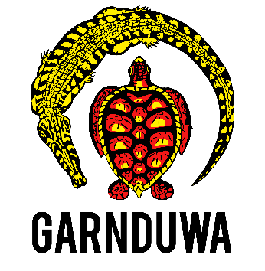

Corporate Services/Operations MANAGER

- Lead and promote a strong internal service culture, ensuring a service delivery approach that is responsive to the operational and strategic needs of the organisation.
- Recruit, induct and manage administration and management employees (excluding the CEO)
- Maximise the organisation’s ability to achieve its strategic goals with a focus on enabling a professional, achievement-focused organisation.
- Prepare, develop and vary all Employee contracts and job descriptions
- Oversee the management of staff levels, salaries and hours in-line with organisational budget and contractual (funding) requirements
- Ensure staff have continued access to professional development
- Confirm all employees and contractors are engaged and managed in-line with NES, Modern Award and FairWork standards
- Oversee the creation and implementation of succession plans
- Review and respond to risk through ongoing maintenance of the Risk Management register
- Review, develop and implement organisational Policies and Procedures that ensure best practice
- Develop suitable resources that support efficient administration and HR procedures
- Provide advice or serve as primary point of contact when there are issues related to client complaints, serious accidents or mishaps
- Maintain and apply a strong understanding of employment and workplace and sector legislation
- Ensure compliance with WWVP federal and state legislation
- Ensure that innovative, cost effective, best practices that are sustainable are applied to all process and actions
- Ensure compliance with all funding guidelines and agreements
- Assistance to the CEO in the preparation of organisational reports as required.
- Prepare succinct and timely performance reports to Garnduwa Directors and funding partners
- Prepare, review and negotiate all contracts and agreements to which Garnduwa is a party
- Assist in the negotiation and preparation of MOU’s, Partnership and Grant agreements.
- Maintain organisational compliance with the CATSI Act 2006 (ORIC)
- Ensure appropriate Insurance schedules are maintained
- Review, refresh and implement initiatives of the Business Plan
- Ensure compliance with the organisations Integrated Business Planning Cycle
- ACNC and ATO
- Develop and Manage organisational budget: Forecast requirements; prepare and manage the annual budget; schedule expenditures; analyse variances; initiating corrective actions in consultation with the CEO and Program Managers
- Work with Accountant and Auditor to ensure budget and accounting standards are upheld.
- Ensure continued maintenance of organisations DGR and PBI status.
- Oversee the management of the Asset Register
- Review and approve all operational invoices
- Review and Approve payroll submissions
- Initiate and/or approve the submission of all grants and tenders.

