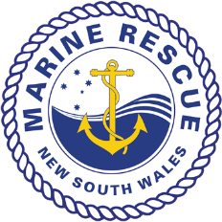
Position Description
Position Title: | Stores Manager
Reports To: | Chief Financial Officer
Position Type: | Permanent Full Time
Office Base: | MRNSW State Headquarters - Cronulla
Purpose Statement
The Stores Manager plays an integral role within MRNSW as a legislated emergency service. The position will manage the logistics and function of the organisations ‘Stores’ (Warehouse) ensuring mission-critical uniform, equipment, PPE and essential supplies are stocked, maintained and distributed to units/personnel with the highest level of efficiency and effectiveness. The Stores Manager will engage with key MRNSW stakeholders on a daily basis including members, staff, suppliers and the general public.

Knowledge, Skills and Experience
Essential
- Previous experience as a Warehouse / Stores Manager (or similar logistics role)
- Commitment to working in support of volunteers
- A friendly, self-motivated, energetic personality
- Personable, accountable and professional
- Highly organised
- A strong customer service focus
- Competency with general mathematics
- Moderate computer and writing literacy and competency
- Ability to work as part of a team and independently
- Flexible attitude towards duties and a willingness to learn
- Current driver’s license
- Australian Citizen (or permanent resident)
Desirable
- Experience working for volunteer organisations, government or emergency services
- Experience with NetSuite (ERP system used by MRNSW)
- Moderate literacy and competency in Microsoft Word/Excel/Outlook

Responsibilities of the role contribute to the core objectives of the MRNSW Strategic Plan:
OUR PEOPLE | A motivated and professional volunteer membership, able to meet current and future demands
OUR SERVICE | The provision of a world-class 24/7 volunteer-based rescue, communications and safety education service
OUR ORGANISATION | A leading volunteer-based emergency service, acting collaboratively at all levels and with our partners and stakeholders
OUR BUSINESS | Application of sound business principles to ensure the long-term financial and management sustainability of the organisation

Key Responsibilities
- Manage daily Stores (warehouse) activities including receiving goods, filling and shipping orders, ensuring accuracy of shipments and supporting documentation.
- Ensure the appropriate use of systems to capture the ordering, receipt, dispatch and transportation of goods into and out of Stores.
- Ensure MRNSW is adequately stocked at all times.
- Purchase of Stores items directly from suppliers while ensuring value for money outcomes for MRNSW.
- Interact and engage with members, staff, suppliers and the public.
- Work within the allocated Stores financial budget.
- Fulfil all new and replacement uniform and personal protective equipment orders.
- Fulfil all orders of resources, awards, certificates, and other miscellaneous items.
- Supply name badges and Photo ID cards for all MRNSW members.
- Manage and facilitate all stock returns.
- Co-ordinate annual stocktake.
- Oversee and deliver Lifejacket servicing and weekly reporting thereon.
- Prepare monthly reports and statistics for presentation to the Chief Financial Officer, including stock forecast reports.
- Ensure compliance with, and assist in the development of standard operating procedures for all Stores related tasks.
- Recommend and implement measures to improve quality of service and increasing efficiency for continuous improvement.
- Mitigate risk to ensure the health, safety, cleanliness and security of the workplace.
- Undertake other duties as advised by the CFO or Commissioner.
Key Performance Indicators (KPI’s)
- Maintain appropriate levels of stock by monitoring the number of days stock on hand and limiting the number of back orders for items not in stock.
- Meet financial budgets set for Stores expenditure.
- Optimal time management and efficiency in completing orders.
- Accuracy of stock balances in Stores as determined by periodical stocktakes.
- Accuracy and timeliness of Stores reporting to the Chief Financial Officer.
- Adherence to and improvement of standard operating procedures.
- Effectiveness in the overall daily running of Stores.
- Consistent high level of customer service and customer satisfaction.

Key Relationships
The role will establish and maintain close liaison and good interpersonal relationships with MRNSW staff, Unit leaders and key stakeholders, including but not limited to:
Internal  - MRNSW Units  - MRNSW Volunteer Members  - MRNSW Headquarters Staff | External  - Suppliers  - Service Agents  - Public

Working Conditions
The position is based at MRNSW Headquarters at Cronulla. Minimum work hours are 0830-1700hrs, Monday-Friday. The nature of working in a volunteer-based organisation means some other work outside of normal business hours may be required. Weekend work may be offset by rostered days off (RDOs) after weekend work, in line with approved work plans and as coordinated through the CFO.
The Organisation
Marine Rescue NSW (MRNSW) is a legislated emergency service and Company Limited by Guarantee that protects the NSW boating community by providing 24/7 marine search and rescue response, marine radio monitoring and boating safety education and advocacy.
MRNSW is made up of more than 3,000 volunteer members in 44 Units along the coastline from Point Danger to Eden and inland on the Alpine Lakes and Murray River. Public marine radio communication/coordination activities are delivered from multiple radio bases and Search and Rescue Coordination Centres (SARCCs). The organisation routinely works with other emergency services, particularly the NSW Police Force Marine Area Command, and promotes boating and water safety through community events, education and engagement activities.
MRNSW Headquarters staff provides ongoing support to the Board of Directors, Units and members across key areas such as finance, training, operational equipment, WHS, public relations and human resources.
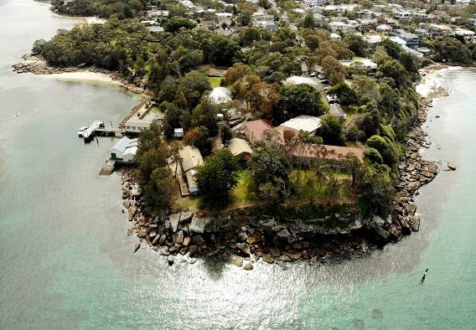
MRNSW Headquarters – South Cronulla

