POSITION DESCRIPTION AND SELECTION CRITERIA

ANYINGINYI HEALTH ABORIGINAL CORPORATION

NYANGIRRU PILIYI-NGARA KURANTTA – CORPORATE SERVICES

POSITION: CORPORATE SERVICES SECTION MANAGER

POSITION NO: CSS 6 POSTION DESCRIPTION REVIEWED: Oct 2019

REPORTS TO: General Manager

LEVEL: Admin Level 10.1 – 10.5 ($131,629 - $148,014) per annum.

CONDITIONS: Full Time
3 month mandatory Probation Period.
6 weeks pro rata annual leave with 17.5% leave loading.
10 days sick leave per annum, pro rata
9.5% employer superannuation.

All other terms and conditions of employment are as per current
Anyinginyi Enterprise Agreement.

Salary Sacrificing: A minimum amount of $15,899.94 per annum can be packaged. It is recommended that you speak with your own Accountant or Financial Adviser to ensure that salary sacrificing arrangements suit your personal situation.

Relocation: Where applicable, contact HR Office for further details.

Accommodation: Where applicable, contact HR Office for further details.

Vehicle: A vehicle does not come with this position. However, a pool of vehicles are provided within each Section for business purposes only. Use and maintenance of these vehicles will be in accordance with the Anyinginyi Motor Vehicle Policy.You must be in possession of a validated license at all times.

Dental: Free General Dentistry is offered to Anyinginyi employees, any Laboratory work must be paid for by the employee.
Gymnasium: Free gym membership is offered to all employees only.

Prescriptions: Free general prescriptions for Anyinginyi employees only.

Ochre Card: It is compulsory to be in possession of an Ochre Card (NT Working with children) or have the ability to apply for one prior to commencement of employment. Please refer to NT Safe for further information.

National Police Where applicable, please contact HR Office for further details.
Check:

Hours of Work: Monday – Friday, excluding public holidays
Between 8.00am – 5.00pm Accrued Day Off (ADO) access OR
8.24am – 5.00pm – no ADOs access

Please Note: It is compulsory for all Anyinginyi employees to be in possession of or have the ability to apply for an OCHRE Card at the cost of $70

OUTLINE OF POSITION OBJECTIVES AND DUTIES

Primary Objectives / Outline

Working under the direction of the General Manager, the Corporate Services Section Manager will be a strategic leader, thinker and contributor. In partnership with the General Manager and the Executive Management Team you will drive systems improvement, performance and strategy across key performance and strategy across key domains including Human Recourses, Finance, ICT, Fleet, Facilities, Infrastructure, WHS, Risk and Business Development. You will uphold the values of Anyinginyi Health Aboriginal Corporation and provide quality services within the scope of the position and associated delegations.

Key responsibilities

Executive Management Responsibilities
- Contribute to the formation and implementation of the Strategic Plan and associated business plans
- Provide clear, relevant reports as scheduled to the Executive Management Team, project working groups, Audit & Risk Management Committee and the Board
- Work collaboratively with members of the Executive Management Team to achieve synergy of work efforts and timely and sustainable outcomes on projects and ongoing operations.
- Support the development of a values driven, collaborative, accountable and innovative workplace culture.

Strategic Leadership of Corporate Services
- Mentor supervise and effectively resource reports, ensuring the structure, roles and functions reflect organizational priorities and results in well-integrated customer focused high-performance teams.
- Use whole of the organization and systems lens, CQI and Data collection, to identify what is needed and how Corporate Services can be responsive and support program delivery and business development.
- Implement collaborative reviews and systems improvements for all Corporate Services functional areas, processes and transactional interfaces, for example; moving to paperless document systems.
- Manage communications interface between the team and the organization, ensure efficient processes facilitate timely customer service that is consistent and accurate.

Financial Leadership
- Further develop the financial management framework, policies and procedures.
- Lead organizational budgeting processes, ensuring financial KPI’s established by the General Manager and Board are monitored, achieved and reported on.
- Ensure financial and compliance reporting is accurate, timely and meets expectations of the General Manager, Board, funders and regulatory authorities.
- Provide authoritative advice to the General Manager, Executive Management Team and Board on key accountabilities.

Other Key Corporate Services Responsibilities
- Oversight and report on the implementation and ongoing review of the Risk Management Framework and associated risk assessment and management strategies and respond to public and systems complaints.
- Ensure a Property Management Plan is developed and implemented to address current and future needs and improve asset management and return on investments.
- Fleet Management Plan meets current and future operational needs and improves asset management.
- Provide strategic advice to the General Manager, Executive Management Team on the development, implementation and monitoring of the ICT Strategy, business plan and major improvement projects.

General Requirements
- Comply with Federal, NT and Local Government Legislation, regulations, permits and / or by laws.
- Adhere to delegations, code of conduct, policies procedures and general conditions of employment.
- Work within contract, program / project parameters and scope of practice.
- Comply with program guidelines, work plans, budget, data and reporting requirements
- Embrace organizational values, work cooperatively and help sustain a respectful workplace as per the Anyinginyi Cultural Framework.
- Support and mentor work colleagues by sharing your skills, knowledge and strengths.
- Help build our Reconciliation Action Plan and build an inclusive and culturally competent workforce.
- Maintain confidential client, staff and organizational information in line with requirements.
- Keep up to date with workplace communications, staff meeting records and the intranet.
- Contribute to planning, evaluation and continues quality improvement activities.
- Participate in supervision, performance reviews and undertake approved training.
- Represent the organization at various forums as required.
- Maintain attendance, payroll and leave records in accordance with procedures.
- Other duties as directed by the General Manager.

Selection Criteria

Position specific requirements
- Tertiary qualifications in Business or related discipline, post graduate studies are desirable.
- Extensive Senior Management experience in Corporate Management, Business or Finance, Endored
- Exceptional analytical, planning, financial management and systems implementation skills.
- Demonstrated highly developed engagement, team building and leadership skills.
- Strong written and oral communication skills along with experience in executive, governance and external reporting and proposal development.
- Proven record of leading projects and meeting project deliverables within deadlines.
- Demonstrated experience in Risk Management, Compliance and / or Quality Improvement.
- High level experience in change management, business development and strategic planning.

General Criteria
- Demonstrated commitment to work respectfully and inclusively with Aboriginal and Torres Strait Islander and culturally and linguistically diverse people.
- Demonstrated adherence to legislation, policies and procedures and a commitment to EEO, WHS, risk management and quality improvement practices.
- Northern Territory Working with Children Clearance (Ochre Card)
- Northern Territory Driver’s License.
- First Aid Certificate (or willingness to obtain within agreed timeframe)

OUTLINE OF ORGANISATIONAL OBJECTIVES AND DUTIES

The Anyinginyi Health Aboriginal Corporation Governance Model

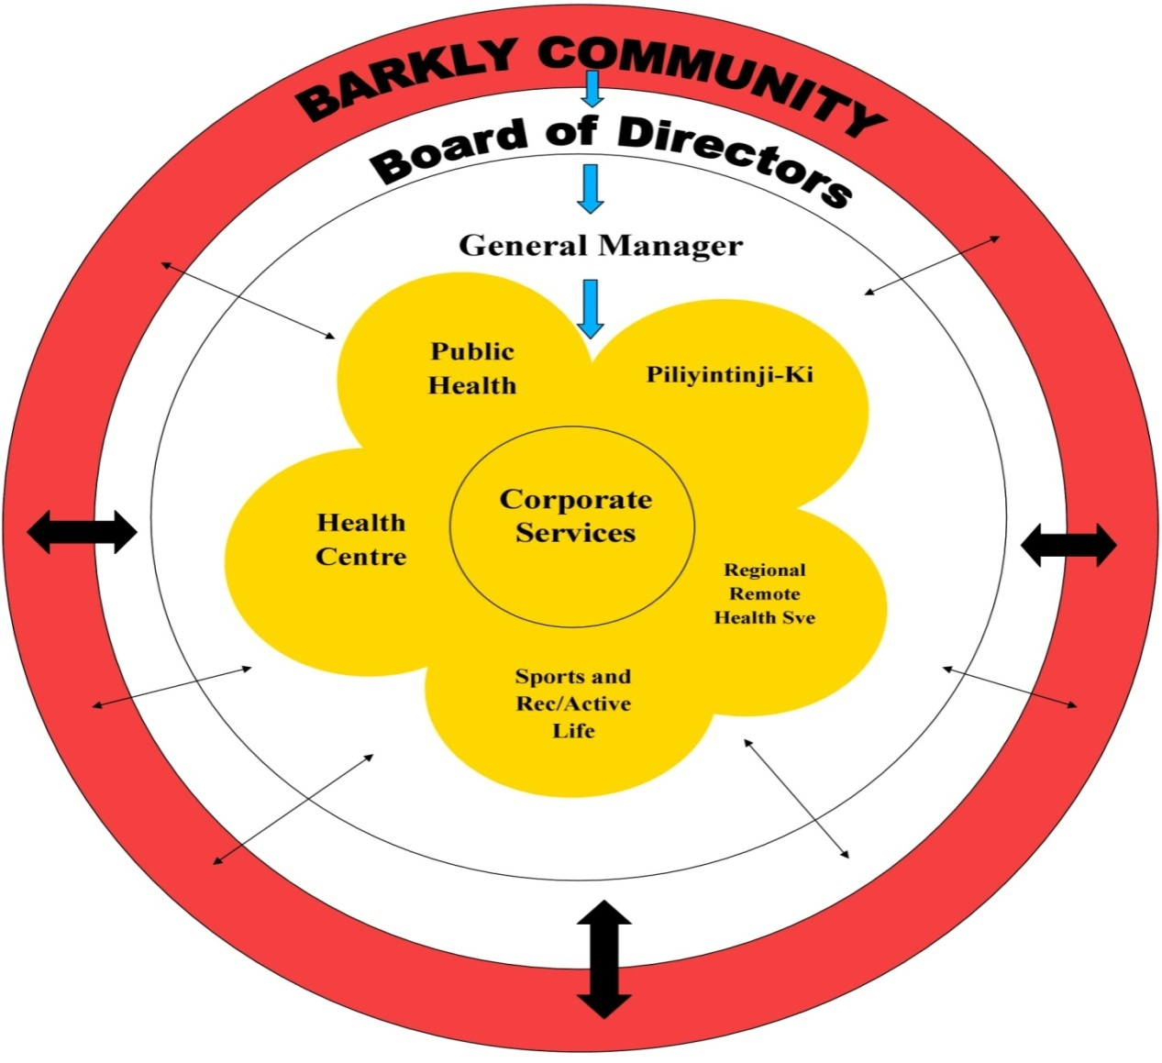

Anyinginyi Governance Model

In line with the Pathways to Community Control “…Community Control requires communities and their organization to possess both the understanding of and the ability to apply the knowledge and competence on which sound engagement is built. It also depends on the capability of government organizations and structures to understand and find new ways of working that responds to community’s calls for greater levels of engagement.” (Page 9, Pathways to Community Control)

The Anyinginyi Governance Model illustrates how the Barkly community, Anyinginyi Board of Directors, the General Manager and the Anyinginyi Sections are integrated and work collaboratively serving the needs of their clients.

The border of the Model represents the Barkly region. The Barkly community representatives are elected to the Anyinginyi Board of Directors situated in the Model’s inner rim. The business of the corporation is managed by or under the direction of the Board of Directors. The Directors may exercise all the powers of the corporation except any that the CATSI Act or the Anyinginyi Rule Book requires the corporation to exercise in general meetings.

The General Manager over sees the everyday operations of Anyinginyi as an entity. Each highlighted Section is managed by individual Section Manager to guide and direct the programs of each section and oversee the management of employees.

The arrows within the Governance Model represent how services are utilised. There are various ways that clients or individuals can access Anyinginyi Services for example:

- Community people accessing our services – on a needs basis
- Anyinginyi representatives from their individual sections going out and providing an outreach service to the community/communities or promotion of programs

The Anyinginyi Health Aboriginal Corporation Primary Health Care Service Delivery Model

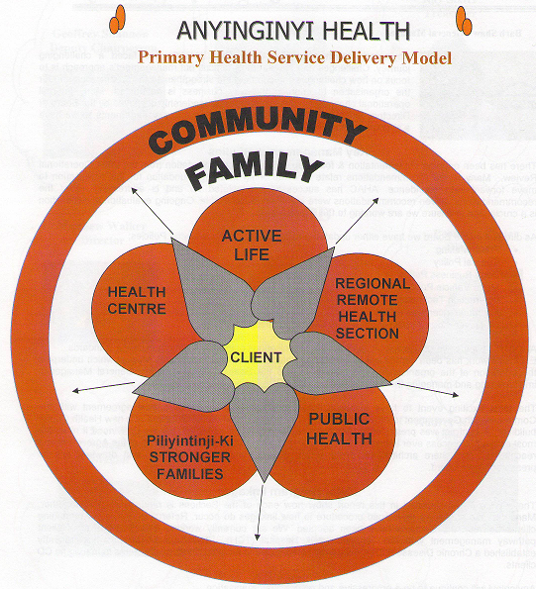

Health Care is a social approach to health that is about ensuring everyone has the right to affordable, accessible and appropriate health care. Primary health care has a broad focus on the social environment rather than just health services. It has a holistic approach to health development and based on social justice, equity, community participation, social acceptability, cultural safety and trust. It also has a broad approach that strongly links with the social determinants of health.

The primary health care approach includes prevention, advice, public health, education, promotion, research, evaluation and community development, as well as primary care delivered in an empowering, multidisciplinary way that helps people to help themselves.

The Anyinginyi Primary Health Care Service Delivery Model reflects the important elements of the holistic health care approach in combining the community, family and client. When managing Aboriginal client care the three components of family, community and culture are intrinsic to good health outcomes.

The Anyinginyi Primary Health Service Delivery Model underpins the way all Anyinginyi services are delivered to the individual client, their family and overall to the community. All Anyinginyi client-Related policies and procedures reflect the Primary Health Service Delivery Model. Each Anyinginyi Section has a set of referral forms and processes in place that links the client to more than one Section.
“Whole of Family” Primary Health Care Approach

Anyinginyi programs have been developed to strengthen all areas of well-being for Aboriginal people. Anyinginyi’s strategic Plan 2014/16 has identified a review of Anyinginyi Section’s roles and responsibilities as required.

The following information is provided as an overview of program areas:

- Parlpuru Ninji Kari - Health Centre

The Health Centre delivers primary health care, clinical, GP, women’s health, men’s health, chronic disease management, Specialist services and community engagement liaison.

Anyinginyi has been working proactively with government service providers to develop partnerships and coordinate service delivery to achieve better outcomes for clients. The Health Centre is often the first point of contact for clients, formal referral systems have been established to link clients with other services. Clients may be referred to other sections within Anyinginyi in line with the service delivery model. It is a priority of Anyinginyi to improve medical input to the Board and management whilst providing improved support to clinicians.

- Manu Kinapina Parlpuru Ninji Kari - Regional Remote Health Service

The Regional Remote Health Section provides the following services –

Bush Mobile – providing primary health care services to remote communities within a 100klm radius of Tennant Creek not serviced by the Northern Territory Department of Health. This service is supported by a medical officer and two nursing staff with the assistance of an ALO/AHP and administrative staff.

North Barkly Zone – providing primary health care services to remote communities of the North Barkly region not serviced by the Northern Territory Department of Health. This service is supported by a medical officer and a registered nurse with assistance of an ALO/AHP and administrative staff.

Allied Health Services – a full-time nutritionist provides services to major communities within the whole of Barkly region (including Tennant Creek). In addition a Physiotherapist and Podiatrist provide fortnightly locum visits six times per year, the latter focusing on Tennant Creek (at present) with the Physiotherapist providing extra services twice yearly for two weeks to the cattle stations in the north Barkly.

Grow Well Program – providing health and capacity building education activities to parents/carers of young children in major communities of the Barkly region. Activities include playgroup, good health & hygiene practices, home skills education, caring for the home environment, self-empowerment.

EHSDI Program – the provision of funding for the identification of community members who have not had regular adult or child health checks and providing the latter in an environment conducive to better compliance.

- Wirlyarra punjarlki kapi Miripartijiki – Sport & Rec

This section delivers programs across a broad spectrum of Sport and Recreational areas to all age groups.

The Sport and Recreation team facilitate a wide range of social sports that the community engages in. These sports include Volleyball, Netball, Cricket, Soccer, Softball and more. Sport and Recreation also manages a commercial, well equipped gymnasium, which is utilised by a broad range of the community. Whilst being a member of the gymnasium, our members our entitled to a personalised fitness program tailor made to suit their needs to live a healthy and more active lifestyle.

Sport and Recreation provide a range of group fitness classes that include Pump, Crossfit, Boxercise, Circuit and our own dedicated women’s classes. There is also a dedicated Womens Program officer employed by Anyinginyi Health Aboriginal Corporation to engage in women of all ages to participate in programs such as gym sessions, fitness classes and sports aswell in a fun friendly environment

Every weekday during the School term, the Sport and Recreation team provide a structured, active lifestyle programs for kids. These activities include Basketball, Soccer, Netball, Tennis, Tball and Dodgeball. This program also flows on into the School Holiday Program where there is a range of activities to keep the kids entertain during the School Holidays.

Wirlyarra Punjarli Kapi Miripartijiki is working towards seeing the whole of the community create healthier lifestyles choices by becoming more active through Sport, Fitness or any other form of movement.

- Kalpa purru Wirranjarlki - Public Health & Promoting Healthy Behaviours Section

This section delivers preventative and educational programs across a broad spectrum of health areas, including trachoma, eye health, skin health, tobacco and healthy lifestyles, FASD and diabetes education, amongst others. Programs in PHU aim to increase community members’ ability to have control over their own health, through raising awareness, health promotion and health education, specific health checks and screening, and responding to public health issues.

- Piliyintinji-ki - Stronger Families

The Stronger Families Section services Aboriginal cliental to promote individual and community well-being through a range of coordinated approaches aimed at addressing family violence, social and emotional wellbeing, family and social dysfunction and cultural issues.

Piliyintinji-ki employs a community development approach and a holistic planning method when working with families throughout the Barkly region. The Stronger Families section’s operational philosophy is to ‘enhance the capacity of Aboriginal people to define the problems and to work with staff to develop the strategies to address them’. A regional framework was developed in 2007.

- Nyangirru Piliyi-ngara Kurantta - Corporate Services

The Corporate Services Section is the business of the organization responsible for Management and Elected Arm administration, regional organizational partnerships, operational policies and procedures, income and expenditure reporting and monitoring service delivery goals for each Anyinginyi Section for implementation. Corporate Services also delivers financial management and asset development, efficient and responsive human resources, Information Technology, and stores and property management.

Corporate Services continually reviews systems to identify the range and scope of accountability pathways, financial policy, management and procedural matters to ensure effective performance and delivery. Regional systems and structures to support appropriate staffing, human resources and industrial arrangements have been aligned with regional governance within budget scope.

Anyinginyi’s CQI processes developed are operational according to the NT CQI program with ongoing CQI participation and support from a locally based Barkly CQI Facilitator position. Anyinginyi strives for an effective CQI program to be in place. The Anyinginyi Board of Directors has identified Quality Assurance as a priority for ongoing organizational development.

