Job Description

Section | Piliyintinji-ki – Stronger Families |  |  | Work Unit | Programs
Job Title | Executive Manger Piliyintinji-ki Stronger Families |  |  | Level | 9.1 – 9.5
Job Type | Full Time |  |  | Duration | Reliant on ongoing funding
Salary | $108,835 - $130,394 |  |  | Location | Tennant Creek
Position Number | PSF 1 | Budget | PSF | Closing
Contact | Anastasia Power (HR Officer) 08 89 6252 633
Position reports to | CEO
Information for Applicants | Applications must be limited to a one-page summary sheet, an attached detailed resume/cv and response to the Selection Criteria. All applications to be sent to hr@anyinginyi.com.au  Confirmation of employment is dependent on the outcome of a Criminal History Check and successful application for an Ochre Card
Hours of Work | Monday – Friday, excluding public holidays  8.00am – 4:30pm
Special Measures | Not applicable to this vacancy.
About Benefits | Salary packaging up to $15,899.94pa, Subsidised accommodation for candidates from outside of the Barkly region,6 weeks annual leave, Free employee gym membership; Free employee General Dentistry (Laboratory work to be paid by employee) Free prescriptions.

OUTLINE OF POSITION OBJECTIVES

The Piliyintinji-Ki Stronger Families Executive Manager is responsible for the provision of services and programs to Aboriginal people in Tennant Creek and the Barkly Region. These services and program address identified life challenges and disadvantage through a practical Culturally Responsive Framework to ultimately enable Aboriginal people to improve and take control of their lives. This position is responsible for the day to day management of the Piliyintinji-Ki Stronger Families Section of Anyinginyi Health, including employee support and performance management, financial and assets management, compliance with Anyinginyi Health’s internal policies and procedures and compliance with external funder’s reporting requirements.

The Executive Manager contributes to the operations of Anyinginyi Health Aboriginal Corporation through participation in Anyinginyi’s fortnightly Leadership Forum attended by the CEO, Executive Managers and Senior Staff.

DUTIES

- Coordinate and lead with Piliyintinji-Ki Stronger Families Women’s Centre and Men’s Centre Team Leaders the planning and delivery of services, programs and events that meet the identified needs of Clients, Staff and requirements of Funders.

- Ensure the services, programs and events address Anyinginyi Health’s Strategic Plan and are delivered within Anyinginyi Health’s Cultural Responsive Framework.

- Uphold Anyinginyi policies and procedures and implement and advocate the Anyinginyi Board’s Strategic Plan and Strategic Priorities to achieve the desired outcomes of Piliyintinji-Ki Stronger Families Action Plan and its contribution to Closing the Gap.

- Contribute holistically to the maintenance of Anyinginyi’s accreditation and compliance by cooperating with external audits conducted by ISO, AGPAL, OSR, CQI, FWC and WHS.

- A commitment to comply with and lead continuous quality reviews and activities across the Section.

- At all times, act in a way that represents Anyinginyi in a positive light and does not bring it or its reputation into disrepute.

- Any other duties delegated by the CEO in line with position or organisational requirements.

Cultural Responsive Framework

In consultation with nominated local Stronger Families Aboriginal staff.

- Vet provide advice and endorse cultural content of communications, promotional and education materials prior to circulation and/or publishing.

- Notify and provide advice to all Anyinginyi staff regarding local culturally significant events such as bereavements, funerals, ceremonies and Anyinginyi Chairperson directed Cultural Shut-Down policy.

- Facilitate the delivery of Anyinginyi Sorry Camp support program.

COVID 19

Ensure staff and clients comply with all COVID 19 measures in the Anyinginyi COVID 19 Action Plan and the Piliyintinji-Ki COVID 19 Action Plan.

Leadership and Human Resources Management

- Promote the role and importance of Aboriginal community-controlled health services, including the importance of operating with strong community engagement and a culturally secure framework to external government, non-Government agencies and business entities.

- Fulfil Commonwealth and NT Aboriginal health key performance indicators and targets through the review and design of staffing and organisational structure and services.

- Ensure Anyinginyi’s Cultural Responsiveness Framework is adhered to by employees and promoted to all relevant external individuals, agencies and communities.

- Ensure Stronger Families employees are aware of and comply with all Anyinginyi policies and procedures.

- Liaise with the HR Manager for the recruitment, selection and induction of new Stronger Families employees.

- Manage employee performance in liaison with the HR Manager while ensuring workplace and external training and career development opportunities are provided to employees.

Financial Management (in partnership with the Executive Manager Corporate Services)

- Manage budgets, including expenditure and monitor funding against PSF Section funding allocations.

- Ensure compliance with funding agreements, including reporting requirements and ensuring funds are expended in line within grant terms and conditions.

- Source and attract additional funding opportunities relating to Anyinginyi Piliyintinji-Ki Stronger Families programs.

General Management
- Oversee and support the Piliyintinji-KI Case Management model where client’s needs are identified, documented and individualised case plans are developed to address the identified client needs.
- Implement the development of sustainable organisational planning that align section activities to Anyinginyi Health Strategic Plan.
- Develop statistical data collection of evidence based on purposes for organisational and program development and reporting to inform service delivery strategy.

- Ensure strategic links are established and maintained with funding bodies and other service providers in areas associated with or complementary to Piliyintinji-Ki Stronger Families Section by attending external meetings with government and non-government agencies as an ambassador of Anyinginyi, as delegated by the CEO.
- Be a proactive member of the Senior Management team and ensure internal coordination between Sections to deliver culturally responsive services that develop group and individual clients who understand the relationship between lifelong health as a result of stronger families, including promoting preventative outreach programs that improve access to screening and early detection of holistic health needs.

- Provide quality diverse Piliyintinji-Ki Stronger Families programs and evaluation of those programs to meet funding requirements and attract new funding sources.

- Records management – ensure data is captured, stored and used in accordance with relevant legislation, Australian Standards, and the needs of funding bodies while maintaining privacy and confidentiality as a priority.

- Perform other duties pertinent to the effective management of Anyinginyi’s
Piliyintinji-Ki Stronger Families Section and other duties as requested by the Chief Executive Manager .

Property and Assets
- Keep secure and maintain all assets of the Section and liaise with Corporate Services Section where disposal is required.

- In conjunction with the Executive Manager Corporate Services, manage and maintain all information technology and associated assets of the Section.

- Keep secure and maintain Anyinginyi’s Piliyintinji-Ki Stronger Families Centre and equipment in a clean and safe condition to ensure employees, clients and visitors are provided with a safe and healthy environment at all times, liaising with Corporate Services Section where maintenance is required.

- Ensure regular stock takes of Anyinginyi’s Piliyintinji-i Stronger Families assets and equipment are undertaken and appropriate measures are implemented and maintained for their ongoing security.

- Ensure property and assets are used by clients and employees as intended.

SELECTION CRITERIA

Essential

- Evidenced understanding of Anyinginyi’s Piliyintinji-Ki Stronger Families services and key issues relevant to closing the gap in health outcomes for Aboriginal and Torres Strait Islander peoples.
- Demonstrated experience in working with a community-controlled Aboriginal organisations and the ability to deliver goals in line with Anyinginyi Health’s Strategic Plan.
- Demonstrated experience working and living in a remote Aboriginal Community and willingness to work in remote conditions in the Barkly Region of the Northern Territory.
- Evidenced ability to deliver culturally responsive programs and services with an understanding of the importance of traditional Aboriginal cultures, values and protocols.
- Formal qualifications in management, community development, public health or project management with evidenced capabilities of working as a part of a multi-disciplinary team.
- Demonstrated experience in a senior management position managing program implementation, evaluation, performance, reporting and coordination, including the ability to use client information management systems to support data collection, health analysis, report writing and budget activities.
- Demonstrated experience in grant administration including compliance processes and procedures requirements of Government and private sector funders.
- Demonstrated high level interpersonal, written, oral communication skills.
- Demonstrated ability to write and develop policy, undertake advocacy and develop collaborative partnerships.
- Demonstrated ability to use information technology resources including Microsoft suite of programs and an aptitude to learn new systems and programs.
- Knowledge and experience ensuring staff and the workplace comply with Work Health and Safety policies and legislation.
- Hold and maintain a current NT Driver’s License and Ochre card (NT Working with Children)
- Satisfactorily complete a National Crime history check before engagement.

Organisational Overview
Governance Model

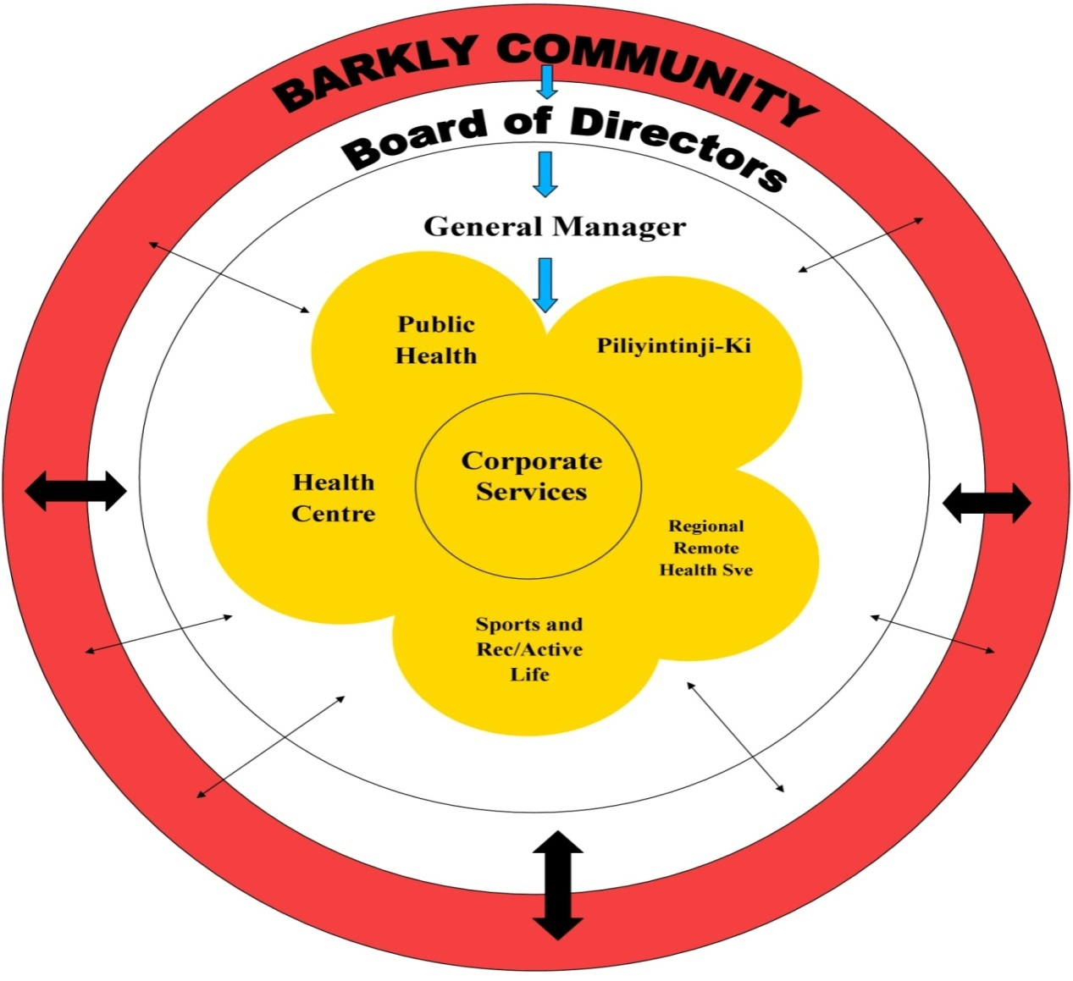

In line with the Pathways to Community Control “…Community Control requires communities and their organization to possess both the understanding of and the ability to apply the knowledge and competence on which sound engagement is built. It also depends on the capability of government organizations and structures to understand and find new ways of working that responds to community’s calls for greater levels of engagement.” (Page 9, Pathways to Community Control)

The Anyinginyi Governance Model illustrates how the Barkly community, Anyinginyi Board of Directors, the General Manager and the Anyinginyi Sections are integrated and work collaboratively serving the needs of their clients.

The border of the Model represents the Barkly region. The Barkly community representatives are elected to the Anyinginyi Board of Directors situated in the Model’s inner rim. The business of the corporation is managed by or under the direction of the Board of Directors. The Directors may exercise all the powers of the corporation except any that the CATSI Act or the Anyinginyi Rule Book requires the corporation to exercise in general meetings.

The General Manager over sees the everyday operations of Anyinginyi as an entity. Each highlighted Section is managed by individual Section Manager to guide and direct the programs of each section and oversee the management of employees.

The arrows within the Governance Model represent how services are utilised. There are various ways that clients or individuals can access Anyinginyi Services for example:
- Community people accessing our services – on a need’s basis
- Anyinginyi representatives from their individual sections going out and providing an outreach service to the community/communities or promotion of programs

Primary Health Care Delivery Model

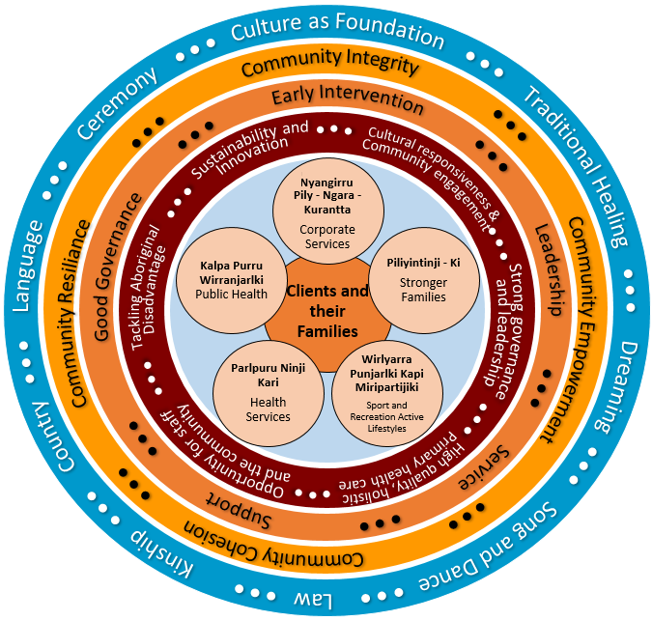Anyinginyi Health adopts a social community development approach to delivering primary health care ensuring Aboriginal people have the right to affordable, accessible and appropriate health care. Primary Health care has a broad focus on the social conditions and environment rather than just health care service. Anyinginyi Health holistic approach is based on social justice, equity, community inclusion and social acceptability broadly linked with the social determinants of health.
The integration of preventative measures through public health awareness, education, health promotion and community development are key to community capacity build and to empowering Aboriginal individuals, families and community accepting self-responsibility for health and wellbeing. When managing Aboriginal client care the three components of family, community and culture are intrinsic to good health outcomes.
The model recognizes the strong role Culture and Cultural Authority plays in a holistic approach to good health and well - being. The model respects the diverse cultural leadership structures and cultural identities of Aboriginal people, families and clients. Culture sets the foundation for Anyinginyi to strive to be compliant with maintaining cultural respect and ensures the principles of cultural responsiveness are considered in the design & implementation of health care.
Our model integrates Primary Health Care best practice and Cultural best practice – this is how we do business

