FINANCIAL ACCOUNTANT
Job Identification
Job Reference
Job Title | Financial Accountant
Work Unit | Finance Section
Responsible to | Finance Manager
Responsible for | 7 Staff Members
Job Purpose | The Financial Accountant will lead the Financial operations side of the Finance Unit which will be responsible for much of the day-to-day financial operations management of the FFA.  The Financial Accountant is also responsible for the timely presentation and clearance of the annual Audited Accounts.  To provide relevant and timely financial accounting information to ensure the Agency meets all financial management and audit requirements; and advise on the day to day financial operations and provide financial reporting needs when required. To ensure implementation and adherence to the International Public Sector Accounting Standards (IPSAS).  The incumbent requires a sound understanding of the policy guidance within the FFA Strategic Plan 2020-2025 and the Roadmap for Sustainable Pacific Fisheries (as endorsed by Leaders in 2015). Strong engagement with the FFA’s development of the annual tasks aligned to the Business Plan and also assistance in the formulation of the Annual Work Program and Budget (AWPB) and the Revised Budget each year. In meeting audit and reporting requirements, the incumbent is expected to have a detailed working knowledge of the FFA’s Financial Regulations, IPSAS, the FFA Corporate Governance Policy, FFA’s Financial Procedures Manual and other key policy documents.
Effective Date | May 2022

The FFA Mission and Vision
Vision of the Members of the Pacific Islands Forum Fisheries Agency
Our people enjoying the greatest possible social and economic benefits from the
sustainable use of offshore fisheries resources.

Mission for the Pacific Islands Forum Fisheries Agency
Empowering FFA Members to take collective and national action for the sustainable
use of offshore fisheries resources
FFA Strategic Plan 2020-2025

Organisational Context
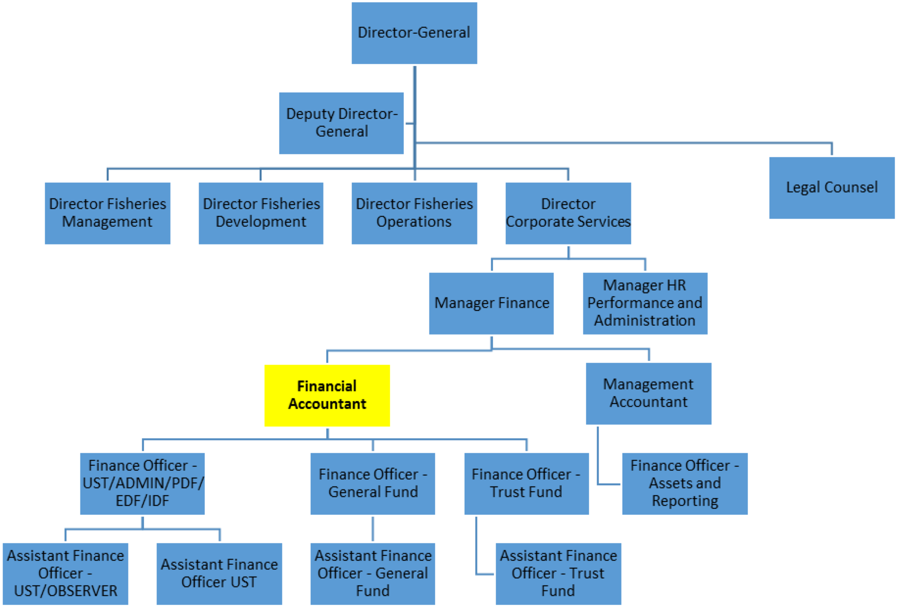

Key Result Areas
The job encompasses the following major functions or Key Result Areas:
Effective day-to-day Financial Management and Preparation of Annual Accounts and Budget support. This may involve:
- Reporting and Preparation of Annual Accounts
- Managing and trouble-shooting within the Financial Operations Team
- Budget Monitoring by program and donor with sound Financial Reporting
4. Assisting with Policy reviews and document storage and retrieval, as required.

The performance requirements of the Key Result Areas are broadly described below
Jobholder is accountable for | Jobholder is successful when
1. Reporting and Preparation of Annual Accounts  - Oversee the preparation of the Annual accounts in accordance with FFA Financial regulations, IPSAS and Financial Procedures Manual.  - Lead initial and ongoing contact on external auditing requirements.  - Assist in providing data and information for the preparations of FFA Annual Reports especially as it relates to the financial performance of the Agency | - Annual Accounts are presented in a timely fashion, signed-off by the Director General with an Unqualified opinion of FFA Audited Accounts issued in a timely manner. Audit field work and submission of signed accounts need to be completed before the end of the end of October of each financial year.  - Issues identified by auditors responded to with management endorsement of actions within required timelines  - Regular Awareness of staff on the Financial Regulations, and is understood and adhered to by staff.  - Provision of timely and accurate data when requested-ad hoc reports.
2. Managing and troubleshooting within the Financial Operations Team  - Effective leadership and engagement with the Financial Operations Team (Receivables, Payables and Payments Unit) and orderly achievement of the day-to-day financial accounting processes  - Oversight of Payroll and Creditor functions  - Contract administration  - Debtor receipting and banking  - Ledgers – FFA output accounting and reconciliations  - Assets management  - Provide on-the-job training for Financial Operations staff and where appropriate provide financial training and advice to FFA’s management and staff.  - Maintain effective working relationships with staff and relevant external bodies (e.g., Banks, Donors and other stakeholders including Auditors. | - Clear sense of purpose and teamwork evident within Financial Operations Team  - Maintenance of timely and high-quality service delivery/  - Financial operations activities clearly defined with internal controls in place and accounts managed to agreed service levels.  - Accurate Asset Register  - Financial Information systems capture and report transactions effectively.  - Well-trained staff that are able to perform their duties, with reduced errors in performance of work’  - Staff understand policies and processes  - Effective working relationships maintained especially with External Auditors  - Ensuring accurate invoicing and accounting of member Contributions.
3. Budget Monitoring by program and donor with sound Financial Reporting;  - Produce accurate and timely Program and individual donor and activity reports  - Assist in the development of the Annual Work Programme and Budget, including for the Finance Section  - Contribute as a member of the AWPB team.  - Provide relevant and timely financial information and reports to managers, including the Monthly report.  - Assist Finance Manager in monitoring budget spending and advice on issues arising out of budget utilisation.  - Provide timely advice on cash flow sufficiency, and revenue/expense issues.  - Assist the Finance Manager in Overseeing the development, compilation and analysis of the FFA financial policies plans, strategies and related financial performance indicators.  - Undertake the more complex financial analysis tasks and resolution of complex enquiries and issues, and offer advice to Management as required. | - Timely and accurate financial advice and donor reporting is provided to Divisional Output Managers for decision making, with minimal revision required.  - Annual Work Programme and Budget supported by accurate data provision.  - Work of the Finance section reflected in and supported by AWPB outputs and outcomes.  - Ensures that the Trial balance (including Income & expenditure statements and Balance Sheet) are up to date at the end of each month to be used by the management accountant for monthly management reports. This underpins effective decision-making by senior management.  - Invoicing of existing donor programs and new funds incorporated in timely fashion  - Contribution evident to effective management of all financial resources.
- Effective support for Financial Policies reviews and document storage:  - Assist the Manager Finance in developing and maintaining financial guidelines, instructions and documentation for financial systems and activities of FFA  - Ensure relevant financial records and documentation are maintained and retrieved as required, in accordance with FFA Policies. | - Accurate support to the Manager Finance and Management Accountant is provided to assist in timely amendments and updating of policies and processes.  - Financial records and documents are up to date and accessible to staff when required in accordance with the FFA Document Storage and Retrieval Policy.
- Effective monitoring and appraisal for staff supervised  - Lead the appraisal process for staff under supervision;  - Development of annual performance agreements  - Monitor performance and the appraisal process for the team  - Develop training and development plans for individual staff | - Annual performance agreement for staff are in place  - Timely submission of completed staff performance appraisals.

Note
The above performance standards are provided as a guide only. The precise performance measures for this position will need further discussion between the jobholder and Forum Fisheries Committee as part of the performance development process.

Work Complexity
Most challenging duties typically undertaken:
- Delivering the Annual Accounts and securing External Audit sign-off.
- Undertake analysis of complex financial accounting issues, tasks and enquiries and provide solutions to these issues
- Managing the Financial Operations team, including staff Performance, training and motivation.
- Acting in the absence of the Manager Finance and or Management Accountant.

Functional Relationship
Key internal and/or external contacts | Nature of contact most typical
External  - FFA Creditors and debtors  - Auditors  - Donors  - Member Countries  - Banks - local and internationals  - Valuers | - Advice and assistance in invoicing and payments  - Provide information related to Audits  - IPSAS Standard matters.  - Account management  • Financial analysis  - Following up Member Country financial Contributions & Reporting  - IPSAS Standard matters.  - Follow up on information  - Answering inquiries and requests for information  - Asset management policy and valuation.  - Seek and provide information
Internal  - Director-General and Deputy Director-General  - Director Corporate Services  - Manager Finance  - Directors  - All Staff | - Provide information  - Explaining the Annual Accounts  - Receive direction/instructions and provide information  - Receive direction and provide timely financial advice in response to staff inquiries at all levels  - Facilitate and process payments and reporting on account balances etc.  - Providing reports, advice and accurate data to Directors and Managers  - Provide complex advice on difficult accounting matters including IPSAS.  - Provide information in response to queries

Level of Delegation
The jobholder is authorised to:
- Co-sign disbursements in accordance with the financial delegation limits

Person Specification
This section is designed to capture the expertise required for the role at the 100% fully effective level. This may be a combination of knowledge/experience, qualifications or equivalent level of learning through experience or key skills, attributes or job specific competencies.

Qualifications, Skills, Knowledge and Experience
Essential
Qualifications:
- Bachelor’s Degree in Accounting
- Current membership from a recognised professional accounting body as a professionally qualified accountant. (CPA or Chartered Accountant).

Experience:
- At least 3 years’ senior level financial accounting experience with at least 3 years IPSAS application
- At least 3 years’ experience in the preparation of annual budgets for an organisation similar in size to FFA
- At least 3 years’ hands-on experience in the preparation of financial and statutory reports for audit.
- At least 3 years’ experience in the development and administration of financial policies and procedures.
- Proven experience in training and development of staff in accounting and finance.

Skills:
- Demonstrated high level skills in the use of financial management information systems
- Proficient in Microsoft Office suite especially in spreadsheet and word-processing programs
- High level oral and written communication skills
- Demonstrated interpersonal skills and ability to engage effectively in a diverse workplace and promote gender issues.
Desirable
- High –level working knowledge of Finance One or equivalent Accounting systems
- Understanding of funding arrangements for regional organisations
- Sound communication, teamwork and people-management skills
- Ability to work effectively in difficult conditions and able to meet deadlines

Key Skills/Attributes/Job Specific Competencies
The following levels would typically be expected for the 100% fully effective level:

Expert Level | - Strong financial analytical skills  - Excellent financial report writing skills  - Excellent analytical skills to interpret large financial information  - Capacity to understand financial systems and processed in FFA  - Strong understanding of the budget process
Advanced Level | · Ability to lead and supervise staff  · Ability to manage, organise and coordinate multiple functions, work-flows and staff to meet objectives, outputs and deadlines  · Highly developed financial accounting, planning and implementation skills  · Knowledge and understanding of donor funding requirements for disbursement of funds and reporting  · Good knowledge of IPSAS and current international accounting and auditing standards and practices and developments in financial accounting and financial management  · Cultural and gender awareness including as reflected in FFA member countries
Working Knowledge | · Knowledge and understanding of FFA Strategic Outcomes, Business Plan, Annual Work Programme and Budget  · The contribution of the position to the work of the Agency

Key Behaviours
Employees are expected to embrace and demonstrate the following Key Behaviours
- Commitment/Personal Accountability
- Professionalism/Technical Expertise
- Teamwork and Leadership
- Gender and Diversity awareness
- Customer Focus
- Effective Communication & Stakeholder Management
- Training, Coaching and Development of staff
- Strategic sector-wide outlook

Personal Attributes
- Relevant Qualifications
- High-level Analytical Skills
- Sound Communication Skills
- Results orientation with strong time-management and organisational skills
- Ability to manage and work well in multi-disciplinary and multi-cultural teams.
- Ability to transfer information/knowledge to a non-technical audience
- Recognizes and responds appropriately to the ideas, interests and concerns of others
- Builds trust and respects gender and diversity
- Ensures understanding and engagement with change processes.

