TERMS OF REFERENCE
OFMP III Fisheries Management Adviser – Climate Change

Job Description

Job Reference: | PIOFMPIII FMA – Climate Change
Job Title: | Fisheries Management Adviser
Work Unit: | Fisheries Management Division
Responsible To: | Director Fisheries Management
Job Purpose: | This job exists to-:  Provide advice and support to FFA member countries in the development of effective national and regional management arrangements for the oceanic fisheries within national waters and throughout the western and central Pacific, with a particular focus on climate change impacts on oceanic fisheries.
Date: | April 2022

The FFA Mission and Vision
Vision
Our people enjoying the greatest possible social and economic benefits from the sustainable use of offshore fisheries resources

Mission
Empowering FFA Members to take collective and national action for the sustainable use of offshore fisheries resources

FFA Strategic Plan 2020

Organisational Context

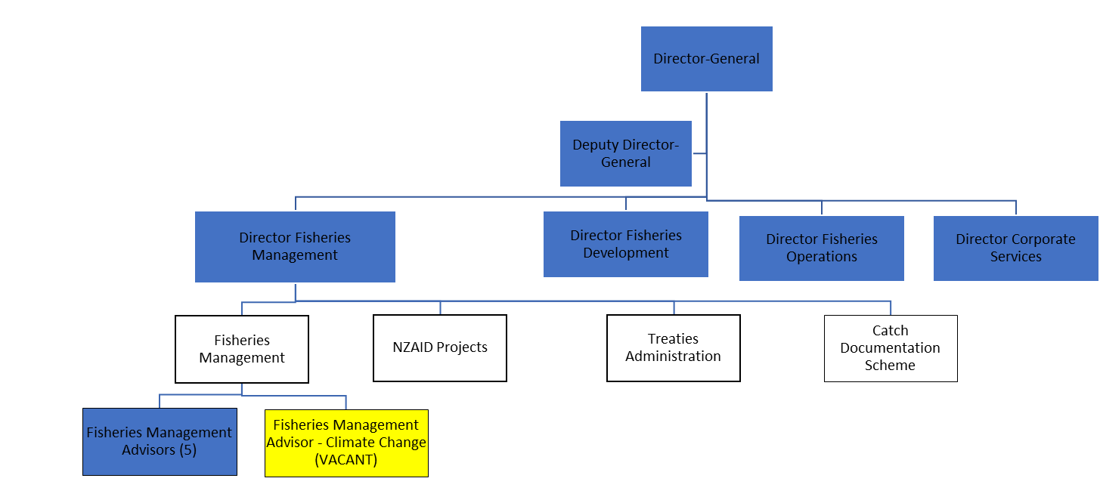

Key Result Areas
This encompasses the following major functions or Key Result Areas
- Technical Advice
- Research and Development
- Project Management
- Networking Relationships
The performance requirements of the Key Result Areas are broadly described below.
Jobholder is accountable for | and is successful when
Technical Advice  - Advise and assist Pacific island countries to identify, prioritise and analyse fisheries management issues in the oceanic fisheries of the western and central Pacific with a particular focus on climate change.  - Coordinate FFA fisheries management advice to FFA Members in relation to the adaptation and mitigation of climate change in oceanic fisheries.  - Advise and assist Pacific Island countries to develop and/or reform national oceanic fisheries management plans, policies, legislative instruments, institutions and programs in view of climate change related needs.  - Research, prepare and present papers to a high standard suitable for presentation at international forums, particularly those concerned with climate change and oceanic fisheries impacts and mitigation.  - Prepare information/negotiating briefs for FFA members on fisheries management and science issues related to the work and meetings of the WCPF Commission and its subsidiary bodies.  - Provide and coordinate training on responsible and sustainable fisheries management including delivering national oceanic fisheries management workshops.  - Support fisheries management activities of the Forum Fisheries Committee and related sub-committees and working groups.  - Assist other staff throughout the FFA to prepare and implement work programs in relation to fisheries management activities in FFA member countries.  - Assist FFA members in reviewing and implementing effective strategies for WCPFC CMM compliance.  - Assist with the preparation and supervision of technical and feasibility studies and oversight of terms of reference for consultants and contractors. | - FFA members are well informed as to climate change potential impacts on oceanic fisheries and associated adaptation and mitigation.  - Close liaison is maintained with SPC on research and reporting of oceanic fisheries climate change impacts and mitigation.  - High quality briefings are prepared and provided to FFA members and other stakeholders.FFA members’ interests in fisheries management are secured.  - Advice is relevant and in line with overall regional development priorities.  - National level fisheries management policies are relevant and current.  - Members able to successfully participate in WCPFC and other regional tuna management meetings to promote SIDS aspirations and secure opportunities for development and ongoing sustainable management.  - Revised and relevant policies for national management and development plans are completed.  - Training workshops covering fisheries management issues are successfully implemented.  - Review/Evaluation reports completed and recommendations documented and accepted.  - FFA member countries receive positive CMM implementation reviews.
Project Management  - Provide technical support to the OFMP III Chief Technical Adviser (CTA)  - Provide support to the OFMP III CTA in the development of project work plans  - Liaise, coordinate and cooperate with other FFA staff, other relevant regional agencies, FFA members and other stakeholders as required to deliver and implement project activities. | - OFMP III workplan is delivered as scheduled and well received.  - Work plans and delivery strategies are timely and well developed.  - Strong stakeholder partnership and stakeholder relationships are sustained in support of effective project management and delivery.
Networking Relationships  - Support the CTA in liaison and networking between and among the 14 OFMP III country participants, relevant regional organisations, other relevant organisations, non-governmental organisations, key stakeholders and other individuals involved in project implementation.  - Foster and establish links with other related Pacific region programmes and projects and, where appropriate, with other regional GEF International Waters projects and IW: LEARN.  - Support the delivery of the knowledge management component of the project including communicating and reporting project results. | - Links are effectively in place with other relevant projects and programmes and full participation in IW Learn and LME meetings, workshops, processes and publications are achieved.  - Agreements sustained with SPC, PNAO, and WWF and other partners as identified.  - Key inputs are provided into the effective communication of project results.

Note:
The above performance requirements are provided as a guide only. The precise performance measures for this job will need further discussion between the jobholder and supervisor as part of the performance development process.

Work Complexity
The most challenging duties typically undertaken are.
- Conduct national stakeholder consultations and issues analysis.
- Provide real time policy and analytical advice to support rapid decision making by members, often during meetings.
- Conduct detailed analysis of scientific reports to provide and present simplified briefs.

Functional Relationships & Relationship Skills:
Key internal and/or external contacts | Nature of Contact most typical
External  - Member County Fisheries Administrations  - WCPFC and other RFMO Secretariats  - SPC and other CROP Agencies  - NGOs | - Receive requests and provide advice and assistance where appropriate  - Provide and receive advice
Internal  - Director-General and Deputy Director-General  - Chief Technical Adviser OFMPIII, Director of Fisheries Management  - Fisheries Management Advisors  - Directors and staff from Operations and Development divisions | - Provide information and technical advice  - Provide and receive technical advice  - Take directions  - Report on progress of work  - Cooperate in and/or manage multi-disciplinary projects and teams  - Cooperate in and/or manage multi-disciplinary projects and teams

Level of Delegation
The jobholder:
- Commit to and organise regional travel in line with FMD work plan and Service Level Agreement tasks (subject to approvals)
- Manage small teams of consultants, including reviewing outputs
- Manage multiple projects across several member countries
- Coordinate or team with staff from other divisions and member personnel.

Person Specification
Essential | Desirable
- Post-graduate qualifications in the field of climate science, fisheries science, fisheries management, natural resource management or a related discipline relevant to the demands of the role.  - At least seven years progressive experience in the relevant field of work.  - Demonstrated experience in policy development and analysis.  - Knowledge (or the capability to rapidly acquire it) of oceanic pelagic fisheries with an emphasis on tuna and the tuna industry.  - Research, prepare and present papers to a high standard and/or at international forums, particularly those concerned with adaptation of oceanic fishery management to the impacts of climate change.  - Excellent English verbal and written communications and presentation skills, both at a technical level and in the preparation of information destined for presentations and general circulation.  - Excellent communication, interpersonal and stakeholder relationship building skills and experience relevant to FFA’s business and organisational context. | - PhD qualification in the field of climate science, fisheries science, fisheries management, natural resource management or a related discipline relevant to the demands of the role.  - At least ten years progressive experience in the relevant field of work.  - Evidence of relevant peer-reviewed academic publications and sound knowledge of climate change research methodologies.  - Demonstrated experience applying contemporary fisheries management principles, methodologies and issues.  - Understanding of the development aspirations and challenges of FFA members.  - An appreciation of donor policies and processes in relation to funding for fisheries projects.  - Experience working and living in a developing country, particularly in the Pacific.

This section is designed to capture the expertise required for the role at a 100% fully effective level. (This does not necessarily reflect what the current jobholder has). This may be a combination of knowledge/experience, qualifications or equivalent level of learning through experience or key skills, attributes or specific competencies.

Key Skills/Attributes/Job Specific Competencies
The following levels would typically be expected for the 100% fully effective level:
Expert Level | Experience at a senior level in regional or national fisheries management, preferably including tuna fisheries, or in the provision of high-level advice relating to climate change impacts on fisheries, preferably including tuna fisheries.
Advanced Level | - Planning and facilitation of stakeholder meetings and/or workshops.  - Thorough understanding of fisheries management principles and techniques.  - Extensive knowledge of the Pacific Islands region and good understanding of the issues in the Pacific and challenges facing Pacific island countries in the Western and Central Pacific Region.
Working Knowledge Level | - WCPFC Conservation Management Measures and compliance requirements  - Integrated fisheries management principles and their application in the Pacific island member countries  - Harvest Strategy Approach to fisheries management  - FFA Strategic Plan 2020-2025
Awareness | - Fisheries MCS Tools  - Understanding the role and contribution of Fisheries Management in supporting Leaders Vision

Key Behaviours
All employees are measured against the following Key Behaviours as part of Performance Development
- Commitment/Personal Accountability
- Professional/Technical Expertise
- Teamwork
- Customer Focus
- Effective Communications & Relationships
- Leadership
- Coaching and Development (for Managers only)
- Strategic Perspective (for Managers only)

Personal Attributes
- Relevant Qualifications
- Excellent Analytical Skills
- Excellent Communication Skills
- Results orientation
- Ability to manage and work well in multi-disciplinary and multi-cultural teams.
- Ability to work in an organised and systematic manner.
- Ability to transfer information/knowledge to a non-technical audience
- Recognizes and responds appropriately to the ideas, interests and concerns of others
- Builds trust and engenders morale by displaying open, transparent and credible behaviour
- Respects individual/ cultural differences
- Utilises diversity to foster teamwork

Change to Job Description:
From time to time it may be necessary to consider changes in the job description in response to the changing nature of our work environment-including technological requirements or statutory changes. Such Change may be initiated as necessary by your Director. This Job Description may also be reviewed as part of the preparation for performance planning for the annual performance cycle.

