JOB DESCRIPTION: DEPUTY DIRECTOR-GENERAL

JOB IDENTIFICATION
Job Reference:
Job Title; | Deputy Director General
Work Unit; | Executive/High Level Advice
Responsible to; | Director-General
Responsible for; | Responsible for oversight of the governance and conduct of the Agency’s technical and professional activities and providing direction on the execution of the Agency’s work programme.  Direct reports consist of: 4 Divisional Directors and, in the ‘High Level Advice’ section, the Legal Counsel, Manager Organisational Transformation, Manager Strategic Communications, Training Adviser, Climate Change Advisor, Strategic Engagement Advisor, Gender Equality and Social Inclusion Advisor.
Job Purpose | The Deputy Director-General is a key position in the management of the FFA Secretariat. It is a hands-on role critical to the effective functioning of the Agency and ensuring high quality corporate governance. In support of the Director General, the role has responsibility for the oversight of all strategic, technical and administrative aspects of the FFA.
Date | 30 Aug 2022
Organisational Context
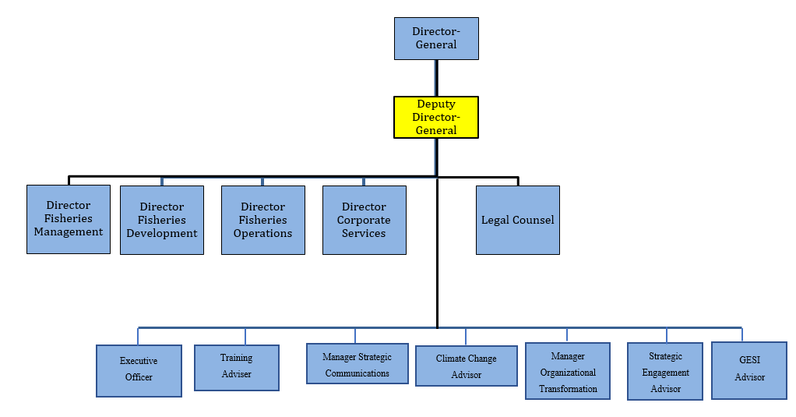

Key Result Areas

Key Results Areas are: Corporate Governance and Strategic Management, Policy Advice and Coordination, Conference Advice and Support, External Engagements, Country Partnership Agreements, Business Plan and Organisational Performance Reporting, Donor Relations, Advocacy and Acting Duties

Jobholder is accountable for | Jobholder is successful when
1. Corporate Governance and Strategic Management  - Oversight of the Agency’s corporate governance and management function.  - Oversight of the preparation, periodical review and implementation of approved FFA Strategic Plan and Business Plan strategies and initiatives. | - Direction of the Agency’s work activities are in line with approved strategic outcomes in the FFA Strategic Plan, Business Plan and AWPB  - Timely implementation of the Agency’s work activities and reporting to Forum Fisheries Committee (FFC).  - Work-plan objectives are in line with approved strategic direction and are delivered on time and within budget·  - There is effective recognition and management of ongoing risk.  - Budgetary, personnel and administrative matters are conducted within approved processes and governance limits.  - Financial management systems and internal controls are in place and adhered to.
2. Policy advice and coordination -  Assist the Director General to maintain effective policy oversight and coordination between the various Divisions and programme units to ensure integrated policy advice and delivery of technical services and that quality of outputs and organisational integrity is maintained. | - Policy coordination and organisational integrity is maintained through regular and effective consideration, delivery and review of major policy advice and technical programs of the Secretariat.
3. Advice and support to meetings of FFA Members  Ensure efficient and effective support for members at meetings and workshops, particularly FFC meetings and meetings of the WCPFC. | - High quality advice and timely logistical support is provided to members.  - The FFA membership exhibits common understandings and agree collective positions based on FFA briefs.  - Members are well supported with technical and policy advice provided well in advance of meetings.
4. External Engagements  - Oversight of the preparation and implementation of Treaties and Regional Fisheries Management initiatives.  - Effective partner relationship management. | - Regional treaties and other fisheries management agreements are negotiated, agreed and implemented.  - Objectives are in line with approved strategic direction and are delivered in accordance with members’ priorities and are delivered on time and within budget  - High level engagement with international partners (including RFMOs) and regional partners (including CROP agencies, PNA and other sub regional bodies) is maintained and enhanced  - Effective FFA participation in key regional and sub-regional fora with strengthened partnerships as a result.
5. Country Partnership Agreements (CPAs)  Oversee liaison with FFA Members on their respective national priorities and implementation and subsequent monitoring and evaluation of projects under the CPAs | - Project design maximises economic and financial dimensions leading to positive social impacts.  - Priority development initiatives are progressing in line with national objectives.
6. Business Planning and Organisational Reporting  Oversight of provision of technical services under the various Divisions | - The respective Divisions are able to meet the Business Plan targets and overall Outcomes at the end of the Strategic Plan period in pursuit of the various strategic outcomes.
7. Advocacy  Ensure the accuracy and timely dissemination of fisheries-related information to member countries and to develop and oversee advocacy and public outreach for both the FFA and for the regional fisheries sector as appropriate. | - Timely, articulate messaging and advocacy is supported by high-usage websites, publications and effective advocacy at national, regional and international level.
8. Donor Relations  Effective oversight and high-level engagement with funding agencies and securing financial support for Agency activities, including financial reporting to donor agencies. | - Key donor relationships and enhanced and well-defined, budgetary support is available and reporting to donors is timely and meet donor requirements.  - Effective project management oversight ensuring delivery of project results and positive economic and social impacts as intended
9. Acting Duties  Assume the responsibilities of the Director-General in their absence. | - Effective management of the Secretariat and sustained delivery of services to Members.

Note
The above performance standards are provided as a guide only. The precise performance measures for this position will need further discussion between the jobholder and the Director General as part of the performance development process.

Work Complexity:

Most challenging duties typically undertaken include:
- Advocacy within complex and contentious policy areas at regional and international fisheries meetings.
- Chairing key regional and internal meetings often with complex and lengthy agendas.
- Facilitation and conflict resolution of complex issues where Members have differing views.
- Managing a complex program of work spanning the breadth of FFA management and technical engagement.
- Leadership of the management team and High-Level Advice (HLA).
- Oversee strategic planning and development for the Secretariat
- Identifying and promoting enhanced governance and accountability including within the Audit Committee and FFC.
- Supervise periodical reporting of results and impacts of Secretariat’s work activities to FFC, Leaders and donors.
- Liaising with donors and other strategic partners.
- Arbitrating on difficult or contentious matters affecting the recruitment and management of FFA staff.
- Leading Tender Panels and Selection Panels while managing a heavy ongoing workload.

Functional Relationship Skills:

Key internal and/or external contacts | Nature of the contact most typical
- Director General  - Divisional Directors  - Staff  - Security Committees  - Member Countries  - Donors  - Other Fisheries Development and Management Agencies | - Present policy recommendations and seek agreement on key management and policy matters.  - Advise on progress of work activities  - Recommend and take decisions regarding technical and administrative matters  - Direct and oversight work activities in functional areas  - Receive recommendations and make decisions on administrative matters  - Manage performance of Directors and HLA staff.  - Oversee implementation of strategic planning and development process  - Approve and participate in personnel performance management system  - Provide leadership during absence of Director –General  - Supervise management of grievances, disciplinary and industrial relations matters.  - Chair and/or participate in the ISMS and broader FFA security committee and ensure the maintenance of timely outcome-focused agendas in both committees.  - Oversee and enhance Country Partnership Agreements.  - Receive and supervise Agency responses to members requests and feedback  - Lead field operations and communication with members as required  - Participate and/or chair high-level engagement with donors and NGOs  - Promote Agency activities and secure funding and support.  - Supervise periodical reporting to Donors including monitoring and evaluation.  - Participate in and lead FFA involvement in key Regional Fisheries Management Organisation (RFMO) and related international meetings.  - Maintain regular contact and liaise on fisheries development and management issues impacting the membership.

Functional Relationships:
External:  Forum Fisheries Committee  Member Countries  WCPFC  PNA  SPC & other CROP Agencies  Donors and NGOs | Internal:  Director-General  Directors  Staff  Staff Associations  Governance Committees

Level of Delegation:
The Deputy Director General in acting as Director General (DG) in the absence of the DG, has the following authorities;
- Can requisition “up to the amounts so approved in the Annual Work Programme and Budget”.
- Approve payments up to maximum allowed under the Financial Regulations
- Sign cheques and Payment authorities to Banks ‘up to the amounts so approved in the Annual Work Programme and Budget”.
Manages the High-Level Advice Output with a current budget of up to US$4.6m.
Levels of Authority: Requisition up to US$1M. Approve payments up to US$500,000, Signs cheques up to amounts approved in the Annual Work Programme and Budget.

Person Specification:

Qualifications
Essential:  Tertiary qualification and demonstrated high level expertise and experience in fisheries-related areas, i.e. fisheries management and/or development. | Desirable:  Tertiary qualification in management
Knowledge / Experience
Essential: | Desirable:
Experience in management of an intergovernmental organisation or medium-sized national organisation or corporation. | Formal budgetary or HR qualifications or equivalent experience.
Ten (10) years’ experience in management with five (5) years in a senior management position.
Knowledge of Pacific fisheries issues and experience working in the Pacific region, ideally with FFA Member countries

Special Criteria

  - Candidates will only be considered from an FFA member country.
  - Candidates must have the endorsement of their national Government.
Selection Criteria:
It is essential that candidates address the following six (6) Selection Criteria when submitting applications in accordance with the instructions.

- A proven ability to provide Leadership and motivation to a diverse workforce, to harness staff skills and capacities and generate sustained positive outcomes.

- A proven ability to maintain effective policy oversight and coordination between various work units and programmes and to manage a complex agenda of issues, to ensure high-quality, integrated policy advice is delivered in a timely fashion.

- Proven experience in fisheries operations and management (or a related field) demonstrating an ability to engage effectively in complex policy negotiations and decision-making.

- Proven capacity to ensure a high level of corporate governance is maintained including through oversight and implementation of effective financial and human resources policies and management.

- Demonstrated stakeholder, advocacy and communication skills, including through cooperation and collaboration with, for example, member governments, donors, other regional organisations and sub-regional bodies.

- Ability to identify and implement continuous improvement and to plan for the future requirements of the agency and its membership.

Competencies:
Key Skills /Attributes / Job Specific Competencies
The following levels would typically be expected for the 100% fully effective level:
Strategic Management and Leadership
- Are future oriented and take a broad perspective on issues, analysing both successes and failures for clues about how to improve.
Supervision
- Can inspire and compel others to collaboratively pursue Secretariat goals within approved governance parameters
Technical Knowledge and experience
- Fisheries Management – Current practices and principles of natural resources management including fisheries
- Fisheries Development – Tested regional and national practices and principles of fisheries industry development, Market developments on fisheries products, economic development
- Fisheries Operations – Legislative requirements with regards to fisheries within EEZs and international waters, border management as well as sub-regional, regional and international agreements on rights-based fisheries.
- Corporate Services – Regional and international best practice on financial, human resources and asset management
Relationship management
- Expert facilitation and influencing skills
- Advanced negotiation skills
Project management skills
Policy development skills
Monitoring and evaluation skills
Excellent oral and written communication skills
Cultural awareness of diverse member representation
Key Behaviours
All employees are measured against the following Key Behaviours as part of Performance Development:
- Commitment/ Personal Accountability
- Professional/Technical Expertise
- Teamwork
- Customer Focus
- Effective Communications & Relationships
- Leadership
- Coaching and Development (for managers only)
- Strategic Perspective (for managers only)
Personal Attributes
- Relevant tertiary qualification or demonstrated high level expertise
- Excellent Analytical Skills
- Excellent communication skills (written, verbal, and interpersonal)
- Results orientation
- Politically savvy,
- Takes personal responsibility for decisions and performance of the Secretariat
- Ability to manage and work well in multi-disciplinary and multi-cultural teams.
- Ability to work in an organized and systematic manner.
- Recognizes and responds appropriately to the ideas, interests and concerns of others
- Builds trust and engenders morale by displaying open, transparent and credible behavior
- Respects individual/cultural differences
- Utilizes diversity to foster teamwork
- Ensures others understanding of , involvement in, adaptation to a change process

Change to Job Description:
From time to time it may be necessary to consider changes in the job description in response to the changing nature of our work environment – including technological requirements or statutory changes. Such change may be initiated as necessary by the Director Corporate Services. This Job Description may be reviewed as part of the preparation for performance planning for the annual performance cycle.

