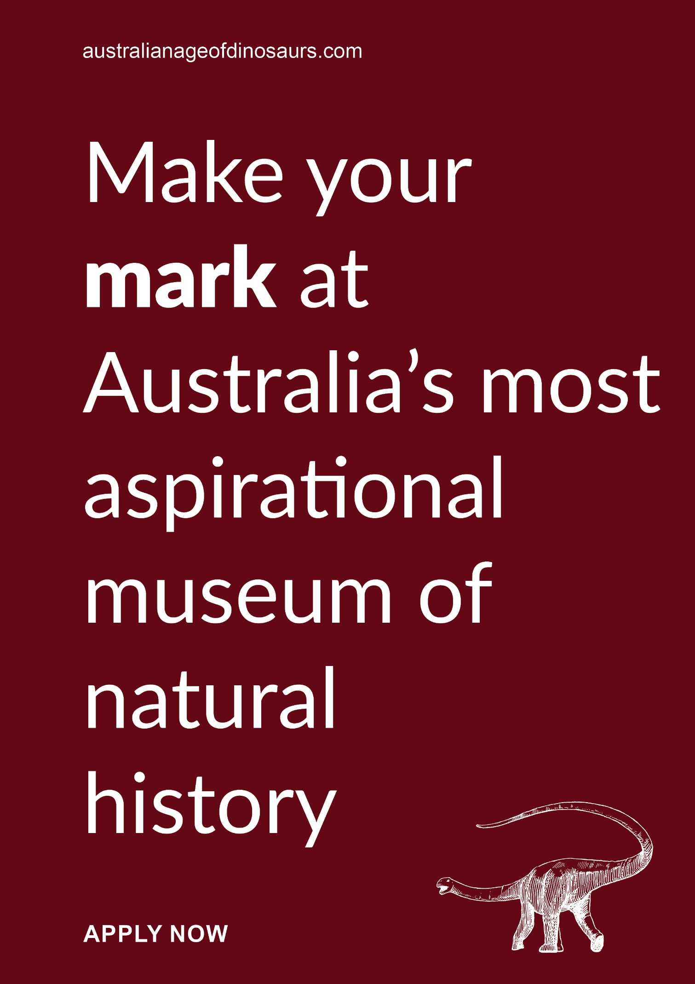 | 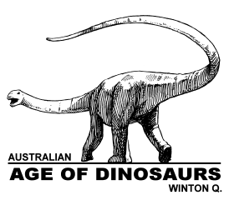
JOB INFORMATION PACK AND JOB DESCRIPTION
FOR THE POSITION OF CURATOR OF PALAEONTOLOGY

The Australian Age of Dinosaurs Museum of Natural History (the Museum, also known as AAOD) is a relatively young museum staffed by people who are passionate about Australian natural history and getting visitors involved. The Museum holds public dinosaur digs every year and has the world’s largest collection of Australian dinosaur fossils. A hands-on fossil preparation laboratory operates year-round and is recognised as one of the most productive facilities of its kind in the Southern Hemisphere. The Museum hosts over 55,000 paying visitors annually, mainly self-drive Australian tourists, school groups and wholesale groups. Giving them a fascinating experience and encouraging them to be ambassadors for the Museum is important to us.

The Museum is located on a spectacular mesa known as The Jump-Up, about 24km south-east of Winton in Central-West Queensland. The Jump-Up covers an area of 1,400 hectares and is Australia’s first designated International Dark Sky Sanctuary. With the Dinosaur Stampede National Monument at Lark Quarry Conservation Park (110km south-west of Winton) and the dinosaur attractions at Richmond and Hughenden (north of Winton), the Museum plays an important role in attracting visitors to the region by offering a combined experience known as Australia’s Dinosaur Trail. The Museum has been managing Dinosaur Stampede National Monument since April 2016 through an agreement with the Winton Shire Council.

Australian Age of Dinosaurs was formed in 2002 and spent its early years based on a local sheep station. The Jump-Up was donated to The Museum by the Britton Family in 2006 and staged development of the site commenced in 2007. Stage 1, located on the northernmost end of The Jump-Up, opened in 2009 and consists of a fossil preparation laboratory, public amenities and staff and volunteer accommodation. Stage 2, located 500m south of Stage 1, opened in 2012 and consists of a Reception Centre with exhibition space (the Collection Room), shop and café. A Staff & Volunteer Amenities building and a shuttle bus station have been added at this location since. Stage 3, located two kilometres south-west of Stage 2, is the site of the Australian Age of Dinosaurs Museum of Natural History. Development at this site to date includes Dinosaur Canyon Outpost and five outdoor galleries (opened in 2017) and March of the Titanosaurs and Gondwana Stars Observatory which opened in May 2021.

The Museum is open seven days a week during the busy tourist season of April to October and six days a week (not Sunday) from November to March. Visitors pay for hourly guided tours of the Laboratory, Collection Room and Dinosaur Canyon. The Laboratory and Collection Room tours run for approximately 30 minutes in duration and the Dinosaur Canyon experience, which includes the March of the Titanosaurs exhibition, runs for approximately 1.5 hours. Visitors can walk or drive between their tours at Reception Centre and the Laboratory whereas a shuttle service transfers them between the Reception Centre and Dinosaur Canyon.

The first tour at the Museum commences at 9:00am and the last tour starts at 4:00pm. At Dinosaur Stampede National Monument, the first tour is at 9:30am and the last tour is at 3:00pm. Wholesale bus tour groups (including school groups) are generally taken on separate tours operating on the half-hour. Some will have morning or afternoon tea and the Museum also offers an evening BBQ experience.

The Museum is headed by a Board, Executive Chairman and management team. It employs around thirty staff during the peak tourist season, reducing to around twenty in the summer months. The Museum also has a strong contingent of volunteers who participate in the Prep-A-Dino program, learning how to prepare dinosaur bones ready for research and display. After completing and passing a 10-day “prep” course, these people become Honorary Technicians, and many return every year to volunteer in the Laboratory. Research on dinosaur fossils recovered during the annual digs is carried out by palaeontologists and students from Australian and international universities and museums.

Winton is an attractive and active town with a shire population of approximately 850 people. The town has a gym, squash court, public swimming pool, golf course, library, Australia Post, NAB Bank, a range of retail outlets and gift shops, several hotels, cafes and grocery stores, a Catholic school (co-ed, prep to year seven) and State School (co-ed, prep to year 12). It is serviced by daily mail trucks and Followmont Transport deliveries (weekdays) and has a range of heavy transport delivery options. There is a small airport at Winton with a twice-weekly service to Brisbane and Townsville. Daily flights to Brisbane are conducted out of Longreach which is 170km south-east of Winton.

Winton is famous as the home of Waltzing Matilda and the Waltzing Matilda Centre, in the town’s main street, is a popular tourist attraction. The town has several festivals each year including the Outback Festival and Way-out-west Fest (biannual) and the annual Vision Splendid Outback Film Festival and Winton Opal Festival. The region is noted for its scorching summers, friendly locals, beautiful scenery and sunsets and unique tourism products.

For further information, please visit:
- the Museum at www.australianageofdinosaurs.com
- Winton at http://www.experiencewinton.com.au/ and http://www.winton.qld.gov.au
- Dinosaur Stampede National Monument at http://www.dinosaurtrackways.com.au/
- Australia’s Dinosaur Trail at http://www.australiasdinosaurtrail.com/

JOB DESCRIPTION

Date 14 October 2022

Job title Curator of Palaeontology

Responsible to General Manager

Responsible for Laboratory Supervisor
Laboratory Co-ordinator/Tour Guide
Exhibition Technician

Key relationships Executive Chairman
Head of Development
Museum Services Manager
Education Manager
Astronomy Manager
Property Maintenance Officer
Laboratory Supervisor
Programs Supervisor
Laboratory Co-ordinator/Tour Guide
Exhibition Technician
Museum volunteers, including Honorary Technicians
Museum Research Committee members

1. Job context

The Australian Age of Dinosaurs Museum of Natural History (the Museum) is a not-for-profit museum based in Winton, regional Queensland. Its purpose is to discover, prepare, interpret and display dinosaur fossils and tell the story of Australia’s natural history. The Museum is dedicated to delivering a world-class attraction that educates and inspires its visitors, providing them with a unique Australian experience.

The Museum is also contracted by Winton Shire Council to manage the Dinosaur Stampede National Monument at Lark Quarry Conservation Park (the Park), a Queensland Parks and Wildlife Service site. The Park represents the most concentrated site, and only definitive record, of dinosaur stampede behaviour in the world. Situated 110km south-west of Winton, this visitor attraction is the largest trace-fossil site in Australia.

The Museum has begun the third and final stage of its development which entails the design and construction of the Australian Age of Dinosaurs Museum of Natural History (MNH). The MNH’s purpose is to present and tell the story of Australia’s geological journey through deep time by way of a centre of excellence that will become renowned worldwide.

2. Job purpose

The position of Curator of Palaeontology exists to:
- manage the Museum’s palaeontology collection
- manage the Museum’s research affiliations
- manage the Museum’s dinosaur digs
- manage Museum fossil preparation laboratories
- manage Laboratory participant and volunteer programs
- manage Museum archives
- manage exhibitions and assist with development of new exhibitions
- assist with education and science outreach programs and
- support Museum operations.

3. Key output areas

The following key output areas represent the responsibilities of the jobholder. From these, agreed performance standards will be established and monitored. These key outputs are not exhaustive. They reflect the current environment and it is recognised that they will be subject to variation dependent on internal and external change.

- Manage the Museum’s palaeontology collection
This will be achieved by:
- managing and monitoring all aspects of collection care, including cleanliness, conservation, preservation, identification, shelf listing and security
- ensuring that all aspects of the Museum's collection-related policies and procedures are complied with and in a timely fashion
- maintaining digital and hard copy documentation of collection registers, accession registers, incoming and outgoing loans, collection catalogues and databases
- managing incoming and outgoing loan agreements with external organisations
- managing software upgrades, system migrations and development of database search capabilities
- collating all 3D fossil-specimen data and overseeing 3D printing for exhibition, exchange and research
- developing, maintaining and ensuring compliance with Museum collection-related policies and procedures
- maintaining strong donor relationships by ensuring appropriate acknowledgements are made, updating donors on the identification and preparation of specimens and managing tax-incentive valuations
- actively enhancing and expanding the fossil collection by sourcing relevant donations and negotiating the exchange and purchase of specimens in collaboration with the Executive Chairman and
- monitoring the safety and condition of in-house exhibition fossils and maintaining condition reports as necessary.
- Manage Museum research affiliations
This will be achieved by:
- co-ordinating and participating in research application considerations with the Museum’s Research Committee
- documenting the Museum’s Research Committee decisions and managing researcher notifications and confidentiality agreements
- managing researcher conflicts of interest and maintaining research confidentiality
- managing the Museum’s research and collection-based intellectual property
- ensuring that researcher requests for specimen loans including offsite scanning and destructive analysis are agreed upon with the Museum’s Research Committee and adhere to the Museum’s best interests
- managing use of microscopes, scanners, cameras and other research-related equipment in accordance with Museum procedures
- assessing external requests for access to the collection for research purposes and supervising approved access as required
- collaborating with researchers and other institutions in consultation with the Museum’s Research Committee
- assisting with the writing of press releases and articles for collection-related media announcements (including dig discoveries) in collaboration with the Executive Chairman and Head of Development and
- prioritising the preparation of fossils for research, in consultation with the Executive Chairman.

- Manage Museum dinosaur digs
This will be achieved by:
- leading the Dig-A-Dino program and engaging with participants, delivering inductions, training, supervision and support
- managing and co-ordinating dinosaur-dig site preparations including accommodation, machinery, equipment, consumables, catering, transport, recruitment, staffing and safety requirements
- assisting with dinosaur-dig excavations in co-operation with landholders, machinery operators and experienced staff and volunteers
- collecting and entering scientific data from all dig sites and other localities to meet existing requirements and standards
- ensuring that exhausted dig sites are returned to their original state and landholders are kept informed of discoveries at the site and
- ensuring that all participants, landholders and staff receive an overview of the dig following its completion and a dig report is written and distributed.
- Manage Museum fossil preparation laboratories
This will be achieved by:
- assisting with recruitment of direct reports and with other staff as required
- managing all operational aspects of Laboratory fossil preparation on a day-to-day basis in co-operation with the Laboratory Supervisor and other managers where relevant
- ensuring that all staff and volunteers working in the Laboratory receive the appropriate level of initial and ongoing training and support
- overseeing the maintenance and replacement of Laboratory tools and equipment and informing the Executive Chairman of any repair or replacement requirements to fixed assets
- overseeing the acquisition of Laboratory consumables
- ensuring that all fossil-preparation and conservation records are maintained and work-in-progress fossils are stored and documented when not in the collection’s designated storage facilities
- establishing, implementing and ensuring compliance with all Laboratory conservation procedures and practices
- ensuring compliance with the Museum’s Laboratory inductions, WHS and other relevant policies and procedures in consultation with the General Manager
- ensuring that pallet racking and shelving storage areas are safe and secure at all times and that forklift operation is only carried out by qualified operators and
- assisting with day-to-day management of the Exhibition Development Facility in co-ordination with the Executive Chairman.

- Manage Laboratory participant and volunteer programs
This will be achieved by:
- managing the Prep-A-Dino program to ensure participant numbers are manageable and Museum preparation requirements are met
- managing the Museum’s Honorary Technicians and encouraging the completion of Honorary Technician fossil-preparation courses including delivery, evaluation and qualification of participants
- overseeing Laboratory participant inductions, training and support in consultation with the General Manager as relevant
- managing Laboratory-based short-term student participation including work-experience students, exchange students, university students and others in consultation with the Education Manager and
- managing the Maloney Lodge Precinct by ensuring that facility supplies and infrastructure are adequate, WHS standards are met and cleanliness is maintained, in consultation with the General Manager where relevant.

- Manage Museum archives
This will be achieved by:
- managing research and storage of the Museum’s non-geological historical data and artefacts
- managing and monitoring all aspects of archival care, cleanliness and security
- managing the acquisition of archive material in consultation with the Executive Chairman, General Manager and Head of Development
- managing digital and hard copy documentation of archival catalogues and maintaining database records, periodic software upgrades, system migrations and search capabilities
- creating and maintaining hard copies of digital records for all archived items
- managing the generation and compilation of digital media covering the Museum’s events, projects and ecology including snapshot representations of day-to-day operations and other Museum-related activities in coordination with other managers and
- developing and managing database for metadata including photographs, publications, research projects, staff alumni, volunteers, supporters, stakeholders and other Museum-related information.
- Manage exhibitions and assist with development of new exhibitions
This will be achieved by:
- managing and monitoring the conservation and security of Dinosaur Stampede National Monument at Lark Quarry Conservation Park
- managing and monitoring the conservation and security of the Snake Creek tracksite at the March of Titanosaurs exhibition
- managing and monitoring the conservation and security of all fossils on display at the Museum
- updating existing displays and exhibitions as required in consultation with the Executive Chairman
- prioritising the preparation of fossils for exhibition as requested by the Executive Chairman
- assisting with the development and creation of displays in collaboration with the Executive Chairman and Head of Development and
- assisting the Executive Chairman and Head of Development to write grant and fundraising proposals for collection and exhibition-related projects.

- Assist with Museum education and science outreach
This will be achieved by:
- preparing and maintaining tour-related information and interpretation, training documents and the delivery of training sessions related to the Museum collection and Australian palaeontology in consultation with relevant managers
- assisting with knowledge assessments and performance reviews of Tour Guides in consultation with relevant managers
- contributing to and assessing scientific content of the Museum’s science and education programs including onsite school visits, virtual excursions, natural history in astronomy and other education-based events in collaboration with relevant managers
- contributing to curriculum mapping and lesson planning with other managers as required
- preparing and delivering public programs onsite and online to share Museum discoveries and generate interest from potential visitors
- contributing to inhouse publications and merchandise relating to the Museum collection and Australian palaeontology including authorship, fact checking, editing and sourcing images as required
- contributing to the Museum’s quarterly newsletters, including dig reports
- identifying Australian palaeontology subjects and events for the Museum’s annual Journal including sourcing authors, fact checking stories, sourcing photographs and assisting with editing and caption writing in collaboration with the Executive Chairman and Head of Development and
- assisting with information, writing and fact checking for social media posts, website development and other Museum information outreach platforms as required.

- Support Museum operations
This will be achieved by:
- mentoring staff to achieve high standards of behaviour and work and being a positive role model
- being familiar with all aspects of the Customer Service Policy & Procedures and always delivering excellent internal and external customer service
- providing input to, and ensuring delivery within, the annual Museum operating budget including close analysis of monthly financial reports to monitor performance for areas of responsibility
- providing input to, and ensuring delivery within, the annual Museum business plan, including monitoring performance for areas of responsibility
- providing a bi-monthly written report to the Board of Directors
- being aware of the Museum’s work health and safety requirements and watching out for hazards at all times
- adhering to the Museum’s policies, procedures, house rules, guidelines and checklists at all times
- assisting with the establishment of personal performance standards and reviewing performance formally with the Executive Chairman and General Manager at least once a year
- identifying, completing and evaluating personal development and training opportunities including external training and participation in Museum training as required
- assisting with the care and maintenance of the Museum grounds, buildings and other assets as required and
- being an excellent role model, advocate and representative for the Museum, both onsite and offsite, including delivery of presentations when required.

4. PROFILE OF AN IDEAL CURATOR OF PALAEONTOLOGY

The following job competencies, qualifications and experience represent an ideal applicant. It is recognised that not all candidates will meet all criteria.

- Job competencies

Knowledge
- In-depth working knowledge of museum curatorial, collection and research procedures
- Comprehensive understanding of modern museum best practice
- Strong knowledge of vertebrate palaeontology
- In-depth working knowledge of online collection databases
- Broad knowledge of geological eras and periods, their exposures in Australia and associated floras and faunas
- Knowledge of legislation related to museum collections
- Working knowledge of work health and safety legislation and considerable practical experience

Skills and abilities
- An ability to recognise high quality work with an eye for detail and perfection
- An aptitude for display and exhibition development and implementation
- A practical outlook and ability to assess existing policies and procedures and identify opportunities for improvement
- Excellent customer service skills
- Open, honest and clear communication skills
- Excellent administrative and organisational skills
- Able to think conceptually and make recommendations
- Able to guide and train others
- Able to work to timely deadlines and project timelines
- Able to deal with multiple issues calmly and effectively
- Able to explain complex tasks or information

Behaviour
- A self-aware, caring, co-operative nature and willingness to help others succeed
- A high level of mental efficiency and self-organisation
- A high level of emotional intelligence
- Embraces change and can implement change
- Enjoys leading and inspiring others
- Self-motivated and enthusiastic with a can-do attitude
- The social skills needed to maintain successful relationships and the personal integrity to establish long-term credibility and trust
- Willing to wear the Museum uniform and meet the requirements of the Uniforms Policy & Procedures

- Qualifications
The following qualifications will be highly regarded:
- Qualification in vertebrate palaeontology
- Qualifications in palaeontology and geology
- Any formal qualifications relevant to the responsibilities of the role, in particular collection management and museum practices
- First Aid and CPR certificates

Experience
The preferred experience is:
- Working in a not-for-profit environment, particularly a museum or tourist attraction
- Curatorial experience with a record of increasing professional responsibility and measurable accomplishments
- Working on museum databases and other applications
- Managing direct reports and volunteers
- Day-to-day collection and laboratory management
- Organising and supervising fossil-dig excavations
- Field and laboratory-based fossil conservation and preservation
- Exhibition management and design
- Training and assessment of staff members
- Stakeholder engagement and customer service delivery

Note: As the Museum is located 25km from Winton, the Curator of Palaeontology is required to have their own car and a current P class or full driving licence.

Agreed:

………………………… ……………………..
Job holder Name

………………………… ……………………..
Executive Chairman Name

Dated: …………………………

