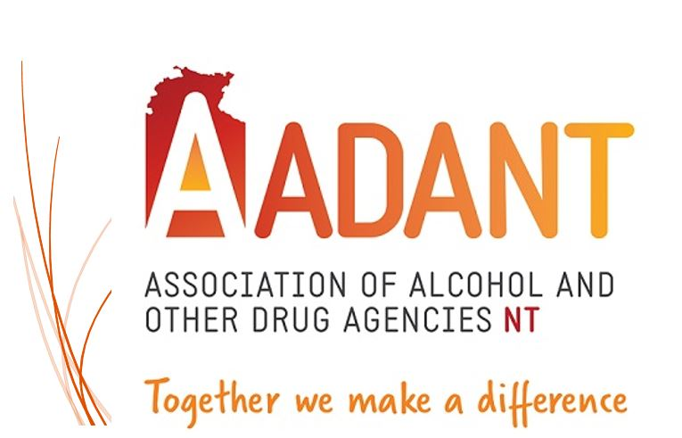
Association of Alcohol and other Drug Agencies NT
ABN 401 9360 4504

8/52 Marina Boulevard
LARRAKEYAH NT 0820
PH: 08 8166 2446
E: admin@aadant.org.au
W: www.aadant.org.au

POSITION DESCRIPTION

Job Title | Executive Officer | Level / Salary range | $108,972-$118,879
Job Number | 1 | Reports to | AADANT Board of  Management through the Chair/Deputy Chair
Position Type | Permanent Full Time | Term End Date | Ongoing subject to funding contract

Primary Objective

AADANT is an independent, membership-driven, not-for-profit organisation whose mission is to provide advocacy and leadership, on behalf of the alcohol and other drug sector in the Northern Territory.
As the Executive Officer you will be working with our membership to support and strengthen Alcohol and Other Drugs (AOD) service capacity and workforce capabilities for the delivery of best practice services to people experiencing harm associated with their alcohol and other drug use and accessing support and treatment in the Northern Territory.

At AADANT our Mission is:
To build and maintain a strong, sustainable, and culturally diverse Alcohol and Other Drugs (AOD) sector that works together to reduce alcohol and other drug related harm across the Northern Territory.
To achieve this, the Executive Officer will work towards achieving the following objectives of AADANT:
To perform as a peak body for the Non-Government Alcohol and Other Drugs sector in the Northern Territory through:
- Sector capacity building including workforce, and agency, training, support, and development.
- Encouraging and/or facilitating collaboration, networking, and other communication across the sector.
- Promoting a range of effective strategies that minimise related harms including promoting links to current research and best practice guidelines and standards.
- Increasing public awareness, and education, regarding AOD issues and strategies to minimise related harms.
- Strategic development of guidelines, resources and publications that support a high functioning AOD sector; and
- Advocacy and representation of a sector perspective on policy and other issues that relate to substance misuse issues.

Responsibilities:

- Responsible for operation and management of the association, and reporting to the Board, and across the membership.
- Responsible for maintaining AADANT membership, and expanding the membership where possible.
- Represent members views to funding bodies, government departments and other agencies, both pro-actively and as requested.
- Ensuring organisation activities are consistent with AADANT’s purpose, mission, and strategic direction.
- Ensure the Chair and the Board are kept up to date and informed on organisation performance, including the full range of issues impacting the organisation.
- Maintain effective, transparent, accountable, ethical operations and governance of AADANT.
- Promote an agenda of Quality Improvement across the AOD sector.
- Provide effective and responsible advocacy for the AOD Sector
- Serve as the AOD sector peak body spokesperson, representing and promoting the values and views of the AADANT membership within the NT and at a National level.
- Develop and manage relationships with external stakeholders, Ministers, government agencies, the AOD sector, and the broader community.
- Develop and promote AADANT’s position on key issues that impact the AOD sector.
- Develop and maintain an AOD sector network for information sharing and support.
- Co-ordinate and facilitate AOD Sector Forums, including an annual conference.
- Oversee and maintain an effective webpage, newsletter and e-library.
- Provide training opportunities aimed at capacity building and sector development, with a focus on policy, emerging issues, governance, best practice, and skills gaps.
- Develop and enable mechanisms that promotes best practice within the AOD sector.
- Manage the budget of AADANT to achieve strategic objectives.
- Plan and develop funding submissions, and regularly meet with funding bodies to negotiate for ongoing funding support.
- Funding compliance and reporting.

Selection Criteria

Essential

- Demonstrated capacity to represent the interests of the AOD community sector organisations at a Territory and Federal level.

- The ability to lead a small team with strategic impact.

- High-level of communication and negotiation skills, both written and oral, with demonstrated capacity to source and secure Non-Government and Commonwealth, State and Local Government funding and prepare high-level policy papers and reports for a range of stakeholders.

- Highly developed analytical skills and demonstrated experience in strategic planning and service design, development, and evaluation, as well as the demonstrated ability to foster the development of research, policy, and practice partnerships which collaboratively advance outcomes of the NT AOD sector.

- Extensive knowledge and understanding of alcohol and other drug issues, policies, legislation, and treatment models operating nationally and internationally.

- Ability to plan and deliver high quality workforce development opportunities for the AOD sector in the Northern Territory.

- Ability to effectively network and liaise with community sector organisations, community, media, Commonwealth, State/Territory and Local Governments.

- The ability to develop and manage budgets within a tight fiscal environment, while meeting key deliverables.

Desirable

- Experience working with, and reporting to, a not-for-profit Board.

- Tertiary qualifications in a relevant field.

- Knowledge and understanding of Aboriginal and Torres Strait Islander people and the harms they have experienced because of trans-generational trauma and substance use.

- Previous experience working within a Peak Body.

- Demonstrated experience within the community sector with AOD service delivery.

Other Essential Work-Related Requirements

- Ochre Card (Working with Children Check NT)
- National Police Clearance
- Driver’s License
- Ability to work in a non-smoking environment.

First developed 2013 - Last reviewed March 2023 by AADANT Board

