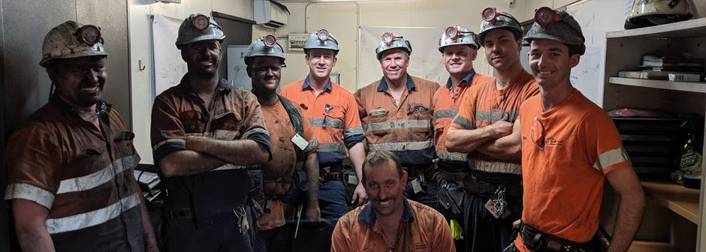
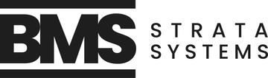
This job is no longer available

Underground Coal Mine Worker - Trainer Assessors
Blackrock Mining Solutions Pty Ltd
Moranbah, Mackay & Coalfields QLD
Mining - Operations (Mining, Resources & Energy)
Casual/Vacation
$70 per hour
Posted 30d+ ago
More jobs from this company
About the business
BMS Strata Systems/Blackrock Mining Solutions is a well-regarded employer of choice with long-term contracts in the Bowen Basin.
We are an innovative company that rewards our employees for the effort they apply, with above industry average remuneration and benefits including Rest & Recreation leave. Ongoing training is considered as a must for all members of our team.
We are seeking experienced Trainer Assessors to work with our crews at various mine sites primarily within the Bowen Basin. You will be responsible for the coordination, training, delivery and assessment of internal training and other site-specific requirements to meet business and operational needs.
Benefits and perks
As a valued employee of Blackrock you can expect:
- A competitive casual remuneration package
- Accrued holiday leave (Rest & Recreation leave) 20 days per year
- Training, development, and relevant tickets
- Long term stable employment due to the duration of contract and our long-term relationships with the mines.
- As part of a small team you will get to expand your skills and be well treated by a company that values its employees above all else

About the role
The roles includes:
- Plan, Prepare and deliver training sessions
- Scheduling and performing assessments to the required standards (including refresher training)
- Ensure all training documentation is accurately completed and entered
- Casual contract with plenty of ongoing work
- 5-2 Roster with the potential for weekend work as required.
- The role will require the incumbent to work from client sites regularly. When not required to be on-site, your work will be based out of the Mackay office
Skills and experience
Key Skills
- 2+ years experience as a Trainer/Assessor in a Coal Mining Industry
- Proven safe working practices, good communication skills and an eye for detail.
- TAE40122 skill set (Essential)
or Full Certificate 4 in TAE40122 (Highly advantageous)
- Current “C” Class Queensland driver’s licence
- Hold a current Standard 11 (Both Surface and Underground components)
- The capacity to handle complex situations.
- Competent with the Microsoft Office Suite and other computer applications
Previous experience in the following will be well regarded:
- Secondary support,
- VCD installation and construction,
- Chemical application,
- LW consolidation and strata consolidation,
- and outbye operations

Employer questions
Your application will include the following questions:
- Which of the following statements best describes your right to work in Australia?
- How many years' experience do you have as a Mineworker?
- Do you have a current Coal Board Medical check and if not, are you willing to obtain one?
- Do you have mine site experience?
- Are you willing to undergo a pre-employment medical check?
- Do you have a current Standard 11 induction?

Employer questions
Your application will include the following questions:
- Which of the following statements best describes your right to work in Australia?
- Do you have mine site experience?
- Do you have a current Coal Board Medical check?
- Are you willing to undergo a pre-employment medical check?
- Do you have a current Australian driver's licence?

Report this job advert
Be careful
Don’t provide your bank or credit card details when applying for jobs.
Learn how to protect yourself

