Position Title: Family Mental Health Support Worker –
Family Mental Health Support Service - Geelong

PROGRAM: Family Mental Health Support Service (FMHSS)

STATUS: Fulltime/Part-time

REPORTING TO: Geelong FMHSS Team Leader & Manager Family Services

DS OVERVIEW

Vision

Our vision for individuals, all families and communities in Australia is that wellbeing is promoted and supported throughout their life cycles, not just in times of crisis.

Mission

Promoting wellbeing for life.

We believe that the most effective way to achieve our vision is to provide two distinct service streams:

Specialised promotion, prevention, early intervention and treatment services designed to meet the needs of individuals, all families and communities utilising a public health framework.

Undertaking applied research to understand what works in service delivery and disseminating that information to contribute to and inform the practice development for the sector.

The values that underpin all aspects of our work:

Leadership
In the face of social, economic and cultural change, our longevity as a leader in the provision of welfare rests in our unwavering commitment to respond creatively to the changing needs of families and communities.

Client centred
drummond street’s services and practice are developed and delivered on the basis of our client’s needs, strengths and aspirations.

Safe and secure environment
drummond street provides a physically and emotionally safe secure and supportive environment, ensuring the privacy of all those who use our services.

Diversity
drummond street’s services and practice are appropriate and responsive to the diverse, complex needs and backgrounds of families in our community.

Inclusiveness
We deliver equitable services promoting all family’s needs. We take extra care that access by families that have something different about them is encouraged and promoted in an equitable manner.

Professionalism
drummond street maintains professional standards of service delivery. We employ highly committed professionally trained and qualified staff, who are enthusiastic about their work with individuals, groups and families.

Quality and transparency
drummond street ensures it delivers the highest quality of services and practice. Our work is founded on research, practice wisdom and the voice and needs of our clients.

Value and Innovation
drummond street will utilise its resources with intelligence by adding value where existing services are appropriate rather than duplicating and we will aim to innovate where service gaps or deficiencies exist.

drummond street services (previously the Citizen’s Welfare Service of Victoria) has a considerable history (126 years) in the development, implementation, management and evaluation of a broad range of innovative projects, programs and services. Since its foundation in 1887, drummond street has both organised and delivered welfare services in the state of Victoria with the overriding aim of the organisation to strengthen family relationships as a key protective factor and determinant of a range of health risk behaviours. All programs and services utilise a whole of family approach which encompasses examining an individual in their broader family context and targeting services to meet all family members’ needs. In addition we adopt a public health approach in all areas of our work which includes:

- Promoting healthy strong families via parenting programs and community education

- Prevention programs throughout the lifespan and family life cycle which aim to increase families strength and protective factors.

- Early intervention programs at key family transitions where families are particularly vulnerable such as birth of a child, relationship difficulties, settlement for newly arrived families or where disadvantage and isolation exist.

- Tertiary programs to intervene in areas which impact on family relationships such as separation and divorce or where families are also experiencing complex issues such as family violence, mental illness, drug and alcohol abuse, and gambling which jeopardises family relationships.

- Maintenance programs which assist families which have negotiated difficulties such as separation and are repartnering.

- PROGRAM BACKGROUND:

Throughout this history drummond street’s Community and Family Programs and Service responses have attempted to keep pace with both the growing evidence base regarding the science of public health interventions (what works) as well as the changing nature and prevalence of health and wellbeing issues impacting on families. We are committed to ensuring our work supports family wellbeing for life through an integrated family service delivery which is essential for effective and efficient outcomes for families.

drummond street has embedded a public health approach to our family services with an increasing emphasis on prevention and early intervention to address common health and wellbeing risk in families, and earlier in life. In addition, we recognise that universalism does not address the unequal burden of health risks within certain populations due to disadvantage and other social determinants. This has been a key driver in further consolidating and implementing a blended approach; using both universal and targeted interventions (proportional universalism) for all families; and for specific ‘at risk’ or vulnerable populations, including geographical areas of disadvantage; at key transition points across the family life cycle which carry greater vulnerabilities; to span:
- Universal family wellbeing promotion and prevention;
- Early interventions for those who are at greater risk or are starting to struggle;
- Tertiary interventions which are evidence informed for known problems and address the impacts on the whole family; and
- Recovery interventions that address long-term recovery for the whole family.
At each public health level there is a clear focus on matching the intensity of services for families based on their needs with evidence informed services and the “dose” increasing as families identify and seek greater levels of service. This multi-servicing in action empowers families, for instance, to access practical parenting education programs delivered in the community by approachable and engaging educators. These seminars offer strategies and tips for ‘good enough parenting’ and child and adolescent development which then allows parents to self-select if they require additional support.

More intensive support can include parenting groups, intensive home-based parenting support, casework and/or family counselling and specialist child and youth programs. In addition, risk factors that increase the likelihood of a family experiencing specific health risks such as mental illness and/or family violence, are also targeted as well as a focus on promoting and building family wellbeing and resilience.

Our targeted interventions have largely focused on specific populations identified within our social mapping of our local communities who experience greater vulnerability due to their minority status or other social factors. For our African families these services are delivered with African Peer Parenting Educators or our African Family Support staff. There is an additional focus on increasing other social determinants of health such as family literacy and school readiness to increase education and employment opportunities.

For our lesbian, gay, bisexual, transgender and intersex community and their families this includes specialist support and programs through our queerspace service delivered by our Queer Affirmative Counselling and Support team.
For all families seeking additional support, our skilled and professional Family Intake engages with families to discuss options and ensure a seamless, timely and supported referral into programs either within drummond street or other appropriate community services.

Increasing demand for family support and a lack of community infrastructure and support services in the western growth corridor has challenged and led to the redistribution of our family service presence into Wyndham and the specific targeting for service provision in the most disadvantaged and socially excluded postcodes.

Family Service Model – embedding Whole-of-Family focused interventions

drummond street services’ Family Services Model embeds a whole-of-family focus and practice that operates across all our program activities and interventions, including counselling, parent support and case work, to address the increased prevalence of families with children presenting with mental health issues and multiple wellbeing risks.

It ensures we provide a meaningful and responsive service to individuals, couples and children through our family relationship/family law services, parenting, practical support and case-work, however to address the negative impacts and multiple risks of so many families that present to us for assistance requires intensive, intentional, whole-of-family work; that is child/family aware, and; with connected interventions across the spectrum if we are to continue to make a difference, specifically in terms of early intervention.

drummond street’s work also ensures targeted responses to reflect the local communities in which it services, including queer communities and those from culturally and linguistically diverse communities, and is based on the following principles;
- drummond street services’ client group includes individuals, couples and families who present with issues impacting on family relationships and children’s mental health.
- The use of an assertive engagement model to ensure programs and interventions are responsive and accessible.
- Families, children, young people and individuals who use our services represent a broad range of physical abilities, cultures, sexualities, socio-economic statuses, ages and occupations and we recognise that they come for support with a diverse set of histories, aspirations and experiences.
- As part of ensuring access and equity in service support, particularly for resource-poor families, drummond street services continues to offer low-cost or no-cost support and counselling based on capacity to pay.
In addition to our ongoing counselling and family support is providing responsive and targeted assistance to support individuals and their families impacted by the Royal Commission into Institutional Responses to Child Sexual Abuse.

drummond streets’ six Domains of Family Well-being

Our family work is structured around supporting 6 key areas of family well-being, with improvements in family functioning considered against these 6 domains throughout the duration of support provided to children, young people and families at each stage of Family Service Delivery; Intake, Assessment, Goal-setting, Case reviews and Closure and Evaluation.
Individual Well-being | The physical, emotional, social and developmental  Well-being of all family members; adults, children and young people.
Connected Family Relationships | Happy connected family relationships including intimate partner relationships, parent-child relationships, and sibling, extended family relationships.
Safe Family Environment: | Safe and supportive family environment that is free from frequent conflict, violence and abuse.
Competent Parenting | Competent, confident, age-appropriate parenting.
Material Security | Adequate stable accommodation, financial resources and transport.
Connection to Community | Family/friends support network and school and community engagement.

This model allows us to provide a service to all individuals, couples, families, young people and children in our community who are facing challenges, whilst ensuring that the families with the highest needs are provided with the level of service they require to achieve the best outcomes for themselves and their children.

Family Service Model of Practice

For many people their first engagement with drummond street services occurs when they attend mental health, parenting groups and seminars, either in community locations (such as schools, Maternal and Child Health Centres, Aboriginal Health Services, community development programs etc.) or at our premises. Such programs provide universal, non-stigmatised pathways to promote family well-being within the community, and allow us to form connections with families who might otherwise not access our services.

For others, their first contact with drummond street is when they contact the agency and speak with our Family Intake Worker. They then undertake a sensitive, directed telephone interview with our Family Intake Worker to assess the family’s presenting needs and match them to the most appropriate program or intervention.

Whilst drummond street is proud to offer a no wrong door approach, we endeavour to tailor the intensity and level of support that we provide to the level of need of each family, and particularly needs of children. Families facing a number of obstacles to well-being will be provided with more intensive interventions than families with fewer obstacles.

In order to provide an individualised service, we offer a suite of programs tailored to the different needs of families in our communities of Carlton, Geelong and Wyndham. These include brief interventions such as single-session assessments and warm referrals; case-work to address practical needs; seminars and groups to heighten skills and knowledge about relationships, parenting and mental health; one-to-one parenting support; individual, couple and family counselling; peer support groups and intensive family support.

For those families with the greatest need, the variety of programs offered allows us to develop a tailored Family Action Plan to achieve goals for the whole family over 12 months. In the initial sessions with a new family, our Child and Family workers conduct a Whole-of-Family assessment to identify the strengths and needs of each family member, as well as the overall family functioning, parenting and community supports. They then work with family members to identify the particular goals to be achieved in order to enhance family well-being.
The variety of programs and tailored interventions on offer allows for families to move between programs as their needs and priorities change. Families are encouraged to participate in setting their own goals they wish to achieve with the help of drummond street and to re-engage with the service or be connected to other supports when they or their children or family face new challenges.

The following diagram provides an overview of the pathway to specific programs and services tailored to meet a family’s needs.

Diagram 1. Family Services Pathway
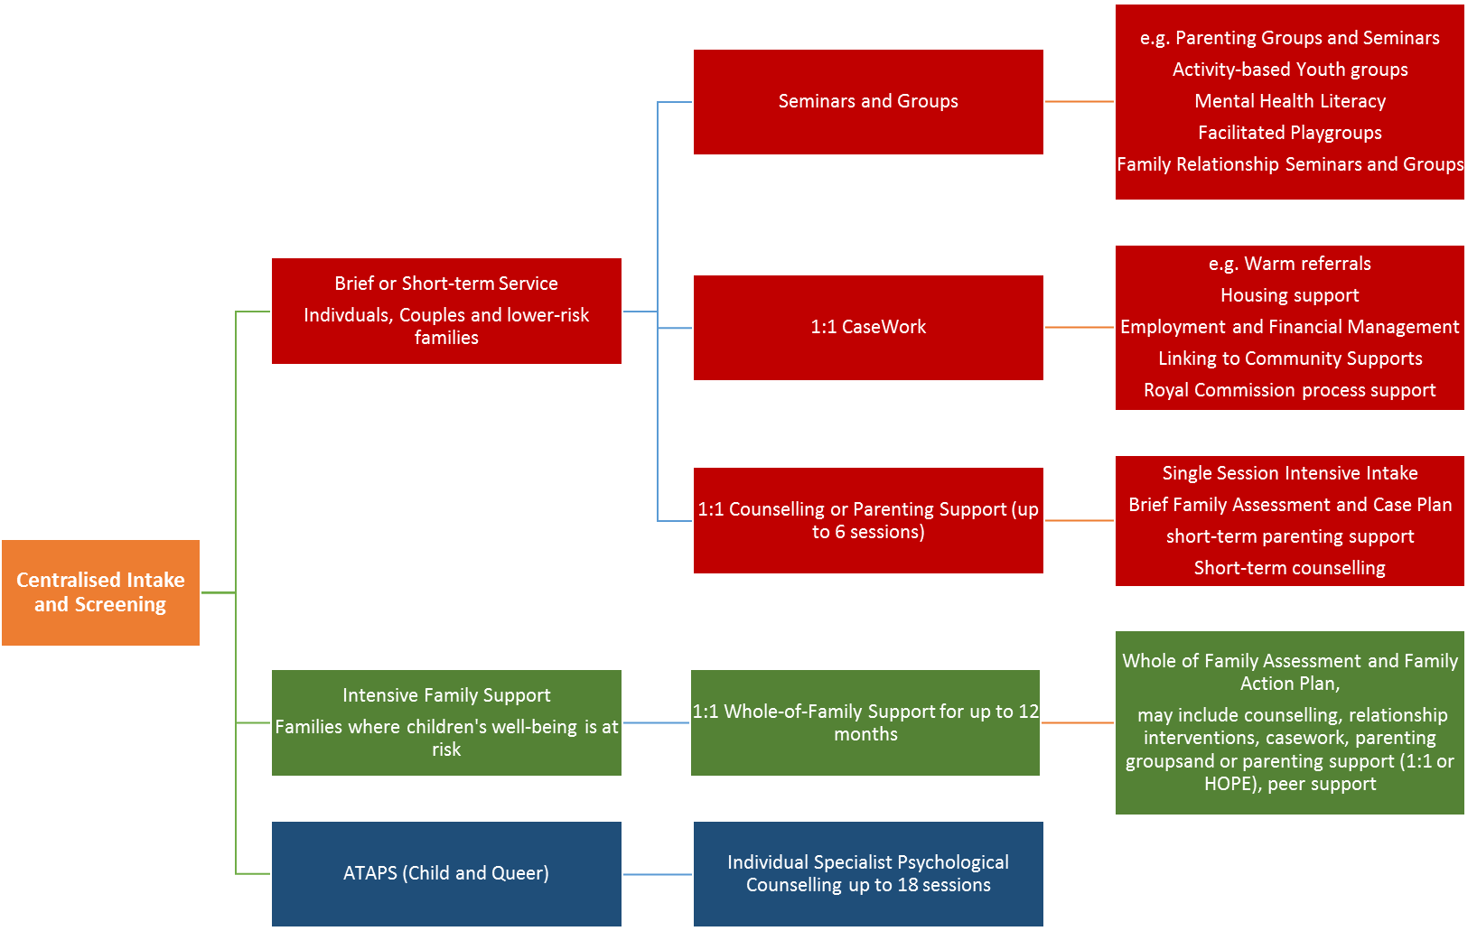

- KEY OBJECTIVES OF THE POSITION

- Working as part of a dynamic, evidence-based Family Services organisation, the Family & Child Mental Health Support Practitioner will provide high quality Family and Child Support to families with children (0-18years) dealing with, or at risk of child and adolescent mental health issues. Supporting interventions may include parent support, information, assessment, psycho-social education and referrals, case work, advocacy, case planning and supportive counselling, along with facilitated connections to other services as part of providing responsive and holistic family support.
- To deliver a range of treatment and recovery family and child focused interventions experiencing a range of complex issues impacting on their emotional and mental health and wellbeing, including family conflict, relationship breakdown, poor mental health, family violence and sexual abuse.
- Demonstrated experience of ‘trauma informed’ care and the recovery oriented service models.
- The provision of appropriate and responsive family casework including supportive engagement and counselling of adults and children and referral to the full range of services within and external to drummond street services.
- The provision of peer support, therapeutic and psycho-educational seminars and groups.
- Contribution to other agency activities and portfolios or working groups in the development of new programs and practice.
- Where appropriate, support to colleagues as peers to ensure integrated and consistent high quality practice and interventions for families, individual, young people and children.

DUTIES

- To engage with and conduct appropriate family/child centred assessments and to negotiate and develop up a support plans based on needs and goals for clients and their families/significant others.
- Provide client-centred, trauma informed, Intake and counselling, utilising a range of educational, recovery oriented and therapeutic approaches and strategies linked to an individual or family assessment and planned interventions.
- Deliver client support within the context of the agency’s family services model and practice, alongside other relevant evidence-informed interventions.
- Network and represent the organisation positively with a range of external health, welfare and other relevant providers for the purpose of making appropriate client referrals or providing conjoint counselling/support where required, and marketing and promoting the agency programs.
- Contribute to the development and where appropriate the delivery of educational and therapeutic groups or programs and practice materials.
- Ensuring the co-design of programs and services with service users (lived experience) and harnessing the use of peer education and support where appropriate
- Complete all client records and other required documentation including case plans and client assessments.
- Ensure adherence to professional practice standards and DS’s policies and procedures including those relating to Clinical Programs.
- Such further and other duties as are allocated to you by your Manager and/or or the Executive.
- Contribute to the achievement of program targets and KPIs as per contractual agreements with funders and those determined by the organisation.

Child and Family Mental Health – Integrated Service Delivery

- The Geelong Family Mental Health Support Service (FMHSS) is co-located with the Barwon Medicare Local Primary Mental Health Partners (Level 1, 131 Myers Street – Geelong) which provides a range of primary mental health services across the Barwon region. All programs specifically target those who often do not access mental health support due to financial, cultural or other barriers to support.
- It is expected that the FMHSS team will work as an active partner of the Primary Mental Health partnership and where appropriate work with Primary Mental Health colleagues on joint-cases, for instance undertaking family-based interventions alongside Child ATAPS evidence based, focused psychological strategies to infants and children up to the age of 12 years and their families.
- Provision of Family-based interventions including, counselling, support, case work and advocacy, brief and intensive interventions as per drummond’s street Family Services Model – including psycho-social education, mental health literacy and promotional activities for families. This may also involve the development and facilitation of group programs.

- KEY SELECTION CRITERIA

Essential
- Social Work, Family Therapy or Psychology qualification and further training in relation to families work and management.
- A minimum of three years’ experience in the family service and/or mental health sector.
- Experience of working as part of multidisciplinary staff teams.
- Demonstrated knowledge and application of a range of therapeutic approaches for individuals, couples, families and specifically children and young people.
- The position requires the incumbent to have demonstrated experience of working with and in programs for families with complex needs such as family violence, drug and alcohol and mental health issues.
- High level communication, negotiation, interpersonal and consultancy skills.
- Demonstrated experience in working with complex change situations and the ability to contribute to high quality practice.
- Experience in the implementation of innovative approaches to service delivery in an integrated not for profit family service environment.
- A strong track record in complex and multi-site workplace environments.
- Experience and understanding of family relationship issues and the family life cycle (this includes relationship formation, enhancement, separation, family reformation and step/blended families).
- Demonstrated capacity to work as part of a team and contribute actively to the viability and functions of a busy Family Services Agency.

Additional requirements – Primary Mental Health programs

- Demonstrated understanding of key issues in comprehensive Primary Health Care, mental health and other clinical and non-clinical supports particularly in the relation to the health, development and wellbeing needs of infants and children (under primary school age) with mental, emotional or behavioural difficulties and their families or carers of children.
- Demonstrated understanding of the ethical issues specific to working with infants, children and families.
- Ability to use Information technology, including Outlook, standard office-based IT applications such as MS Word, Excel along with relevant Health databases, reporting and client record software.

- CONDITIONS OF EMPLOYMENT:

Conditions of employment are in accordance with the current DS Policy and Procedures including the Code of Conduct. Willing to undertake or have undertaken Current Police Check and Working with Children’s check.

SALARY: Negotiable on experience.

Full salary packaging benefits available

Hours: Full or Part time

- LOCATION
Geelong FMHSS, Level 1, 131 Myers Street Geelong VIC 3200, along with outreach and home-based work. Other drummond street locations; Wyndham, 220 Hopper Crossing Lane, Werribee and 100 Drummond Street, Carlton 3053.

- APPROVED BY: Karen Field – Chief Executive Officer DATE October 2014

