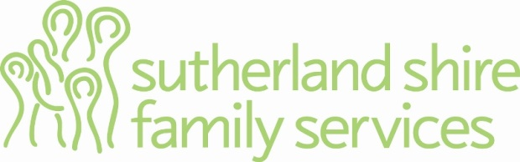

Program Manager

The Position:
You are a professional who will provide management support with regard to the coordination of service delivery for programs within Sutherland Shire Family Services. Within this role you will be able to offer a preparedness to work flexible hours when required. This is a fulltime position.

The Organisation:
Sutherland Shire Family Services aims to support and strengthen the capacity of families within our community by providing programs and services which are designed to contribute to the promotion and maintenance of safety and well-being to all family members.

Selection Criteria:
Essential Criteria:
- University qualifications in Social Work, Social Science or related discipline.
- Extensive (minimum 5 years) casework (family work) experience working within a strengths based framework.
- Experience working with women and children impacted by domestic and family violence
- Demonstrated experience in a senior role within the human services sector.
- Proven ability to lead and manage teams with demonstrated experience in effectively supervising, supporting and developing staff
- Experience with budgets, data collection, reporting procedures and funding agreements
- Experience working with families within a child protection context
- Results orientated with an ability to plan, monitor and report on relevant outcomes
- Demonstrated skills in project management
- Highly developed interpersonal and communication skills with a positive attitude
Desirable Criteria:
- Drivers licence
- Experience working within a trauma informed framework
- Strong IT skills, including the ability to provide IT support to other staff
- Demonstrated organisational skills
The successful applicant will benefit from excellent ongoing professional development opportunities, a flexible family-friendly working environment and an attractive remuneration package with a tax free salary component. The preferred applicant will be subject to screening in relation to child-related employment.

