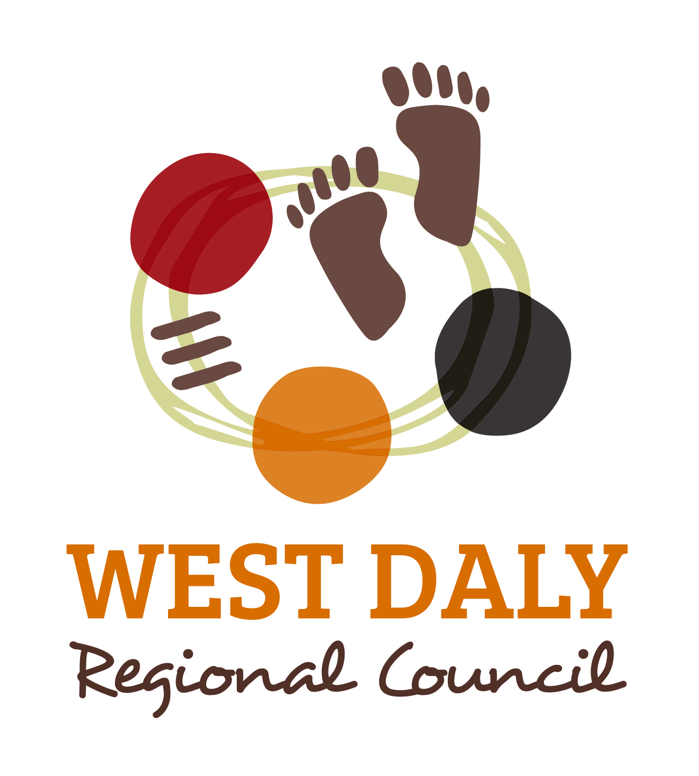
WH&S and Property Officer

Position: | Work Health Safety and Property Officer
Classification Level: | Level 7
Temporary: | Full Time
Reports to: | Chief Executive Officer

Organisational Environment

The West Daly Regional Council commenced operations on 1 July 2014. The new council was formed as part of the 2013 Local Government reforms in the Northern Territory. The Regional Council has been formed by the demerger of the Victoria Daly Regional Council. It includes the communities of, Peppimenarti, Palumpa and Wadeye and has a population of approximately 2778.

Personal Attributes

Ethical behavior – It is imperative that the Special Projects Officer displays the highest level of integrity and ethical conduct.

Attitude – demonstrates a positive approach towards the workplace ensuring to display appropriate behaviors and to be seen as a respected role model.

Discretion – being able to make decisions on what to do in a variety of situations and ability to make sound judgments.

Consistency of service – all work performed by the officer needs to be of the highest quality and consistent.

Safe work practices – perform all work duties following WHS regulations.

Summary of Position

To review, develop, monitor and evaluate the implementation of policies, procedures, strategies and programs related to WH&S and Tenancy Agreements that most effectively and efficiently meet the goals and objectives of Council whilst adhering to all relevant Acts, Regulations and Legislation.

Position Liaises with

Internal | External
Chief Executive Officer | Government Representatives
Executive team | Community Organisation Representatives
Regional Service Managers | Local Government Association Of the Northern Territory (LGANT) staff
All Council Staff | Consultants
 | Community members

Specific Duties

Work Health Safety
- Develop and implementation of appropriate WH&S Management System.
- Implement strategies to ensure annual WH&S results are improved.
- Developing, implementing and reviewing effective timely hazard and incident/accident investigation and reporting.
- Complete scheduled internal audits of WH&S management system and co-ordinate external audits as required.
- Establish and maintain risk assessment records.
- Liaising with Council’s insurer to ensure adherence to the Work Health & Safety (National Uniform Legislation) Act.
- Actively monitor the workplace to determine the presence of hazards and risks and take appropriate action to rectify any hazards or risks found.
- Identify and recommend appropriate WH&S training requirements in the workplace.
- Ensure all mandatory qualifications and tickets are up to date and current prior to staff engaging in required work activities.
- Ensure standard operating procedures and safe work method statements are implemented and adhered to at all times.
- Ensure toolbox meetings are carried out properly and duly documented and appropriately signed off.
- Conduct spot checks on licences, tickets and work procedures.
- Monitor Workers Compensation incidents and provide regular reports and statistics to management.
- Assist HR Advisor with claims management and incident investigation as required.
- Any additional tasks as requested by the CEO.

Property
- Administration of Council owned properties including maintenance, lessee liaison and property inspections.
- Contribute to policy development, establishment and review of related asset administration and management plans, programmes and procedures, as appropriate.
- Prepare property inspection schedules, including data on condition status and maintenance statistics.
- Develop works programs for property maintenance, minor capital improvements, disposal and replacement.
- Provide reports outlining maintenance schedules, condition of assets and other asset related reports as required.
- Administer arrangements for the commencement and completion of tenancies for Council housing.
- Administer inventories for Council’s furniture, fixtures and fittings in Council properties.
- Investigate, report and follow up any insurance claims in relation to any of Council’s properties.
- Oversee security arrangements for all council properties and facilities.
- Document and implement regular maintenance programs for all the Councils buildings and ensure issues are rectified.
- Act as Contact Officer for tenants, licensees and lessees as well as Council staff and contractors with regard to all licences and leases.
- Assist in resolution of Council property issues include g complaints.
- Source appropriate external contractors as required for security, fire safety and pest control services.
- Provide input into Council’s delivery program regarding maintenance and repairs of Council’s building and assets.
- Airport Reporting.
- Implement, review and engage with managers regarding:
- Council’s Public Liability/Property portfolio
- Asset Management Plans
- Any additional tasks as requested by the CEO.

Selection Criteria

Essential:
- Relevant qualifications and experience in the areas of WH&S & Risk Assessment – Diploma WH&S.
- First Aid Certificate.
- Extensive knowledge of WH&S and Risk assessment legislation & ability to complete risk assessments.
- Demonstrated experience in property management or relevant field as it relates to land, buildings and public facilities.
- Understanding and experience in tenancy process.
- Knowledge of Local Government Act.
- Previous experience working in Remote Indigenous Communities.
- Current Northern Territory drivers licence.

Desirable
- Property or asset management and/or real estate qualifications.
- Qualifications and/or experience in Airport Reporting.

Key Performance Measures

Authority & Accountability
- This position reports directly to the CEO and is accountable for ensuring compliance with the Local Government Act, Work health & Safety (National Uniform Legislation) Act and all relevant Tenancy Acts.

Judgment & Problem Solving
- Development of suitable Work Health Safety and Property Management compliance procedures and implement tracking systems.

Specialist Knowledge & Skills
- Provide sound advice regarding Work Health Safety and Property Management in the West Daly region and effectively contribute to the operational planning of each community.
- Provide accurate and timely reports regarding Work Health Safety and Property Management.
- Sound knowledge of the Local Government Act and Regulations.

Interpersonal Skills
- Effective communication skills and the ability to provide specialised advice.
- Ability to interact effectively with contractors and Indigenous community members.

Qualifications & Experience
- Extensive experience in a similar position (3+ years).
- Current police check and Ochre Cared.
- Current NT Driver’s licence.

Approval

This appointment is a full time position and the appointed applicant will be required to undergo a Police check and Ochre Card. The position holder must be willing to adhere to Councils Code of Conduct, Conditions of Employment, Policies and Procedures.

_____________________
Glenda Teede
Chief Executive Officer

Created: | 12th January 2016
Version: | 1
Updated:
I ____________________________ have read, understood and agree to the position description as set out above.

_______________________ _____________________________
(Signature) (Date)

