RECRUITMENT PACK

Chief Executive Officer

November 2017

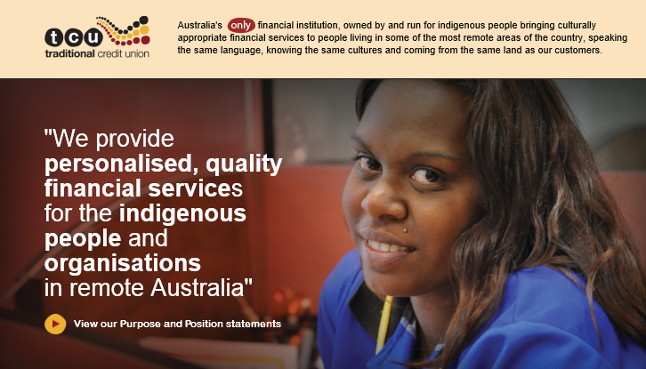

Traditional Credit Union (TCU) is the leading provider of personalised banking services to the First Nations people and organisations. TCU is a member owned financial institution serving the urban, regional and remote areas of the Northern Territory, working in two worlds to deliver both employment opportunities and real financial services.
We are proud of where we have come from and who we are, and we are passionate about where we are going.
The teams at TCU are important to us and the key to our success
We currently have a vacancy in our Executive area for
Chief Executive Officer

The key selection criteria for this role is:
- General management experience within a service industry or the financial services industry
- Digital and channel management experience
- Ability to embrace diversity within a multicultural indigenous environment
- Experience in corporate transformation projects and change management
- Strong leadership, interpersonal and people development skills
- Proven capability to think strategically and implement strategic initiatives to transition an organisation
- Ability to develop and acquit grants and submissions
- Tenacity to follow through the implementation of agreed key initiatives, and overcome the challenges presented.
- Flexibility to adapt strategy and initiatives to create value in an ever changing environment.
The person we are looking for:
- Will be comfortable representing TCU at stakeholder liaison and engagement forums
- Motivated to form relationships with key stakeholder groups
- Be self-motivated and able to implement the TCU strategic initiatives
- Have a sound understanding of local indigenous cultural and community needs
- Able to work within communities and demonstrated experience working within either a local and/or federal government environment
This position reports to the Board of Directors. Remuneration package will be negotiated with the successful candidate.
CONDITONS OF EMPLOYMENT
POSITION REQUIREMENTS
- All prospective persons must be assessed as Fit & Proper for the role as required by TCU’s Fit & Proper Policy
- Current driver’s license
- Undergo a National Police Check.
MINIMUM EMPLOYMENT PERIOD
Under the Fair Work Act 2009 all new employees are subject to a six-month minimum employment (probationary) period. During this period, the Board will monitor your performance in your role as well as your overall fit with the TCU Culture.
INDUCTION / ON THE JOB TRAINING
Traditional Credit Union (TCU) realises the importance of induction to assist new Employees to settle into the workplace and to inform new Employees about TCU and TCU’s policies and procedures.
General Induction:
Typically conducted by the TCU HR / Training Team on commencement and generally takes 2 days. It involves:
- Introduction to the workplace
- Filling out commencement forms
- Completing compliance modules
Job Role Induction:
The Training Team or a delegate will provide job role inductions that are tailored according to the role.
HOURS OF WORK
- This position is a Contract position for a period of 2 years. Extension may be offered based on outcomes.
- Head Office Hours are 8:24 to 4:30pm with a 30 minute unpaid lunch break
LEAVE ENTITLEMENTS
- 5 weeks annual leave pro rata
- 10 days sick leave pro rata
- Long service after 10 years of service

UNIFORMS
5 uniform shirts are provided free of charge at the start of employment and replaced on a fair wear and tear basis.
SUPERANNUATION
Under the superannuation guarantee, TCU have to pay super contributions of 9.5% of an employee’s ordinary time earnings. Staff may nominate the superannuation find of their choice as long as it is compliant. If a superannuation fund has not been nominated after 28 days of employment, contributions will be paid into the default superannuation fund Australian Super.
BENEFITS OF WORKING WITH TCU
Traditional Credit Union is committed to providing staff with flexible, family and a work-friendly environment and offers a variety of benefits.
- Financial products for employees
- Salary paid into a TCU account and free of most fees and charges
- A competitive remuneration
- Being part of a growing innovative organisation that gives back to the community
- Flexible work arrangements where possible
REWARDS AND RECOGNITION
Traditional Credit Union values our staff. Our rewards and recognition policy aims to reward staff fairly, equitably and consistently in accordance with their value to our Organisation.
Celebrations:
- Birthdays, Professional Development achievements, Arrivals, TCU achievements, End of Year, AGM, Melbourne Cup

Professional Development Opportunities:
- Conferences, Training courses, Academic opportunities, Career Development, Team Building

Outstanding effort:
- Gift or Celebration, Leave early or Start late, Shopping Vouchers, Movie Passes

TCU CORPORATE STATEGY

Our Purpose
- Be the leading provider of personalised banking services to First Nations People and organisations
Our Objectives
- Provide banking services to First Nations people in remote and regional areas of Northern and Central Australia
- Provide financial and digital literacy information
- Provide Indigenous employment and training through our remote branches
Our Values
- Respect culture
- Walk together
- Care for members

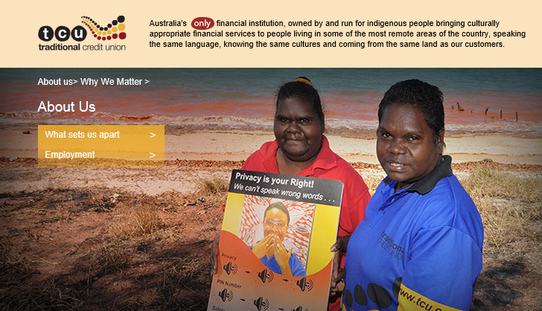

Traditional Credit Union

Position Description

Position Title: Chief Executive Officer

Location: Head Office, Darwin

Reporting Position: Board of Directors

Position Purpose

TCU is a member owned financial institution serving the urban, regional and remote areas of the Northern Territory. It has been providing banking services, employment, and financial literacy training to Indigenous communities since 1994, and, more recently, digital literacy information to its members.

It is governed by a Board of five Indigenous and four non-Indigenous directors.

Reflecting the commercial reality of financial institutions operating in an increasingly digital environment, TCU needs to commence a process of transition from a branch, face to face customer service, to a digital (mobile and internet based) service supported by an ATM network.

Its members have appreciated and relied upon TCU’s face to face service, particularly where this is conducted in local language. The transition to a digital service delivery will require an engagement with members that is sensitive to culture and their current banking experience, and responds to the generally low levels of financial digital literacy.

Allied to this transition process will be the management of the transition of TCU employees, giving them digital skills and increased employment opportunities.

The CEO will be required to lead TCU though the transition processes, with oversight from the Board. It is expected that a project management consultancy will assist the Board and CEO in the design and implementation of these processes.

The CEO will be supported by a team of experienced staff in the areas of compliance, financial management, regulatory requirements, banking systems and technology management.

Principal Duties
Provide leadership, inspiration and guidance to management and staff and foster a collegiate inclusive culture. Understand the cultural aspects unique to the operational needs of TCU – spanning the two worlds of Balanda and Yolgnu. Specifically, to foster a collaborative culture that builds indigenous digital and financial literacy, business acumen and independence.
- Guide and implement the organisation’s strategic transformation objectives and together with the Board further develop and implement the new business model to achieve the objectives. This involves but is not limited to a new digital offering to both urban and remote communities.
- Implementation of TCU’s strategic objectives, achievement of the overall financial and non-financial performance goals, and guiding its transformation program; whilst working with key stakeholders and alliance partners within established risk appetite, approved budget, policies, legal and regulatory obligations, and in accordance with authority delegated by the Board.
- Engage with members, staff and key stakeholders to enable and promote higher levels of customer self-service (via digital and direct channels), digital and financial literacy, and ensure resourcing requirements meet customer expectations. Cultural awareness and connection to communities is critical to appropriately tailor products and services
- Employ a team-oriented and collaborative approach; and demonstrate a high level of integrity, trust and respect, and use of excellent communication and interpersonal skills.
- Lead, manage and develop staff to achieve outcomes, and build skills and knowledge to enable staff to transition to a digital model.
- Provide leadership, direction and oversight of TCU activities in accordance with policies and plans established by the Board of Directors, and provide strategic insight to the Board into the implementation of strategic and operational projects and initiatives.
- Together with the management team ensure the sound day to day operational management of TCU functions are maintained, including: accounting, ALM, business development, compliance, facility management, finance, human resources, investments, lending, marketing, deposit operations, transaction operations, retail and remote member services, risk management, supplier governance, product and service integrity and security.
- Develop and maintain strong strategic relationships with stakeholders including government, potential alliance partners and banking associations and business partners to enable TCU to fulfill its strategic objectives and in transforming the business model
- Communicate to government, regulatory bodies, alliance partners and members the transition of TCU into a new business model.
- Ensure that together with Management TCU is compliant with applicable laws and regulatory requirements particularly in relation to APRA, ASIC, and AUSTRAC , in accordance with

Qualification, Experience and Competencies

Relevant tertiary qualifications, preferably in management, finance or business administration, e.g. Bachelor of Accounting/Commerce/Economics/Banking and Finance. Marketing and Digital technology qualifications highly desirable and Post graduate qualifications will be favorably considered.

General Requirements
A demonstrated track record in developing communication strategies and project plans and effectively implementing them in a dynamic environment
- General management experience within a service industry or the financial services industry
- Digital and channel management experience
- Ability to embrace diversity within a multicultural indigenous environment
- Experience in corporate transformation projects and change management
- Strong leadership, interpersonal and people development skills
- Proven capability to think strategically and implement strategic initiatives to transition an organisation
- Ability to develop and acquit grants and submissions
- Tenacity to follow through the implementation of agreed key initiatives, and overcome the challenges presented.
- Flexibility to adapt strategy and initiatives to create value in an ever changing environment.

Reporting
- Issue regular CEO’s report to the Board covering key transformation objectives and provide a summary of significant items of interest as directed by the Board
- Liaise with the Company Secretary on ASIC reporting and Constitutional requirements including Annual General Meetings and director appointments and elections
- Together with Senior Management prepare Board Committee and Board meeting papers and provide minute secretary services for meetings
- Communicate on a monthly basis with the Chairman.
- Oversight of the provision of all reporting including legal and statutory information, compliance reporting, and financial performance reporting necessary to satisfy the Board and Board Committees in relation to operations, strategic plans, risk management,, compliance and corporate governance requirements
- With the senior management Team work with auditors and other outside evaluation authorities (ATO, APRA etc.) in providing them the information needed to measure the practices and performance of TCU

Performance Measurements

Specific KPI’s will be developed the successful applicant.

Relationships
Internal
- Board of Directors
- CEO and Management
- Members

External
- Federal Government
- State (NT) Government & Shires
- Key indigenous organisations (e.g.: NLC, AIG, ABA, ALPA)
- Media and other interested groups
- Banking and Finance industry contacts

Authority
- As approved by the Board in accordance with the Board approved Strategic Relations Engagement Plan

Accountability
- Responsible for all activities of the Credit Union as established under principal duties
- Accountable to the Board of Directors
- Accountable to the Chief Executive Officer on day to day operations and decision making, you will comply with OH&S responsibilities, FSR training requirements/qualifications, Responsible Person (APRA) requirements and other codes and practices relating to your role

TCU Organisation Structure as at November 2017

