POSITION DESCRIPTION

POSITION DETAILS
Position Title: |  | Human Resources/Work Health & Safety Advisor
Business Unit: | Corporate Services |  | Classification/Grade: |  | Band 2,Level 3 MC Grade 9
Position No: | MC235 |  | Reports to: | Corporate & Community Services Manager MC230
Location: | Negotiable within the local government area |  | Positions reporting directly to this position: | NIL

Primary Purpose of the Position

The Human Resources (HR) / Work Health & Safety (WHS) Advisor is responsible for providing high quality human resources and workplace health and safety guidance and support to management and employees that enables continuous improvement in operational performance as well as the achievement of desired cultural change through Councils new strategic direction.

Reporting to the Corporate & Community Services Manager, the HR/WHS Advisor is responsible for undertaking the full range of generalist Human Resource and Work Health and Safety services encompassing: Employee Relations; Work Health & Safety; Employee Wellbeing; Learning and Development; HR Systems, Policy, Practice and Procedures; Performance Management, Recruitment and Selection; and HR Projects so that management and staff are supported in enabling the organisation to meet its current and future goals.

This position assists with the implementation of operational policies, plans and procedures to drive change management programs which support the development of robust, efficient and effective management of the new Murrumbidgee Council.

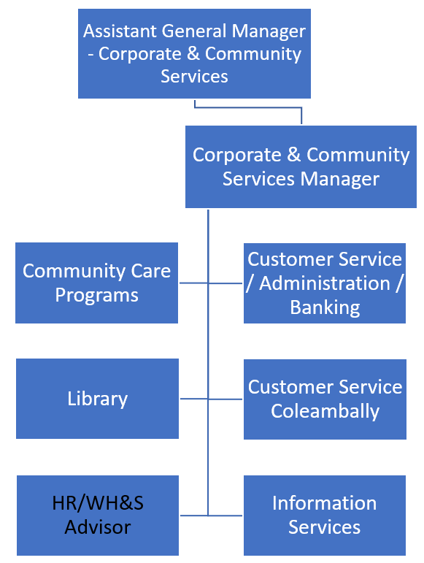
Organisation Context

Established in 2016, following the merger of Murrumbidgee Shire Council and Jerilderie Shire Council, Murrumbidgee Council covers an area of 6,680 square kilometres including over 100 kilometres of natural river frontage to the Murrumbidgee River. The longest creek in Australia, the Billabong Creek, also runs through the Council. The council area has a population of 4,047.

The organisation comprises approx. 100 staff; a very talented and motivated group working hard to ensure the smooth delivery of services and infrastructure. Council oversees and manages $212M in Infrastructure and Community Assets. In 2016/17, Council’s operating budget is $21.4M with capital expenditure of $9.9M.

This role description reflects the Murrumbidgee Council view of the functions, service delivery model and structures of the new organisation.

Key Outcomes/Deliverables

The Human Resources / Work Health & Safety Advisor is directly responsible for the following outcomes:
- Demonstrated behaviours and actions that instil our values of ‘Trust, Honesty, Respect & Teamwork’ and workplace safety across the organisation and community at all times.
- Human resource systems, processes and procedures are implemented, understood and utilised by managers and staff.
- Work Health & Safety systems, processes and procedures are implemented, understood and utilised by managers and staff.
- Projects within the responsibility of the role are planned, implemented, reported and reviewed ensuring effective, safe and quality outcomes.
- Timely and effective guidance, advice and support are provided to the organisation in a positive manner.
- Employee wellbeing initiatives, supporting a culture of individual & team health and performance are implemented.
Duties and accountabilities

The HR/WHS Advisor will assist the Corporate & Community Services Manager in the following areas:

- Ensure all work is carried out in accordance with legislative, industrial and Council policy requirements and standards including Equal Employment Opportunity (EEO) principles
- Maintaining currency of organisation knowledge regarding human resources, work health safety and employment related legislation, codes of practice as adopted by State legislation, Council policy, corporate practices and procedures
- Provide advice on the Local Government (State) Award and other employment related legislation
- Provide advice on a range of human resources activities including; terms and conditions of employment, recruitment and selection, induction, resignation/retirement, salary administration, staff benefits, employee assistance, disciplinary matters and grievances
- Review and update policies, corporate practices, procedures and/or guidelines to ensure they comply with Award and statutory requirements
- When requested, participate in the management of grievances and disciplinary matters, as required ensuring they are managed in accordance with procedural fairness and due process
- Seek employment related guidance and advice from appropriate sources (eg LGNSW, Fair Work Australia) as required
- Participate in the development of human resource and workforce planning, human resources work plans and other development initiatives as required
- Oversee staff induction, probation and annual performance appraisal processes.
- Monitor and audit staff appointments ensuring they are based on merit and in accordance with EEO principles, and take corrective action where anomalies are identified
- Facilitate the development and implementation of HR/WHS systems in accordance with Council policy, corporate practice and legislation
- Undertake human resource and WHS related projects as directed
- Coordinate and participate in Council's employee-related committees such as Consultative Committee and Work Health Safety Committee as required
- Provide guidance and support to managers, staff, contractors and volunteers in understanding and carrying out their responsibilities in relation to WHS
- Coordinate the development of WH&S risk management strategies, risk assessments, safe work method statements and a risk register for WHS matters
- Oversee and coordinate work health and safety inspections and the capture and collation of information and subsequent reporting
- Provide WHS support, training and required documentation for managers and staff engaging and managing contractors and supervising volunteers
- Develop mechanisms to ensure Council responds effectively to legislation and other changes and issues identified in prescribed audits
- Review, update and maintain procedures for incident and hazard reporting
- Review, update and maintain first aid procedures including creation and maintenance of a register for first aid kits and contents, and ensuring first aid training is current for first aid officers
- Contribute to the review, update and maintain Emergency Procedures across Council in accordance with legislative requirements and Codes of Practice
- Prepare WHS reports to be incorporated into monthly HR reporting for MANEX including details on Workers Compensation matters
- Coordinate workers compensation and post-injury management activities, to facilitate the early and safe return of injured employees to suitable or pre-injury duties
- Develop and maintain the Corporate Learning & Development calendar (including employee development, corporate, technical, WHS and other mandatory training)
- Provide advice to management and employees on learning and development opportunities
- Coordinate conference, tertiary and corporate training requests as required
- Maintain accurate training and development data, and assist with monitoring budget expenditure
- Promptly and accurately register and record all business correspondence and documentation into Council's electronic document record management system (TRIM) and personnel files
- Other duties within the skills, competencies and grading of the role as directed

Key Challenges and Influences
- Displaying a positive image while meeting customer service standards for all Council stakeholders both internal and external in a high volume and varied environment.
- Maintaining knowledge of legislation, regulation and guidelines across a broad range of activities to ensure that decisions made and activities undertaken are current and objective.
- Participating in a multidisciplinary team together with a range of stakeholders to achieve operational plan outcomes and service delivery.
- Managing client’s expectations and ensuring service provided is in line with corporate strategies and programs.
- Understanding the diversity of learning needs within the Council and negotiating outcomes with a variety of clients with conflicting needs and deadlines
Authority & Accountability
Responsible to provide a specialized service and to complete work which has some elements of complexity. Make recommendations within the employer and represent the employer to the public or other organizations associated with the role.
Judgement & Problem Solving
Problem solving and judgements are made where there is a lack of definition requiring analysis of a number of options. Typical judgements may require variation of work priorities and approaches.
Management Skills
May supervise groups of operational and/or other administrative/trades/technical employees. Employees supervised may be in a number of different work areas, requiring motivation, monitoring and co-ordination to achieve specific outputs.
Interpersonal Skills
Skills to communicate with staff and the public and/or negotiation/persuasive skills to resolve disputes with staff or the public.
Specialist Knowledge & Skills
Positions have knowledge and skills in a number of areas where analysis of complex options is involved.
Qualifications & Experience
An advanced certificate, associate diploma, appropriate in-house training or equivalent combined with extensive experience in the application of skills in the most complex areas of the job.
Skills, Knowledge & Experience
- Diploma level qualifications in human resources, industrial relations or related field
- Demonstrated experience in human resources and employment relations
- Demonstrated experience and knowledge of WHS legislation, procedures and processes and implementation of employee wellbeing programs
- Effective communication and presentation skills, including the ability to facilitate meetings and engage with groups to achieve outcomes
- Ability to see the big picture and still have strong attention to the detail
- Demonstrated time management and organising skills including the ability to plan, prioritise and work across competing demands
- Proven ability to engage and influence while building effective relationships across organisation boundaries
- Knowledge of and ability to apply EEO and merit principles to Human Resources processes and practices
- Current NSW Driver Licence and willingness to travel.
- Experience in managing workers compensation and return to work matters (desirable)
CERTIFICATION – Workforce Planning Use Only
File location: | G:\Human Resources\MC Proposed Roles
Final PD sign off: | Oct 2017
Updated by: | MURRUMBIDGEE COUNCIL Human Resources Specialist
Current Status: | Approved 20 Oct 2017

