ANYINGINYI HEALTH ABORIGINAL CORPORATION
POSITION DESCRIPTION AND SELECTION CRITERIA

PARLPURU NINJI KARI - HEALTH CENTRE SECTION

POSITION: CHILD AND MATERNAL HEALTH - REGISTERED NURSE

POSITION NO: Clinic POSITION DESCRIPTION REVIEWED: July 2018

REPORTS TO: Practice Nurse Manager, then Health Services Section Manager and through them, to the General Manager.

LEVEL: N4Y1 – N4Y3
$101,076 - $108,591
Based on qualifications and experience.

Conditions: 1 – 2 year contract.
3 month mandatory Probation Period.
6 weeks pro rata annual leave with 17.5% leave loading.
10 days sick leave per annum, pro rata.
9.5% employer superannuation.
RDO’s.

Relocation: Where applicable, please contact HR Office for further details.
Accommodation: Where applicable, please contact HR Office for further details.

Vehicle: A vehicle does not come with this position. However, a pool of vehicles are provided within each Section for business purposes only. Use and maintenance of these vehicles will be in accordance with the Anyinginyi Motor Vehicle Policy. You must be in possession of a validated licence at all times.

Dental: Free General Dentistry is offered to Anyinginyi employees, any Laboratory work must be paid for by the employee.

Gymnasium: Free gym membership is offered to all Anyinginyi employees only.

Prescriptions: Free general prescriptions for Anyinginyi employees only.

Ochre Card: It is compulsory to be in possession of an Ochre Card or have the ability to apply for one prior to commencement of employment.

National Police Where applicable, please contact HR Office for further details.
Check:

Hours of Work: Monday – Friday, excluding public holidays
8.00am – 5.00pm Rostered Day Off (RDO) access
8.24am – 5.00pm – no RDOs access.

Please Note: It is compulsory for all Anyinginyi personnel to be in possession of or have the ability
to apply for an OCHRE Card

OUTLINE OF POSITION OBJECTIVES AND DUTIES

Primary Objectives / Outline

The Child Maternal Health Nurse will work as part of the Anyinginyi Health team, where she/he will deliver and make accessible a range of culturally appropriate health services to children and families in Tennant Creek and surrounding Communities. While the majority of work will be in the field of Child and Maternal Health, the Child and Maternal Health Nurse will also be required to provide general health services to all community members.

Duties

- Maintain confidentiality and work as a member of a high performing multi-disciplinary team
- Acknowledge and respect Aboriginal values, beliefs, customs, language and traditional practices.
- Maintain and develop culturally appropriate and accessible health services for women and Children.
- Contribute to policy and procedure development on child and maternal health.

Clinical Duties

- Provide general health care – assessment and management of a broad range of clinical problems in consultation with AHPs, Doctors, other nurses or CARPA Standard Treatment Manual written protocols. Also deliver health checks and promote health awareness.
- Facilitate and participate in opportunistic and community screening activities.
- Provide advice to clients on diet, smoking, drugs and other lifestyle issues involved in clients health and make appropriate referrals to other service providers.
- Dispense pharmaceutical therapies, including the administration of vaccines and prescribed pharmaceuticals for common conditions.
- Assist in implementation of quality assurance and other evaluation programs to ensure a high quality of clinical care.

Specific Care

Provide support services in the area of –

- Child health and development
- Infant and child nutrition
- Parenting skills
- Home safety for children
- Maternal and Neonatal care
- Immunisation
- Assist with clinical skills training and preparation of child health resources/material for ongoing staff education needs as required.
- In all areas/duties, work closely with the health care team and especially the Child Maternal Aboriginal Health Practitioner in promoting and delivery of Child and Maternal Health services.
- Contribute to other health areas as directed to better the service for all clients.
- Work in collaboration with other Child and Maternal Health stakeholders (Grow Well Team, Midwifery Group Practice, Territory Families, NT Maternal, Alice Springs Hospital Paediatric Team and Child Health Nurse) to improve delivery of Child and Maternal Health services.

Management and Teams

- Advocate for rights and needs of individuals, families and communities on health related issues.
- Demonstrate safe work practices.
- Cohesive team work to deliver effective health outcomes.
- Provide informal training, specifically support and education for nurses, Doctors and other allied health staff.
- Participate in the implementation of disaster plans.
- Supervise the work of AHP’s.
- Manage projects from time to time.

Administration

- Use and maintain Anyinginyi Health Service clinical records.
- Use office equipment and technology in accordance with Anyinginyi policies & procedures.
- Use client database (Communicare) and electronic health records.
- Assist in the ordering and accounting for pharmaceutical and other supplies.
- Produce written reports as requested.

Research

- Collect data on community health.
- Facilitate the maintenance of accurate and up to date data for the population register (community profile).
- Contribute to clinical reports and research activities.

As part of a multi-disciplinary team assist in the delivery of primary health care services to patients of Anyinginyi Health Aboriginal Corporation Health Centre and to communities within the Yapakurlangu Region.

Selection Criteria

Essential

1. Understanding of the philosophy which guides independent Aboriginal Community-controlled Organisation.

2. Demonstrated knowledge and understanding of Aboriginal and Torres Strait Islander culture and tradition, as well as sensitivity to values, beliefs, customs, language and traditional health practices.

3. Knowledge of Primary Health Care principles and their application in a remote health care setting.

4. Eligible for registration with AHPRA Registered Nurse with a current practicing certificate.

5. Demonstrated ability of your knowledge and experience within the field of Child and Maternal Health & development, Infant & Child Nutrition, Immunisation & Child safety.

6. Demonstrated ability to be self-motivated and work with minimal supervision.

7. Demonstrated ability to maintain accurate records, and a neat and sterile workplace.

8. Demonstrated ability to maintain strict confidentiality.

9. Current driver’s license.

10. Understanding of practices and principles of Occupational Health and Safety in the workplace.

11. Be in possession of or have the ability to obtain an OCHRE Card (Working with Children).

Highly desirable

- Computer skills.
- Communication and interpersonal Skills

ORGANISATIONAL OVERVIEW

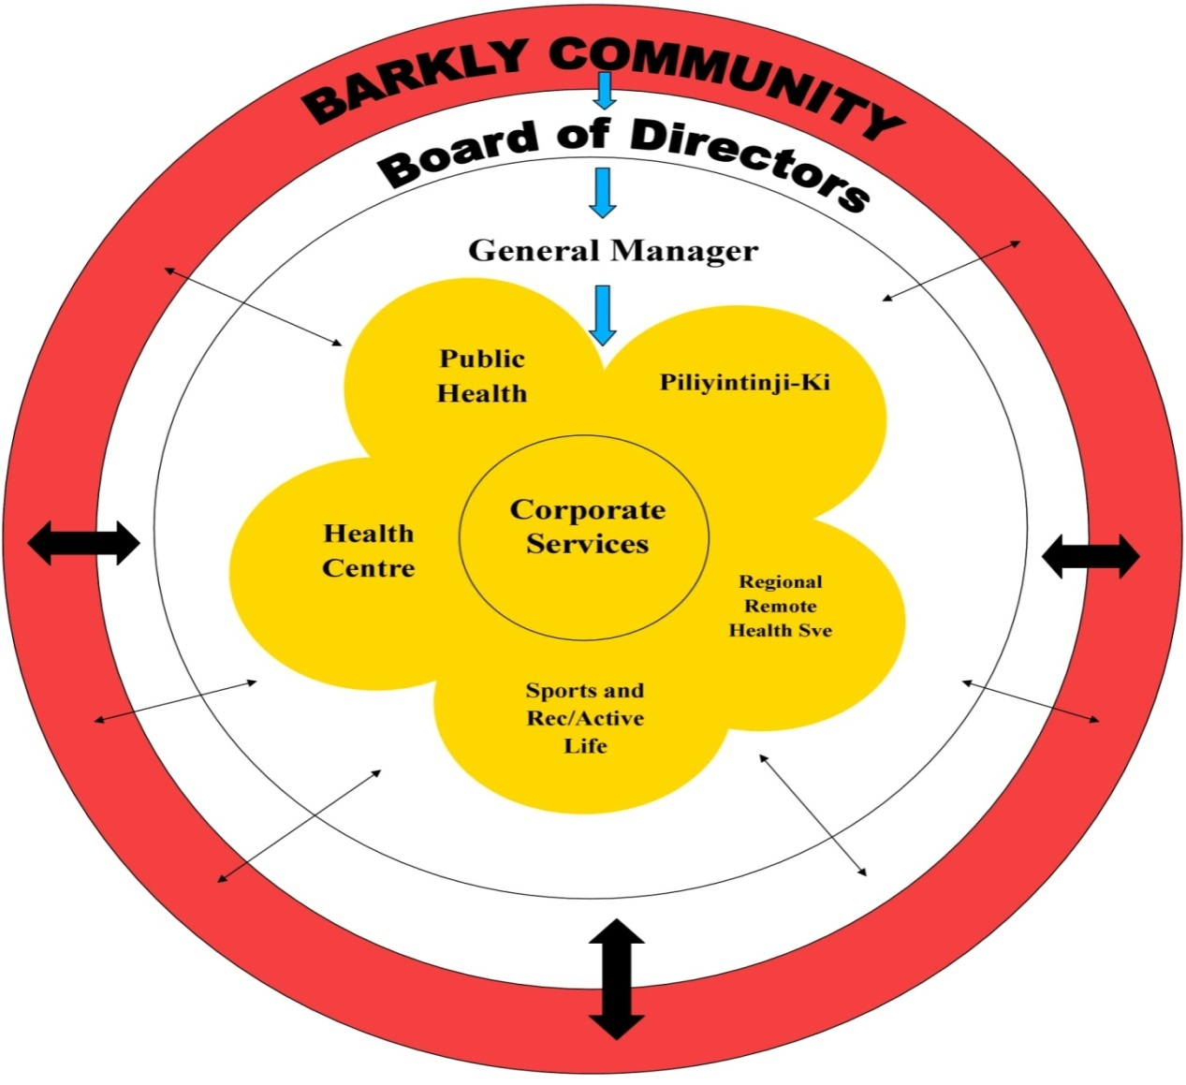

Anyinginyi Governance Model

In line with the Pathways to Community Control “…Community Control requires communities and their organization to possess both the understanding of and the ability to apply the knowledge and competence on which sound engagement is built. It also depends on the capability of government organizations and structures to understand and find new ways of working that responds to community’s calls for greater levels of engagement.” (Page 9, Pathways to Community Control)

The Anyinginyi Governance Model illustrates how the Barkly community, Anyinginyi Board of Directors, the General Manager and the Anyinginyi Sections are integrated and work collaboratively serving the needs of their clients.

The border of the Model represents the Barkly region. The Barkly community representatives are elected to the Anyinginyi Board of Directors situated in the Model’s inner rim. The business of the corporation is managed by or under the direction of the Board of Directors. The Directors may exercise all the powers of the corporation except any that the CATSI Act or the Anyinginyi Rule Book requires the corporation to exercise in general meetings.

The General Manager over sees the everyday operations of Anyinginyi as an entity. Each highlighted Section is managed by individual Section Manager to guide and direct the programs of each section and oversee the management of employees.

The arrows within the Governance Model represent how services are utilised. There are various ways that clients or individuals can access Anyinginyi Services for example:
- Community people accessing our services – on a needs basis
- Anyinginyi representatives from their individual sections going out and providing an outreach service to the community/communities or promotion of programs

The Anyinginyi Health Aboriginal Corporation Primary Health Care Service Delivery Model

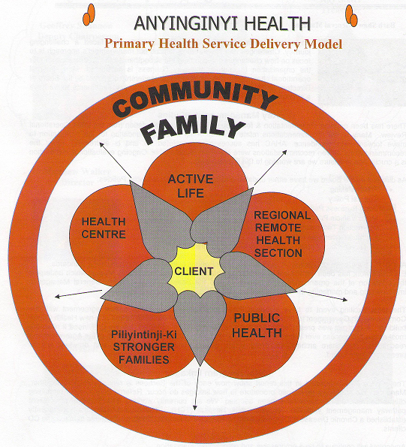

Primary Health Care is a social approach to health that is about ensuring everyone has the right to affordable, accessible and appropriate health care. Primary health care has a broad focus on the social environment rather than just health services. It has a holistic approach to health development and based on social justice, equity, community participation, social acceptability, cultural safety and trust. It also has a broad approach that strongly links with the social determinants of health.

The primary health care approach includes prevention, advice, public health, education, promotion, research, evaluation and community development, as well as primary care delivered in an empowering, multidisciplinary way that helps people to help themselves.

The Anyinginyi Primary Health Care Service Delivery Model reflects the important elements of the holistic health care approach in combining the community, family and client. When managing Aboriginal client care the three components of family, community and culture are intrinsic to good health outcomes.

The Anyinginyi Primary Health Service Delivery Model underpins the way all Anyinginyi services are delivered to the individual client, their family and overall to the community. All Anyinginyi client-Related policies and procedures reflect the Primary Health Service Delivery Model. Each Anyinginyi Section has a set of referral forms and processes in place that links the client to more than one Section.
“Whole of Family” Primary Health Care Approach

Anyinginyi programs have been developed to strengthen all areas of well-being for Aboriginal people. Anyinginyi’s strategic Plan 2014/16 has identified a review of Anyinginyi Section’s roles and responsibilities as required.

The following information is provided as an overview of program areas:

- Parlpuru Ninji Kari - Health Centre

The Health Centre delivers primary health care, clinical, GP, women’s health, men’s health, chronic disease management, Specialist services and community engagement liaison.

Anyinginyi has been working proactively with government service providers to develop partnerships and coordinate service delivery to achieve better outcomes for clients. The Health Centre is often the first point of contact for clients, formal referral systems have been established to link clients with other services. Clients may be referred to other sections within Anyinginyi in line with the service delivery model. It is a priority of Anyinginyi to improve medical input to the Board and management whilst providing improved support to clinicians.

- Manu Kinapina Parlpuru Ninji Kari - Regional Remote Health Service

The Regional Remote Health Section provides the following services –

Bush Mobile – providing primary health care services to remote communities within a 100klm radius of Tennant Creek not serviced by the Northern Territory Department of Health. This service is supported by a medical officer and two nursing staff with the assistance of an ALO/AHP and administrative staff.

North Barkly Zone – providing primary health care services to remote communities of the North Barkly region not serviced by the Northern Territory Department of Health. This service is supported by a medical officer and a registered nurse with assistance of an ALO/AHP and administrative staff.

Allied Health Services – a full-time nutritionist provides services to major communities within the whole of Barkly region (including Tennant Creek). In addition a Physiotherapist and Podiatrist provide fortnightly locum visits six times per year, the latter focusing on Tennant Creek (at present) with the Physiotherapist providing extra services twice yearly for two weeks to the cattle stations in the north Barkly.

Grow Well Program – providing health and capacity building education activities to parents/carers of young children in major communities of the Barkly region. Activities include playgroup, good health & hygiene practices, home skills education, caring for the home environment, self-empowerment.

EHSDI Program – the provision of funding for the identification of community members who have not had regular adult or child health checks and providing the latter in an environment conducive to better compliance.

- Wirlyarra punjarlki kapi Miripartijiki – Sport & Rec

This section delivers programs across a broad spectrum of Sport and Recreational areas to all age groups.

The Sport and Recreation team facilitate a wide range of social sports that the community engages in. These sports include Volleyball, Netball, Cricket, Soccer, Softball and more. Sport and Recreation also manages a commercial, well equipped gymnasium, which is utilised by a broad range of the community. Whilst being a member of the gymnasium, our members our entitled to a personalised fitness program tailor made to suit their needs to live a healthy and more active lifestyle.

Sport and Recreation provide a range of group fitness classes that include Pump, Crossfit, Boxercise, Circuit and our own dedicated women’s classes. There is also a dedicated Womens Program officer employed by Anyinginyi Health Aboriginal Corporation to engage in women of all ages to participate in programs such as gym sessions, fitness classes and sports aswell in a fun friendly environment

Every weekday during the School term, the Sport and Recreation team provide a structured, active lifestyle programs for kids. These activities include Basketball, Soccer, Netball, Tennis, Tball and Dodgeball. This program also flows on into the School Holiday Program where there is a range of activities to keep the kids entertain during the School Holidays.

Wirlyarra Punjarli Kapi Miripartijiki is working towards seeing the whole of the community create healthier lifestyles choices by becoming more active through Sport, Fitness or any other form of movement.

- Kalpa purru Wirranjarlki - Public Health & Promoting Healthy Behaviours Section

This section delivers preventative and educational programs across a broad spectrum of health areas, including trachoma, eye health, skin health, tobacco and healthy lifestyles, FASD and diabetes education, amongst others. Programs in PHU aim to increase community members’ ability to have control over their own health, through raising awareness, health promotion and health education, specific health checks and screening, and responding to public health issues.

- Piliyintinji-ki - Stronger Families

The Stronger Families Section services Aboriginal cliental to promote individual and community well-being through a range of coordinated approaches aimed at addressing family violence, social and emotional well being, family and social dysfunction and cultural issues.

Piliyintinji-ki employs a community development approach and a holistic planning method when working with families throughout the Barkly region. The Stronger Families section’s operational philosophy is to ‘enhance the capacity of Aboriginal people to define the problems and to work with staff to develop the strategies to address them’. A regional framework was developed in 2007.

- Nyangirru Piliyi-ngara Kurantta - Corporate Services

The Corporate Services Section is the business of the organization responsible for Management and Elected Arm administration, regional organizational partnerships, operational policies and procedures, income and expenditure reporting and monitoring service delivery goals for each Anyinginyi Section for implementation. Corporate Services also delivers financial management and asset development, efficient and responsive human resources, Information Technology, and stores and property management.

Corporate Services continually reviews systems to identify the range and scope of accountability pathways, financial policy, management and procedural matters to ensure effective performance and delivery. Regional systems and structures to support appropriate staffing, human resources and industrial arrangements have been aligned with regional governance within budget scope.

Anyinginyi’s CQI processes developed are operational according to the NT CQI program with ongoing CQI participation and support from a locally based Barkly CQI Facilitator position. Anyinginyi strives for an effective CQI program to be in place. The Anyinginyi Board of Directors has identified Quality Assurance as a priority for ongoing organizational development.

