Position: | Marketing Assistant
Division: | Marketing
Department: | Marketing
Reporting to | Senior Manager, Brand and Advertising
Direct Reports | N/A
Employment Type | 12-month contract

Key Relationships | Internal  All Staff  Marketing Department  Sales and Commercial Department  Media & Communications Department  Motorsport & Entertainment Department  Other internal stakeholders as relevant and appropriate  External  Creative agency  Print agency  Grand Prix Travel  Ticketmaster  Visit Victoria  City of Melbourne  Destination Phillip Island  Formula One  Dorna  Key suppliers and commercial partners  Other stakeholders as relevant and appropriate

Values | Knowledge of and consistent demonstration of the Corporation’s IIQCAT values: Integrity, Innovation, Quality, Customer, Accountability, Teamwork.  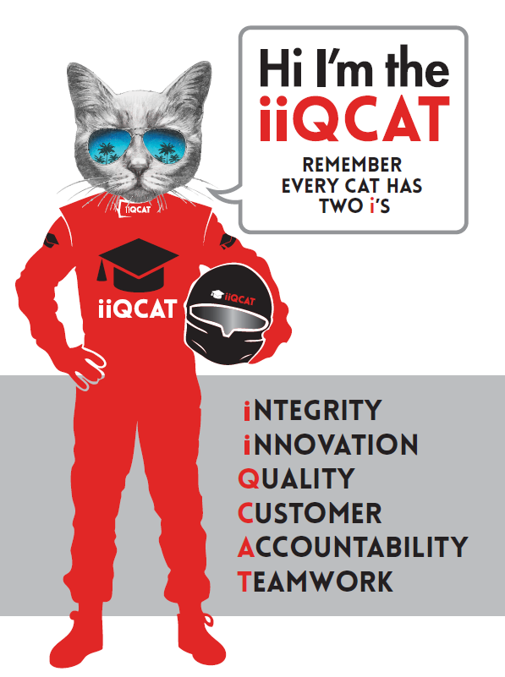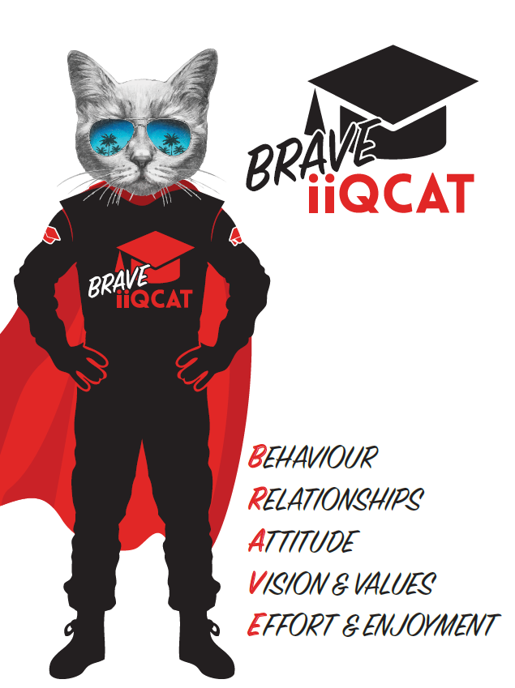
Corporation Objectives | To promote Melbourne and Victoria via the staging of two international sporting events - the Formula 1 Australian Grand Prix at Albert Park and the Australian MotoGP at Phillip Island.
Governed by | The Corporation is governed by the Australian Grands Prix Act 1994 (Vic).
Standards of behaviour | The Code of Conduct for Victorian Public Sector Employees governs the behaviour of all Corporation employees.
Human Rights | The Charter of Human Rights and Responsibilities Act 2006 is a Victorian law that sets out the basic rights, freedoms and responsibilities of all people in Victoria. The Charter requires the Corporation to act compatibly with human rights, and to consider human rights when developing policies, making laws, delivering services and making decisions.

Role Objectives | To assist in the coordination of marketing promotions, retail campaigns, partnerships and tourism marketing, and experiential marketing in close liaison with the marketing team and internal stakeholders.
Core Responsibilities | Assist the Senior Manager - Brand and Advertising in delivering promotions and retail campaigns that drive demand for the Formula 1 and MotoGP with an emphasis on fan engagement to help increase ticket sales, awareness and enjoyment of patrons pre-event and at event.  - Develop the retail marketing calendar and work in close liaison with Ticketmaster marketing teams for execution.  - Identify other retail marketing opportunities to drive demand in line with overarching marketing strategy.  - Develop the promotions campaign calendar in line with overarching marketing strategy.  - See promotional campaigns through from concept to execution in line with brand guidelines for F1 and MotoGP.  - Prize facilitation & liaising with promotional winners including tickets and notification of experiences.  - Assist in the delivery of promotional experiences at the Formula 1 and MotoGP events.  - Assisting in the delivery of pre-event experiential marketing and activations for the Formula 1 Australian Grand Prix.  - Liaise closely with internal/external stakeholders and creative agencies on the delivery of pre-event activations.  - Ensure pre-event activations are delivered to plan, achieve campaign goals and meet brand standards.  - Assist with fan engagement initiatives associated with pre-event and at event activations.  - Assist in developing the marketing partnerships strategy for F1 and MotoGP.  - Execution of marketing partnerships and co-branded campaigns for F1 and MotoGP.  - Execution of tourism marketing campaigns and collaborating with tourism bodies.  - Other duties at the reasonable request of the Senior Manager - Brand and Advertising and General Manager of Marketing. Assisting in ad hoc projects, brand campaigns and administrative support of the marketing department as required.  Governance  Adhere to Corporation policies, procedures, and directives regarding standards of workplace behaviour in completing job duties and assignments.  Conducting every aspect of work in a trustworthy, reliable and transparent manner, and maintaining the highest ethical standards.  Customer Service  Putting internal and external customers first, building strong relationships and ensuring that the approach is responsive to the needs of the internal/external customer.  Encouraging openness and trust by sharing information widely, listening, welcoming constructive challenge and encouraging free dialogue.  Continuous Improvement  Taking initiative to improve operations/services/products and systems so that they are consistent with the Corporation’s strategic direction and values; incorporating innovation and experimentation into daily work.  Health and Safety  To assist the Corporation in meeting its health and safety obligations you will be required to:  - Actively participate in the reporting of hazards, incidents and near misses.  - Take corrective action to address or mitigate any risks or hazardous situations throughout the course of your work.  - Take reasonable care for your own health and safety, and for the health and safety of others.  - Adhere to the Corporation’s various policies, procedures, work practices and standard operating procedures.  - Perform your role in accordance with any specific responsibilities as outlined in the Corporation’s safety management system.  To enable the Corporation to meet its obligations for providing a healthy and safe working environment for you, you must inform your manager of any issues which may impact your ability to safely perform your role.  Environmental Considerations  Cooperate with the Corporation regarding caring for the environment, by acting in a sustainable way and minimising environmental impact by adhering to the Corporation’s policies, procedures and work practices.

Person Specification

Qualifications and Experience | - 2 years’ experience in a fast-paced Marketing environment.  - Ability to understand, support and implement business objectives.  - Excellent written and verbal communication skills  - Strong organisational skills, including time management and ability to balance multiple projects with attention to detail.  - Experience in delivering marketing promotions and activations preferred.

Relevant Traits and Characteristics | Customer Service  - Demonstrated achievement in and enthusiasm for the provision of quality customer service  - Immediately respond to customers needs or concerns to ensure the quality of service meets agreed standards  Teamwork, Adaptability and Resilience  - Demonstrated commitment to teamwork and the maintenance of a supportive work environment  - Ability to work effectively as part of a team in a fast-changing environment  - Keeping calm by demonstrating a capacity to positively deal with unanticipated problems and changing circumstances  Interpersonal, Verbal and Written Communication  - Well-developed written communication ability  - Strong interpersonal and communication skills  - An ability to liaise, negotiate and constructively provide and accept feedback from staff at all levels  Organisation and Planning  - Organisational and planning skills in managing a personal workload in a busy environment with conflicting demands  - Ability to meet deadlines  Technology  - Experience in the use of Microsoft desktop products such as Word, Excel, Outlook and PowerPoint  - Experience in information management systems, including internet and on-line environments  Continuous Learning and Professional Development  - Demonstrated commitment to continual professional and personal development

