Position: | Senior Accountant/Analyst
Division: | Finance
Department: | Business Services
Reporting to | Division Manager - Finance
Direct Reports | 2 x Financial Accountants
Employment Type | Permanent

Key Relationships | Internal  General Manager – Business Services  Division Manager - Finance  Wider Finance team  Sales & Partnerships, Consumer sales team  All other departments  External  Auditors – Internal & External  Government – Department of Jobs, Precincts and Regions, Department of Treasury and Finance  Australian Taxation Office  External professional services firms  Other stakeholders as relevant and appropriate

Values | Knowledge of and consistent demonstration of the Corporation’s IIQCAT values: Integrity, Innovation, Quality, Customer, Accountability, Teamwork.  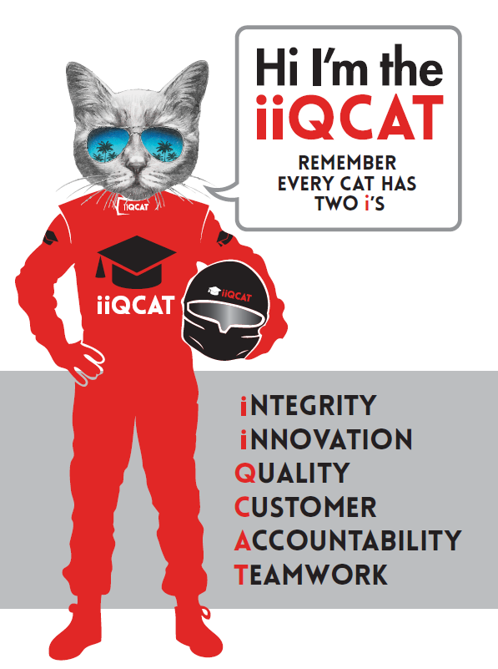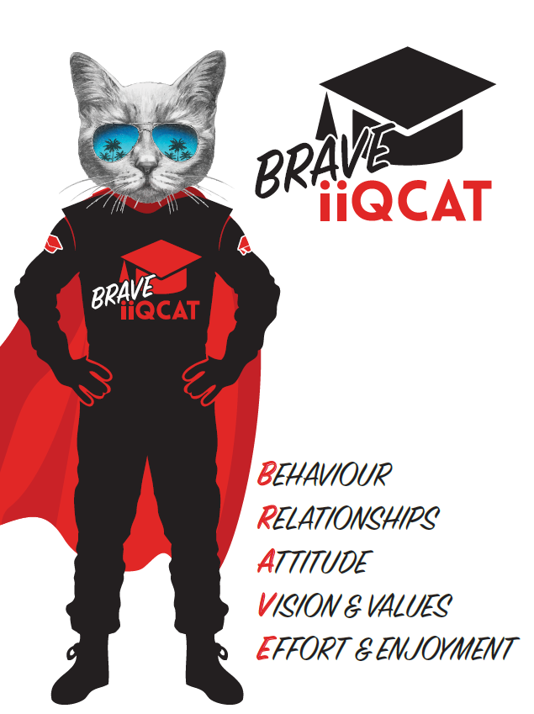
Corporation Objectives | To promote Melbourne and Victoria via the staging of two international sporting events - the Formula 1 Australian Grand Prix at Albert Park and the Australian MotoGP at Phillip Island.
Governed by | The Corporation is governed by the Australian Grands Prix Act 1994 (Vic).
Standards of behaviour | The Code of Conduct for Victorian Public Sector Employees governs the behaviour of all Corporation employees.
Human Rights | The Charter of Human Rights and Responsibilities Act 2006 is a Victorian law that sets out the basic rights, freedoms and responsibilities of all people in Victoria. The Charter requires the Corporation to act compatibly with human rights, and to consider human rights when developing policies, making laws, delivering services and making decisions.

Role Objectives | As a key member of the Finance department, the objective of the Senior Accountant/Analyst role is to assist the Division Manager - Finance with budgeting and forecasting, financial and management accounting, month end and year end reporting, and commercial modelling and analysis. The role also includes assisting the Division Manager - Finance with any projects, process improvements and adhoc accounting tasks.  The role has the requirement to:  - ensure accurate forecasting of event revenue and associated costs for decision making; and  - provide commercial guidance to ensure best possible outcome for the Corporation.
Core Responsibilities | Financial  - Maintain and develop sales/ direct cost modelling, accurately tracking and forecasting revenue and associated trailing costs.  - Produce individual facility/ grandstand sales and profitability analysis with key recommendations for future events on:  - Pricing and pricing strategies;  - Grandstand and Corporate Hospitality build;  - Timing of release of tickets; and  - Packaging of tickets  - Ensure accurate forecasting of event revenue and associated costs for decision making;  - Assist the Division Manager - Finance, wider leadership team and departments to:  - Financially review all new product proposals;  - Model and analyse sales, demographic and customer behaviour data to identify opportunities to improve sales, revenue and profits;  - Produce yield and sales data analysis by segment, customer, year, geography;  - Produce insights on changes and emerging needs of the market, customers, sponsors and fans to guide decision making;  - Maintain a price database of comparable events in the marketplace;  - Assist in the analysis of tenders and business cases, in order to form guidance on the signing of new agreements;  - Assist in the development of robust sales targets and variable commission plans; and  - Assist with preparing the annual budget, business plan and board reports.  - Facilitate monthly department forecast meetings;  - Oversee the preparation of monthly financial statements;  - Budgeting and forecasting  - Lead the development of Business Intelligence reporting tools to provide data analysis to support sales growth;  - Develop and implement process improvements with regards to revenue reporting, payment/ sales processing and reconciliations; and  Compliance  Assist in the maintenance and development of compliance frameworks, policies and internal control environment.  Ensure strict adherence to all elements of the Financial Management Act (1994) and Standing Directions of the Minister for Finance.  Process  To assist in the maintenance and upgrades in relation to accounting system and finance processes, including recommendations for enhancement/ improvement where required and review of finance procedural documentation.  To remain up to date on non-profit best practise, and state and federal law and AASBs in relation to not-for-profit organisations.  Other  To assist the General Manager - Business Services and Division Manager - Finance, when required  To work across the Formula 1TM Australian Grand Prix event and the Australian Motorcycle Grand Prix event at a site on the circuits and perform prescribed roles which may not be finance related during the Events.  At the reasonable request of your Division Manager; General Manager and/or the Chief Executive Officer, role responsibilities may be altered at any time. Changes will be tied to the Corporation’s strategic objectives, workforce planning and the structural alignment of the Corporation.  Governance  Adhere to Corporation policies, procedures, and directives regarding standards of workplace behaviour in completing job duties and assignments.  Conducting every aspect of work in a trustworthy, reliable and transparent manner, and maintaining the highest ethical standards.  Customer Service  Putting internal and external customers first, building strong relationships and ensuring that the approach is responsive to the needs of the internal/external customer.  Encouraging openness and trust by sharing information widely, listening, welcoming constructive challenge and encouraging free dialogue.  Continuous Improvement  Taking initiative to improve operations/services/products and systems so that they are consistent with the Corporation’s strategic direction and values; incorporating innovation and experimentation into daily work.  Health and Safety  To assist the Corporation in meeting its health and safety obligations you will be required to:  - Actively participate in the reporting of hazards, incidents and near misses.  - Take corrective action to address or mitigate any risks or hazardous situations throughout the course of your work.  - Take reasonable care for your own health and safety, and for the health and safety of others.  - Adhere to the Corporation’s various policies, procedures, work practices and standard operating procedures.  - Perform your role in accordance with any specific responsibilities as outlined in the Corporation’s safety management system.  To enable the Corporation to meet its obligations for providing a healthy and safe working environment for you, you must inform your manager of any issues which may impact your ability to safely perform your role.  Environmental Considerations  Cooperate with the Corporation regarding caring for the environment, by acting in a sustainable way and minimising environmental impact by adhering to the Corporation’s policies, procedures and work practices.

Person Specification

Qualifications and Experience | Degree qualified in accounting or business. CA or CPA qualified with minimum 3 years post qualification experience.  - Recent experience working in an accounting/analyst role, with proven financial and management accounting and analytical skills. (experience in a sales-orientated environment is desirable);  - Advanced excel modelling skills, extensive use of ERP systems and BI tools.  - Outstanding communication skills and an engaging presentation style.  - Good customer service ethos.  - Experience in strict deadline environment.  Operation within a strong governance led environment, working knowledge of the Financial Management Act (1994) along with the Standing Directions of the Minister for Finance, and the Audit Act (1994) is highly desirable.

Relevant Traits and Characteristics | Customer Service  - Demonstrated achievement in and enthusiasm for the provision of quality customer service  - Immediately respond to customer’s needs or concerns to ensure the quality of service meets agreed standards  Teamwork, Adaptability and Resilience  - Demonstrated commitment to teamwork and the maintenance of a supportive work environment  - Ability to work effectively as part of a team in a fast-changing environment  - Keeping calm by demonstrating a capacity to positively deal with unanticipated problems and changing circumstances  Interpersonal, Verbal and Written Communication  - Well-developed written communication ability  - Strong interpersonal and communication skills  - An ability to liaise, negotiate and constructively provide and accept feedback from staff at all levels  Organisation and Planning  - Organisational and planning skills in managing a personal workload in a busy environment with conflicting demands  - Ability to meet deadlines  Technology  - Experience in the use of Microsoft desktop products such as Word, Excel, Outlook and PowerPoint  - Experience in information management systems, including internet and on-line environments  Continuous Learning and Professional Development  - Demonstrated commitment to continual professional and personal development

