Position: | Accounts Receivable Officer
Division: | Finance
Department: | Business Services
Reporting to | Division Manager - Finance
Direct Reports | N/A
Employment Type | Permanent

Key Relationships | Internal  General Manager – Business Services  Manager - Finance  Wider Finance team  All other departments  External  Ticketing Agents/Onsellers  Customers  Suppliers  Banks  Debtor collector  Auditors – Internal & External  Other stakeholders as relevant and appropriate

Values | Knowledge of and consistent demonstration of the Corporation’s IIQCAT values: Integrity, Innovation, Quality, Customer, Accountability, Teamwork.  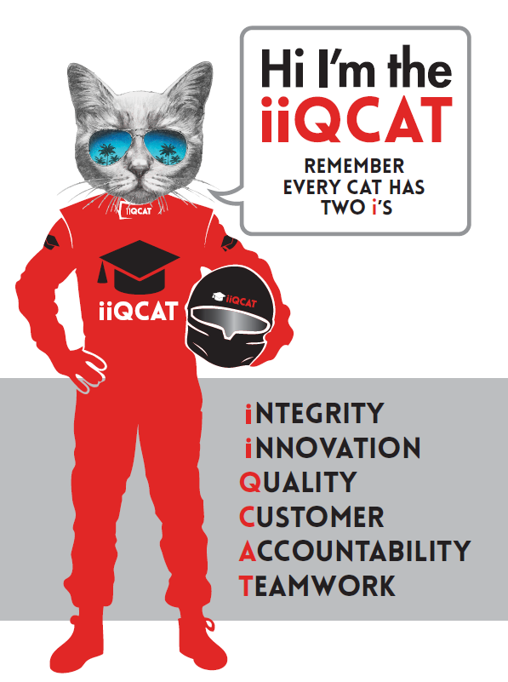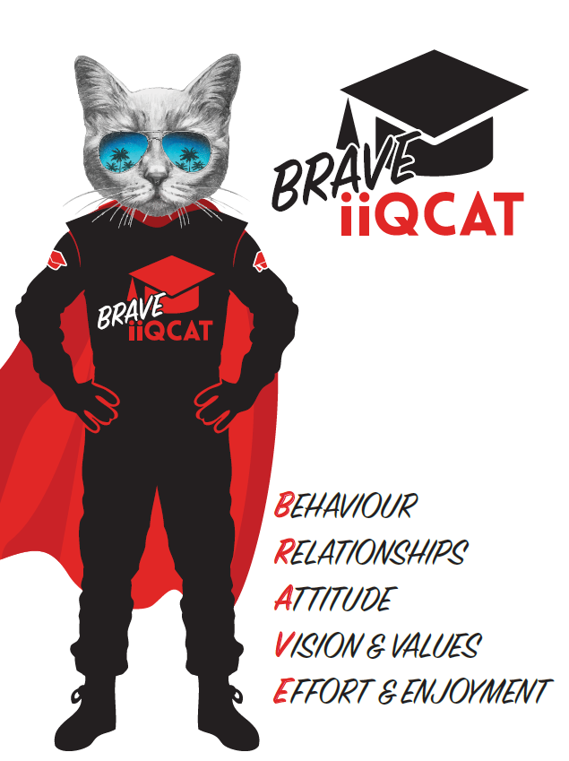
Corporation Objectives | To promote Melbourne and Victoria via the staging of two international sporting events - the Formula 1 Australian Grand Prix at Albert Park and the Australian MotoGP at Phillip Island.
Governed by | The Corporation is governed by the Australian Grands Prix Act 1994 (Vic).
Standards of behaviour | The Code of Conduct for Victorian Public Sector Employees governs the behaviour of all Corporation employees.
Human Rights | The Charter of Human Rights and Responsibilities Act 2006 is a Victorian law that sets out the basic rights, freedoms and responsibilities of all people in Victoria. The Charter requires the Corporation to act compatibly with human rights, and to consider human rights when developing policies, making laws, delivering services and making decisions.

Role Objectives | As a key member of the Finance department, the objective of the Accounts Receivable role is to complete the end-to-end Accounts Receivable (AR) function which includes, but not limited to, the processing of sales, invoicing, receipting, banking, credit collection and debtors reporting. The role also includes the completion of AR related month end/year end responsibilities, as well as assisting the wider Finance team on projects, process improvements and adhoc accounting tasks.
Core Responsibilities | Accounts Receivable  - Processing of booking forms, customer orders and complimentary bookings;  - Creation of invoices and credit notes to customers;  - Taking payment and receipting of payments;  - Credit collection and sending of customer statements;  - Liaise with internal stakeholders to troubleshoot invoicing and debtors issues;  - Prepare reports and manage the release of tickets to paid customers, via ticketing team.  - Management of debtors to minimise outstanding debtors and reduce the risk of doubtful or bad debts;  - Preparation of debtors report for month end and board reporting;  - Preparation of daily and monthly bank reconciliation;  - Monthly reconciliation:  - Aged debtors report to trial balance;  - Prepare general ledger journals as required;  - Assist internal and external auditors with any queries  - Identify and implement process improvements;  - Manage ongoing relationships with key internal stakeholders;  - Adhoc tasks as required by the Finance Manager and GM of Business Services;  - Collaborate with other teams during event week to deliver a successful event.  Compliance  Assist in the maintenance and development of compliance frameworks, policies and internal control environment.  Ensure strict adherence to all elements of the Financial Management Act (1994) and Standing Directions of the Minister for Finance.  Process  To assist in the maintenance and upgrades in relation to accounting system and finance processes, including recommendations for enhancement/ improvement where required and review of finance procedural documentation.  To remain up to date on non-profit best practise, and state and federal law and AASBs in relation to not-for-profit organisations.  Other  To assist the General Manager - Business Services and Division Manager - Finance, when required  To work across the Formula 1TM Australian Grand Prix event and the Australian Motorcycle Grand Prix event at a site on the circuits and perform prescribed roles which may not be finance related during the Events.  At the reasonable request of your Division Manager; General Manager and/or the Chief Executive Officer, role responsibilities may be altered at any time. Changes will be tied to the Corporation’s strategic objectives, workforce planning and the structural alignment of the Corporation.  Governance  Adhere to Corporation policies, procedures, and directives regarding standards of workplace behaviour in completing job duties and assignments.  Conducting every aspect of work in a trustworthy, reliable and transparent manner, and maintaining the highest ethical standards.  Customer Service  Putting internal and external customers first, building strong relationships and ensuring that the approach is responsive to the needs of the internal/external customer.  Encouraging openness and trust by sharing information widely, listening, welcoming constructive challenge and encouraging free dialogue.  Continuous Improvement  Taking initiative to improve operations/services/products and systems so that they are consistent with the Corporation’s strategic direction and values; incorporating innovation and experimentation into daily work.  Health and Safety  To assist the Corporation in meeting its health and safety obligations you will be required to:  - Actively participate in the reporting of hazards, incidents and near misses.  - Take corrective action to address or mitigate any risks or hazardous situations throughout the course of your work.  - Take reasonable care for your own health and safety, and for the health and safety of others.  - Adhere to the Corporation’s various policies, procedures, work practices and standard operating procedures.  - Perform your role in accordance with any specific responsibilities as outlined in the Corporation’s safety management system.  To enable the Corporation to meet its obligations for providing a healthy and safe working environment for you, you must inform your manager of any issues which may impact your ability to safely perform your role.  Environmental Considerations  Cooperate with the Corporation regarding caring for the environment, by acting in a sustainable way and minimising environmental impact by adhering to the Corporation’s policies, procedures and work practices.

Person Specification

Qualifications and Experience | Minimum 2 years’ credit collection experience in a fast paced, dynamic and high-volume environment. The candidate should have proven success in dealing with debt disputes, difficult customers and successfully recovering overdue debts.  Strong communication skills and a strong customer focused and problem solving ethos are essential.  Advanced excel skills are desirable.  Operation within a strong governance led environment, working knowledge of the Financial Management Act (1994) along with the Standing Directions of the Minister for Finance, and the Audit Act (1994) is highly desirable.

Relevant Traits and Characteristics | Customer Service  - Demonstrated achievement in and enthusiasm for the provision of quality customer service  - Immediately respond to customers’ needs or concerns to ensure the quality of service meets agreed standards  Teamwork, Adaptability and Resilience  - Demonstrated commitment to teamwork and the maintenance of a supportive work environment  - Ability to work effectively as part of a team in a fast-changing environment  - Keeping calm by demonstrating a capacity to positively deal with unanticipated problems and changing circumstances  Initiative and Problem solving  - Ability to self-motivate and take initiative to complete the deliverables required of the accounts receivable team;  - Demonstrated experience in dealing with difficult customers or difficult situations, and the ability to problem solve, whilst maintaining a high level of customer service.  Interpersonal, Verbal and Written Communication  - Well-developed written communication ability  - Strong interpersonal and communication skills  - An ability to liaise, negotiate and constructively provide and accept feedback from staff at all levels  Organisation and Planning  - Organisational and planning skills in managing a personal workload in a busy environment with conflicting demands  - Ability to meet deadlines  Technology  - Experience in the use of Microsoft desktop products such as Word, Excel, Outlook and PowerPoint  - Experience in information management systems, including internet and on-line environments  Continuous Learning and Professional Development  - Demonstrated commitment to continual professional and personal development

