Position: | Manager - Projects and Procurement
Division: | Infrastructure
Department: | Operations
Reporting to | Division Manager – Infrastructure
Employment Type | 12-month contract

Key Relationships | Internal  CEO  Leadership Team  Division Manager – Infrastructure  Operations Team  Key direct reports  All staff and AGPC Departments  Other internal stakeholders as relevant and appropriate  External  APP Corporation (Engineering Project Manager)  PI Operations  Parks Victoria, Park Tenants and local Community  Contractors and Suppliers  Utilities service providers  Corporate Clients and sponsors (as required)  Formula One Management, FIA, MA Dorna, FIM,  Local Councils (CoPP and BCSC)  Worksafe, Energy Safe Victoria, Victorian Building Authority and other regulatory authorities.  Key suppliers and commercial partners  Other stakeholders as relevant and appropriate

Values | Knowledge of and consistent demonstration of the Corporation’s IIQCAT values: Integrity, Innovation, Quality, Customer, Accountability, Teamwork.  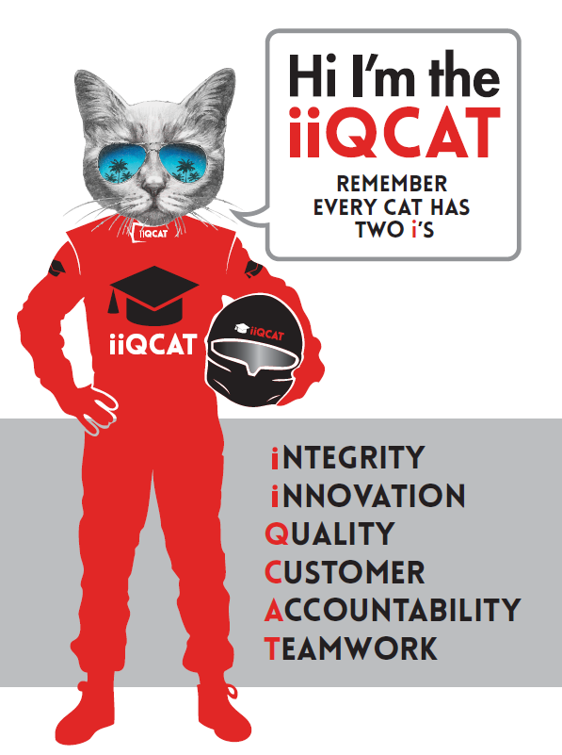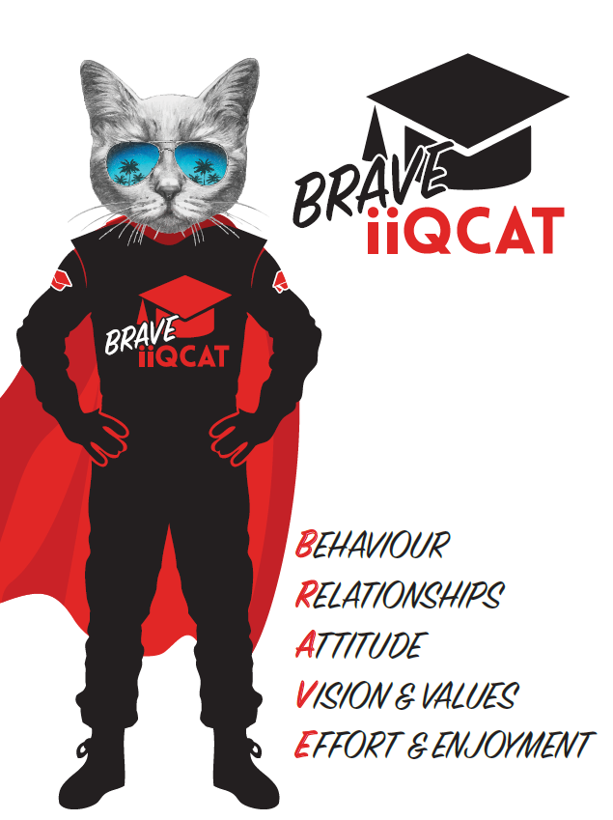
Corporation Objectives | To create value for the state of Victoria.  Our corporate strategy is underpinned by six strategic pillars:  - Build a powerful organisation and culture  - Secure the future of our events  - Connect people to business, brands and our sport  - Understand our customers and attract new audiences  - Inspire the future by driving technology and innovation  - Diversify and increase revenues to ensure our success  More specifically, we exist to promote Melbourne and Victoria via the staging of two international sporting events - the Formula 1 Australian Grand Prix at Albert Park and the Australian MotoGP at Phillip Island.
Governed by | The Corporation is governed by the Australian Grands Prix Act 1994 (Vic).
Standards of behaviour | The Code of Conduct for Victorian Public Sector Employees governs the behaviour of all Corporation employees.
Human Rights | The Charter of Human Rights and Responsibilities Act 2006 is a Victorian law that sets out the basic rights, freedoms and responsibilities of all people in Victoria. The Charter requires the Corporation to act compatibly with human rights, and to consider human rights when developing policies, making laws, delivering services and making decisions.

Role Objectives | This role is responsible for the successful, delivery of Infrastructure projects and other Infrastructure related services for both the Formula 1 Australian Grand Prix and the Australian Motorcycle Grand Prix on time and within budget.  The Manager - Projects and Procurement will provide support to the Division Manager of Infrastructure on a range of duties including Project Planning, Procurement, Project controls, Budgeting, Contract Management, Site Coordination, Health and Safety, and other miscellaneous works.  This role is an important leadership role within the Infrastructure team, helping to drive the AGPC cultural values, strategic pillars to ensure the success of the team, culture and events.
Core Responsibilities | General:  The Manager - Projects and Procurement core responsibilities include:  - Scoping and program delivery of projects internal to AGPC.  - Prepare business cases and recommendations.  - Oversight and coordination of delivery of projects with APP.  - Project management and planning.  - Delivery of the infrastructure projects in accordance with AGPC policies and procedures.  - Delivery of the infrastructure projects in accordance with the AGP Act and all applicable licences and contracts.  - Provide technical support on Infrastructure based requirements.  - Implementation of infrastructure projects and activities in accordance with project schedules, plans and AGPC’s Timeline Manager.  - Procurement functions in accordance with the AGPC procurement policy.  - Detailed financial control and reporting.  - Construction and contractor management.  - Site, safety and compliance management.  - AGPC’s representative for the implementation of all infrastructure works necessary for the staging of the Formula 1 and MotoGP events.  - Team management, leadership and support to the Infrastructure team.  - Develop systems of work and processes to promote efficient work practices within the Department.  - Maintain key organisational timelines and ensure the Department is adequately prepared.  - Develop correspondence and documentation for key internal and external stakeholders.  - Undertake research to assist in the delivery of projects and deliverables.  - Maintain the Project Pipeline.  - Maintain the Infrastructure page on GP Connect (intranet)  - Manage the Asset Management requirements applicable to the AGPC Strategic Asset Management Plan. E.g. Asset Register.  - Regularly update the Infrastructure Risk Register.  - Proactively engage in various team meetings including - Infrastructure team WIPS, Project Management WIPS, Operations Meetings and Weekly Staff meetings.  - Build and maintain a powerful organisational culture.  - Other works as requested by the GM Operations, Division Manager Infrastructure, Manager Infrastructure.  Project planning and Construction Management:  The Manager - Projects and Procurement will play a key leadership role through supporting the project management deliverables of the AGPC Infrastructure team, including but not limited to:  Formula 1:  Manage the planning, contract administration, and on-site implementation of the infrastructure for the Formula 1 Australian Grand Prix including:  - Implementation of the Engineering Project Management Services Contract for the Formula 1 Grand Prix.  - Support with the management and supervision of the F1 Engineering Project Manager.  - Ensure critical functions are on time, on budget and in accordance with current planning requirements.  - Actively participate in and assist the Operations Department in the successful delivery of GP Command and EOC functions during Events.  MotoGP:  Manage the planning, contract administration, and on-site implementation of the infrastructure for the Australian Motorcycle Grand Prix including:  - Provide clear direction and guidance on critical Infrastructure functions, including but not limited to Venue Design, Asset Management, Health and Safety.  - Provide support to the Infrastructure team in the delivery of Infrastructure services applicable to the Australian Motorcycle Grand Prix.  - Provide support to internal departments on the implementation of Infrastructure obligations.  - Contract Management.  - Project Planning.  - Actively participate in and assist the Operations Department in the successful delivery of GP Command and EOC functions during Events.  Financial Control and Reporting:  Responsible for:  - Annual preparation of the Infrastructure recurrent and capital budgets for the Australian Formula 1 Grand Prix and MotoGP events.  - Implementation of cost control and savings initiatives.  - Processing of invoices in Nitro as required.  - Accurate and regular update of budget and cost control documents and reporting of forecast final costs against the approved budgets.  - Budget reconciliation.  Procurement:  Responsible for:  - Preparation of specifications/ scope of works and tender documents.  - Support with the evaluation of tenders.  - Seek quotations for contract works.  - Investigate new opportunities within the market which offer new innovative cost-effective solutions to the event.  - Prepare business cases which seek competitive outcomes in accordance with the AGPC procurement guidelines.  - Prepare recommendations for management approval.  Stakeholder Relationship Management  Responsible for:  - Management of key external relationships to ensure the effective and efficient delivery and operation of Grand Prix infrastructure and minimise the negative impacts of the Grand Prix infrastructure project on external stakeholders.  Asset Maintenance and Capital Works Management  Responsible for:  - Coordination and oversight of the capital works budget for the Australian Motorcycle Grand Prix.  - Management of AGPC assets in accordance with AGPC’s Strategic Asset Management Plan (SAMP).  Leadership  Responsible for:  - Providing support, advice and leadership to members of the infrastructure team (especially direct reports), to drive a strong culture, motivation, performance and achievement of outcomes.  - Lead by example and in alignment with AGPC values to ensure a cohesive, constructive and trust driven team culture.  - Ensure appropriate development, succession, performance review and monitoring procedures/strategies are in place/maintained for team members.  At the reasonable request of your Division Manager, General Manager and/or the Chief Executive Officer, role responsibilities may be altered at any time. Such changes will be aligned to the Corporation’s strategic objectives, workforce planning and the structural alignment of the Corporation.  Governance  Adhere to Corporation policies, procedures, and directives regarding standards of workplace behaviour in completing job duties and assignments.  Conducting every aspect of work in a trustworthy, reliable and transparent manner, and maintaining the highest ethical standards.  Customer Service  Putting internal and external customers first, building strong relationships and ensuring that the approach is responsive to the needs of the internal/external customer.  Encouraging openness and trust by sharing information widely, listening, welcoming constructive challenge and encouraging free dialogue.  Continuous Improvement  Taking initiative to improve operations/services/products and systems so that they are consistent with the Corporation’s strategic direction and values; incorporating innovation and experimentation into daily work.  Safety and Compliance  To assist the Corporation in meeting its health and safety obligations you will be required to:  - Actively participate in the reporting of hazards, incidents and near misses.  - Take corrective action to address or mitigate any risks or hazardous situations throughout the course of your work.  - Take reasonable care for your own health and safety, and for the health and safety of others.  - Adhere to the Corporation’s various policies, procedures, work practices and standard operating procedures.  - Perform your role in accordance with any specific responsibilities as outlined in the Corporation’s safety management system.  - Ensuring adequate arrangements for the safe delivery of the infrastructure build, delivery and dismantle.  - Site management of the venue and ensuring adherence to all site safety requirements by AGPC personnel and third parties on site.  - Cooperating with external stakeholders to address any safety or compliance related matters.  - In conjunction with the Risk and Safety team, review HSE documentation including Safe Work Instructions and Safe Work Method Statements.  - Proactively, perform compliance activities which eliminate the exposure to risks onsite.  - Ensure ongoing compliance, resolution, and recommendations.  - Maintain files, paperwork, document procedures, and monitor compliance activities.  - Assist with maintaining compliance with various regulatory requirements.  - Identify, communicate, and implement required controls and documents such as Safe Work Instructions (SWI) and Safe Work Methods (SWM).  - Track all audit and compliance remediation efforts and escalate issues not properly addressed.  - Assist in the design and development of documentation and implementation of solutions, policies, and procedures.  - So far as is reasonably practicable, provide and maintain an environment which is safe and free from harm.  To enable the Corporation to meet its obligations for providing a healthy and safe working environment for you, you must inform your manager of any issues which may impact your ability to safely perform your role.  Environmental Considerations  Cooperate with the Corporation regarding caring for the environment, by acting in a sustainable way and minimising environmental impact by adhering to the Corporation’s policies, procedures and work practices.

SELECTION CRITERIA

Qualifications and Experience | Degree qualified, in event management, project /construction management, engineering, business or a related field.  Minimum 10 years’ experience in major event infrastructure construction or project management of other complex and dynamic projects or operations  Significant project management experience, including management of infrastructure or building projects.  Experience of cost control/ budget responsibility.  Significant experience in preparing business cases, and recommendations for approval within the business.

Relevant Traits and Characteristics | Customer Service  - Demonstrated achievement in and enthusiasm for the provision of quality customer service  - Immediately respond to customers’ needs or concerns to ensure the quality of service meets agreed standards  Teamwork, Collaboration, Adaptability and Resilience  - Demonstrated commitment to teamwork and the maintenance of a supportive work environment  - Ability to work effectively as part of a team in a fast-changing environment  - Keeping calm by demonstrating a capacity to positively deal with unanticipated problems and changing circumstances  - A commitment to collaborate effectively with colleagues across the business  Interpersonal, Verbal and Written Communication  - Well-developed written communication ability  - Strong interpersonal and communication skills  - An ability to liaise, negotiate and constructively provide and accept feedback from staff at all levels  Organisation and Planning  - Organisational and planning skills in managing a personal workload in a busy environment with conflicting demands  - Ability to effectively prioritise and meet deadlines  Technology  - Experience in the use of Microsoft desktop products such as Word, Excel, Outlook and PowerPoint  - Experience in information management systems, including internet and on-line environments  Continuous Learning and Professional Development  - Demonstrated commitment to continual professional and personal development

