Position: | Biosecurity Operations Manager
Division: | Operations & Risk
Department: | Operations
Reporting to | Division Manager – Operations & Risk
Direct Reports | MotoGP21 Logistics Officer (from June 2021)  MotoGP21 Priority Zone Controller (from August 2021)  AUSGP21 Logistics Officer (from July 2021)  AUSGP21 Priority Zone Controller (from September 2021)
Employment Type | Contract (March to December 2021)

Key Relationships | Internal  Division Manager – Operations & Risk  General Manager – Operations  General Manager – Legal & Strategy and General Counsel  Quarantine Manager  Event Biosecurity Panel  Risk & Resilience Panel  Motorsport, Entertainment and Industry department  Corporate Affairs and Communications department  Other internal stakeholders as relevant and appropriate  External  COVID-19 Quarantine Victoria (CQV)  Aspen Medical  Private transport operators  Hotel operators  Phillip Island Operations  Parks Victoria  Victoria Police  Security Staff Suppliers  Fire Rescue Victoria, Ambulance Victoria, and St John Ambulance Victoria  Other external stakeholders as relevant and appropriate

Values | Knowledge of and consistent demonstration of the Corporation’s IIQCAT values: Integrity, Innovation, Quality, Customer, Accountability, Teamwork.  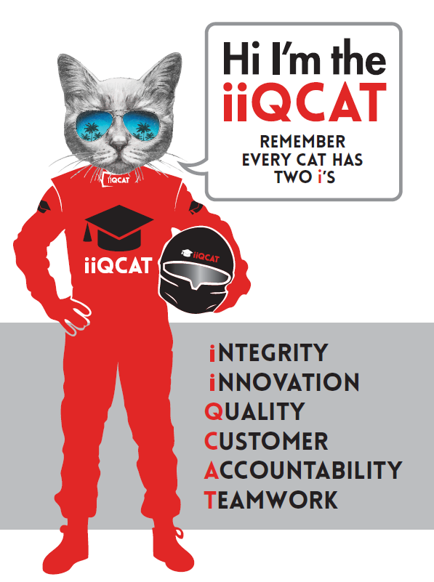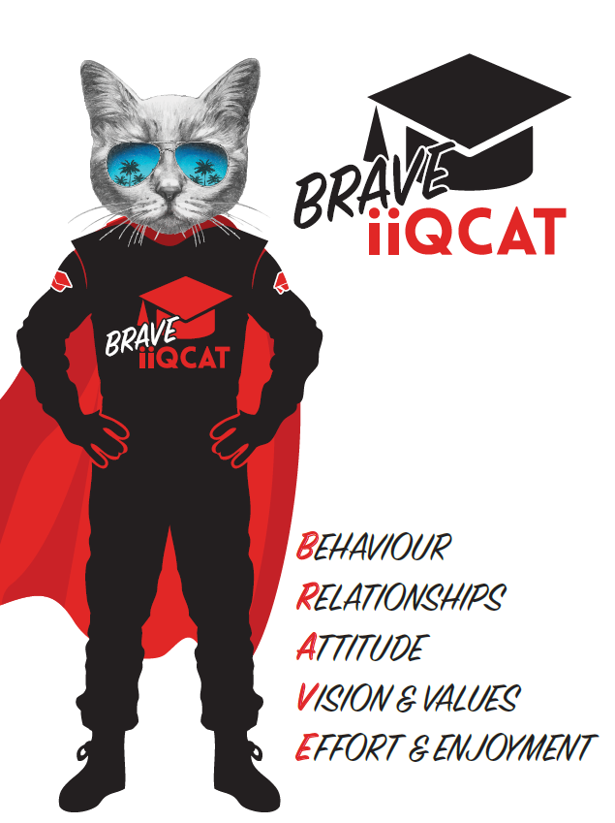
Corporation Objectives | To promote Melbourne and Victoria via the staging of two international sporting events - the Formula 1® Australian Grand Prix at Albert Park and the Australian MotoGP at Phillip Island.
Governed by | The Corporation is governed by the Australian Grands Prix Act 1994 (Vic).
Standards of behaviour | The Code of Conduct for Victorian Public Sector Employees governs the behaviour of all Corporation employees.
Human Rights | The Charter of Human Rights and Responsibilities Act 2006 is a Victorian law that sets out the basic rights, freedoms and responsibilities of all people in Victoria. The Charter requires the Corporation to act compatibly with human rights, and to consider human rights when developing policies, making laws, delivering services, and making decisions.

Role Objectives | Successfully manage the operational delivery of international arrival quarantine arrangements for the staging of the Australian Motorcycle Grand Prix 2021 and the Formula 1® 2021 Australian Grand Prix.  In association with the Australian Grand Prix Corporation’s Event Biosecurity Panel, Risk & Resilience Panel, Quarantine Manager and Aspen Medical, develop comprehensive and effective international arrival quarantine arrangements and processes.  In association with relevant Australian Grand Prix Corporation personnel, engage and ongoingly liaise with external stakeholders on the operational planning and delivery of international arrival quarantine arrangements and processes.  Maintain total oversight, control and responsibility for the operational planning and delivery of international arrival quarantine arrangements and processes.  Provide management oversight and direction to the International Arrival Quarantine Team, ensuring a high standard of planning, readiness, execution, and delivery of the required objectives.  Identify best-practice opportunities to continuously enhance international arrival quarantine arrangements and processes, to maximise outcomes for the Australian Grand Prix Corporation, the Victorian Government, and members of the public.  Knowledge of and consistent demonstration of the Corporation’s IIQCAT values including integrity, innovation, quality, customer, accountability, and teamwork.

Core Responsibilities | International Arrival Quarantine Design  Design and development of international arrival quarantine arrangements and processes for the staging of the Australian Motorcycle Grand Prix 2021 and the Formula 1® 2021 Australian Grand Prix.  International Arrival Quarantine Operational Delivery  Oversight, control, and responsibility for the operational delivery of international arrival quarantine arrangements and processes for the staging of the Australian Motorcycle Grand Prix 2021 and the Formula 1® 2021 Australian Grand Prix including:  - Participant pre-departure.  - International arrival.  - Airport activities and border process.  - Road transport,  - Quarantine hotels.  - Circuit Priority Zone activities.  - International departure.  - International freight.  - Logistics.  Police and Emergency Services  Engagement and ongoing liaison with Victoria Police and all other relevant Emergency Services, to ensure that international arrival quarantine arrangements and processes do not interfere with, or otherwise impede, the overall safety and agency response capabilities at the events.  Staff and Personnel Management  Management of the International Arrival Quarantine Team - providing support and direction in the coordination of required responsibilities and providing continual feedback on performance.  Outline clear areas of responsibility, expectations, objectives, and project timelines for each role within the team.  Develop and implement sound project management, timeline management and performance monitoring processes to ensure the effective and timely delivery of international arrival quarantine arrangements and processes.  Other Duties  Other duties as directed by the Division Manager – Operations & Risk.  At the reasonable request of your General Manager and/or the Chief Executive Officer, role responsibilities may be altered at any time. Changes will be tied to the Corporation’s strategic objectives, workforce planning and the structural alignment of the Corporation.  Governance  Adhere to Corporation policies, procedures, and directives regarding standards of workplace behaviour in completing job duties and assignments.  Conducting every aspect of work in a trustworthy, reliable, and transparent manner, and maintaining the highest ethical standards.  Continuous Improvement  Taking initiative to improve operations/services/products and systems so that they are consistent with the Corporation’s strategic direction and values; incorporating innovation and experimentation into daily work.  Health and Safety  To assist the Corporation in meeting its health and safety obligations you will be required to:  - Actively participate in the reporting of hazards, incidents and near misses.  - Take corrective action to address or mitigate any risks or hazardous situations throughout the course of your work.  - Take reasonable care for your own health and safety, and for the health and safety of others.  - Adhere to the Corporation’s various policies, procedures, work practices and standard operating procedures.  - Perform your role in accordance with any specific responsibilities as outlined in the Corporation’s safety management system.  To enable the Corporation to meet its obligations for providing a healthy and safe working environment for you, you must inform your manager of any issues which may impact your ability to safely perform your role.  Environmental Considerations  Cooperate with the Corporation regarding caring for the environment, by acting in a sustainable way and minimising environmental impact by adhering to the Corporation’s policies, procedures, and work practices.

Person Specification

Qualifications and Experience | - Demonstrated relevant, equivalent professional experience within the last five years.  - Past experience in biosecurity, international quarantine, or similar arrangements preferred.  - Past experience in major sporting or similar large-scale events preferred.  - Exceptional leadership, management, and coordination skills.  - Excellent interpersonal and communication skills.  - Experience in stakeholder management, both internal and external.  - Sound organisational and time management.  - Ability to work as part of a team.  - Ability to work effectively and efficiently under pressure.  - Ability to manage constant and/or conflicting deadlines.  - Tertiary Qualifications (degree, diploma, or certificate) in a relevant discipline preferred.

Relevant Traits and Characteristics | Strategy and Risk Management  - Ability to develop commercially workable solutions to complex challenges.  - Commitment to practical and effective risk mitigation strategies.  Teamwork, Adaptability and Resilience  - Demonstrated commitment to teamwork and the maintenance of a supportive work environment.  - Ability to work effectively as part of a team in a fast-changing environment.  - Keeping calm by demonstrating a capacity to positively deal with unanticipated problems and changing circumstances.  Interpersonal, Verbal and Written Communication  - Well-developed written communication ability.  - Strong interpersonal and communication skills.  - Experience in consultation, liaison, and engagement with internal and external stakeholders.  Organisation and Planning  - Organisational and planning skills in managing a personal workload in a busy environment with conflicting demands.  - Ability to meet deadlines.  Technology  - Experience in the use of Microsoft desktop products such as Word, Excel, Outlook, and PowerPoint.  - Experience in information management systems, including internet and on-line environments.

