Position | Digital Manager
Division | Digital
Department | Marketing
Reporting to | General Manager – Marketing
Direct reports | Video Producer  Digital Coordinator  Website Coordinator  Social Media Coordinator
Employment Type | Permanent

Key Relationships | Internal  Chief Executive Officer  General Manager – Marketing  General Manager – Sales & Commercial  General Manager – Motorsport, Entertainment & Industry  Division Manager – Corporate Affairs & Communications  Division Manager – People, Performance & Culture  Manager – ICT  Senior Manager – Brand and Advertising  Senior Manager – Consumer Sales  Marketing team  Corporate Affairs & Communications team  Sales & Commercial team  Motorsport, Entertainment & Industry team  External  Digital agency  Advertising agency  Research agency  Marketing automation provider  Ticketing provider  PR agencies  Visit Victoria  Key supply and commercial partners  Other external stakeholders as relevant and appropriate

Values | Knowledge of and consistent demonstration of the Corporation’s IIQCAT values: Integrity, Innovation, Quality, Customer, Accountability, Teamwork.  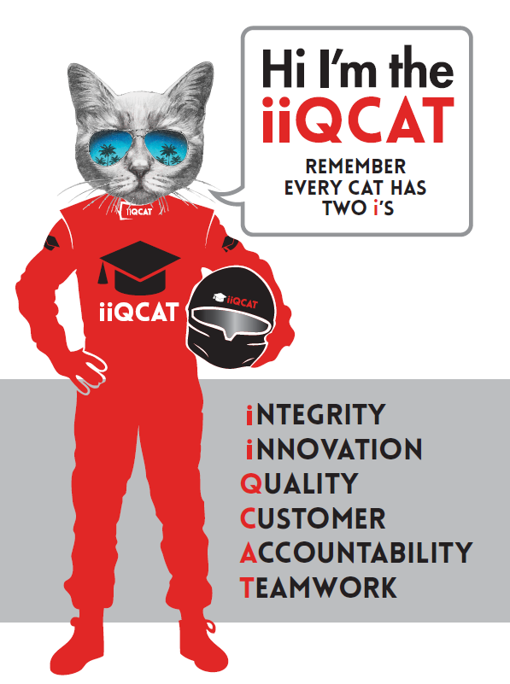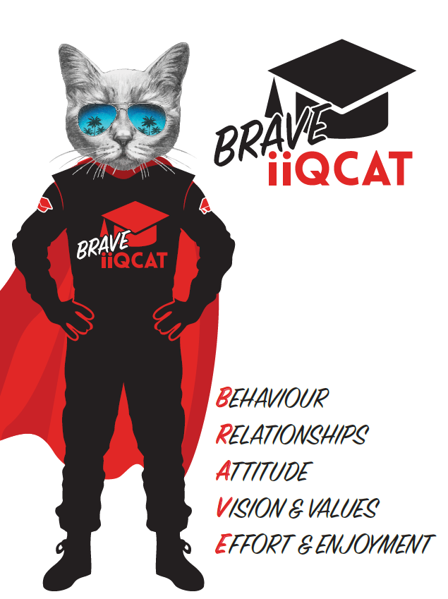
Corporation Objectives | To create value for the state of Victoria.  Our corporate strategy is underpinned by six strategic pillars:  - Build a powerful organisation and culture  - Secure the future of our events  - Connect people to business, brands and our sport  - Understand our customers and attract new audiences  - Inspire the future by driving technology and innovation  - Diversify and increase revenues to ensure our success  More specifically, we exist to promote Melbourne and Victoria via the staging of two international sporting events - the Formula 1 Australian Grand Prix at Albert Park and the Australian MotoGP at Phillip Island.
Governed by | The Corporation is governed by the Australian Grands Prix Act 1994 (Vic).
Standards of behaviour | The Code of Conduct for Victorian Public Sector Employees governs the behaviour of all Corporation employees.
Human Rights | The Charter of Human Rights and Responsibilities Act 2006 is a Victorian law that sets out the basic rights, freedoms and responsibilities of all people in Victoria. The Charter requires the Corporation to act compatibly with human rights, and to consider human rights when developing policies, making laws, delivering services and making decisions.

Role Objectives | As a key member of the Marketing department, the Senior Manager – Digital is tasked with the follow following key objectives:  - Manage the development and execution of AGPC's digital strategy  - Lead AGPC's online presence, including its event websites, social media channels, email marketing and in-house video production  - Increase engagement and maximise conversions through a mix of retail/brand messaging and relevant content  - Evaluate fan experiences across multiple channels and touchpoints and use marketing tools to continuously improve dynamic and personalised communication  - Create opportunities to commercialise digital assets to further enhance AGPC's brands and increase revenue  - Work closely with Formula One Management, Dorna Sports and other key stakeholders to deliver world-class events for the Victorian Government
Core Responsibilities | Strategy  - Manage the development and execution of AGPC's digital strategy  - Research and present new ideas and concepts to to improve growth and engagement across AGPC’s digital platforms  Leadership  - Manage four direct reports – Video Producer, Website Coordinator, Social Media Coordinator and Digital Coordinator  - Communicate clearly to achieve business objectives and growth  Content  - Generate unique year-round content to engage new and existing fans and increase conversions  - Create content working with key stakeholders to ensure AGPC’s digital channels contain interesting, newsworthy, accurate, engaging and informative subject matter at all times  - Develop video content to drive engagement and reach new audiences  - Ensure AGPC’s content plans are regularly reviewed and deadlines communicated clearly to all key stakeholders  - Work across the Formula 1 and MotoGP events on site, managing all digital content capture and output  - Ensure Facebook, Twitter, Instagram and other relevant social media channels for each event are regularly updated with relevant and timely content  - Write news articles as required and constantly seek new opportunities for unique and engaging content  - Ensure all content has a consistent tone of voice and is relevant to the target audience  - Ensure all digital content is relevant, accurate and uploaded in line with agreed timelines  Measurable  - Work with the Senior Manager – Brand and Advertising to plan and execute all paid web, SEO/SEM, marketing database, email, social media campaigns  - Increase organic Google rankings by developing and implementing SEO best practises  - Use marketing automation tools to continuously improve personalisation  - Evaluate emerging technologies and provide feedback and perspective for adoption where appropriate  - Identify trends and optimise spend and performance based on insights  - Use knowledge of CRM, profiling and segmentation to develop engagement strategies  - Measure and report performance of all digital marketing campaigns and assess against goals (ROI and KPIs)  - Implement strategies in conjunction with the Senior Manager – Brand and Advertising to grow email databases  - Increase exposure for each event on Victorian tourism websites and other partner websites  - Measure and track all owned-channel marketing activity that drives revenue to the business  Website and Social Media Management  - Develop suggested links and placements within partnership network (e.g. sponsors, Visit Victoria etc.) to leverage AGPC’s websites to drive traffic to the relevant website before, during and after event times  - Using Google Analytics, provide regular reports and analysis of website statistics  - Using social media monitoring tools, provide regular reports, analysis and trends  - Manage digital budget, ensuring accurate financial reporting and content delivered within financial parameters set by the business  - Manage digital service providers, ensuring positive relationships are maintained, constructive feedback given, conflicts resolved and all contract deliverables are met on time and on budget  - Deliver website updates and new features as determined by the digital strategy, on time and on budget  - Work with Senior Manager – Brand and Advertising to develop consistent tone of voice for website, social media and email communications  - Ensure all style guide/branding standards are met  Database/Membership Program  - Build and distribute monthly email newsletters  - Develop online strategies to encourage growth of AusGP Access and Riders United programs  - Meet deadlines for all membership/database online communications  IT  - Work closely with the Manager – ICT to ensure website upgrades are well planned and executed and resourced appropriately  - Work closely with the Manager – ICT and digital agency to ensure server capabilities are meeting web and social media requirements  At the reasonable request of your Manager, General Manager and/or the Chief Executive Officer, role responsibilities may be altered at any time. Changes will be tied to the Corporation’s strategic objectives, workforce planning and the structural alignment of the Corporation.  Governance  Adhere to Corporation policies, procedures, and directives regarding standards of workplace behaviour in completing job duties and assignments.  Conducting every aspect of work in a trustworthy, reliable and transparent manner, and maintaining the highest ethical standards.  Customer Service  Putting internal and external customers first, building strong relationships and ensuring that the approach is responsive to the needs of the internal/external customer.  Encouraging openness and trust by sharing information widely, listening, welcoming constructive challenge and encouraging free dialogue.  Continuous Improvement  Taking initiative to improve operations/services/products and systems so that they are consistent with the Corporation’s strategic direction and values; incorporating innovation and experimentation into daily work.  Health and Safety  To assist the Corporation in meeting its health and safety obligations you will be required to:  - Actively participate in the reporting of hazards, incidents and near misses.  - Take corrective action to address or mitigate any risks or hazardous situations throughout the course of your work.  - Take reasonable care for your own health and safety, and for the health and safety of others.  - Adhere to the Corporation’s various policies, procedures, work practices and standard operating procedures.  - Perform your role in accordance with any specific responsibilities as outlined in the Corporation’s safety management system.  To enable the Corporation to meet its obligations for providing a healthy and safe working environment for you, you must inform your manager of any issues which may impact your ability to safely perform your role.  Environmental Considerations  Cooperate with the Corporation regarding caring for the environment, by acting in a sustainable way and minimising environmental impact by adhering to the Corporation’s policies, procedures and work practices.

SELECTION CRITERIA

Qualifications and Experience | Marketing and/or Communications qualifications or relevant industry experience of at least five years.  - Extensive CMS and online communications experience  - Proven working experience in digital marketing  - Highly creative with experience in identifying target audiences and devising digital campaigns that engage, inform and motivate  - Experience in optimising landing pages and user funnels  - Demonstrable experience of generating content for web and social media, including copy writing  - Strong background in understanding importance of brand and customer segments  - Project management experience  - Management of social and digital channels  Attributes  - Online content specialist, from client side or agency  - Demonstrable track record of delivering original and dynamic content across websites and social media  - Passion for the digital world, keeping informed of new developments and opportunities, keen to present ideas and sell them to key stakeholders with passion and conviction  - Strong business acumen and analytical – able to demonstrate the effectiveness of digital activity and how it drives value to the bottom line including commercialisation of digital assets  - A people person, with a track record of building relationships, influencing people and working with multiple stakeholders  - Possess creative flair as well as the ability to navigate their way around the back end of the website  - Demonstrable skills in managing a content plan to tight deadlines  Skills  - Proactive/takes initiative/outgoing  - Excellent attention to detail  - Highly organised  - Strong written and verbal communication skills  - Team oriented  - Ability to develop and implement strategic plans  - Excellent computer skills, including Microsoft Office, CMS, blogs, forums, social media, mobile, SMS applications, HTML, social media listening tools and marketing automation tools  - Project management including budgets, timelines, project plans, production

Relevant Traits and Characteristics | Customer Service  - Demonstrated achievement in and enthusiasm for the provision of quality customer service  - Immediately respond to customers’ needs or concerns to ensure the quality of service meets agreed standards  Teamwork, Collaboration, Adaptability and Resilience  - Demonstrated commitment to teamwork and the maintenance of a supportive work environment  - Ability to work effectively as part of a team in a fast-changing environment  - Keeping calm by demonstrating a capacity to positively deal with unanticipated problems and changing circumstances  - A commitment to collaborate effectively with colleagues across the business  Interpersonal, Verbal and Written Communication  - Well-developed written communication ability  - Strong interpersonal and communication skills  - An ability to liaise, negotiate and constructively provide and accept feedback from staff at all levels  Organisation and Planning  - Organisational and planning skills in managing a personal workload in a busy environment with conflicting demands  - Ability to effectively prioritise and meet deadlines  Technology  - Experience in the use of Microsoft desktop products such as Word, Excel, Outlook and PowerPoint  - Experience in information management systems, including internet and on-line environments  Continuous Learning and Professional Development  - Demonstrated commitment to continual professional and personal development

