Position: | Talent Acquisition Coordinator
Division: | Business Services
Department: | People, Performance & Culture
Reporting to | Division Manager – People, Performance & Culture
Employment Type | Contract (to end of November 2021)

Key Relationships | Internal  Division Manager – People, Performance & Culture (PP&C)  People, Performance & Culture Specialist  CFO & General Manager - Business Services  Hiring Managers & other AGPC staff  External  Prospective employees of AGPC

Values | Knowledge of and consistent demonstration of the Corporation’s IIQCAT values: Integrity, Innovation, Quality, Customer, Accountability, Teamwork.  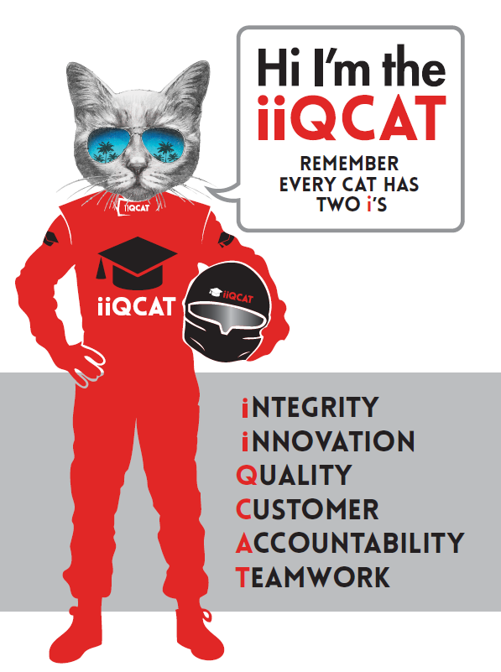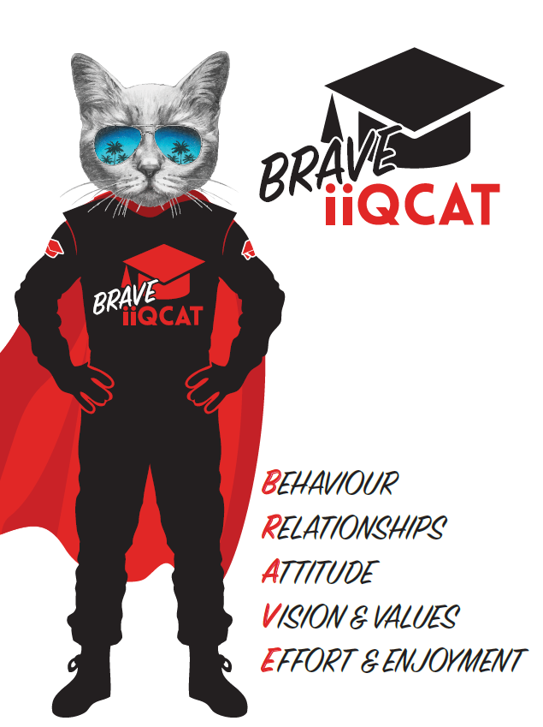
Corporation Objectives | To create value for the state of Victoria.  Our corporate strategy is underpinned by six strategic pillars:  - Build a powerful organisation and culture  - Secure the future of our events  - Connect people to business, brands and our sport  - Understand our customers and attract new audiences  - Inspire the future by driving technology and innovation  - Diversify and increase revenues to ensure our success  More specifically, we exist to promote Melbourne and Victoria via the staging of two international sporting events - the Formula 1 Australian Grand Prix at Albert Park and the Australian MotoGP at Phillip Island.
Governed by | The Corporation is governed by the Australian Grands Prix Act 1994 (Vic).
Standards of behaviour | The Code of Conduct for Victorian Public Sector Employees governs the behaviour of all Corporation employees.
Human Rights | The Charter of Human Rights and Responsibilities Act 2006 is a Victorian law that sets out the basic rights, freedoms and responsibilities of all people in Victoria. The Charter requires the Corporation to act compatibly with human rights, and to consider human rights when developing policies, making laws, delivering services and making decisions.

Role Objectives | This role is responsible for managing the acquisition of talent to work on the planning and development of the Formula 1 Australian Grand Prix at Albert Park and the Australian MotoGP at Phillip Island.
Core Responsibilities | Talent Acquisition  - Manage the recruitment of short-term event staff for the Formula 1 Australian Grand Prix at Albert Park and the Australian MotoGP at Phillip Island.  - Proactively working with and providing support to hiring managers in relation to current vacancies  - Conducting shortlisting, phone screenings, interviews and reference checks as appropriate  - Coordination of recruitment activities for permanent staff & long term contractors  - Maintenance of current talent pool via ATS software (Scout)  - Ensuring campaign progress is accurately noted within ATS  - Work with the PP&C team to provide coaching & education of hiring managers as to recruitment & interviewing techniques & guidelines  Induction & Onboarding  - Generate contracts via HR Onboard system (new starters).  - Liaison with other departments as to new start requisition requirements  - PP&C induction of new staff on their first day  - Ensure all new starter forms are completed and distributed to relevant staff, then electronically filed  Offboarding  - Offboard event staff following the conclusion of the Australian MotoGP 2021 and the Formula 1® Australian Grand Prix 2021  Payroll data entry  - Entry of employees’ data and payroll information into Preceda (payroll system)  Management of confidential information  - Handling and processing personal information of applicants and current employees sensitively and in such a way to ensure that confidentiality is maintained.  Support to the PP&C team  - Provide support to the PP&C team as required in relation to BAU activities, HR projects or event planning  At the reasonable request of your Manager, General Manager and/or the Chief Executive Officer, role responsibilities may be altered at any time. Changes will be tied to the Corporation’s strategic objectives, workforce planning and the structural alignment of the Corporation.  Governance  Adhere to Corporation policies, procedures, and directives regarding standards of workplace behaviour in completing job duties and assignments.  Conducting every aspect of work in a trustworthy, reliable and transparent manner, and maintaining the highest ethical standards.  Customer Service  Putting internal and external customers first, building strong relationships and ensuring that the approach is responsive to the needs of the internal/external customer.  Encouraging openness and trust by sharing information widely, listening, welcoming constructive challenge and encouraging free dialogue.  Continuous Improvement  Taking initiative to improve operations/services/products and systems so that they are consistent with the Corporation’s strategic direction and values; incorporating innovation and experimentation into daily work.  Health and Safety  To assist the Corporation in meeting its health and safety obligations you will be required to:  - Actively participate in the reporting of hazards, incidents and near misses.  - Take corrective action to address or mitigate any risks or hazardous situations throughout the course of your work.  - Take reasonable care for your own health and safety, and for the health and safety of others.  - Adhere to the Corporation’s various policies, procedures, work practices and standard operating procedures.  - Perform your role in accordance with any specific responsibilities as outlined in the Corporation’s safety management system.  To enable the Corporation to meet its obligations for providing a healthy and safe working environment for you, you must inform your manager of any issues which may impact your ability to safely perform your role.  Environmental Considerations  Cooperate with the Corporation regarding caring for the environment, by acting in a sustainable way and minimising environmental impact by adhering to the Corporation’s policies, procedures and work practices.

SELECTION CRITERIA

Qualifications and Experience | - 2 - 3 years’ experience in talent acquisition  - Payroll data entry experience  - Generalist HR experience desirable  - Event planning experience desirable

Relevant Traits and Characteristics | Customer Service  - Demonstrated achievement in and enthusiasm for the provision of quality customer service  - Immediately respond to customers’ needs or concerns to ensure the quality of service meets agreed standards  Teamwork, Collaboration, Adaptability and Resilience  - Demonstrated commitment to teamwork and the maintenance of a supportive work environment  - Ability to work effectively as part of a team in a fast-changing environment  - Keeping calm by demonstrating a capacity to positively deal with unanticipated problems and changing circumstances  - A commitment to collaborate effectively with colleagues across the business  Interpersonal, Verbal and Written Communication  - Well-developed written communication ability  - Strong interpersonal and communication skills  - An ability to liaise, negotiate and constructively provide and accept feedback from staff at all levels  Organisation and Planning  - Organisational and planning skills in managing a personal workload in a busy environment with conflicting demands  - Ability to effectively prioritise and meet deadlines  Technology  - Experience in the use of Microsoft desktop products such as Word, Excel, Outlook and PowerPoint  - Experience in information management systems, including internet and on-line environments  Continuous Learning and Professional Development  - Demonstrated commitment to continual professional and personal development

