Position: | Financial Accountant
Division: | Finance
Department: | Business Services
Reporting to | Senior Accountant/Analyst
Direct Reports | N/A
Employment Type | 12 - month contract

Key Relationships | Internal  General Manager – Business Services  Financial Controller  Senior accountant/analyst  Wider Finance team  All other departments  External  Auditors – Internal & External  Government – Department of Jobs, Precincts and Regions (DJPR), Department of Treasury and Finance (DTF)  Australian Taxation Office, Australian Bureau of Statistics and State Revenue Office  Outsourced payroll provider (Ascender)  External professional services firms  Key suppliers and commercial partners  Other stakeholders as relevant and appropriate

Values | Knowledge of and consistent demonstration of the Corporation’s IIQCAT values: Integrity, Innovation, Quality, Customer, Accountability, Teamwork.  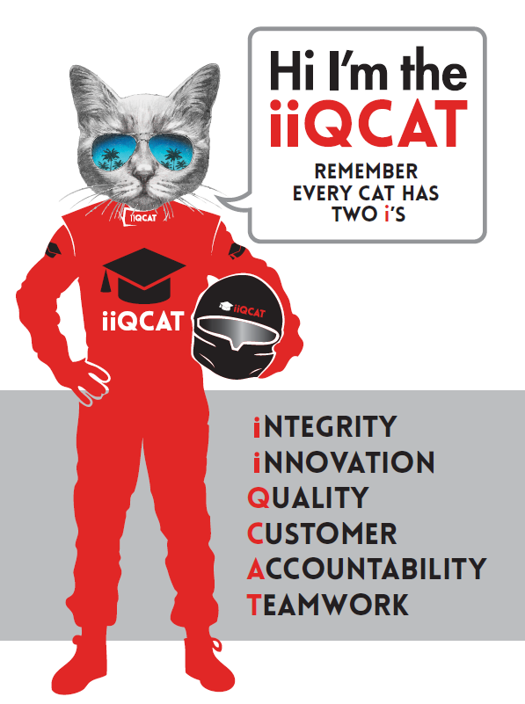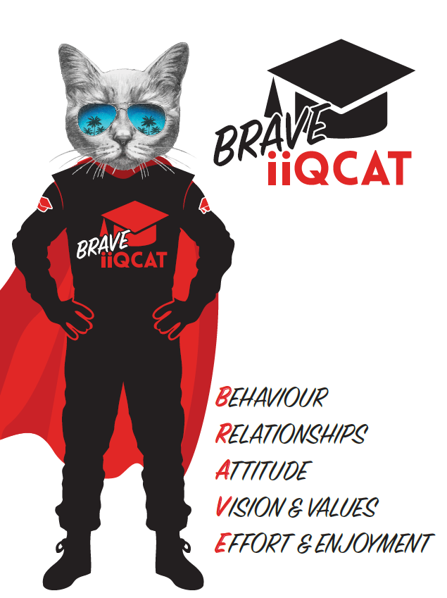
Corporation Objectives | To promote Melbourne and Victoria via the staging of two international sporting events - the Formula 1 Australian Grand Prix at Albert Park and the Australian MotoGP at Phillip Island.
Governed by | The Corporation is governed by the Australian Grands Prix Act 1994 (Vic).
Standards of behaviour | The Code of Conduct for Victorian Public Sector Employees governs the behaviour of all Corporation employees.
Human Rights | The Charter of Human Rights and Responsibilities Act 2006 is a Victorian law that sets out the basic rights, freedoms and responsibilities of all people in Victoria. The Charter requires the Corporation to act compatibly with human rights, and to consider human rights when developing policies, making laws, delivering services and making decisions.

Role Objectives | As a key member of the Finance department, the objective of the Financial accountant role is to assist the General Manager – Business Services, Financial Controller and Senior Accountant/Analyst with financial and management accounting, month end, year-end, payroll and financial compliance responsibilities. The role also includes assisting the Finance team with any other tasks as required, including projects, process improvements and ad hoc accounting tasks.
Core Responsibilities | Financial  - Complete month-end processes, including the preparation of financial reports and analysis, journals and reconciliation;  - Facilitate month forecast meetings;  - Assist with budgeting and forecasting;  - Business partner with departments to understand their business and provide accounting support;  - Complete Ticketmaster and revenue reconciliations;  - Complete fixed assets, capital project reporting and depreciation processes;  - Assist with statutory reporting and preparation of the Annual report and financial statements;  - Assist in internal and external audits, including collecting supporting evidence and responding to auditor queries;  - Support accounts payable and receivable with any queries relating to reconciliation and general ledger;  - Assist with government reporting and surveys (DTF, DJPR, ATO, SRO, ABS);  - Preparation of monthly BAS & Payroll Tax payments;  - Preparation of annual FBT return;  - Responsible for driving process improvements;  - Manage ongoing relationships with stakeholders;  - Assist with adhoc reporting as required by the Financial Controller and GM of Business Services;  - Assist the wider finance team with any adhoc tasks and/or projects; and  - Collaborate with other teams during event week to deliver a successful event.  Compliance  Assist in the maintenance and development of financial compliance frameworks, policies and internal controls environment, which includes staying up to date with accounting standard changes, government requirements, review and update of policies and completion of compliance attestations.  Ensure strict adherence to all elements of the Financial Management Act (1994) and Standing Directions of the Minister for Finance.  Process  To assist in the maintenance and upgrades in relation to accounting system and finance processes, including recommendations for enhancement/improvement where required and review of finance procedural documentation.  To remain up to date on non-profit best practice, and state and federal law and AASBs in relation to not-for-profit organisations.  Other  To assist the General Manager - Business Services and –Financial Controller, when required  To work across the Formula 1® Australian Grand Prix event and the Australian Motorcycle Grand Prix event and perform prescribed roles which may not always be finance related during the Events.  At the reasonable request of the Financial Controller; General Manager and/or the Chief Executive Officer, role responsibilities may be altered at any time.  Changes will be tied to the Corporation’s strategic objectives, workforce planning and the structural alignment of the Corporation.  Governance  Adhere to Corporation policies, procedures, and directives regarding standards of workplace behaviour in completing job duties and assignments.  Conducting every aspect of work in a trustworthy, reliable and transparent manner, and maintaining the highest ethical standards.  Customer Service  Putting internal and external customers first, building strong relationships and ensuring that the approach is responsive to the needs of the internal/external customer.  Encouraging openness and trust by sharing information widely, listening, welcoming constructive challenge and encouraging free dialogue.  Continuous Improvement  Taking initiative to improve operations/services/products and systems so that they are consistent with the Corporation’s strategic direction and values; incorporating innovation and experimentation into daily work.  Health and Safety  To assist the Corporation in meeting its health and safety obligations you will be required to:  - Actively participate in the reporting of hazards, incidents and near misses.  - Take corrective action to address or mitigate any risks or hazardous situations throughout the course of your work.  - Take reasonable care for your own health and safety, and for the health and safety of others.  - Adhere to the Corporation’s various policies, procedures, work practices and standard operating procedures.  - Perform your role in accordance with any specific responsibilities as outlined in the Corporation’s safety management system.  To enable the Corporation to meet its obligations for providing a healthy and safe working environment for you, you must inform your manager of any issues which may impact your ability to safely perform your role.  Environmental Considerations  Cooperate with the Corporation regarding caring for the environment, by acting in a sustainable way and minimising environmental impact by adhering to the Corporation’s policies, procedures and work practices.

Person Specification

Qualifications and Experience | Degree qualified in accounting or finance with a minimum of 2 years’ experience. Ideally the candidate is progressing towards their CPA or CA qualification.  Good customer service ethos and strong values-based attitude. Experience working in a dynamic and fast paced environment.  Advanced Excel and Word skills are necessary.  Relevant experience in:  - Management of full general ledger accounting including fixed assets. Knowledge of Sage ERP will be viewed favourably.  - Solid tax knowledge base including GST, Payroll taxes and FBT  Operation within a strong governance led environment, working knowledge of the Financial Management Act (1994) along with the Standing Directions of the Minister for Finance, and the Audit Act (1994) is highly desirable.

Relevant Traits and Characteristics | Customer Service  - Demonstrated achievement in and enthusiasm for the provision of quality customer service  - Immediately respond to customers’ needs or concerns to ensure the quality of service meets agreed standards and professionalism  Teamwork, Adaptability and Resilience  - Demonstrated commitment to teamwork and the maintenance of a supportive work environment  - Ability to work effectively as part of a team in a fast-changing environment  - Keeping calm by demonstrating a capacity to positively deal with unanticipated problems and changing circumstances  Initiative and Problem solving  - Ability to self-motivate and taking initiative to come up with innovative solutions to existing problems;  - Demonstrated experience in dealing with difficult customers or difficult situations, and the ability to problem solve, whilst maintaining a high level of customer service.  Interpersonal, Verbal and Written Communication  - Well-developed written communication ability  - Strong interpersonal and communication skills  - An ability to liaise, negotiate and constructively provide and accept feedback from staff at all levels  Organisation and Planning  - Organisational and planning skills in managing a personal workload in a busy environment with conflicting demands  - Ability to meet deadlines  Technology  - Experience in the use of Microsoft desktop products such as Word, Excel, Outlook and PowerPoint  - Experience in information management systems, including internet and on-line environments  Continuous Learning and Professional Development  - Demonstrated commitment to continual professional and personal development

