Position: | Motorsport, Entertainment, Industry Coordinator
Division: | Motorsport, Entertainment & Industry
Department: | Motorsport, Entertainment & Industry
Reporting to | Manager – Industry Integration
Employment Type | Long term contract

Key Relationships | Internal  Manager – Industry Integration  General Manager, Motorsport, Entertainment & Industry  Manager - Motorsport, Entertainment & Industry  Marketing Department  Division Manager - Risk and Operations  Venue Operations Managers and Coordinators  Sales & Partnerships Department  Manager – Infrastructure  Infrastructure Department  Legal Department  Other internal stakeholders as relevant and appropriate  External  Engineering Project Manager (IEDM)  External Entertainment suppliers  Harry the Hirer  Promotional Personnel provider  Event Sponsors  Exhibitors  VIP’s/Drivers  Key suppliers and commercial partners  Other stakeholders as relevant and appropriate

Values | Knowledge of and consistent demonstration of the Corporation’s IIQCAT values: Integrity, Innovation, Quality, Customer, Accountability, Teamwork.  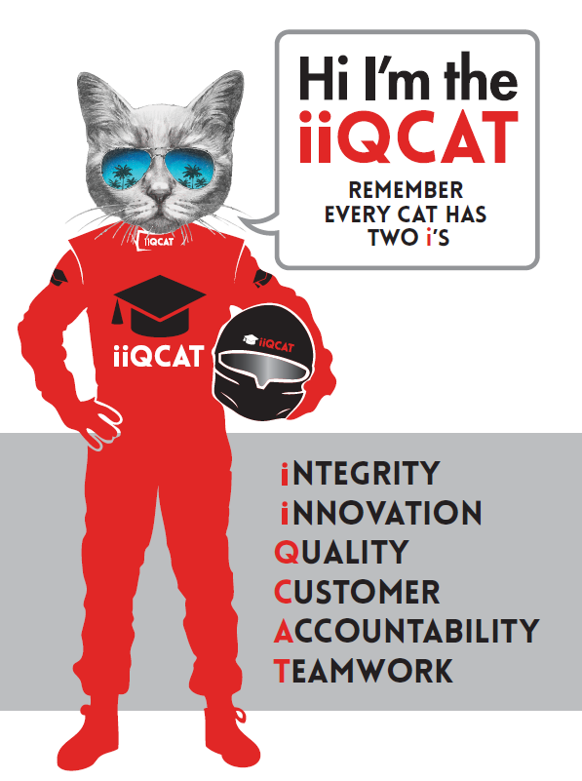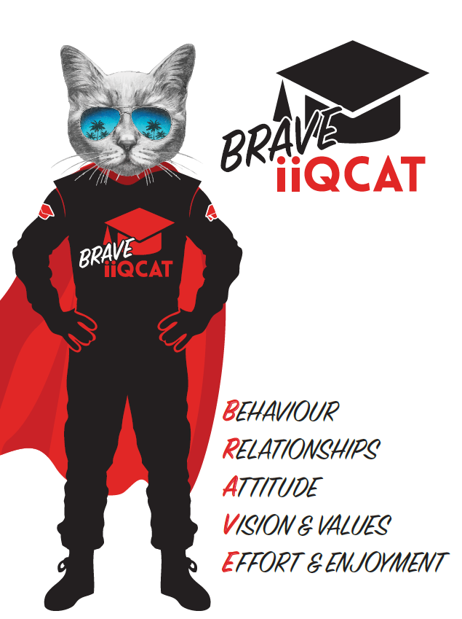
Corporation Objectives | To create value for the state of Victoria.  Our corporate strategy is underpinned by six strategic pillars:  - Build a powerful organisation and culture  - Secure the future of our events  - Connect people to business, brands and our sport  - Understand our customers and attract new audiences  - Inspire the future by driving technology and innovation  - Diversify and increase revenues to ensure our success  More specifically, we exist to promote Melbourne and Victoria via the staging of two international sporting events - the Formula 1 Australian Grand Prix at Albert Park and the Australian MotoGP at Phillip Island.
Governed by | The Corporation is governed by the Australian Grands Prix Act 1994 (Vic).
Standards of behaviour | The Code of Conduct for Victorian Public Sector Employees governs the behaviour of all Corporation employees.
Human Rights | The Charter of Human Rights and Responsibilities Act 2006 is a Victorian law that sets out the basic rights, freedoms and responsibilities of all people in Victoria. The Charter requires the Corporation to act compatibly with human rights, and to consider human rights when developing policies, making laws, delivering services and making decisions.

Role Objectives | Working closely with the MEI team, the role’s purpose is to effectively coordinate particular aspects of the motorsport, entertainment and industry content associated with the staging of the off-track entertainment at the Formula 1® Australian Grand Prix at Albert Park and Australian Motorcycle Grand Prix at Phillip Island.  This role requires delivering exceptional customer service in combination with continuing to build strong relationships and communication across a wide number of all internal and external stakeholders.  With a high level of multi-tasking event logistics, this fast-paced role will add value and increase the event enjoyment and event experience for all patrons and stakeholders.  Coordination in the development, planning, review and production of various key event and operations plans is required as well as appropriately managing safety and risk, ensuring that stakeholders and patrons are comfortable within the environment of the event.  Attention to detail is required to autonomously research, negotiate and contract innovative entertainment suppliers in consultation with AGPC Legal team to ensure value for money and the best prices a key objective.
Core Responsibilities | Key Entertainment and Fan Engagement Activities  Coordination and on-site management of various off-track event entertainment activities including scheduling, credentials, cost analysis, catering, signage, facility ordering, operation plans, security briefing notes, contracts and safety information, bump in/out information and post event debrief processes.  Working with MEI management to continually grow and ensure off-track entertainment remains innovative and contemporary and is continually enhanced. Research, plan and execute new activities to events.  Activities include:  Entertainment Performances – Roving and Staged  Coordination of various entertainment performances including selection, event schedule, event logistics and event facilities in conjunction with the MEI Manager.  Fan Engagement  Grow the fan engagement experience for the fans and continually look for new initiatives to ensure exceptional fan experiences.  M-Lane  Coordination of the continual growth and expansion of M-Lane to include researching, negotiating and contracting new and exciting activities to continually enhance the area while working with strategic objectives.  Entertainment Activities including:  Coordination of other off-track event entertainment which may vary from event to event and is subject to regular change. Examples include:  Formula 1  - Kids Activities  - Stunt Displays  - Music Entertainment  - Sailing  - Interactive Entertainment  Key Merchandise Activities:  Working closely with the ME&I Manager to coordinate all planning, operations and logistics related to Merchandise contractor sites to maximise commercial opportunities and ensure budgets are met.  Assist the ME&I Manager with analysis of sales and royalty reports and contract compliance.  Staff Uniform (Formula 1 & MotoGP)  Coordination of ongoing maintenance of the staff uniform program to include inventory management, maintenance and distribution. Development of additional items as required.  Requirement to liaise with internal department, key stakeholders and event suppliers to ensure optimal customer experiences at optimal cost.  Assist in the development of processes and procedures for event management in order to improve and optimise event planning and execution.  At the reasonable request of your Manager; General Manager and/or the Chief Executive Officer, role responsibilities may be altered at any time. Changes will be tied to the Corporation’s strategic objectives, workforce planning and the structural alignment of the Corporation.  Governance  Adhere to Corporation policies, procedures, and directives regarding standards of workplace behaviour in completing job duties and assignments.  Conducting every aspect of work in a trustworthy, reliable and transparent manner, and maintaining the highest ethical standards.  Customer Service  Putting internal and external customers first, building strong relationships and ensuring that the approach is responsive to the needs of the internal/external customer.  Encouraging openness and trust by sharing information widely, listening, welcoming constructive challenge and encouraging free dialogue.  Continuous Improvement  Taking initiative to improve operations/services/products and systems so that they are consistent with the Corporation’s strategic direction and values; incorporating innovation and experimentation into daily work.  Health and Safety  To assist the Corporation in meeting its health and safety obligations you will be required to:  - Actively participate in the reporting of hazards, incidents and near misses.  - Take corrective action to address or mitigate any risks or hazardous situations throughout the course of your work.  - Take reasonable care for your own health and safety, and for the health and safety of others.  - Adhere to the Corporation’s various policies, procedures, work practices and standard operating procedures.  - Perform your role in accordance with any specific responsibilities as outlined in the Corporation’s safety management system.  To enable the Corporation to meet its obligations for providing a healthy and safe working environment for you, you must inform your manager of any issues which may impact your ability to safely perform your role.  Environmental Considerations  Cooperate with the Corporation regarding caring for the environment, by acting in a sustainable way and minimising environmental impact by adhering to the Corporation’s policies, procedures and work practices.

Person Specification

Qualifications and Experience | Degree qualified, possibly in event management, sport management, marketing or business management.  Minimum 3-4 years’ experience in a similar coordination role  Experience in the following areas:  - Understanding key requirements of event management including logistics and delivery  - Working within budgets with the ability to conduct cost analysis for various activities  - Contract management  - Schedule development and management  - Working in high pressure environments juggling conflicting deadlines  - Ability to undertake tasks with minimal supervision  - Advanced computer skills  - Negotiation skills

Relevant Traits and Characteristics | Customer Service  - Demonstrated achievement in and enthusiasm for the provision of quality customer service  - Immediately respond to customers’ needs or concerns to ensure the quality of service meets agreed standards  Teamwork, Collaboration, Adaptability and Resilience  - Demonstrated commitment to teamwork and the maintenance of a supportive work environment  - Ability to work effectively as part of a team in a fast-changing environment  - Keeping calm by demonstrating a capacity to positively deal with unanticipated problems and changing circumstances  - A commitment to collaborate effectively with colleagues across the business  Interpersonal, Verbal and Written Communication  - Well-developed written communication ability  - Strong interpersonal and communication skills  - An ability to liaise, negotiate and constructively provide and accept feedback from staff at all levels  Organisation and Planning  - Organisational and planning skills in managing a personal workload in a busy environment with conflicting demands  - Ability to effectively prioritise and meet deadlines  Technology  - Experience in the use of Microsoft desktop products such as Word, Excel, Outlook and PowerPoint  - Experience in information management systems, including internet and on-line environments  Continuous Learning and Professional Development  - Demonstrated commitment to continual professional and personal development

