Position | Operations Manager
Division | Venue Operations
Department | Operations
Reporting to | Senior Manager – Operations
Direct Reports
Employment Type | 9 month contract – Maternity leave

Key Relationships | Internal  General Manager – Operations  Division Manager - Operations & Risk  Venue Manager  All Staff  Other internal stakeholders as relevant and appropriate  External  Local Councils (City of Port Phillip, City of Melbourne, City of Stonnington, Bass Coast Shire Council)  Disability Consultants  Engineering Project Manager  Patron Service Providers  Phillip Island Operations (PIO)  FOM, FIA, MA, FIM, Dorna, Motorcycling Australia  Event Contractor/Suppliers  Key suppliers and commercial partners  Event Patrons  Other stakeholders as relevant and appropriate

Values | Knowledge of and consistent demonstration of the Corporation’s IIQCAT values: Integrity, Innovation, Quality, Customer, Accountability, Teamwork.  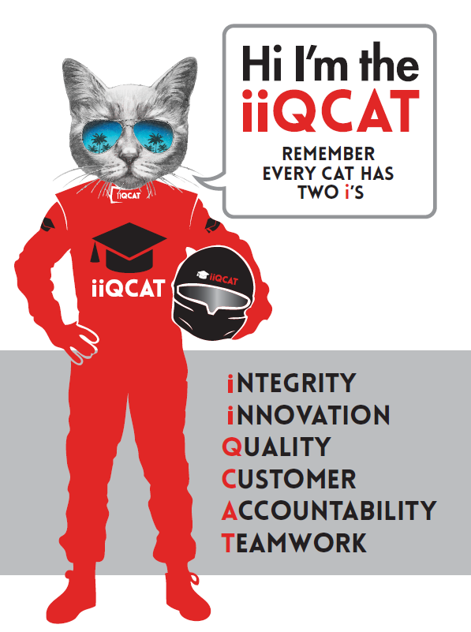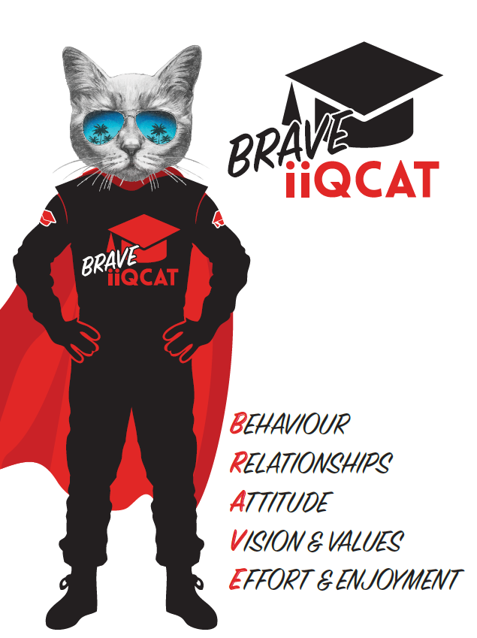
Corporation Objectives | To create value for the state of Victoria.  Our corporate strategy is underpinned by six strategic pillars:  - Build a powerful organisation and culture  - Secure the future of our events  - Connect people to business, brands and our sport  - Understand our customers and attract new audiences  - Inspire the future by driving technology and innovation  - Diversify and increase revenues to ensure our success  More specifically, we exist to promote Melbourne and Victoria via the staging of two international sporting events - the Formula 1 Australian Grand Prix at Albert Park and the Australian MotoGP at Phillip Island.
Governed by | The Corporation is governed by the Australian Grands Prix Act 1994 (Vic).
Standards of behaviour | The Code of Conduct for Victorian Public Sector Employees governs the behaviour of all Corporation employees.
Human Rights | The Charter of Human Rights and Responsibilities Act 2006 is a Victorian law that sets out the basic rights, freedoms and responsibilities of all people in Victoria. The Charter requires the Corporation to act compatibly with human rights, and to consider human rights when developing policies, making laws, delivering services and making decisions.

Role Objectives | The overarching objective of this role is to effectively coordinate venue operations associated with the annual staging of the Australian Formula 1® Grand Prix and the Australian Motorcycle Grand Prix.  This includes the aim to:  - Facilitate alignment with AGPC’s 2023 Strategy, particularly:  - Providing an exceptional event experience for all attendees;  - Integrate our story into our local communities and integrate our local communities in to our event;  - Understand our customers and what they want from our events and personalise their event experiences;  - Diversify our product offerings to overcome barriers to attendance; and  - Provide events that are accessible to all people.  - Develop strong relationships with all internal/external stakeholders;  - Ensure that the well-being of all patrons is maintained and maximised, not only within the nominated event’s venue, but in patron travels to and from the event.
Core Responsibilities | Department  - Development, cost control and reporting of the operations budget.  - Development and coordination of an event planning tool to ensure a state of readiness prior to each event and ensure a safe and secure operations is delivered each year in accordance to the Operations Coordinators core responsibilities.  Relationships  - Control of operational service providers, including liaison, consultation and coordination with members of Local Councils, disability stakeholders, patron service suppliers, event suppliers, park tenants and other relevant stakeholders.  Customer Experience  - Support and facilitation of the Customer Experience strategy and overall delivery of customer service on-site, including the contract management of the patron services provider.  - Collaboration with the Senior Manager – Operations and Division Manager – Operations & Risk to ensure Customer Experience is delivered across all departments and stakeholders.  - Coordination of the Customer Service portal and systems associated with the portal to ensure a timely and efficient customer feedback process is achieved.  - Recruitment, supervision and coordination of the Customer Service Manager for each Formula 1® and MotoGPTM event.  Local Councils  - Coordination of local council responsibilities and requirements as they relate to operational planning for:  - Formula 1® - City of Port Phillip (including coordination of the Local Access Zone), City of Melbourne, City of Stonnington; and  - MotoGPTM - Bass Coast Shire.  - Facilitation of important relationship with the local council representatives to ensure ongoing improvements and overall event delivery within the local municipality.  Community Relations  - Support and facilitation of the Community Relations strategy and overall delivery of community relations as it relates to Venue Operations for the Formula 1® and MotoGPTM events.  - Collaboration with the Senior Manager – Operations and Division Manager – Operations & Risk to ensure Community Relations is delivered across all departments and stakeholders.  - Coordination of all Community Relations information systems to ensure the timely and efficient communications of information as it relates to local residents and business of the Formula 1® and MotoGPTM events.  - Recruitment and coordination of the Community Relations Officer for each Formula 1® event and coordination of all Community Relations matters. This includes working closely with the City of Port Phillip to ensure the best outcome for AGPC.  Disability Services  - Creation and management of AGPC’s Disability and Inclusion Plan (DIAP) in alignment with AGPC Strategy.  - Collaboration with wider AGPC departments to deliver Community Relations.  - Oversee the coordination of disability service provisions at each event including:  - Liaison with the contracted Disability Consultants;  - Collaboration with Engineering Project Management Team to ensure all accessible infrastructure and services comply with latest legislative standards;  - Ensure both events are accessible to best practice methods for patrons with a disability; and  - Review, update and ensure implementation of the Disability Action Plan.  Other Departmental Tasks  Responsible for the coordination of the following activities/tasks:  - Circuit Planning  - Budget development and cost control  - Liaison with local tenants (inc Lakeside Stadium, MSAC, SSCT)  - Consultancy on development of AGPC Event Access Management System  - Other ad hoc operational duties as required  - Completion of other tasks as directed by the General Manager – Operations or the CEO.  At the reasonable request of your Division Manager; General Manager and/or the Chief Executive Officer, role responsibilities may be altered at any time. Changes will be tied to the Corporation’s strategic objectives, workforce planning and the structural alignment of the Corporation.  Governance  Adhere to Corporation policies, procedures, and directives regarding standards of workplace behaviour in completing job duties and assignments.  Conducting every aspect of work in a trustworthy, reliable and transparent manner, and maintaining the highest ethical standards.  Customer Service  Putting internal and external customers first, building strong relationships and ensuring that the approach is responsive to the needs of the internal/external customer.  Encouraging openness and trust by sharing information widely, listening, welcoming constructive challenge and encouraging free dialogue.  Continuous Improvement  Taking initiative to improve operations/services/products and systems so that they are consistent with the Corporation’s strategic direction and values; incorporating innovation and experimentation into daily work.  Health and Safety  To assist the Corporation in meeting its health and safety obligations you will be required to:  - Actively participate in the reporting of hazards, incidents and near misses.  - Take corrective action to address or mitigate any risks or hazardous situations throughout the course of your work.  - Take reasonable care for your own health and safety, and for the health and safety of others.  - Adhere to the Corporation’s various policies, procedures, work practices and standard operating procedures.  - Perform your role in accordance with any specific responsibilities as outlined in the Corporation’s safety management system.  To enable the Corporation to meet its obligations for providing a healthy and safe working environment for you, you must inform your manager of any issues which may impact your ability to safely perform your role.  Environmental Considerations  Cooperate with the Corporation regarding caring for the environment, by acting in a sustainable way and minimising environmental impact by adhering to the Corporation’s policies, procedures and work practices.

SELECTION CRITERIA

Qualifications and Experience | - Experience in event management  - Experience working with a diverse range of internal and external stakeholders  - Experience in delivering large-scale events in a world-class operational setting  - Ability to be able to bring something fresh, exciting and innovative to the team

Relevant Traits and Characteristics | Customer Service  - Demonstrated achievement in and enthusiasm for the provision of quality customer service  - Immediately respond to customers’ needs or concerns to ensure the quality of service meets agreed standards  Teamwork, Collaboration, Adaptability and Resilience  - Demonstrated commitment to teamwork and the maintenance of a supportive work environment  - Ability to work effectively as part of a team in a fast-changing environment  - Keeping calm by demonstrating a capacity to positively deal with unanticipated problems and changing circumstances  - A commitment to collaborate effectively with colleagues across the business  Interpersonal, Verbal and Written Communication  - Well-developed written communication ability  - Strong interpersonal and communication skills  - An ability to liaise, negotiate and constructively provide and accept feedback from staff at all levels  Organisation and Planning  - Organisational and planning skills in managing a personal workload in a busy environment with conflicting demands  - Ability to effectively prioritise and meet deadlines  Technology  - Experience in the use of Microsoft desktop products such as Word, Excel, Outlook and PowerPoint  - Experience in information management systems, including internet and on-line environments  Continuous Learning and Professional Development  - Demonstrated commitment to continual professional and personal development

