Position | Ticketing Customer Experience Executive
Division | Marketing
Department | Marketing
Reporting to | Senior Manager- Consumer Sales
Employment Type | Full time

Key Relationships | Internal  Marketing Team  Sales and Commercial Team  Operations  Infrastructure  Legal Department  Other internal stakeholders as relevant and appropriate  External  Ticketmaster  Official Licensees and Suppliers, as appropriate  Retailers  Key suppliers and commercial partners  Other stakeholders as relevant and appropriate

Values | Knowledge of and consistent demonstration of the Corporation’s IIQCAT values: Integrity, Innovation, Quality, Customer, Accountability, Teamwork.  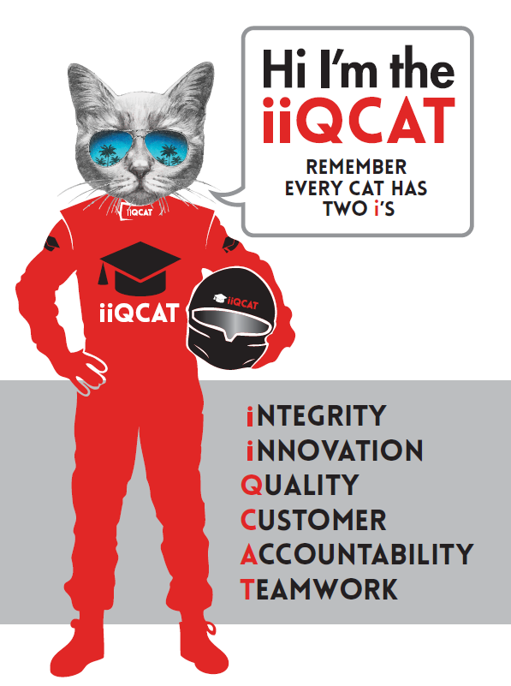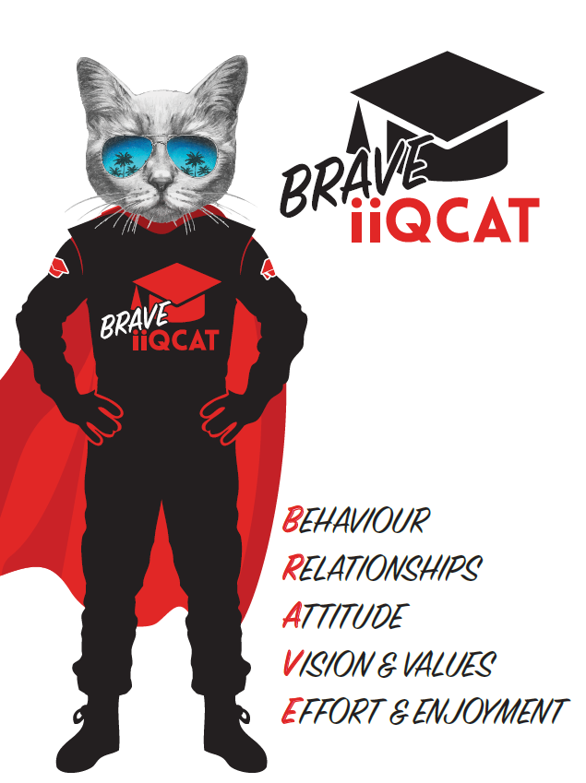
Corporation Objectives | To create value for the state of Victoria.  Our corporate strategy is underpinned by six strategic pillars:  - Build a powerful organisation and culture  - Secure the future of our events  - Connect people to business, brands and our sport  - Understand our customers and attract new audiences  - Inspire the future by driving technology and innovation  - Diversify and increase revenues to ensure our success  More specifically, we exist to promote Melbourne and Victoria via the staging of two international sporting events - the Formula 1 Australian Grand Prix at Albert Park and the Australian MotoGP at Phillip Island.
Governed by | The Corporation is governed by the Australian Grands Prix Act 1994 (Vic).
Standards of behaviour | The Code of Conduct for Victorian Public Sector Employees governs the behaviour of all Corporation employees.
Human Rights | The Charter of Human Rights and Responsibilities Act 2006 is a Victorian law that sets out the basic rights, freedoms and responsibilities of all people in Victoria. The Charter requires the Corporation to act compatibly with human rights, and to consider human rights when developing policies, making laws, delivering services and making decisions.

Role Objectives | Reporting to the Senior Manager - Consumer Sales, the Ticketing and Customer Experience Executive role will be responsible for ticketing portfolio for both F1 and MotoGP as well as a key part of the implementation and delivery for the organisations overall Customer Experience model.  This role will assist in the management and growth of revenue streams across the consumer portfolio through best practice ticketing strategies and CX deliverables.  Ticketing:  This role will be responsible for a range of operational ticketing requirements for the Formula 1® and Motorcycle Grands Prix.  This is inclusive of assisting with:  - Ticketing builds  - Product analysis and reporting  - Collaboration with the Manager - Digital to assist with the implementation of effective and contemporary digital marketing tools (e.g. EDMs etc)  - Manage, develop, plan and constantly review sales and product inventory and ticketing systems to provide optimal use of resources and maximise revenues for AGPC  - Manage internal ticketing requirements leading up to each event.  Customer Experience:  With a passion and curiosity for customers, their needs, and journeys, this role is pivotal to putting customers at the heart of the organisation and creating a culture that enhances their experience at every touchpoint.  - Assist in the evolution of the CRM program to better understand customer metrics and embed measurements of customer satisfaction and its impact on future sales growth  - Work with the Marketing team to validate and help uncover insights to be ised in strategic planning  - Assist with the implementation of the end to end customer journey, mapping touchpoints, pain points and and continuous business improvement
Core Responsibilities | As an integral part of the Ticketing and CX team, the Ticketing and Customer Experience Executive, will require a sound understanding for logical analysis, commercial acumen and a strong understanding of target markets, and their segmentation to facilitate growth in ticket sales, whilst maintaining a strong customer-first approach in all that they do.  The core responsibilities of this role include:  - Work in conjunction with the ticketing agent to ensure timely builds.  - Develop, plan and constantly review sales and product inventory and ticketing systems to provide optimal use of resources and maximise revenues for AGPC  - Manage internal ticketing requirements leading up to each event.  - Manage the customer service strategy for all GA, Grandstand customers.  - Assist in the Implementation of the end to end customer journey, mapping touchpoints, pain points and continuous improvement  - Assist in the evolution of the CRM program to better understand customer metrics and embed measurements of customer satisfaction and its impact on future sales growth  - Work with the Marketing team to validate and help uncover insights to be ised in strategic planning  - Combine CX data with market research to identify strategic findings  At the reasonable request of your Senior Manager, General Manager and/or the Chief Executive Officer, role responsibilities may be altered at any time. Changes will be tied to the Corporation’s strategic objectives, workforce planning and the structural alignment of the Corporation.  Governance  Adhere to Corporation policies, procedures, and directives regarding standards of workplace behaviour in completing job duties and assignments.  Conducting every aspect of work in a trustworthy, reliable and transparent manner, and maintaining the highest ethical standards.  Customer Service  Putting internal and external customers first, building strong relationships and ensuring that the approach is responsive to the needs of the internal/external customer.  Encouraging openness and trust by sharing information widely, listening, welcoming constructive challenge and encouraging free dialogue.  Continuous Improvement  Taking initiative to improve operations/services/products and systems so that they are consistent with the Corporation’s strategic direction and values; incorporating innovation and experimentation into daily work.  Health and Safety  To assist the Corporation in meeting its health and safety obligations you will be required to:  - Actively participate in the reporting of hazards, incidents and near misses.  - Take corrective action to address or mitigate any risks or hazardous situations throughout the course of your work.  - Take reasonable care for your own health and safety, and for the health and safety of others.  - Adhere to the Corporation’s various policies, procedures, work practices and standard operating procedures.  - Perform your role in accordance with any specific responsibilities as outlined in the Corporation’s safety management system.  To enable the Corporation to meet its obligations for providing a healthy and safe working environment for you, you must inform your manager of any issues which may impact your ability to safely perform your role.  Environmental Considerations  Cooperate with the Corporation regarding caring for the environment, by acting in a sustainable way and minimising environmental impact by adhering to the Corporation’s policies, procedures and work practices.

SELECTION CRITERIA

Qualifications and Experience | - 2+ years of Customer Experience management  - 2 - 3 years Ticketing experience in the events landscape (preferable)  - Highly developed customer service and relationship management skills  - Effective self-management, including the ability to prioritise, meet deadlines and time management  - Strong understanding of CRM applications  - Strong knowledge of ticketing systems  - Flexibility of working hours (to suit the varying time schedule and seasonal priorities)  - Hold a valid Driver's Licence  - The successful candidate will require a valid Victorian Working with Children Check

Relevant Traits and Characteristics | Customer Service  - Demonstrated achievement in and enthusiasm for the provision of quality customer service  - Immediately respond to customers’ needs or concerns to ensure the quality of service meets agreed standards  Teamwork, Collaboration, Adaptability and Resilience  - Demonstrated commitment to teamwork and the maintenance of a supportive work environment  - Ability to work effectively as part of a team in a fast-changing environment  - Keeping calm by demonstrating a capacity to positively deal with unanticipated problems and changing circumstances  - A commitment to collaborate effectively with colleagues across the business  Interpersonal, Verbal and Written Communication  - Well-developed written communication ability  - Strong interpersonal and communication skills  - An ability to liaise, negotiate and constructively provide and accept feedback from staff at all levels  Organisation and Planning  - Organisational and planning skills in managing a personal workload in a busy environment with conflicting demands  - Ability to effectively prioritise and meet deadlines  Technology  - Experience in the use of Microsoft desktop products such as Word, Excel, Outlook and PowerPoint  - Experience in information management systems, including internet and on-line environments  Continuous Learning and Professional Development  - Demonstrated commitment to continual professional and personal development

