Position | Manager– Entertainment Operations
Division | Motorsport, Entertainment & Industry
Department | Motorsport, Entertainment & Industry
Reporting to | Manager - Industry Integration
Direct Reports | Any temporary staff engaged prior to both events as part of the Events requirements. Currently including:  - Entertainment Assistants  - Campground Coordinator  - VIP Talent drivers
Employment Type | Long term contract

Key Relationships | Internal  Manager – Industry Integration  General Manager, Motorsport, Entertainment & Industry  Motorsport, Entertainment & Industry Coordinator  Manager - Communications  Brand Manager  Manager – Digital  Division Manager - Operations and Risk  Venue Operations Managers and Coordinators  Sales and Partnerships Department  Infrastructure Department  Legal Department  Finance Department  Other internal stakeholders as relevant and appropriate  External  Infrastructure Project Managers (IEDM)  GPTV production providers  MDG Pty Ltd and Highfields (Merchandise contractor)  VIP Talent  DORNA  MotoGP Teams  Formula 1 Management /F1 Teams  Supercars Australia and teams (appearances)  All External Entertainment suppliers  Harry the Hirer  Event Sponsors  Key suppliers and commercial partners  Other stakeholders as relevant and appropriate

Values | Knowledge of and consistent demonstration of the Corporation’s IIQCAT values: Integrity, Innovation, Quality, Customer, Accountability, Teamwork.  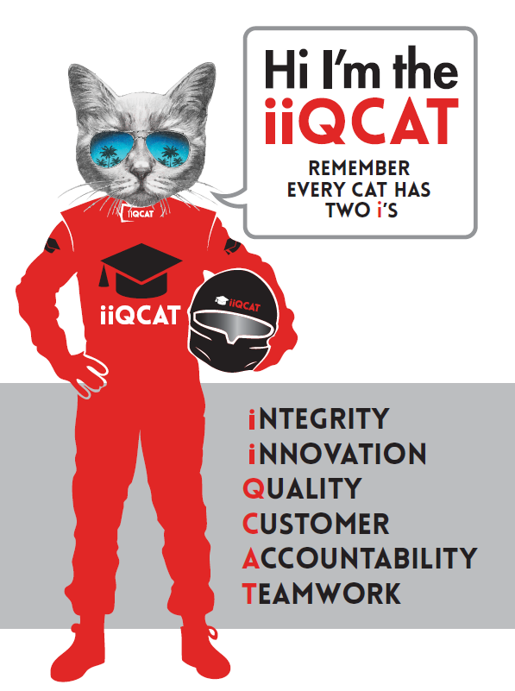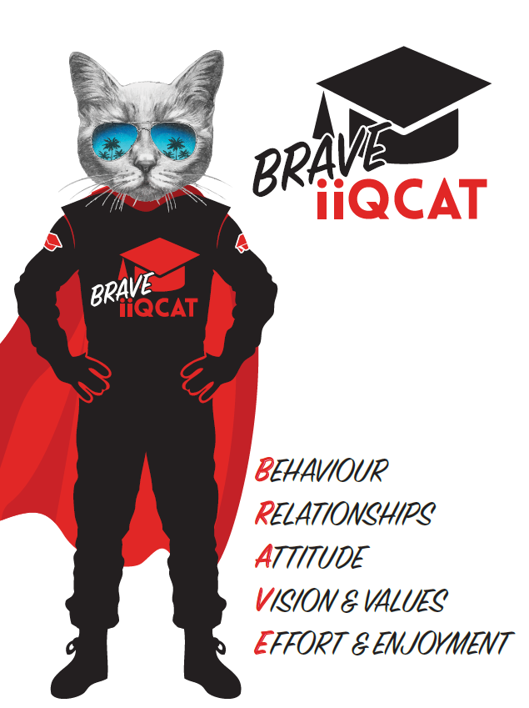
Corporation Objectives | To create value for the state of Victoria.  Our corporate strategy is underpinned by six strategic pillars:  - Build a powerful organisation and culture  - Secure the future of our events  - Connect people to business, brands and our sport  - Understand our customers and attract new audiences  - Inspire the future by driving technology and innovation  - Diversify and increase revenues to ensure our success  More specifically, we exist to promote Melbourne and Victoria via the staging of two international sporting events - the Formula 1 Australian Grand Prix at Albert Park and the Australian MotoGP at Phillip Island.
Governed by | The Corporation is governed by the Australian Grands Prix Act 1994 (Vic).
Standards of behaviour | The Code of Conduct for Victorian Public Sector Employees governs the behaviour of all Corporation employees.
Human Rights | The Charter of Human Rights and Responsibilities Act 2006 is a Victorian law that sets out the basic rights, freedoms and responsibilities of all people in Victoria. The Charter requires the Corporation to act compatibly with human rights, and to consider human rights when developing policies, making laws, delivering services and making decisions.

Role Objectives | The objective of this role is to efficiently manage the identification, procurement and delivery of the event entertainment content. Manage the efficient delivery of the Merchandise operations and services for both the Formula 1 Australian Grand Prix at Albert Park and the Australian Motorcycle Grand Prix at Phillip Island.  Other key objectives are to:  - Develop strong relationships with all internal and external stakeholders.  - Successfully manage the various areas of responsibility at the event, within budget.  - Add value, innovate and increase the event enjoyment and event experience for all fans and/or stakeholders by continually enhancing and improving the fan engagement activities and overall event experience.  - Continuously improve the effectiveness of the customer/fan experience by bringing new and innovative entertainment to life, constantly reviewing opportunities and interactions with the Sponsorship department particularly in relation to commercialising entertainment opportunities and regular liaison with key areas of the Marketing department.  - Ensure Entertainment program is in alignment with strategic objectives of the Australian Grand Prix Corporation and associated marketing initiatives and research.  - Work collaboratively with Motorsport and Industry departments to ensure successful outcomes for wider team deliverables.
Core Responsibilities | EVENT ENTERTAINMENT, DISPLAYS AND ATTRACTIONS  Pre-race Entertainment including Anthem Ceremony - ‘On track’ (Formula 1 & MotoGP)  Assist with coordination, and implementation of the pre-race entertainment (if applicable) & ‘on track’ anthem ceremony, presentation of VIP dignitaries. Includes the procurement of anthem talent and liaising with Formula One, Dorna, GPTV broadcast technicians and circuit sound technicians etc.  Podium Operations (Formula 1 & MotoGP)  Manage the integration of GPTV, Formula One Management/DORNA FOM/DORNA (live broadcast), MCs, sound feeds and cueing of the podium ceremonies alongside the Motorsport department.  Talent Management, Procurement & Scheduling of appearances (Formula 1 & MotoGP)  Schedule appearances of VIP talent and special events. Coordination and implementation of the VIP Hospitality Suite appearance schedule.  Fan Engagement Activities (Formula 1 & MotoGP)  Manage on – stage talent appearance and Q&A sessions, potentially including Formula One drivers and team personnel, Supercar drivers and team personnel, MotoGP riders and team personnel. Continually enhance the fan experience with innovative concepts.  General and Roving Entertainment (Formula 1 & MotoGP)  Generate new and innovative entertainment aligned to target audience. Coordination of the procurement process for the entertainment.  GPTV/ Host Broadcaster (Formula 1 & MotoGP)  Coordination of the GPTV provider in relation to operations, scheduling and production of GPTV. Liaison with Host Broadcasters in relation to integration of GPTV elements with international ‘feed’ from Formula One Management and DORNA where required.  Merchandise (Formula 1 & MotoGP)  Coordination of the merchandise program and management of all elements of the agreement between AGPC and Merchandisers are fulfilled.  Maximise growth opportunities at both the event and on-line sales and wholesale presence. Ensure merchandise range is continually reviewed and updated as required, in-line with brand guidelines.  Budgets and Planning (Formula 1 & MotoGP)  Ensure compliance with the Entertainment budget including forecasting, accurate reporting and monitoring.  Kids and Family Activations (Formula 1)  Coordination of the procurement of kids and family focused activations as well as all operational elements for the Formula One event.  Temporary Event Staff (Formula 1 & MotoGP)  Coordination of the recruitment of temporary event staff prior and during each event to assist with Event Entertainment requirements.  At the reasonable request of your General Manager and/or the Chief Executive Officer, role responsibilities may be altered at any time. Changes will be tied to the Corporation’s strategic objectives, workforce planning and the structural alignment of the Corporation.  Governance  Adhere to Corporation policies, procedures, and directives regarding standards of workplace behaviour in completing job duties and assignments.  Conducting every aspect of work in a trustworthy, reliable and transparent manner, and maintaining the highest ethical standards.  Customer Service  Putting internal and external customers first, building strong relationships and ensuring that the approach is responsive to the needs of the internal/external customer.  Encouraging openness and trust by sharing information widely, listening, welcoming constructive challenge and encouraging free dialogue.  Continuous Improvement  Taking initiative to improve operations/services/products and systems so that they are consistent with the Corporation’s strategic direction and values; incorporating innovation and experimentation into daily work.  Health and Safety  To assist the Corporation in meeting its health and safety obligations you will be required to:  - Actively participate in the reporting of hazards, incidents and near misses.  - Take corrective action to address or mitigate any risks or hazardous situations throughout the course of your work.  - Take reasonable care for your own health and safety, and for the health and safety of others.  - Adhere to the Corporation’s various policies, procedures, work practices and standard operating procedures.  - Perform your role in accordance with any specific responsibilities as outlined in the Corporation’s safety management system.  To enable the Corporation to meet its obligations for providing a healthy and safe working environment for you, you must inform your manager of any issues which may impact your ability to safely perform your role.  Environmental Considerations  Cooperate with the Corporation regarding caring for the environment, by acting in a sustainable way and minimising environmental impact by adhering to the Corporation’s policies, procedures and work practices.

SELECTION CRITERIA

Qualifications and Experience | Degree qualified, possibly in event management, sport management or business management;  - Extensive Event Management and Event Operations experience  - Project management and scheduling  - Marketing and Communications understanding  - Budget management

Relevant Traits and Characteristics | Customer Service  - Demonstrated achievement in and enthusiasm for the provision of quality customer service  - Immediately respond to customers’ needs or concerns to ensure the quality of service meets agreed standards  Teamwork, Collaboration, Adaptability and Resilience  - Demonstrated commitment to teamwork and the maintenance of a supportive work environment  - Ability to work effectively as part of a team in a fast-changing environment  - Keeping calm by demonstrating a capacity to positively deal with unanticipated problems and changing circumstances  - A commitment to collaborate effectively with colleagues across the business  Interpersonal, Verbal and Written Communication  - Well-developed written communication ability  - Strong interpersonal and communication skills  - An ability to liaise, negotiate and constructively provide and accept feedback from staff at all levels  Organisation and Planning  - Organisational and planning skills in managing a personal workload in a busy environment with conflicting demands  - Ability to effectively prioritise and meet deadlines  Technology  - Experience in the use of Microsoft desktop products such as Word, Excel, Outlook and PowerPoint  - Experience in information management systems, including internet and on-line environments  Continuous Learning and Professional Development  - Demonstrated commitment to continual professional and personal development

