Position | Legal Counsel
Division | Legal
Department | Legal & Strategy
Reporting to | Senior Legal Counsel
Employment Type | Permanent

Key Relationships | Internal  Legal & Strategy Team  Operations Department  Sales & Commercial Department  Marketing & Experience Department  Corporate Affairs & Communications  Business Services Department  AGPC Board Members  Other internal stakeholders as relevant and appropriate  External  External legal advisors  Government  Key suppliers and commercial partners  Other stakeholders as relevant and appropriate

Values | Knowledge of and consistent demonstration of the Corporation’s IIQCAT values: Integrity, Innovation, Quality, Customer, Accountability, Teamwork.  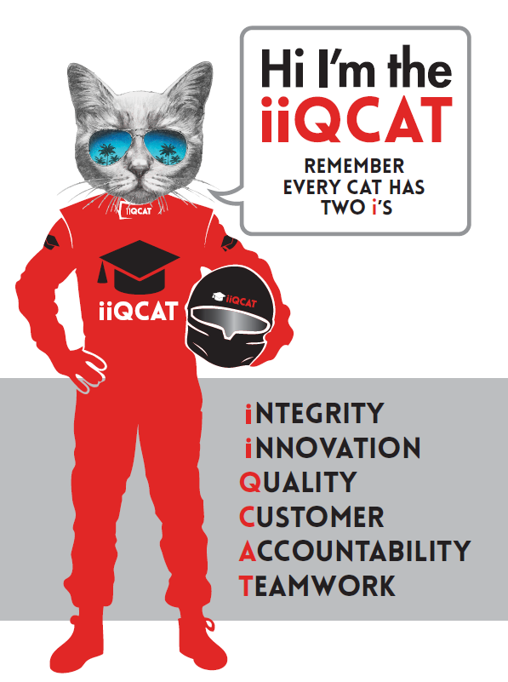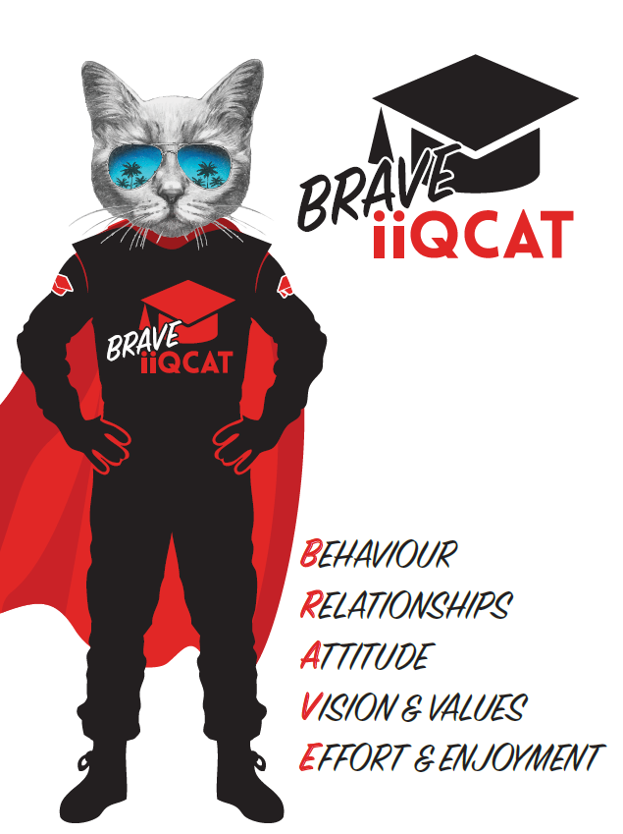
Corporation Objectives | To create value for the state of Victoria.  Our corporate strategy is underpinned by six strategic pillars:  - Build a powerful organisation and culture  - Secure the future of our events  - Connect people to business, brands and our sport  - Understand our customers and attract new audiences  - Inspire the future by driving technology and innovation  - Diversify and increase revenues to ensure our success  More specifically, we exist to promote Melbourne and Victoria via the staging of two international sporting events - the Formula 1 Australian Grand Prix at Albert Park and the Australian MotoGP at Phillip Island.
Governed by | The Corporation is governed by the Australian Grands Prix Act 1994 (Vic).
Standards of behaviour | The Code of Conduct for Victorian Public Sector Employees governs the behaviour of all Corporation employees.
Human Rights | The Charter of Human Rights and Responsibilities Act 2006 is a Victorian law that sets out the basic rights, freedoms and responsibilities of all people in Victoria. The Charter requires the Corporation to act compatibly with human rights, and to consider human rights when developing policies, making laws, delivering services and making decisions.

Role Objectives | - Proactively manage all instructions and lead delivery of solutions and contract drafting of all legal requirements across the business  - Map and deliver a contract priority system, both in terms of current drafting and future procurement priorities  - Become the trusted business partner in guiding procurement and tendering processes  - Maintain and update a suite of standard form precedent contracts  - Provide sound, practical, succinct and solutions orientated advice and strategic guidance  - Be able to communicate contractual risk effectively  - Assist with the administrative requirements of contract management system, budgeting and other legal operations.  - Assist with the administrative requirements of the Board and committees.  - Ability to use technological solutions in development and implementation of legal, contract management and procurement systems
Core Responsibilities | Legal  - Structure of commercial arrangements - drafting and negotiation of various agreements particularly sponsorship, supplier, talent and engineering agreements including strategic advice in terms of structuring and use of purchase orders where appropriate  - Procurement & Tender Processes - preparation of tender documents and management and provision of strategic advice and guidance to ensure commercial outcomes are optimised, including advising on Local Jobs First Policy. Will be required to manage Tender submissions via online portal (Tendersearch). Ensure compliance, as required, with Victorian Government Purchasing Board policies and requirements.  - Risk Management – work in partnership with the Risk Manager to ensure risk assessments are undertaken and risk minimisation strategies are implemented across all contractual arrangements  - Precedents – initial development of and updating on an annual basis sponsorship, supplier, offsite services and purchase order precedents  - Marketing Collateral – review and approving marketing collateral and trade promotions in accordance with regulatory requirements  - Terms & Conditions – reviewing and updating all Corporation’s terms and conditions required by the business including conditions of entry and sale, corporate facility order forms and general conditions of contracts  - Intellectual Property - management and enforcement of the intellectual property portfolio including liaising with FOM as required  - Staff Policies – assist Human Resources with updating policies and briefing of staff on an on-going basis  - Dispute Resolution – support litigation as required and pragmatically advise on all dispute resolution options  - FOI – assist FOI officer with administration of Freedom of Information requests and overall business compliance  - Declarations - obtaining necessary Ministerial approvals and declarations for logos and event names including gazettals;  - Operations Declarations – assist Operations with declarations for road closures, race periods, declared area and designated access areas  - Event Attendances - co-ordination and facilitation of Governor, Premier and Ministerial attendances including arrivals, departures and tours of venues  - Brand Protection - assist Sponsorship with anti-counterfeiting program at each event  Operations/Administration  - Electronc filing - Manage online and hardcopy filing system of Contracts including uploading all signed contracts to ensure the accuracy of the contract management system, liaising with software provider as required and training and assisting AGPC Staff to use the system.  - Manage administration and scheduling requirements for government offocials and dignitary attendance at upcoming events.  - Manage administration requirements for Board and Committees.  - Undertake monthly budgeting review and invoice coding for the legal budget.  - Keep up to date with external stakeholders contact lists.  - Coordinate and chair pre and post event meetings with all departments.  - Assist with the preparation and delivery of internal legal training.  - Manage any ad hoc gifts or meals for meetings.  - Coordinate inductions and manuals.  Strategy  - Assisting the strategy area of the Corporation through work on the strategy document and strategy implementation through relevant areas like local community connection.  Governance  - Manage the annual Conflict of Interest Declaration Process  - Assist with annual reporting  - Co-ordinate obligations and reporting under the Modern Slavery Act  - Assist with the Local Laws Declaration  - Oversee and advise on compliance with Social Procurement Strategy  - Submit annual Gazettals  Adhere to Corporation policies, procedures, and directives regarding standards of workplace behaviour in completing job duties and assignments.  Conducting every aspect of work in a trustworthy, reliable and transparent manner, and maintaining the highest ethical standards.  Customer Service  Putting internal and external customers first, building strong relationships and ensuring that the approach is responsive to the needs of the internal/external customer.  Encouraging openness and trust by sharing information widely, listening, welcoming constructive challenge and encouraging free dialogue.  Continuous Improvement  Taking initiative to improve operations/services/products and systems so that they are consistent with the Corporation’s strategic direction and values; incorporating innovation and experimentation into daily work.  Health and Safety  To assist the Corporation in meeting its health and safety obligations you will be required to:  - Actively participate in the reporting of hazards, incidents and near misses.  - Take corrective action to address or mitigate any risks or hazardous situations throughout the course of your work.  - Take reasonable care for your own health and safety, and for the health and safety of others.  - Adhere to the Corporation’s various policies, procedures, work practices and standard operating procedures.  - Perform your role in accordance with any specific responsibilities as outlined in the Corporation’s safety management system.  To enable the Corporation to meet its obligations for providing a healthy and safe working environment for you, you must inform your manager of any issues which may impact your ability to safely perform your role.  Environmental Considerations  Cooperate with the Corporation regarding caring for the environment, by acting in a sustainable way and minimising environmental impact by adhering to the Corporation’s policies, procedures and work practices.  At the reasonable request of your Manager, General Manager and/or the Chief Executive Officer, role responsibilities may be altered at any time. Changes will be tied to the Corporation’s strategic objectives, workforce planning and the structural alignment of the Corporation.

SELECTION CRITERIA

Qualifications and Experience | - Tertiary qualifications in Law  - Current Australian practising certificate  - Minimum 3+ years PQE gained within a leading law firm or in-house (including secondment)
Relevant Traits and Characteristics | Customer Service  - Demonstrated achievement in and enthusiasm for the provision of quality customer service  - Immediately respond to customers’ needs or concerns to ensure the quality of service meets agreed standards  Teamwork, Collaboration, Adaptability and Resilience  - Demonstrated commitment to teamwork and the maintenance of a supportive work environment  - Ability to work effectively as part of a team in a fast-changing environment  - Keeping calm by demonstrating a capacity to positively deal with unanticipated problems and changing circumstances  - A commitment to collaborate effectively with colleagues across the business  Interpersonal, Verbal and Written Communication  - Well-developed written communication ability  - Strong interpersonal and communication skills  - An ability to liaise, negotiate and constructively provide and accept feedback from staff at all levels  - Excellent attention to detail  Organisation and Planning  - Organisational and planning skills in managing a personal workload in a busy environment with conflicting demands  - Ability to effectively prioritise and meet deadlines  Technology  - Experience in the use of Microsoft desktop products such as Word, Excel, Outlook and PowerPoint  - Experience in information management systems, including internet and on-line environments  Continuous Learning and Professional Development  - Demonstrated commitment to continual professional and personal development

