Position | Business Development Executive
Division | Sales
Department | Sales & Commercial
Reporting to | Division Manager - Commercial
Employment Type | Permanent

Key Relationships | Internal  Chief Executive Officer  General Manager – Sales & Commercial  Division Manager - Commercial  Business Development Executives/s  Senior Manager – Partnerships  Partnerships Managers  Partnerships Executive/s  Sales Operations Team  All Staff  Other internal stakeholders as relevant and appropriate  External  Clients/Prospective Clients within the Portfolio  Promotional Agencies as relevant to role  Contemporaries/Peers within the event space  Key suppliers and commercial partners  Other stakeholders as relevant and appropriate

Values | Knowledge of and consistent demonstration of the Corporation’s IIQCAT values: Integrity, Innovation, Quality, Customer, Accountability, Teamwork.  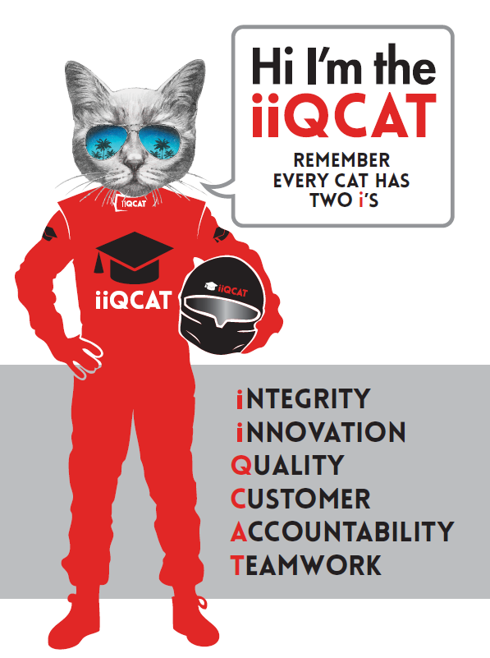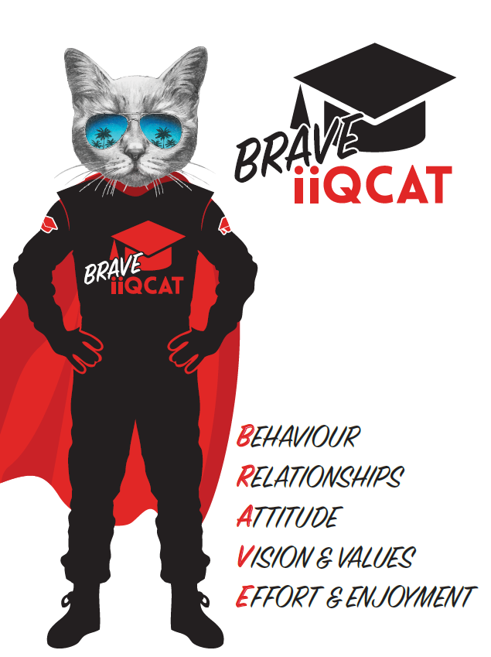
Corporation Objectives | To create value for the state of Victoria.  Our corporate strategy is underpinned by six strategic pillars:  - Build a powerful organisation and culture  - Secure the future of our events  - Connect people to business, brands and our sport  - Understand our customers and attract new audiences  - Inspire the future by driving technology and innovation  - Diversify and increase revenues to ensure our success  More specifically, we exist to promote Melbourne and Victoria via the staging of two international sporting events - the Formula 1 Australian Grand Prix at Albert Park and the Australian MotoGP at Phillip Island.
Governed by | The Corporation is governed by the Australian Grand Prix Act 1994 (Vic).
Standards of behaviour | The Code of Conduct for Victorian Public Sector Employees governs the behaviour of all Corporation employees.
Human Rights | The Charter of Human Rights and Responsibilities Act 2006 is a Victorian law that sets out the basic rights, freedoms and responsibilities of all people in Victoria. The Charter requires the Corporation to act compatibly with human rights, and to consider human rights when developing policies, making laws, delivering services and making decisions.

Role Objectives | This role reports to the Division Manager to manage a portfolio of clients/prospective clients within the designated industry sector, and is responsible for the generation of sales revenue, primarily through acquisition of new business deals in addition to building existing relationships.  These roles work together, as well as independently, to drive sales across the entire AGPC product suite, including corporate and VIP hospitality and corporate partnerships/sponsorship, for both the Formula 1® and Motorcycle Grands Prix.  The role focuses on the following areas of activity:  - New business  - Retention/Re-signing of existing clients  - Conversion rate for new accounts  - Activity and discipline in sales generation tasks – e.g. research, prospecting, sales calls, customer visits and networking  In undertaking these functions, this role is part of a wider team which is expected to act as ambassadors for the Corporation, its events and products; and in doing so to set the benchmark in terms of aligning with the organisation values (IIQCAT).
Key Results Areas | This document sets out the Key Result Areas (KRAs) and the resultant core competencies that relate to the position.  - Achievement of the event sales and sponsorship targets (both personal and team) in relation to:  - New business  - Account growth  - Account retention  - Sales related activity (metrics)  - Conversion rates  - Provision of outstanding customer service which facilitates and where possible, grows enduring and positive client engagement with AGPC.  - Active contribution to team success, including mentoring, knowledge sharing and collaboration.  - A high level of personal presentation and grooming that is appropriate to the role, and reflects the importance of the function as corporate ambassadors. The ability to present compellingly to existing and potential customers (both written and verbal).  - Maintain an active presence and understanding within the contemporary sales space, including an awareness of best practice for hospitality and sponsorship. Active research and awareness of competitor trends, activities, products and pricing, and the ability to utilise this in formulating and driving sales strategies.  - Disciplined and meticulous maintenance of data sources and sales resources i.e. CRM.
Core Responsibilities | Achieve hospitality and sponsorship sales targets for the Australian Motorcycle Grand Prix and the Formula 1 Australian Grand Prix.  Research, develop and update a rolling pipeline of prospects to achieve retention and new business targets on an ongoing basis, utilising a variety of tools and resources such as (but not limited to):  - Connector  - Australian Bureau of Statistics Market Segmentation information  - CRM Database  - Internet and media sources  - Business Directories  - LinkedIn  - Competitor Data  Undertake proactive (and productive) lead generation through a structured and disciplined approach involving:  - Cold Calling  - Client Visits  - Cross selling  - Networking  - Active promotion of the AGPC and its endeavours  Engage in proactive and customer-focussed relationship management to promote long term engagement/retention and maximisation of revenue potential across both sponsorship and hospitality.  Work collaboratively with the Partnerships team to ensure accurate, timely and professional scoping, planning and delivery of client requirements.  Support all team members to achieve common targets and goals, through supportive sharing of knowledge, ideas and leads.  Undertaking all housekeeping and administrative tasks required to maintain sales tools, systems and resources (e.g. CRM). Key administrative tasks include updating CRM  Skills and Experience  Previous outbound sales experience ideally within a highly professional and polished commercial environment. Experience selling sporting properties or services in a B2B environment is advantageous.  “Hunter” sales mentality, initiative and a passion for continually unlocking new business opportunities.  Proven ability to generate, grow and retain sales accounts, through a combination of discipline and creativity.  Demonstrable interpersonal, networking, communication and relationship management skills.  Demonstrable skills in time management, planning and strategic thinking, combined with strong commercial acumen.  Integrity, focus and emotional maturity, combined with the ability to self- motivate and contribute positively as a team member.  Computer and database literacy and numeracy, especially in relation to sales based technology and tools.  Superior organisation skills and attention to detail.  The ability to combine a systematic and logical approach with broader strategic thinking.  Immaculate and professional personal presentation.  Must have valid Australian driving licence & a registered vehicle.  Team  Provide support to members of the Sales and Commercial Team, to drive motivation, performance and achievement of outcomes.  All work to be done in alignment with AGPC values to ensure a cohesive, constructive and excellence-driven team culture.  Act as a role model for organisational standards, values and professionalism.  At the reasonable request of your Manager, General Manager and/or the Chief Executive Officer, role responsibilities may be altered at any time. Changes will be tied to the Corporation’s strategic objectives, workforce planning and the structural alignment of the Corporation.  Governance  Adhere to Corporation policies, procedures, and directives regarding standards of workplace behaviour in completing job duties and assignments.  Conducting every aspect of work in a trustworthy, reliable and transparent manner, and maintaining the highest ethical standards.  Customer Service  Putting internal and external customers first, building strong relationships and ensuring that the approach is responsive to the needs of the internal/external customer.  Encouraging openness and trust by sharing information widely, listening, welcoming constructive challenge and encouraging free dialogue.  Continuous Improvement  Taking initiative to improve operations/services/products and systems so that they are consistent with the Corporation’s strategic direction and values; incorporating innovation and experimentation into daily work.  Health and Safety  To assist the Corporation in meeting its health and safety obligations you will be required to:  - Actively participate in the reporting of hazards, incidents and near misses.  - Take corrective action to address or mitigate any risks or hazardous situations throughout the course of your work.  - Take reasonable care for your own health and safety, and for the health and safety of others.  - Adhere to the Corporation’s various policies, procedures, work practices and standard operating procedures.  - Perform your role in accordance with any specific responsibilities as outlined in the Corporation’s safety management system.  To enable the Corporation to meet its obligations for providing a healthy and safe working environment for you, you must inform your manager of any issues which may impact your ability to safely perform your role.  Environmental Considerations  Cooperate with the Corporation regarding caring for the environment, by acting in a sustainable way and minimising environmental impact by adhering to the Corporation’s policies, procedures and work practices.

SELECTION CRITERIA

Qualifications and Experience | Experience in direct selling to clients, both in person and over the phone  Experience in customer service  Experience in proposal writing, pitch development, influencing clients, professional communications and presenting  Experience in Account Management a bonus  Previous experience in sponsorship negation a bonus  Deep understanding of developing networks  Ownership of a previous network a bonus

Relevant Traits and Characteristics | Customer Service  - Demonstrated achievement in and enthusiasm for the provision of quality customer service  - Immediately respond to customers’ needs or concerns to ensure the quality of service meets agreed standards  Teamwork, Collaboration, Adaptability and Resilience  - Demonstrated commitment to teamwork and the maintenance of a supportive work environment  - Ability to work effectively as part of a team in a fast-changing environment  - Keeping calm by demonstrating a capacity to positively deal with unanticipated problems and changing circumstances  - A commitment to collaborate effectively with colleagues across the business  Interpersonal, Verbal and Written Communication  - Well-developed written communication ability  - Strong interpersonal and communication skills  - An ability to liaise, negotiate and constructively provide and accept feedback from staff at all levels  Organisation and Planning  - Organisational and planning skills in managing a personal workload in a busy environment with conflicting demands  - Ability to effectively prioritise and meet deadlines  Technology  - Experience in the use of Microsoft desktop products such as Word, Excel, Outlook and PowerPoint  - Experience in information management systems, including internet and on-line environments  Continuous Learning and Professional Development  - Demonstrated commitment to continual professional and personal development

