Position: | Graphic Designer
Division: | Marketing
Department: | Sales, Commercial & Marketing
Reporting to | Senior Manager – Brand and Advertising
Direct Reports | None
Employment Type | Contract (12 months)

Key Relationships | Internal  All Staff  Marketing Department  Sales and Commercial Department  Media & Communications Department  Motorsport & Entertainment Department  Other internal stakeholders as relevant and appropriate  External  Print production agency  Creative agency  Other stakeholders as relevant and appropriate

Values | Knowledge of and consistent demonstration of the Corporation’s IIQCAT values: Integrity, Innovation, Quality, Customer, Accountability, Teamwork.  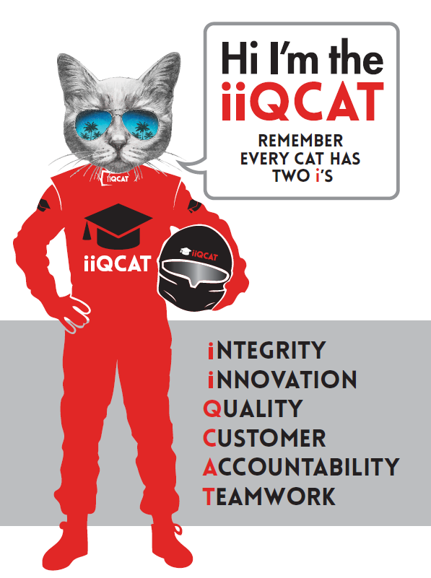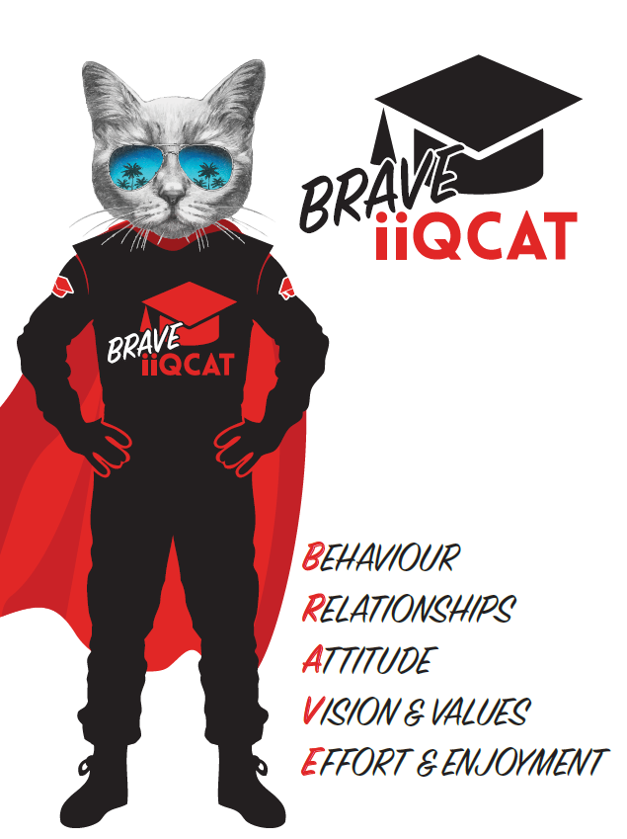
Corporation Objectives | To promote Melbourne and Victoria via the staging of two international sporting events - the Formula 1 Australian Grand Prix at Albert Park and the Australian MotoGP at Phillip Island.
Governed by | The Corporation is governed by the Australian Grands Prix Act 1994 (Vic).
Standards of behaviour | The Code of Conduct for Victorian Public Sector Employees governs the behaviour of all Corporation employees.
Human Rights | The Charter of Human Rights and Responsibilities Act 2006 is a Victorian law that sets out the basic rights, freedoms and responsibilities of all people in Victoria. The Charter requires the Corporation to act compatibly with human rights, and to consider human rights when developing policies, making laws, delivering services and making decisions.

Role Objectives | Assist with the development of AGPC creative and graphic design needs in house reporting to the Senior Manager, Brand and Advertising and collaborating with the Marketing Coordinator. Uphold the brand identity for the Formula 1 and MotoGP events working on marketing collateral for print and digital channels. Work in close liaison with the wider marketing department and other AGPC departments to deliver on creative briefs.
Core Responsibilities | - Develop print and digital creative for marketing collateral for two world class sporting brands including; newsletters, web banners (MREC’s/mobile advertising), web/social media content, flyers, at event signage, branded templates, look books and outdoor advertising  - Work with the Senior Manager, Brand and Advertising on developing brand creative and establish companywide brand standards  - Translate hero campaign concepts across multiple channels seamlessly and consistently  - Work closely with the marketing team to understand content, brands and customers segments in order to deliver design solutions  - Effectively follow a brief, delivering creative designs that are on brand and on deadline  - Manage the production schedule and deadlines for internal design jobs  - Manage external print agencies to see production of print collateral through from start to end  - Work on numerous brands and briefs with multiple deadlines  - Assist with the co-ordination of the photography brief and delivery prior to and during event times  - Manage photography files and archives  - Work during event times to deliver on design and photography needs  - Other duties at the reasonable request of the Senior Manager, Brand and Advertising and Division Manager - Marketing  At the reasonable request of your Division Manager; General Manager and/or the Chief Executive Officer, role responsibilities may be altered at any time. Changes will be tied to the Corporation’s strategic objectives, workforce planning and the structural alignment of the Corporation.  Governance  Adhere to Corporation policies, procedures, and directives regarding standards of workplace behaviour in completing job duties and assignments.  Conducting every aspect of work in a trustworthy, reliable and transparent manner, and maintaining the highest ethical standards.  Customer Service  Putting internal and external customers first, building strong relationships and ensuring that the approach is responsive to the needs of the internal/external customer.  Encouraging openness and trust by sharing information widely, listening, welcoming constructive challenge and encouraging free dialogue.  Continuous Improvement  Taking initiative to improve operations/services/products and systems so that they are consistent with the Corporation’s strategic direction and values; incorporating innovation and experimentation into daily work.  Health and Safety  To assist the Corporation in meeting its health and safety obligations you will be required to:  - Actively participate in the reporting of hazards, incidents and near misses.  - Take corrective action to address or mitigate any risks or hazardous situations throughout the course of your work.  - Take reasonable care for your own health and safety, and for the health and safety of others.  - Adhere to the Corporation’s various policies, procedures, work practices and standard operating procedures.  - Perform your role in accordance with any specific responsibilities as outlined in the Corporation’s safety management system.  To enable the Corporation to meet its obligations for providing a healthy and safe working environment for you, you must inform your manager of any issues which may impact your ability to safely perform your role.  Environmental Considerations  Cooperate with the Corporation regarding caring for the environment, by acting in a sustainable way and minimising environmental impact by adhering to the Corporation’s policies, procedures and work practices.

Person Specification

Qualifications and Experience | - Tertiary Qualification in Graphic Design  - 2-5 years’ experience in a design role working in house or in an agency environment  - High proficiency with Adobe Creative Suite, in particular Illustrator, Photoshop and InDesign  - Basic HTML, CSS, HTML5 skills for digital display ads a bonus  - Strong typography & layout skills  - Strong organisational skills, including time management and ability to balance multiple projects with attention to detail  - Ability to work under pressure and adhere to deadlines  - Enthusiasm a must along with a willingness to up-skill  - Ability to work with the team and on independent projects  - Animation experience or skills with motion graphics are not a necessity but will be highly regarded  - Excellent written and verbal communication skills

Relevant Traits and Characteristics | Customer Service  - Demonstrated achievement in and enthusiasm for the provision of quality customer service  - Immediately respond to customers needs or concerns to ensure the quality of service meets agreed standards  Teamwork, Adaptability and Resilience  - Demonstrated commitment to teamwork and the maintenance of a supportive work environment  - Ability to work effectively as part of a team in a fast-changing environment  - Keeping calm by demonstrating a capacity to positively deal with unanticipated problems and changing circumstances  Interpersonal, Verbal and Written Communication  - Well-developed written communication ability  - Strong interpersonal and communication skills  - An ability to liaise, negotiate and constructively provide and accept feedback from staff at all levels  Organisation and Planning  - Organisational and planning skills in managing a personal workload in a busy environment with conflicting demands  - Ability to meet deadlines  Technology  - Experience in the use of Microsoft desktop products such as Word, Excel, Outlook and PowerPoint  - Experience in information management systems, including internet and on-line environments  Continuous Learning and Professional Development  - Demonstrated commitment to continual professional and personal development

