Position: | Senior Manager – Consumer Sales and Commercial Operations
Division: | Marketing
Department: | Sales, Commercial & Marketing
Reporting to | Division Manager – Marketing
Employment Type | Permanent

Key Relationships | Internal  Marketing Team  Sales and Commercial Team  Management Team  Operations  Engineering  Legal Department  Other internal stakeholders as relevant and appropriate  External  Ticketmaster  Grand Prix Travel Office  Official Licensees and Suppliers, as appropriate  Retailers  AGPC Corporate Licensee & Official Sponsors  Key suppliers and commercial partners  Other stakeholders as relevant and appropriate

Values | Knowledge of and consistent demonstration of the Corporation’s IIQCAT values: Integrity, Innovation, Quality, Customer, Accountability, Teamwork.  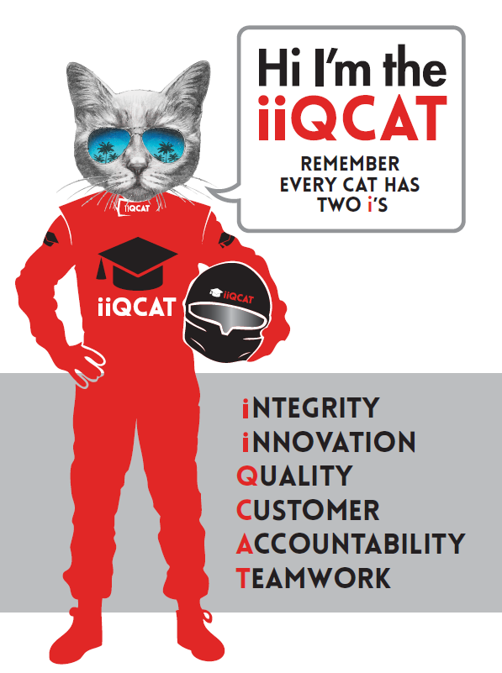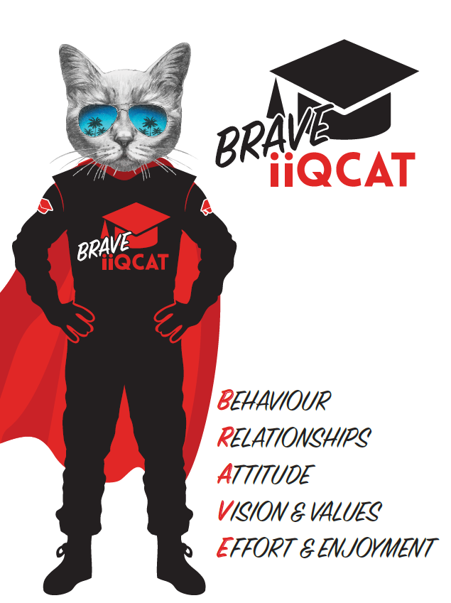
Corporation Objectives | To promote Melbourne and Victoria via the staging of two international sporting events - the Formula 1 Australian Grand Prix at Albert Park and the Australian MotoGP at Phillip Island.
Governed by | The Corporation is governed by the Australian Grands Prix Act 1994 (Vic).
Standards of behaviour | The Code of Conduct for Victorian Public Sector Employees governs the behaviour of all Corporation employees.
Human Rights | The Charter of Human Rights and Responsibilities Act 2006 is a Victorian law that sets out the basic rights, freedoms and responsibilities of all people in Victoria. The Charter requires the Corporation to act compatibly with human rights, and to consider human rights when developing policies, making laws, delivering services and making decisions.

Role Objectives | This role is an essential conduit between the sales and marketing function, with an emphasis on strategic data analysis and inventory management, product development and supplier management.  The primary functions of this role is to manage, develop, grow and maximise revenue across the consumer retail commercial portfolio, to manage all operational ticketing requirements and to oversee the corporate ticketing delivery program in collaboration with the sales and commercial team for the FORMULA 1® and Motorcycle Grands Prix.  This is inclusive of managing:  - Consumer Sales  - General admission sales;  - Grandstand sales;  - Upsell product sales;  - On-seller product sales;  - Travel product sales;  - General admission ticket dispatch;  - Grandstand ticket dispatch;  - Ancillary event sales and dispatch;  - Upsell product ticket dispatch; and  - Pit Lane Walk and Main Straight Walk ticket dispatch.  - Corporate Sales and Commercial  - Corporate ticket dispatch;  - Upsell product ticket dispatch; and  - Pit Lane Walk and Main Straight Walk ticket dispatch.  The role is also responsible for managing the following commercial contracts:  - Ticketing Operations  - On-Seller Operations  - Travel Operations  - Campground Operations  The role is also responsible for event day ticketing operations for both the commercial and consumer sectors for both the FORMULA 1® and Motorcycle Grands Prix and the campground operations for the Motorcycle Grand Prix.  The role requires demonstrably sophisticated data analysis skills and CRM management, combined with commercial savvy, strategic thinking, superior stakeholder management and customer service skills, and confidence with digital marketing tools.
Core Responsibilities | General  Development of a strategic and sound business model for consumer sales growth, based on logical analysis, commercial acumen and an informed understanding of target markets and their segmentation to facilitate increased and sustainable growth in ticket sales. This incorporates general admission and grandstand patrons, GP Advantage and Riders United members as well as on sellers and travel package providers.  The provision of detailed, informed and timely data analysis and reporting, to inform sales and marketing activities and initiatives.  Work in conjunction with the ticketing agent to ensure timely builds.  Work closely with the ticketing agent to ensure revenue opportunities are being maximised.  Collaborate with the Corporate Sales Team to ensure a successful corporate Ticket Delivery Program and manage staff effectively.  Develop innovative methods in regards to corporate ticketing fulfilment.  Collaboration with the Manager - Digital to facilitate the implementation of effective and contemporary digital marketing tools (e.g. EDMs etc)  Collaboration with the Consumer Insights and Marketing Manager to develop and administer acquisition and retention strategies, loyalty programs and engagement.  To identify and develop opportunities both in established and new commercial business streams, and to negotiate and manage agreements relating to these.  To identify and implement an optimal product mix that supports marketing objectives, and is soundly based on market data and segmentation.  Prepare ticketing strategy and timelines for both events  in collaboration with Marketing Department.  Manage, develop, plan and constantly review sales and product inventory and ticketing systems to provide optimal use of resources and maximise revenues for AGPC  Prepare, manage and leverage all contracts for suppliers and on sellers, including ticketing and travel package suppliers  Operation of the AGPC office ticketing outlet in the lead up to the event, including complete servicing of any ticket purchases  Manage internal ticketing requirements leading up to each event.  Manage the customer service strategy for all GA, Grandstand and GP Advantage/Riders United members.  Customer Champion  Set up processes internally to ensure customer feedback is front of mind for marketing / operations and others. Report feedback on a regular basis and include measures of success for promotions / marketing through sales tracking and anecdotal evidence.  Marketing  Working closely with the Marketing Department, develop consumer direct marketing programs and associated communication materials to drive the sales and engagement of both General Admission, Grandstand seating and membership programs for both events.  Finance  Work closely with the Finance team to ensure that all projects undertaken are in line with the organisations financial frameworks and goals.  Operations  Work closely with the Operations team to ensure that all projects undertaken are in line operational feasibility.  Database maintenance  Working closely with the Marketing Department, Ticketing Agent and the Digital Content Specialist, maintain and grow the database, and quality of data and analysis to directly and positively impact upon both reporting and sales/marketing strategy. Help develop and advise CRM utilisation and database management.  Administration  Preparation of monthly board paper submissions. Preparation of monthly management reports.  Preparation of capacity and sales reports.  Preparation of performance and financial reports (royalty reports).  Management of additional staff as required during event time.  Any other duties as requested by the CEO or General Manager Sales and Commercial.  At the reasonable request of your Division Manager; General Manager and/or the Chief Executive Officer, role responsibilities may be altered at any time. Changes will be tied to the Corporation’s strategic objectives, workforce planning and the structural alignment of the Corporation.  Governance  Adhere to Corporation policies, procedures, and directives regarding standards of workplace behaviour in completing job duties and assignments.  Conducting every aspect of work in a trustworthy, reliable and transparent manner, and maintaining the highest ethical standards.  Customer Service  Putting internal and external customers first, building strong relationships and ensuring that the approach is responsive to the needs of the internal/external customer.  Encouraging openness and trust by sharing information widely, listening, welcoming constructive challenge and encouraging free dialogue.  Continuous Improvement  Taking initiative to improve operations/services/products and systems so that they are consistent with the Corporation’s strategic direction and values; incorporating innovation and experimentation into daily work.  Health and Safety  To assist the Corporation in meeting its health and safety obligations you will be required to:  - Actively participate in the reporting of hazards, incidents and near misses.  - Take corrective action to address or mitigate any risks or hazardous situations throughout the course of your work.  - Take reasonable care for your own health and safety, and for the health and safety of others.  - Adhere to the Corporation’s various policies, procedures, work practices and standard operating procedures.  - Perform your role in accordance with any specific responsibilities as outlined in the Corporation’s safety management system.  To enable the Corporation to meet its obligations for providing a healthy and safe working environment for you, you must inform your manager of any issues which may impact your ability to safely perform your role.  Environmental Considerations  Cooperate with the Corporation regarding caring for the environment, by acting in a sustainable way and minimising environmental impact by adhering to the Corporation’s policies, procedures and work practices.

Person Specification

Qualifications and Experience | A tertiary qualification in business, marketing or similar would be extremely highly regarded  Significant experience in a similar ticketing/consumer sales/data analysis role, with a demonstrable ability to drive positive outcomes and growth  Broad and deep understanding of market segmentation, product development and inventory management principles  Broad understanding of membership programs, fulfilment, customer service and loyalty programs  Outstanding stakeholder management and customer service skills, combined with lateral thinking, problem solving, resilience and the ability to balance both transactional and strategic agendas  Exceptional data management, analysis and reporting skills, combined with commercial savvy and attention to detail  Computer literacy, especially in relation to digital marketing tools, excel and reporting tools, and data base management, especially in relation to databases/CRM and ticketing platforms

Relevant Traits and Characteristics | Customer Service  - Demonstrated achievement in and enthusiasm for the provision of quality customer service  - Immediately respond to customers needs or concerns to ensure the quality of service meets agreed standards  Teamwork, Adaptability and Resilience  - Demonstrated commitment to teamwork and the maintenance of a supportive work environment  - Ability to work effectively as part of a team in a fast-changing environment  - Keeping calm by demonstrating a capacity to positively deal with unanticipated problems and changing circumstances  Interpersonal, Verbal and Written Communication  - Well-developed written communication ability  - Strong interpersonal and communication skills  - An ability to liaise, negotiate and constructively provide and accept feedback from staff at all levels  Organisation and Planning  - Organisational and planning skills in managing a personal workload in a busy environment with conflicting demands  - Ability to meet deadlines  Technology  - Experience in the use of Microsoft desktop products such as Word, Excel, Outlook and PowerPoint  - Experience in information management systems, including internet and on-line environments  Continuous Learning and Professional Development  - Demonstrated commitment to continual professional and personal development

