Position: | Communications Coordinator
Division: | Corporate Affairs & Communications
Department: | Corporate Affairs & Communications
Reporting to | Division Manager – Corporate Affairs & Communications
Employment Type | Permanent

Key Relationships | Internal  CEO  Manager – Corporate Affairs & Communications  GM – Motorsport, Entertainment and Industry  GM – Sales, Commercial and Marketing  Division Manager - Marketing  Marketing and Sales teams  Operations  External  Media  PR Agencies  Formula One Management  FIA  DORNA  Official Charities  Key suppliers and commercial partners  Other stakeholders as relevant and appropriate

Values | Knowledge of and consistent demonstration of the Corporation’s IIQCAT values: Integrity, Innovation, Quality, Customer, Accountability, Teamwork.  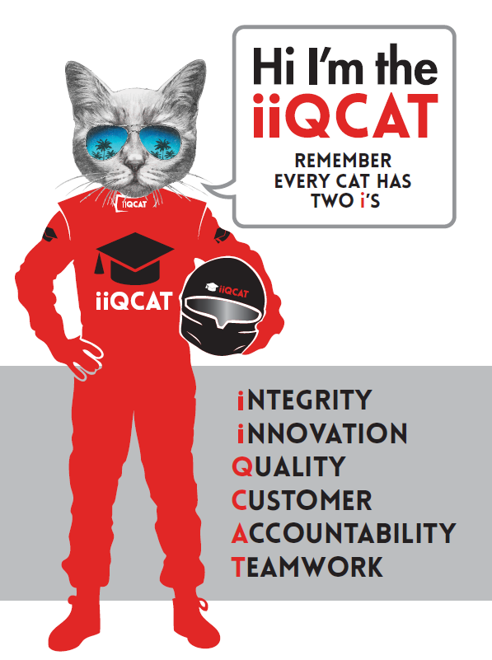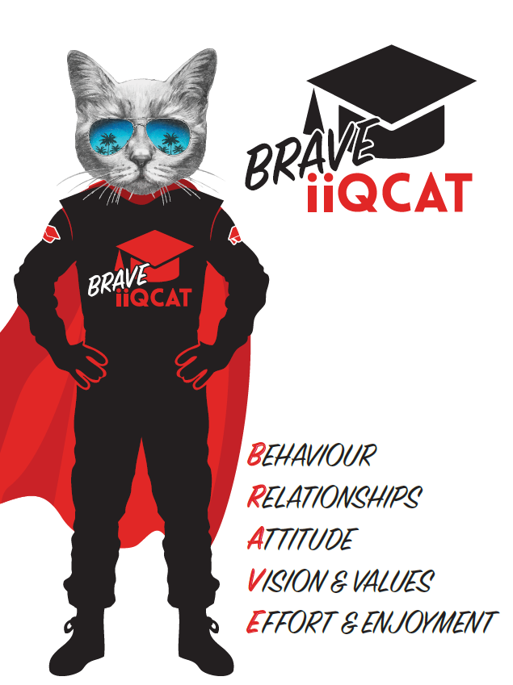
Corporation Objectives | To promote Melbourne and Victoria via the staging of two international sporting events - the Formula 1® Australian Grand Prix at Albert Park and the Australian MotoGP at Phillip Island.
Governed by | The Corporation is governed by the Australian Grands Prix Act 1994 (Vic).
Standards of behaviour | The Code of Conduct for Victorian Public Sector Employees governs the behaviour of all Corporation employees.
Human Rights | The Charter of Human Rights and Responsibilities Act 2006 is a Victorian law that sets out the basic rights, freedoms and responsibilities of all people in Victoria. The Charter requires the Corporation to act compatibly with human rights, and to consider human rights when developing policies, making laws, delivering services and making decisions.

Role Objectives | The objective of this role is to be an active member of Australian Grand Prix Corporation’s communications team with a focus on communications, PR, media relations, issues management, official charities and CSR in the lead up to and during the Formula 1® and Motorcycle Grands Prix.  This role will also help to support the ongoing communications strategy for the team. Note that this role will require a candidate who is able to work outside of normal working hours as well as on weekends as required.
Core Responsibilities | - Manage from concept to delivery of various media events such as launches, photo opportunities and media announcements including the development of event schedules and running orders.  - Writing copy for a wide variety of communications materials including press releases, statements, corporate sales content and speaking notes for our management, marketing and sales teams.  - Timely management of media enquiries and issues including interviews, information and image requests.  - Liaising with PR agencies – briefing, managing and providing timely information as required.  - Content creation and development of influencers and stakeholders, including motorsport.  - Manage and develop the compilation of newsletter content for distribution to F1 and MotoGP subscribers.  - Managing Official Charities and charitable requests.  - Developing and implementing a CSR program.  - Liaison and partnership with Marketing and Motorsport departments.  - Assist in development of overall department strategy, including implementation of campaigns and formulation of key messaging for spokespeople.  - Support in maintaining existing relationships and cultivating new contacts with key media personnel and act as point of contact for media enquiries.  - Key contact for Media Monitoring account and day to day liaison and management of brief.  - Administration of invoicing and the media budget.  Governance  Adhere to Corporation policies, procedures, and directives regarding standards of workplace behaviour in completing job duties and assignments.  Conducting every aspect of work in a trustworthy, reliable and transparent manner, and maintaining the highest ethical standards.  Customer Service  Putting internal and external customers first, building strong relationships and ensuring that the approach is responsive to the needs of the internal/external customer.  Encouraging openness and trust by sharing information widely, listening, welcoming constructive challenge and encouraging free dialogue.  Continuous Improvement  Taking initiative to improve operations/services/products and systems so that they are consistent with the Corporation’s strategic direction and values; incorporating innovation and experimentation into daily work.  Health and Safety  To assist the Corporation in meeting its health and safety obligations you will be required to:  - Actively participate in the reporting of hazards, incidents and near misses.  - Take corrective action to address or mitigate any risks or hazardous situations throughout the course of your work.  - Take reasonable care for your own health and safety, and for the health and safety of others.  - Adhere to the Corporation’s various policies, procedures, work practices and standard operating procedures.  - Perform your role in accordance with any specific responsibilities as outlined in the Corporation’s safety management system.  To enable the Corporation to meet its obligations for providing a healthy and safe working environment for you, you must inform your manager of any issues which may impact your ability to safely perform your role.  Environmental Considerations  Cooperate with the Corporation regarding caring for the environment, by acting in a sustainable way and minimising environmental impact by adhering to the Corporation’s policies, procedures and work practices.

Person Specification

Qualifications and Experience | Degree in Journalism, Communications, PR or related area  - Demonstrated media experience  - Proven media relationships  - Excellent written and verbal communications skills  - Event management experience

Relevant Traits and Characteristics | Customer Service  - Demonstrated achievement in and enthusiasm for the provision of quality customer service  - Immediately respond to customers’ needs or concerns to ensure the quality of service meets agreed standards  Teamwork, Adaptability and Resilience  - Demonstrated commitment to teamwork and the maintenance of a supportive work environment  - Ability to work effectively as part of a team in a fast-changing environment  - Keeping calm by demonstrating a capacity to positively deal with unanticipated problems and changing circumstances  Interpersonal, Verbal and Written Communication  - Well-developed written communication ability  - Strong interpersonal and communication skills  - An ability to liaise, negotiate and constructively provide and accept feedback from staff at all levels  Organisation and Planning  - Organisational and planning skills in managing a personal workload in a busy environment with conflicting demands  - Ability to meet deadlines  Technology  - Experience in the use of Microsoft desktop products such as Word, Excel, Outlook and PowerPoint  - Experience in information management systems, including internet and on-line environments  Continuous Learning and Professional Development  - Demonstrated commitment to continual professional and personal development

