Position: | Event Coordinator (Innovation & Technology Hub)
Division: | Industry
Department: | Motorsport, Entertainment and Industry
Reporting to | Manager – Industry Integration
Employment Type | Long Term Contract

Key Relationships | Internal  General Manager – Motorsport, Entertainment and Industry  General Manager – Operations  General Manager – Sales, Commercial and Marketing  Division Managers – Risk and Operations  Division Manager – Infrastructure  Division Manager – Corporate Affairs and Communications  Division Manager – Marketing  Motorsport & Entertainment department colleagues  Marketing Department  Legal Department  Operations Department  Sales & Commercial Department including sponsorship and activation teams  Media & Communications Department  Performance and Culture Department  Other internal stakeholders as relevant and appropriate  External  Government stakeholders in particular education/industry sector department contacts  Industry and Innovation Precinct stakeholders and exhibitors  RMIT representatives and wider schools program commercial partners  Australian Defence Force in particular the Royal Australian Air Force  Australian Road Safety Foundation  Victoria Police  Beacon Foundation or similar  Community groups/educational institutes  AGPC suppliers/stakeholders

Values | Knowledge of and consistent demonstration of the Corporation’s IIQCAT values: Integrity, Innovation, Quality, Customer, Accountability, Teamwork.  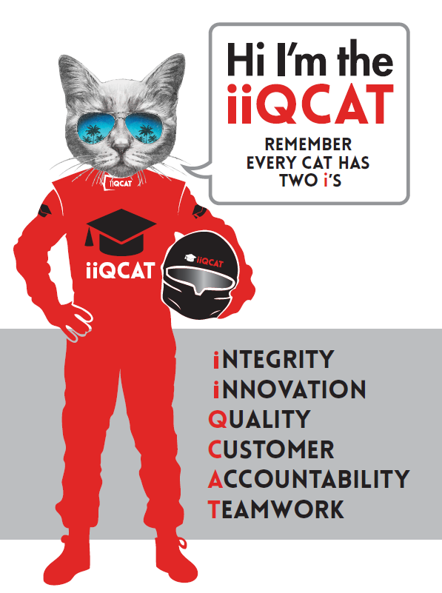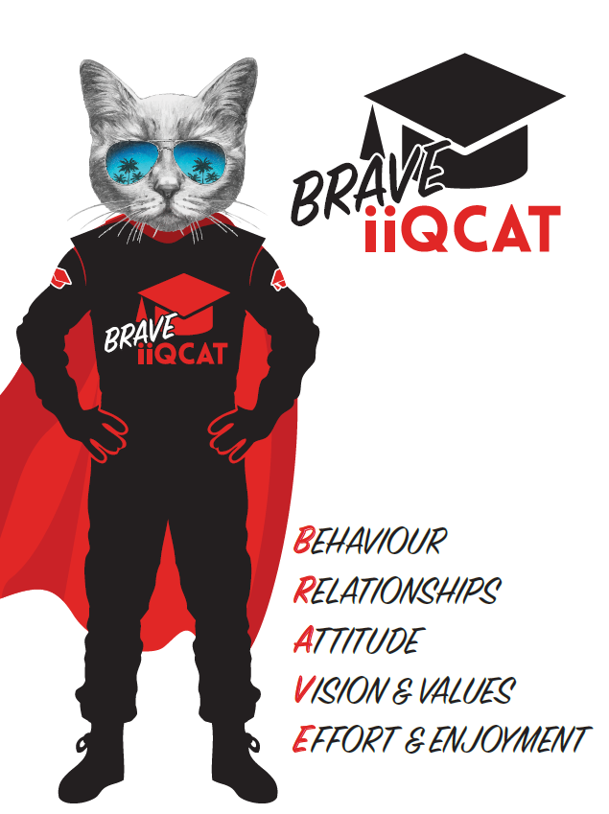
Corporation Objectives | To promote Melbourne and Victoria via the staging of two international sporting events - the Formula 1 Australian Grand Prix at Albert Park and the Australian MotoGP at Phillip Island.
Governed by | The Corporation is governed by the Australian Grands Prix Act 1994 (Vic).
Standards of behaviour | The Code of Conduct for Victorian Public Sector Employees governs the behaviour of all Corporation employees.
Human Rights | The Charter of Human Rights and Responsibilities Act 2006 is a Victorian law that sets out the basic rights, freedoms and responsibilities of all people in Victoria. The Charter requires the Corporation to act compatibly with human rights, and to consider human rights when developing policies, making laws, delivering services and making decisions.

Role Objectives | The objective of this role is to work as part of a team to drive positive brand outcomes and stakeholder relationships through engagement with schools, and associated education groups as well as to develop and facilitate the smooth delivery of the Innovation & Technology Hub project. Assist in selling exhibitor space in the expo and administrate all associated paperwork.  Role provides essential support in coordinating/facilitating practical/infrastructure aspects across education, government, industry and community initiatives.  A key component is also to support the smooth delivery of customised projects and events, key project of note being the staff uniform management and distribution process.
Core Responsibilities | Customised project Coordination  - AGPC staff uniform – support the delivery and distribution process for staff uniform. Inclusive of stakeholder management  - Undertake proactive (and productive) lead generation through a structured and disciplined approach involving: cold calling, client visits, cross selling and networking  - Develop/Collate all exhibitor paper work inclusive of prospectus documents, EOI forms, T&C’s documentation, working safely for the AGPC, insurance declarations, Parks Victoria documentation and debrief documentation  - Lead/chase payment issues and resolve  - Coordinate all areas of site build and preparation for the Innovation and Technology Hub, directional signage and approvals/set up as well as at event infrastructure build dealings  - Manage schools@grandprix.com.au enquiries and delivery of all school’s communications  - Continually build education program/s (Driving Learning and Learn Trackside) registrations/awareness levels for event day registrations and seminars/workshops (annual targets)  - Coordinate seminar/workshop timetabling process  Partnership project execution  - Support the smooth delivery of Government partnerships and activities inclusive of Australian Defence Force, State Government aligned partnerships (Industry sector), Department of Education, Victoria Police, Australian Road Safety Foundation and/or similar.  - Coordinate exhibitor site bump in/out processes  - Become a point of contact for all exhibitors and third parties involved in the Industry and Innovation Precinct  At Event responsibilities  - Exhibitor main point of contact  - Supervisor of Industry and Innovation Precinct and all facilities/timetabling included  - Manage main stage activity/support paddock stage in regard to education content  - Support for schools ticketing and all associated communications  At the reasonable request of your Manager; General Manager and/or the Chief Executive Officer, role responsibilities may be altered at any time. Changes will be tied to the Corporation’s strategic objectives, workforce planning and the structural alignment of the Corporation.  Governance  Adhere to Corporation policies, procedures, and directives regarding standards of workplace behaviour in completing job duties and assignments.  Conducting every aspect of work in a trustworthy, reliable and transparent manner, and maintaining the highest ethical standards.  Customer Service  Putting internal and external customers first, building strong relationships and ensuring that the approach is responsive to the needs of the internal/external customer.  Encouraging openness and trust by sharing information widely, listening, welcoming constructive challenge and encouraging free dialogue.  Continuous Improvement  Taking initiative to improve operations/services/products and systems so that they are consistent with the Corporation’s strategic direction and values; incorporating innovation and experimentation into daily work.  Health and Safety  To assist the Corporation in meeting its health and safety obligations you will be required to:  - Actively participate in the reporting of hazards, incidents and near misses.  - Take corrective action to address or mitigate any risks or hazardous situations throughout the course of your work.  - Take reasonable care for your own health and safety, and for the health and safety of others.  - Adhere to the Corporation’s various policies, procedures, work practices and standard operating procedures.  - Perform your role in accordance with any specific responsibilities as outlined in the Corporation’s safety management system.  To enable the Corporation to meet its obligations for providing a healthy and safe working environment for you, you must inform your manager of any issues which may impact your ability to safely perform your role.  Environmental Considerations  Cooperate with the Corporation regarding caring for the environment, by acting in a sustainable way and minimising environmental impact by adhering to the Corporation’s policies, procedures and work practices.

Person Specification

Qualifications and Experience | 2-3 years prior experience in a similar role  Tertiary or higher qualifications in marketing, event management, project management or similar discipline.  Skills and experience in working with children, must have Working with Children’s Certificate  Exceptional communication and influencing skills  Proven ability to generate, grow and retain sales accounts, through a combination of discipline and creativity.  Maturity, initiative, and the ability to maintain a calm and controlled demeanour in a fast paced and complex environment  Exceptional organisation, problem solving and time management skills with the ability to balance multiple priorities taking on board strategic business considerations  The ability to work autonomously and independently, and as a constructive team member, as required

Relevant Traits and Characteristics | Customer Service  - Demonstrated achievement in and enthusiasm for the provision of quality customer service  - Immediately respond to customers’ needs or concerns to ensure the quality of service meets agreed standards  Teamwork, Adaptability and Resilience  - Demonstrated commitment to teamwork and the maintenance of a supportive work environment  - Ability to work effectively as part of a team in a fast-changing environment  - Keeping calm by demonstrating a capacity to positively deal with unanticipated problems and changing circumstances  Interpersonal, Verbal and Written Communication  - Well-developed written communication ability  - Strong interpersonal and communication skills  - An ability to liaise, negotiate and constructively provide and accept feedback from staff at all levels  Organisation and Planning  - Organisational and planning skills in managing a personal workload in a busy environment with conflicting demands  - Ability to meet deadlines  Technology  - Experience in the use of Microsoft desktop products such as Word, Excel, Outlook and PowerPoint  - Experience in information management systems, including internet and on-line environments  Continuous Learning and Professional Development  - Demonstrated commitment to continual professional and personal development

