Position: | Risk and Safety Manager
Division: | Risk & Operations
Department: | Operations
Reporting to | Division Manager – Risk & Operations
Employment Type | Long Term Contract

Key Relationships | Internal  AGPC General Managers and Division Managers  Infrastructure Team  Venue Operations Team  Motorsport, Entertainment & Industry Team  Activations Team  Performance & Culture Team  Strategy & Contracts Team  Storage Yard Operations staff  Other internal stakeholders as relevant and appropriate  External  Confederation of Australian Motorsport (CAMS)  Motorcycling Australia (MA)  APP Corporation (Engineering Project Managers)  Phillip Island Grand Prix Circuit  VMIA (Victorian Managed Insurance Authority)  External safety and risk consultants  Victorian WorkCover Authority and regulatory authorities  Contractors/suppliers  Security service providers  Victoria Police and other emergency services  Port Phillip Council, Melbourne City Council, Stonnington City Council, Bass Coast Shire Council  Formula One  DORNA  Key suppliers and commercial partners  Other stakeholders as relevant and appropriate

Values | Knowledge of and consistent demonstration of the Corporation’s IIQCAT values: Integrity, Innovation, Quality, Customer, Accountability, Teamwork.  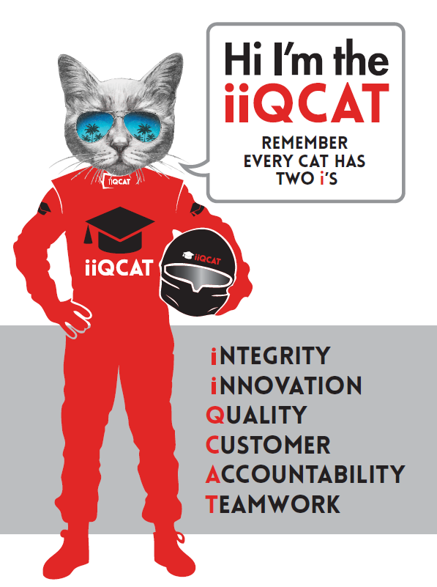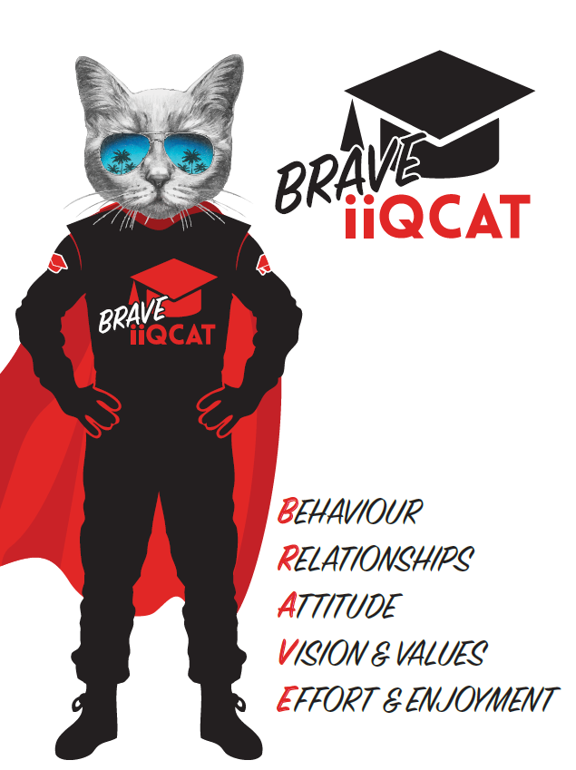
Corporation Objectives | To promote Melbourne and Victoria via the staging of two international sporting events - the Formula 1 Australian Grand Prix at Albert Park and the Australian MotoGP at Phillip Island.
Governed by | The Corporation is governed by the Australian Grands Prix Act 1994 (Vic).
Standards of behaviour | The Code of Conduct for Victorian Public Sector Employees governs the behaviour of all Corporation employees.
Human Rights | The Charter of Human Rights and Responsibilities Act 2006 is a Victorian law that sets out the basic rights, freedoms and responsibilities of all people in Victoria. The Charter requires the Corporation to act compatibly with human rights, and to consider human rights when developing policies, making laws, delivering services and making decisions.

Role Objectives | - The objective of the position is to support the development, implementation and monitoring of the AGPC Risk and Safety Management Systems, ensuring effective and systematic management of risk across the organisations business activities.  - Ensure effective safety and risk management practices are established, implemented and embedded across the organisation and events with the overall aim of creating a safe and healthy environment for staff, contractors, volunteers, event personnel and the public.
Core Responsibilities | - General  - Foster a positive workplace culture through collaboration, engagement, consultation and inclusion.  - Develop and implement the risk and safety frameworks to support the effective identification, mitigation and monitoring of risks and opportunities.  - Consult with key stakeholders when developing or improving frameworks, systems and procedures to promote an effective change management program.  - Proactively engage with and provide support to AGPC departments and team personnel to ensure key deliverables are met.  - Oversee the successful site safety operations across the breadth of AGPC business activities including events, construction, office, storage yard and logistics.  - Ensure conformance to AGPC policies and procedures.  - Take corrective action to address or mitigate any risks or hazardous situations throughout the course of your work.  - Take reasonable care for your own health and safety, and for the health and safety of others.  - Assist with budget and business planning for the Risk & Operations department, processing of invoices and financial tracking of the risk and safety budget.  - Systems  - Develop, implement, monitor and continuously improve AGPC’s risk and safety management systems in accordance with the strategic priorities, action plan and risk profile.  - Consult with key internal and external stakeholders when developing, testing or changing systems and processes.  - Facilitate the ongoing development and enhancement of organisational and departmental risk registers.  - Contribute to the development and delivery of the internal audit and assurance program to demonstrate due diligence, validate implementation and enable continuous improvement.  - Assist with the implementation and continuity of existing management systems including the Timeline Manager, Risk Manager, Intranet etc  - Risk Management  - Deliver improved risk management outcomes through the effective development and implementation of risk mitigation strategies.  - Liaise with key internal and external stakeholders to delivery operational requirements, clear and efficient systems and work practices.  - Undertake and facilitate risk assessments in relation to key organisational risks, operational activities and event activations (where required).  - Provide leadership and support to AGPC personnel, contractors and stakeholders on risk, health and safety matters.  - Facilitate and participate in key consultation forums including committees, briefings, meetings and other relevant forums.  - Liaise with regulatory authorities and act as the first point of contact for regulator liaison.  - Consult, engage and monitor contractor and third party activities including high risk work activities with respective stakeholders, provide feedback and collaboratively manage identified issues.  - Liaise with relevant persons from contractors, safety staff, event operations staff, Police and Emergency Services and Security to ensure that issues raised are appropriately addressed.  - Assist with the development and implementation of emergency management arrangements in consultation with key internal and external stakeholders.  - Oversee, recruit, develop, manage and provide support to the Event Safety Officers.  - Carry out planned inspections, audits, monitoring and testing of critical plans, procedures and practices.  - Ensure an active presence across the event site, conducting regular walk-arounds, safety inspections and identify safety concerns and risk issues which may require intervention or control.  - Ensure the successful implementation of event related health and safety initiatives.  - Facilitate the joint consultation and resolution of risk, health and safety matters.  - Assist in the reporting and/or rectifying of any safety issues identified Inspecting, observing and testing critical safety requirements and risk controls  - Facilitate / co-facilitate incident investigation reported and relevant regulatory consultation.  - Participate in / deliver relevant pre-event briefings and debriefs.  - Readiness Program  - Assist in the development and delivery of the event readiness program, including the establishment of a schedule, facilitation of readiness exercises and implementing corrective actions to address risks, threats and vulnerabilities.  - Timeline Manager  - Assist in the development and delivery of the corporate timeline manager program, including the establishment of an annual plan, identification of key deliverables, timelines, compliances and business obligations.  - Implement a program to embed a sustainable process across the business to ensure accountability for completion of key deliverables and effective monitoring of progress.  - Exercises, Training and Briefings  - Collaborate with key stakeholders on the development of risk, safety and emergency management exercises.  - Development and delivery of event safety briefings.  - Development and delivery of key risk and safety staff training sessions.  - Develop and deliver training / development programs to improve staff and or contractor / third party risk management capabilities.  - Venue Operations  - Provide support to the broader Venue Operations Team in the effective and safe delivery of key operations including track protection, track invasion, pit lane walks and ancillary events.  - Assist with customer service and experience initiatives and practices.  - Fulfil duty manager role in GP Command for both events.  - Liaise with key agencies including Formula One, DORNA, CAMS, Emergency Services, MSS Security, APP, Victoria Police and Teams in relation to safety arrangements – including relevant briefings.  - Insurance  - Assist with the placement and renewal of annual and event-based insurances.  - Provide regular updates to the VMIA on specific insurance requirements in the lead up to events.  - Manage claims in consultation with the relevant stakeholders and develop subsequent management plans as required.  At the reasonable request of your Division Manager; General Manager and/or the Chief Executive Officer, role responsibilities may be altered at any time. Changes will be tied to the Corporation’s strategic objectives, workforce planning and the structural alignment of the Corporation.  Governance  Adhere to Corporation policies, procedures, and directives regarding standards of workplace behaviour in completing job duties and assignments.  Conducting every aspect of work in a trustworthy, reliable and transparent manner, and maintaining the highest ethical standards.  Customer Service  Putting internal and external customers first, building strong relationships and ensuring that the approach is responsive to the needs of the internal/external customer.  Encouraging openness and trust by sharing information widely, listening, welcoming constructive challenge and encouraging free dialogue.  Continuous Improvement  Taking initiative to improve operations/services/products and systems so that they are consistent with the Corporation’s strategic direction and values; incorporating innovation and experimentation into daily work.  Health and Safety  To assist the Corporation in meeting its health and safety obligations you will be required to:  - Actively participate in the reporting of hazards, incidents and near misses.  - Take corrective action to address or mitigate any risks or hazardous situations throughout the course of your work.  - Take reasonable care for your own health and safety, and for the health and safety of others.  - Adhere to the Corporation’s various policies, procedures, work practices and standard operating procedures.  - Perform your role in accordance with any specific responsibilities as outlined in the Corporation’s safety management system.  To enable the Corporation to meet its obligations for providing a healthy and safe working environment for you, you must inform your manager of any issues which may impact your ability to safely perform your role.  Environmental Considerations  Cooperate with the Corporation regarding caring for the environment, by acting in a sustainable way and minimising environmental impact by adhering to the Corporation’s policies, procedures and work practices.

Person Specification

Qualifications and Experience | It is highly desirable that the person will have appropriate tertiary qualifications application for the position. Qualifications of relevance may include, but are not limited to:  - Graduate Certificate / Diploma OH&S  - Certificate IV Training & Assessment  - Diploma of Event Safety Management  Demonstrated ability to manage and report on key project deliverables.  Communication Skill - applicants will be required to have strong oral and written communication skills which clearly articulate the requirements of the risk and safety management system.  Related experience in Risk Management, OH&S and event management or sports sector is highly regarded.  Knowledge of incident management protocols, including response, investigation and regulatory reporting requirements.

Relevant Traits and Characteristics | Customer Service  - Demonstrated achievement in and enthusiasm for the provision of quality customer service  - Immediately respond to customers needs or concerns to ensure the quality of service meets agreed standards  Teamwork, Adaptability and Resilience  - Demonstrated commitment to teamwork and the maintenance of a supportive work environment  - Ability to work effectively as part of a team in a fast-changing environment  - Keeping calm by demonstrating a capacity to positively deal with unanticipated problems and changing circumstances  Interpersonal, Verbal and Written Communication  - Well-developed written communication ability  - Strong interpersonal and communication skills  - An ability to liaise, negotiate and constructively provide and accept feedback from staff at all levels  Organisation and Planning  - Organisational and planning skills in managing a personal workload in a busy environment with conflicting demands  - Ability to meet deadlines  Technology  - Experience in the use of Microsoft desktop products such as Word, Excel, Outlook and PowerPoint  - Experience in information management systems, including internet and on-line environments  Continuous Learning and Professional Development  - Demonstrated commitment to continual professional and personal development

