Position: | Sales Operations Manager
Division: | Sales and Commercial
Department: | Sales, Commercial & Marketing
Reporting to | Manager – Activations, Sponsorship and Corporate Hospitality
Direct Reports | Sales Operations Coordinator, Sales Operations & CRM Coordinator
Employment Type | Permanent

Key Relationships | Internal  General Manager - Sales, Commercial and Marketing  Manager/s - Business Development  Business Development Executives/s  Manager - Activations, Sponsorship and Corporate Hospitality  Finance Analyst  Activations Executive/s  All Staff  Other internal stakeholders as relevant and appropriate  External  Key event partners, major sponsors, suppliers, clients  Key international stakeholders i.e. Formula One and Dorna  Key suppliers and commercial partners  Other stakeholders as relevant and appropriate

Values | Knowledge of and consistent demonstration of the Corporation’s IIQCAT values: Integrity, Innovation, Quality, Customer, Accountability, Teamwork.  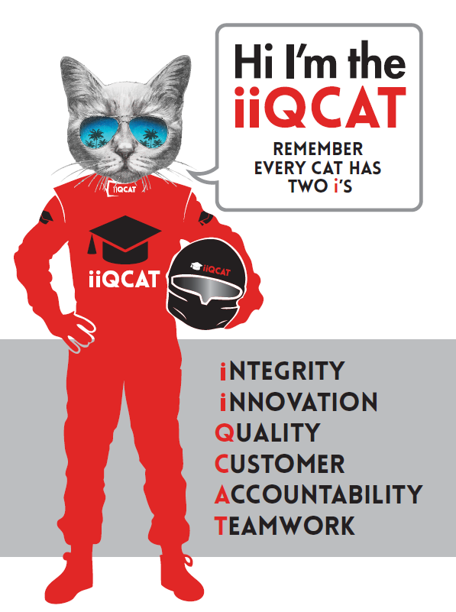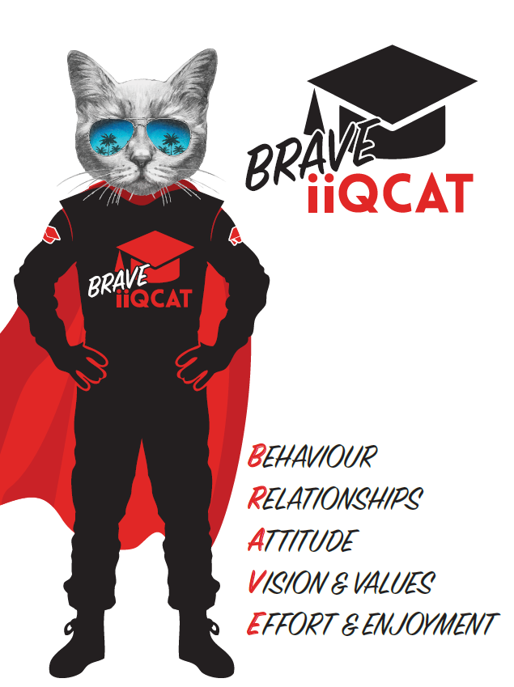
Corporation Objectives | To promote Melbourne and Victoria via the staging of two international sporting events - the Formula 1 Australian Grand Prix at Albert Park and the Australian MotoGP at Phillip Island.
Governed by | The Corporation is governed by the Australian Grands Prix Act 1994 (Vic).
Standards of behaviour | The Code of Conduct for Victorian Public Sector Employees governs the behaviour of all Corporation employees.
Human Rights | The Charter of Human Rights and Responsibilities Act 2006 is a Victorian law that sets out the basic rights, freedoms and responsibilities of all people in Victoria. The Charter requires the Corporation to act compatibly with human rights, and to consider human rights when developing policies, making laws, delivering services and making decisions.

Role Objectives | This role is responsible for driving the sales and commercial operations to support the team to generate sales/revenue and the delivery of contractual benefits, through strategic and operational excellence.  The key areas of focus for revenue generation include corporate hospitality and sponsorship, while also shaping patron offerings and experiences during AGPC events, with the aim of ensuring a strategic, contemporary and customer -focussed approach.  This position will be an integral part of the Sales and Commercial team. The role provides administrative direction to ensure maximum revenue and increased net contribution is achieved, while ensuring that the service elements associated with these areas meet and exceed customer’s expectations.  The role requires the individual to work at all times as a member of a cohesive sales team and provide assistance to the Manager, Activations, Sponsorship and Corporate Hospitality where necessary.
Core Responsibilities | Undertaking the required elements of the role, in a way that aligns with the view to quality work practices, including but not limited to assisting and managing the sales and commercial team:  Sales Operations:  - CRM Champion – including implementation of the new system;  - Work with the Finance Analyst and Manager - Activation, Sponsorship and Corporate Hospitality to accurate manage and report on corporate facility capacity and revenue forecast;  - Ensure the Sales Operations Coordinator is communicating available stock to the Business Development Team and online ticket platforms.  - Working with Business Development Team to ensure the CRM data is accurate and sales dashboards are updated;  - Establish a comprehensive 'asset bible' for partnership sales (to be integrated with CRM);  - Work with Finance Analyst and Manager - Activation, Sponsorship and Corporate Hospitality to ensure hospitality occupancy is in line with company objectives;  - Work with Sales Coordinator to maintain and improve Ticketmaster integration;  - Sales & Commercial Uniform Champion;  - Oversee booking input requirements from Sales Coordinator;  - Manage Sales Coordinator to provide accurate reporting, data and analysis for key business reports (i.e. Weekly sales graphs, Business Planning forecasting etc);  - Develop and initiate data acquisition and sales programs to drive new business and sales retention.  Corporate Retail Sales:  - Ensure the Sales Operations & CRM Coordinator is efficiently managing the ‘Corporate Retail’ segment (Division T – Private Bookings);  - Guide and Support Corporate Retail active selling and account management; and  - Work with the Marketing Team during hospitality sales campaigns.  Finance:  - Develop accurate occupancy trackers with Financial Analysts  - Implement targets & micro-targets (i.e. blitz). Define and record the necessary steps.  - Work with relevant BD's to ensure commission is tracked accurately and provided to the finance analyst.  - Verify BD target's and results  - Work with the Finance Analyst and Sales Coordinator on sales budget and forecasting.  - Assist the Manager – Activations, Sponsorship and Corporate Hospitality to manage the departmental expense budget.  - Ensure the Sales Operations Coordinator is accurately processing expense claims and outgoing invoices in line with forecasted spends.  Marketing:  - Work with the Marketing team to implement the digital collateral briefing process with the Sales Team.  - Liaise with the Ticketing team for hospitality issue resolution  - Explore lead generation opportunities through Marketo/Marketing systems to feed to the sales team.  - Explore and manage lead generation tasks (data acquisition (including from internal events), LinkedIn, connector, point drive)  Activations:  - Play an active role in delivery of event time client requirements and assist wherever needed with the successful delivery of our corporate product on site  - Assist with the preparation and delivery of professional tailored sponsorship presentations to potential and existing sponsors of the Australian Formula 1® and Australian Motorcycle Grands Prix  Team:  Provide leadership and coaching to the Sales Coordinator  Provide support to members of the Sales and Commercial Team, to drive motivation, performance and achievement of outcomes.  All work to be done in alignment with AGPC values to ensure a cohesive, constructive and excellence-driven team culture.  Act as a role model for organisational standards, values and professionalism.  At the reasonable request of your General Manager and/or the Chief Executive Officer, role responsibilities may be altered at any time. Changes will be tied to the Corporation’s strategic objectives, workforce planning and the structural alignment of the Corporation.  Governance  Adhere to Corporation policies, procedures, and directives regarding standards of workplace behaviour in completing job duties and assignments.  Conducting every aspect of work in a trustworthy, reliable and transparent manner, and maintaining the highest ethical standards.  Customer Service  Putting internal and external customers first, building strong relationships and ensuring that the approach is responsive to the needs of the internal/external customer.  Encouraging openness and trust by sharing information widely, listening, welcoming constructive challenge and encouraging free dialogue.  Continuous Improvement  Taking initiative to improve operations/services/products and systems so that they are consistent with the Corporation’s strategic direction and values; incorporating innovation and experimentation into daily work.  Health and Safety  you will be required to:  - Actively participate in the reporting of hazards, incidents and near misses.  - Take corrective action to address or mitigate any risks or hazardous situations throughout the course of your work.  - Take reasonable care for your own health and safety, and for the health and safety of others.  - Adhere to the Corporation’s various policies, procedures, work practices and standard operating procedures.  - Perform your role in accordance with any specific responsibilities as outlined in the Corporation’s safety management system.  To enable the Corporation to meet its obligations for providing a healthy and safe working environment for you, you must inform your manager of any issues which may impact your ability to safely perform your role.  Environmental Considerations  Cooperate with the Corporation regarding caring for the environment, by acting in a sustainable way and minimising environmental impact by adhering to the Corporation’s policies, procedures and work practices.

Person Specification

Qualifications and Experience | - Appropriate tertiary qualifications (degree, diploma or certificate) in Sport or Event Management  - Experience working in events is preferred  - Proven ability to manage change in a complex environment  - Highly developed interpersonal skills, with the proven ability to build effective relationships and communicate with a diverse range of people both internal and external  - Knowledge and understanding of CRM systems, in particular Sage CRM.

Relevant Traits and Characteristics | Customer Service  - Demonstrated achievement in and enthusiasm for the provision of quality customer service  - Immediately respond to customers’ needs or concerns to ensure the quality of service meets agreed standards  Teamwork, Adaptability and Resilience  - Demonstrated commitment to teamwork and the maintenance of a supportive work environment  - Ability to work effectively as part of a team in a fast-changing environment  - Keeping calm by demonstrating a capacity to positively deal with unanticipated problems and changing circumstances  Interpersonal, Verbal and Written Communication  - Well-developed written communication ability  - Strong interpersonal and communication skills  - An ability to liaise, negotiate and constructively provide and accept feedback from staff at all levels  Organisation and Planning  - Organisational and planning skills in managing a personal workload in a busy environment with conflicting demands  - Ability to meet deadlines  Technology  - Experience in the use of Microsoft desktop products such as Word, Excel, Outlook and PowerPoint  - Experience in information management systems, iespecially CRM and booking systems.  - A broad understanding of computer systems and the ability to learn new programs will be highly important.  Continuous Learning and Professional Development  - Demonstrated commitment to continual professional and personal development

