Position: | Manager - Corporate Affairs & Communications
Division: | Corporate Affairs & Communications
Reporting to | Division Manager – Corporate Affairs & Communications
Employment Type | Full time

Key Relationships | Internal  Chief Executive Officer  Chairman  General Managers across the business  Sales and Marketing teams  External  International and National Media  Government  External Stakeholders  External agencies  F1 and MotoGP Teams  Dorna  CAMS  FIA  FOM

Values | Knowledge of and consistent demonstration of the Corporation’s IIQCAT values: Integrity, Innovation, Quality, Customer, Accountability, Teamwork.  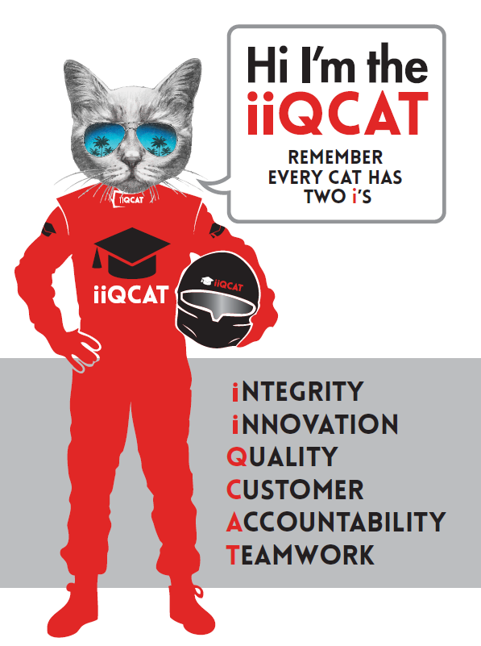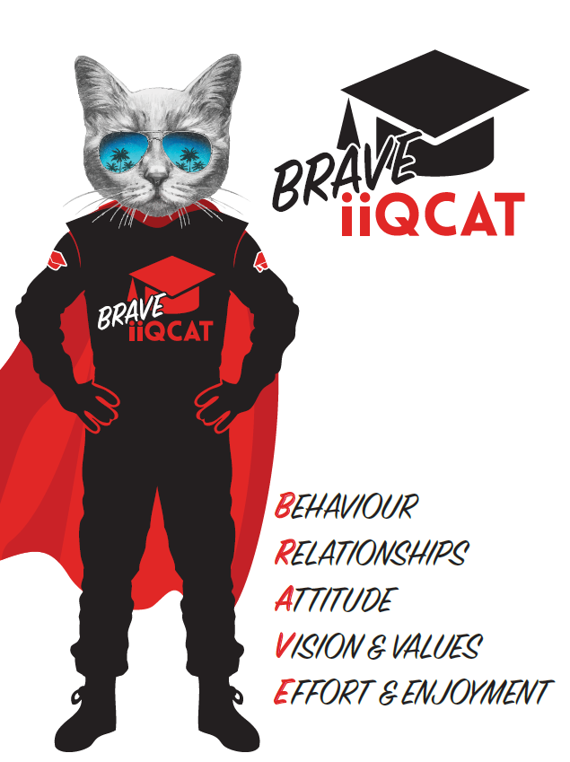
Corporation Objectives | To promote Melbourne and Victoria via the staging of two international sporting events - the Formula 1 Australian Grand Prix at Albert Park and the Australian MotoGP at Phillip Island.
Governed by | The Corporation is governed by the Australian Grands Prix Act 1994 (Vic).
Standards of behaviour | The Code of Conduct for Victorian Public Sector Employees governs the behaviour of all Corporation employees.
Human Rights | The Charter of Human Rights and Responsibilities Act 2006 is a Victorian law that sets out the basic rights, freedoms and responsibilities of all people in Victoria. The Charter requires the Corporation to act compatibly with human rights, and to consider human rights when developing policies, making laws, delivering services and making decisions.

Role Objectives | The objective of this role is to develop and manage the Australian Grand Prix Corporation’s corporate affairs and communications strategy including PR, motorsport, stakeholder engagement, media relations and special events.
Core Responsibilities | - Lead and implement a year round PR and communications strategy for the Australian Formula 1 Grand Prix and the Australian Motorcycle Grand Prix.  - Drive a proactive media strategy along with managing company media enquiries; develop and enhance relationships with key media and industry contacts.  - Develop all internal and external communications - a wide variety of media materials including press releases, statements, website and speaking notes.  - Help develop stakeholder engagement strategy.  - Liaising with and briefing the company’s PR agency for all motorsport related activities.  - Management of the editorial content of both Official Programs from flat plans to artistic direction.  - Management of media events including launches, show car runs and motorsport related announcements.  - Management, content planning, production and release of the AGPC’s podcast and newsletter for both events.  - Developing strategy for motorsport ambassador program. This includes acquisition, management and liaison.  - Liaison with team press officers for implementation of driver/rider PR opportunities in the lead-up to and during each event.  - Liaison with support categories and off-track motorsport related entertainment (ie Supercross and Crusty Demons) to drive additional event PR.  - Assist with PR/Media budget management.  Governance  Adhere to Corporation policies, procedures, and directives regarding standards of workplace behaviour in completing job duties and assignments.  Conducting every aspect of work in a trustworthy, reliable and transparent manner, and maintaining the highest ethical standards.  Customer Service  Putting internal and external customers first, building strong relationships and ensuring that the approach is responsive to the needs of the internal/external customer.  Encouraging openness and trust by sharing information widely, listening, welcoming constructive challenge and encouraging free dialogue.  Continuous Improvement  Taking initiative to improve operations/services/products and systems so that they are consistent with the Corporation’s strategic direction and values; incorporating innovation and experimentation into daily work.  Health and Safety  To assist the Corporation in meeting its health and safety obligations you will be required to:  - Actively participate in the reporting of hazards, incidents and near misses.  - Take corrective action to address or mitigate any risks or hazardous situations throughout the course of your work.  - Take reasonable care for your own health and safety, and for the health and safety of others.  - Adhere to the Corporation’s various policies, procedures, work practices and standard operating procedures.  - Perform your role in accordance with any specific responsibilities as outlined in the Corporation’s safety management system.  To enable the Corporation to meet its obligations for providing a healthy and safe working environment for you, you must inform your manager of any issues which may impact your ability to safely perform your role.  Environmental Considerations  Cooperate with the Corporation regarding caring for the environment, by acting in a sustainable way and minimising environmental impact by adhering to the Corporation’s policies, procedures and work practices.

Person Specification

Qualifications and Experience | - Degree qualified in Communications or Journalism  - Minimum of five years experience with government, corporate affairs, media relations and/or media management experience  - Excellent written and oral communication skills  - Project/event management experience  - Existing motorsport knowledge, passion and/or contacts  - Excellent computer skills including a demonstrated of Microsoft Office programs

Relevant Traits and Characteristics | Customer Service  - Demonstrated achievement in and enthusiasm for the provision of quality customer service  - Immediately respond to customers needs or concerns to ensure the quality of service meets agreed standards  Teamwork, Adaptability and Resilience  - Demonstrated commitment to teamwork and the maintenance of a supportive work environment  - Ability to work effectively as part of a team in a fast-changing environment  - Keeping calm by demonstrating a capacity to positively deal with unanticipated problems and changing circumstances  Interpersonal, Verbal and Written Communication  - Well-developed written communication ability  - Strong interpersonal and communication skills  - An ability to liaise, negotiate and constructively provide and accept feedback from staff at all levels  Organisation and Planning  - Organisational and planning skills in managing a personal workload in a busy environment with conflicting demands  - Ability to meet deadlines  Technology  - Experience in the use of Microsoft desktop products such as Word, Excel, Outlook and PowerPoint  - Experience in information management systems, including internet and on-line environments  Continuous Learning and Professional Development  - Demonstrated commitment to continual professional and personal development

