SCHEDULE 2

Position: | Activations Manager
Division: | Activations
Department: | Sales & Commercial
Reporting to | Senior Manager – Activations
Employment Type | Fixed Term Contract – Maternity Cover

Key Relationships | Internal  Activations Team  Business Development Team  Sales Operations Team  Consumer Sales  Infrastructure  Venue Operations  Marketing  Corporate Affairs & Communications  Motorsport, Entertainment & Industry  Safety and Risk  External  Event Partners, sponsors and hospitality clients  Promotional Agencies as relevant to role  Contemporaries/Peers within the event space  Corporate Caterers  Other stakeholders as required/relevant

Values | Knowledge of and consistent demonstration of the Corporation’s IIQCAT values: Integrity, Innovation, Quality, Customer, Accountability, Teamwork.  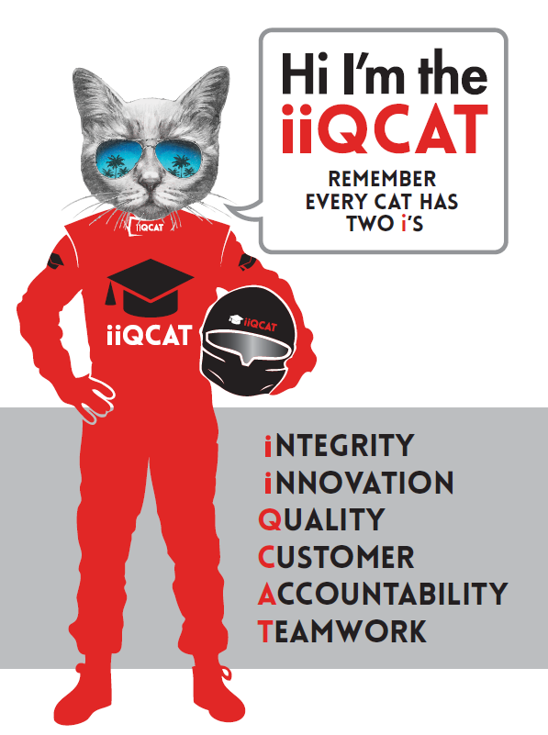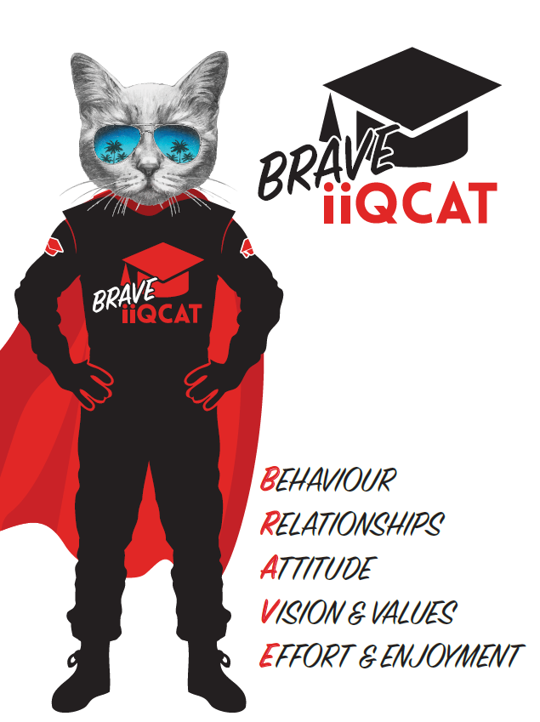
Corporation Objectives | To promote Melbourne and Victoria via the staging of two international sporting events - the Formula 1 Australian Grand Prix at Albert Park and the Australian MotoGP at Phillip Island.
Governed by | The Corporation is governed by the Australian Grands Prix Act 1994 (Vic).
Standards of behaviour | The Code of Conduct for Victorian Public Sector Employees governs the behaviour of all Corporation employees.
Human Rights | The Charter of Human Rights and Responsibilities Act 2006 is a Victorian law that sets out the basic rights, freedoms and responsibilities of all people in Victoria. The Charter requires the Corporation to act compatibly with human rights, and to consider human rights when developing policies, making laws, delivering services and making decisions.

Core Responsibilities | Activations:  This role is responsible for the activation and  servicing of client accounts, and encompasses  all AGPC assets and partnership opportunities,  from corporate hospitality products to  sponsorship activations.  This role manages an allocated portfolio of clients, to ensure that they receive the highest level of service and engagement in the delivery of contracted services. In doing so, this function plays a vital role in influencing client retention and re-signing behaviours, and the function is incentivised on this basis.  The role focuses on the following areas of activity:  - Management of The Paddock Club including seamless delivery of all private client suites and AGPC shared facilities which includes supervision of contracted short term staff and suite budgets  - Work with AGPC contractors (ie. Harry the Hirer) to design fit-out and manage all AGPC shared hospitality facilities around circuit  - Work with appointed design agency to deliver and project manage The Lounge to be aligned with organisation and partner objectives  - Where applicable, work with private Paddock Club clients to deliver additional partner activations (ie. Rolex)  - Delivery of sponsorship contractual rights and benefits  - Delivery of corporate hospitality  - Relationship/account management of sponsors  - Development of legal briefs for sponsor contracts  - Assisting Business Development team with proposals/quotations  - Coordination of special events  - Coordination of debrief documents  - Facilitation of operational processes, i.e. safety and insurance, accreditation, infrastructure ordering and planning, invoicing and other related administrative tasks  In undertaking these functions, this role is part of a wider team which is expected to act as ambassadors for the Corporation, its events and products; and in doing so to set the benchmark in terms of professionalism and polish.  Work proactively with the Business Development  Team to transition signed clients/partners, as  seamlessly and professionally as possible  Engage in proactive and customer-focussed relationship management to promote long term engagement/ retention and maximisation of revenue potential  Work collaboratively with both the Activation and Sales Operations Teams to ensure accurate, timely and professional scoping, planning and delivery of client requirements.  Play an active role in delivery of event time client requirements.  Undertake all housekeeping and administrative tasks required to maintain account management tools, systems and resources (E.g. database maintenance).  Governance  Adhere to Corporation policies, procedures, and directives regarding standards of workplace behaviour in completing job duties and assignments.  Conducting every aspect of work in a trustworthy, reliable and transparent manner, and maintaining the highest ethical standards.  Customer Service  Putting internal and external customers first, building strong relationships and ensuring that the approach is responsive to the needs of the internal/external customer.  Encouraging openness and trust by sharing information widely, listening, welcoming constructive challenge and encouraging free dialogue.  Continuous Improvement  Taking initiative to improve operations/services/products and systems so that they are consistent with the Corporation’s strategic direction and values; incorporating innovation and experimentation into daily work.  Health and Safety  To assist the Corporation in meeting its health and safety obligations you will be required to:  - Actively participate in the reporting of hazards, incidents and near misses.  - Take corrective action to address or mitigate any risks or hazardous situations throughout the course of your work.  - Take reasonable care for your own health and safety, and for the health and safety of others.  - Adhere to the Corporation’s various policies, procedures, work practices and standard operating procedures.  - Perform your role in accordance with any specific responsibilities as outlined in the Corporation’s safety management system.  To enable the Corporation to meet its obligations for providing a healthy and safe working environment for you, you must inform your manager of any issues which may impact your ability to safely perform your role.  Environmental Considerations  Cooperate with the Corporation regarding caring for the environment, by acting in a sustainable way and minimising environmental impact by adhering to the Corporation’s policies, procedures and work practices.

Person Specification

Qualifications and Experience | - Minimum of 5 years’ experience in managing activations and sponsorship delivery.  - Minimum of 5 years’ experience in events industry and specialised events.  - Minimum of 5 years’ experience in account management roles.

Relevant Traits and Characteristics | Customer Service  - Demonstrated achievement in and enthusiasm for the provision of quality customer service  - Immediately respond to customers needs or concerns to ensure the quality of service meets agreed standards  Teamwork, Adaptability and Resilience  - Demonstrated commitment to teamwork and the maintenance of a supportive work environment  - Ability to work effectively as part of a team in a fast-changing environment  - Keeping calm by demonstrating a capacity to positively deal with unanticipated problems and changing circumstances  Interpersonal, Verbal and Written Communication  - Well-developed written communication ability  - Strong interpersonal and communication skills  - An ability to liaise, negotiate and constructively provide and accept feedback from staff at all levels  Organisation and Planning  - Organisational and planning skills in managing a personal workload in a busy environment with conflicting demands  - Ability to meet deadlines  Technology  - Experience in the use of Microsoft desktop products such as Word, Excel, Outlook and PowerPoint  - Experience in information management systems, including internet and on-line environments  Continuous Learning and Professional Development  - Demonstrated commitment to continual professional and personal development

