Position Description: Golf Course Superintendent
Auburn Golf Course & Woodville Golf Course
PRIMARY ROLE STATEMENT
Our purpose is to provide valuable services that strengthen and support the Cumberland Community.
Decisions, actions and behaviours are governed by our Code of Conduct and Values and the delivery of our services is aligned to the commitments outlined in our Community Strategic Plan, Delivery Plan and Operational Plan. All employees have an accountability to ensure work and conduct is aligned to these.
In contributing to the overarching vision, the Golf Course Superintendent will be held accountable for the daily management and maintenance of Council’s recreational assets – Auburn Golf Course and Woodville Golf Course ensuring these assets are maintained to meet communities’ expectations.

KEY DUTIES AND RESPONSIBILITIES
- Key Relationships
This position reports directly to the Supervisor in the Recreational Assets team. Other key relationships include the Manager Premium Recreational Assets, all other Council staff, members of the public/residents, employees of other Councils, product and equipment suppliers and contractors and Golf Course Professionals.

- Principal Responsibilities

  - Operations:

- To plan, develop and implement all maintenance and construction works associated with Auburn and Woodville golf courses in line with Council policy and legislative requirements providing consistency across councils two courses
- Optimise golf course productivity through implementing current industry best practices providing consistency across councils two courses, including but not limited to
-Developing and regularly reviewing golf course maintenance plans
-Developing and regularly reviewing chemical application programs
-Developing and regularly reviewing fertiliser application programs
- Maintaining complete and accurate records of works undertaken
- Develop site masterplans and course design to improve course accreditation and grading
- Develop a strategic management plan
- Identify opportunities, problems and issues as they relate to the golf course and exterior grounds and recommend appropriate action with a proactive approach
- Establish direction and priorities for the team in line with Operational Plan
- In conjunction with golf course teams undertake programmed and reactive maintenance works in Council’s courses including but not limited to:
- grounds / renovations
- litter removal
- trees
-gardens
-street verge mowing
- To operate golf course equipment
- Undertake traffic control operations
- Ensure plant and equipment is correctly used, maintained and kept in a clean and tidy condition
- Participate in trials of new techniques and systems of work to improve work practices and productivity
- Carry out all duties in accordance with all relevant legislative, industrial and Council policy requirements and standards and procedures including the areas of EEO, Code of Conduct, all staffing policies
- Maintain a high standard of work quality, safety and environmental protection in all works under your control and have a proactive approach
- Practically apply WH&S principles and maintain all requirements of the Work Health and Safety legislation
- Conduct on site risk assessments
- Actively participate in all training requirements including the training of other work colleagues
- Act in a manner consistent with the values of Cumberland Council and demonstrate integrity, inspiring trust, avoiding conflicts of interest and promoting high standards in all work
- Undertake other duties as required.

2.2 People Management

- Supervise and coordinate the activities of teams and monitor and quality check work outputs across both sites
- Support golf course teams (including tradespersons, team members and apprentices) by leading, coaching and providing technical support
- Ensure plant and equipment is operated and maintained are per WH&S and manufacturers guidelines
- Ensure all staff and contractors are compliant with relevant WH&S legislation and procedures
- Carry out or participate in recruitment and selection for all relevant roles

2.3 Finance:

- Develop cost, quantity and time estimates for activities
- Adjust work approach to suit budget restrictions
- Assist in preparation and administration of the annual budgets and grant funding
- Contribute to continuous improvements involving internal systems of work

2.4 Customer Service

- Lead, investigate and respond to customer enquiries in a timely manner
- Be responsive to and supportive of customer requests
- Assist with service delivery issues by using a flexible approach to problem solving and by addressing individual customer concerns and expectations
- Compliance with Council complaints management policy and procedures

- Child Safe Organisation
- This position is not currently designated as child related but Council may at any time choose to apply to the NSW Office of the Children’s Guardian to have this role designated as child related, even though it may not involve face to face contact with children. Workers would be duly notified if this was to occur.
- Council fully supports the aims and objectives of NSW Child Protection Legislation and associated provisions, and will implement all necessary measures to ensure a safe and supporting Council environment, which endeavours to promote child safe, child friendly practices.

- Fraud and Corruption Prevention
Council constantly strives to improve our practices to ensure we uphold the highest ethical standards. Council has a zero tolerance approach to any fraud and corruption, and all staff are required to participate in and support fraud and corruption control initiatives. All officers must report any potential fraud or corruption misconduct to Council’s Internal Ombudsman in the first instance, who will notify the General Manager. Council also has a Public Interest Disclosures Policy which you should review, outlining that Council will consider each report and make every attempt to protect the staff member making the report from any form of reprisal.

- Risk Management
  - Worker Risk Responsibilities
Staff are required to act at all times in a manner which does not place at risk the health and safety of themselves or any other person in the workplace. Staff should provide input into various risk management activities. Staff are responsible and accountable for taking practical steps to minimise Council’s exposure to risks including contractual, legal and professional liability in so far as is reasonably practicable within their area of activity and responsibility.

- Work Health & Safety
In accordance with councils WHS policy 2018, all employees have a responsibility to take reasonable care of their own health and safety, and that of others. To meet this commitment, all levels of management shall be held responsible for ensuring all staff are aware of and have agreed to work to this policy.

- Energy & Water Commitment Statement
7.1 Employees Responsibilities
All staff are responsible for taking practical steps to reduce Council’s energy and water use within their activity and responsibility.

- Record Keeping
To accept and undertake the requirements and obligations for effective recordkeeping as outlined in the document 'What have records got to do with me?' and to ensure the creation, careful handling and preservation of records which are entrusted to my care, as an employee of council.

ORGANISATION STRUCTURE
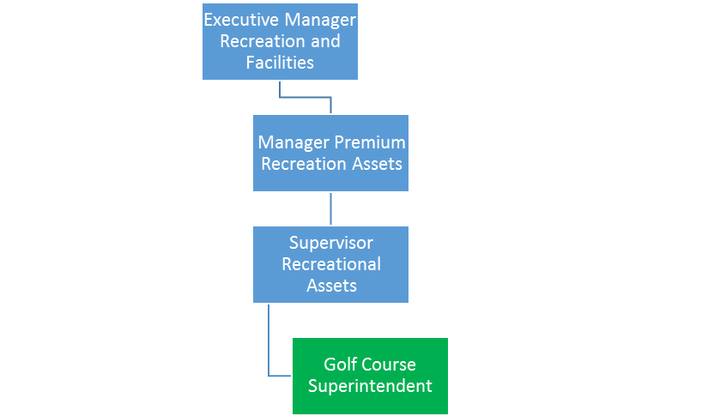

ABILITIES, QUALIFICATIONS, EXPERIENCE
Essential
- Diploma in Sports Turf Management or equivalent, combined with extensive relevant experience
- Relevant experience and demonstrated understanding of golf course and industry best-practice
- Demonstrated ability to lead, manage & supervise multiple teams across multiple sites (includes apprentices, contractors & volunteers) and contribute to team goals and outcomes
- Experience in high level managing of delivery services in an operation based organisation
- Proven experience in a supervisory role, with a demonstrated ability to achieve outcomes within budget and within defined time lines
- Demonstrate an excellent working knowledge of turf management
- Demonstrate ability to provide strategic reports
- Demonstrate an ability to solve problems by examination and analysis of available options
- Demonstrated ability to deal in a positive and courteous manner with the public and other workers
- Be able to demonstrate a strong customer focus with sound customer service skills and the ability to embrace a system of change and continual improvement.
- Proven ability to lead multiple teams across multiple sites with good interpersonal skills
- Sound knowledge and practical application of WH&S principles and the Work Health and Safety legislation
- Computer literacy, particularly in the MS office suite packages and Tech1
- Possess AQF3 Chemical Certification
- Possess a current Class C Drivers Licence

Desirable
- Qualified to Certificate III in Horticulture (Parks and Gardens)/Landscape Construction with relevant experience in gardens maintenance and enhancement, arboriculture and or bushcare relevant trade qualifications
- Current Senior First Aid Certificate.
- Ability to Implement Traffic Control Plans (Yellow Card)
- Current qualification as a Traffic controller (Blue Card)
- Current Chainsaw Accreditation

Employment Screening Required
- Qualifications verification
- Licence Check if driving Council vehicles
Position & Est Number
Classification
Job Function Group:
Reports to: | Supervisors and Managers
Staff Reporting Responsibilities: | Nil
Budget Responsibility: | Nil

Date:
Agreed:

_____________________________ __________________________________
[Insert Employee Name] Employee signature

