Apprentice Heavy Vehicle Mechanic
Position Description

1. POSITION SUMMARY

Job Title: | Apprentice Heavy Vehicle Mechanic
Position No: | 8150.000
Department: | Infrastructure & Operations
Reports to: | Senior Mechanic
Band and Level: | T2 – T5
Grade: | 4 Year Apprenticeship
Updated: | August 2018

2. OVERVIEW

The position of Apprentice Heavy Vehicle Mechanic is to carry out to a satisfactory level of service the repair, maintenance, modification and servicing of Council’s plant and vehicle fleet in both field and workshop conditions under the supervision of workshop staff.
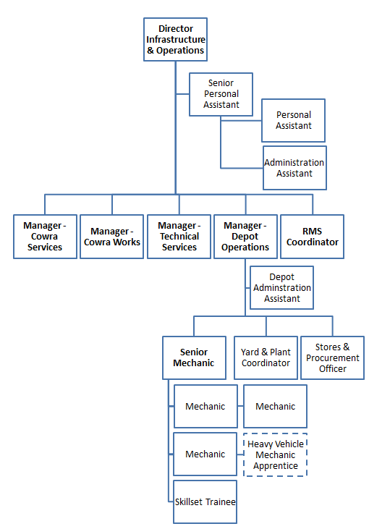

3. RESPONSIBILITIES AND DUTIES

The duties and responsibilities listed here are considered essential to achieving the primary objectives of this job. These duties will be undertaken in such a manner that will enable the section to operate in an effective and efficient manner and within budgetary constraints.

Essential duties and responsibilities include the following:

- Successfully complete all apprenticeship requirements relating to identified units within the Certificate III in Heavy Commercial Vehicle Mechanical Technology – Trade qualification.
- Under the guidance of the workshop staff carry out the servicing and repair of fleet, plant and equipment in accordance with manufacturer’s recommendations and acceptable industry and Council standards.
- Under the guidance of the workshop staff carry out auto electrical, hydraulic, welding, and fabrication tasks.
- Under the guidance of the workshop staff operate plant and equipment for the purpose of testing.
- To be conversant with all safety aspects associated with the workplace.
- Accurately complete relevant timesheets, log sheets, job cards and record information and other paperwork as required by supervisors and Council policies.
- Provide input to enhance workshop operations.
- To perform allocated duties and make a positive contribution to work quality, productivity, in a cost efficient manner.
- Act in accordance with Council’s Code of Conduct, Safety Policy and other policies as advised.
- Any other task allocated by your supervisor.
- Maintain a sound knowledge of current legislation, standards, policies and guidelines relevant to area of responsibility, and ensures that activities comply with relevant legislation, standards and policies.
- Communicate known problems/issues, including but not limited to: hazards, risks, incidents, accidents and near misses in a timely manner to direct supervisor.
- Perform allocated duties utilising initiative, making positive contributions to work quality, productivity, and to work to a timetable, in a cost effective manner.
- Other duties that may arise at the direction of the Senior Mechanic that are consistent with the level of competencies of the position and in line with the principles of multi-skilling.

4. KNOWLEDGE, SKILLS AND ABILITIES

To perform this job successfully, an individual must be able to perform each essential duty satisfactorily. The requirements listed below are representative of the knowledge, skill, and/or ability required.

- Authority and Accountability
- The position is accountable to the Senior Mechanic.
- Comply with legislative, technical, industry and Council standards.
- Comply with WHS Act, Regulations and Cowra Shire Council policies and procedures.
- The completion of regularly occurring tasks under the guidance of the workshop staff on a daily basis.

- Judgement and Problem Solving
- Be prepared to learn the skills required to assess situations and determine processes, tools and solutions to problems. (Guidance is available).
- Be prepared to learn to minimise costs.
- Be prepared to learn the skills required to identify and solve technical problems related to plant and equipment.
- Contribute to group discussions in problem solving.

- Specialist Skills and Knowledge
- Be prepared to undertake training to develop all aspects of the trade.

- Management Skills
- The position of Apprentice Mechanic does not have any supervisory responsibilities.

- Interpersonal Skills
- Ability to read and comprehend simple instructions, and write short correspondence and memos.
- Ability to read and comprehend safety signs/rules, SWMS, technical publications, operating instructions and government regulations.
- Communication skills to explain situations or advise others.
- Ability to accurately complete job details and timesheets and write simple correspondence.
- Ability to deal courteously and effectively with the public and other staff members.
- Promote a positive image of the organisation.

- Qualifications and Experience
- Year 10.
- Basic computer skills (in Microsoft Office and data entry).

5. WORK, HEALTH & SAFETY RESPONSIBILITIES

All employees are responsible for Work Health and Safety (WHS) for Council and their duties include:
- Complying with Council’s WHS policies and procedures.
- Working with due diligence and consideration to safeguard their own health and safety and the health and safety of others.
- Reporting any potential hazards, incidents or injuries to their Supervisor and Human Resources within 48 hours.
- Participating in any applicable WHS consultation arrangements.
- Complying with any Return to Work Plan if injured and supporting rehabilitation in the workplace.
- Correctly using all personal protective equipment.
- Complying with emergency and evacuation procedures and site rules if applicable.

6. PHYSICAL DEMANDS

The physical demands described here are representative of those that must be met by an employee to successfully perform the essential functions of this job.

While performing the required indoor duties of this job, the employee is regularly required to sit and use hands to input data and write. The employee is frequently required to talk or hear in person and on the telephone. The employee is occasionally required to stand, walk, and occasionally lift items up to 15kg. Specific vision abilities required by this job include close vision and the ability to adjust focus.

While performing the required outdoor duties of this job, the employee is regularly required to use hands to finger, handle or feel; reach with hands and arms; climb or balance; stoop, kneel, crouch or crawl; and talk or hear. The employee frequently is required to stand, walk, run and smell. The employee is regularly required to sit. The employee may be occasionally required to lift and/or move up to 25kg. Specific vision abilities required by this job include close vision, distance vision, colour vision, peripheral vision, depth perception and ability to adjust focus. The employee may be required to climb into/onto mobile plant items.

7. CONDITIONS OF EMPLOYMENT
Hours
Council’s outdoor staff work a 38 hour week on the basis of a nine day fortnight. Some variation in work hours may be required from time to time to ensure the efficient undertaking of the position.

Performance Appraisal
A performance appraisal will be undertaken on an annual basis utilising performance indicators and include formulation of a career path and training plan.

Policies and Procedures
The employee who occupies this position must comply with Council's Code of Conduct and all other policies and procedures that affect his or her employment.

All other conditions of employment are in accordance with the Local Government (State) Award.

8. ACKNOWLEDGEMENT

I, ......................................................................................... (Print Name) acknowledge that I have read and understand the duties, responsibilities and requirements of this position.

Sign: ……………………………………… Date: ………………………..

This is not a static document. Management reserves the right to review and amend this Position Description in consultation with the position holder as the need arises.

