Business Administration Trainee
Position Description

1. POSITION SUMMARY

Job Title: | Business Administration Trainee
Position No: | 1130.000
Department: | Corporate Services
Reports to: | Personal Assistant
Band and Level: | Operational Band 1
Grade: | T2 – T4
Updated: | October 2018

2. OVERVIEW

The Business Administration Trainee is to undertake a 12 month Traineeship while completing a Certificate III in Business Administration. On-the-job training will include varied administration tasks across Council’s Administration areas; General Manager’s Department, Corporate Services, Infrastructure & Operations and Environmental Services, contributing to the overall efficient and effective operation of the organisation.

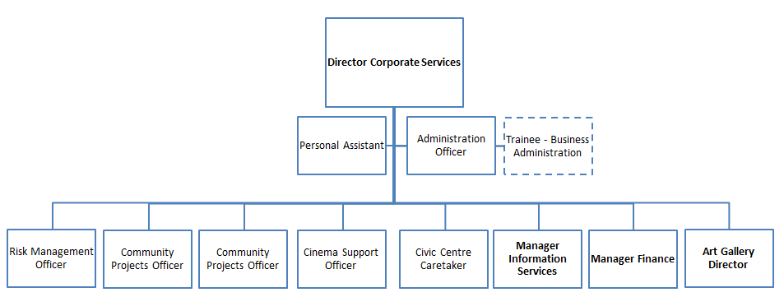

3. RESPONSIBILITIES AND DUTIES

The duties and responsibilities listed here are considered essential to achieving the primary objectives of this job. These duties will be undertaken in such a manner that will enable the section to operate in an effective and efficient manner and within budgetary constraints.

- Undertake and complete Certificate III in Business Administration through TAFE NSW within the 12 month Traineeship.
- Undertake general administrative duties as instructed across all administration areas of Council.
- Take responsibility for and manage own work, and contribute to a productive work environment.
- Maintain a strong customer focus throughout all duties.
- Ensures all appropriate actions are taken to implement Council’s Workplace Health and Safety (WHS) System and relevant WHS legislative requirements within area of responsibility.
- Monitors the condition of facilities and equipment and reports any faults, breakdowns and maintenance/repairs.
- Communicate known problems/issues, including but not limited to: hazards, risks, incidents, accidents and near misses in a timely manner to direct supervisor.
- To perform allocated duties utilising initiative, making positive contributions to work quality, productivity, and to work to a timetable, in a cost effective manner.
- To be conversant with all safety aspects associated with the workplace.
- Act in accordance with Council’s Code of Conduct, Safety Policy and other policies as advised.
- Participate in training programs and seminars to enhance professional performance.
- Other duties that may arise at the direction of Directors, Managers and Supervisor that are consistent with the level of competencies of the position.
- Maintain a sound knowledge of current legislation, standards, policies and guidelines relevant to area of responsibility, and ensures that activities comply with relevant legislation, standards and policies.
- Perform allocated duties utilising initiative, making positive contributions to work quality, productivity, and to work to a timetable, in a cost effective manner.
- Other duties that may arise at the direction of the Personal Assistant/Administration Officer that are consistent with the level of competencies of the position and in line with the principles of multi-skilling.

4. KNOWLEDGE, SKILLS AND ABILITIES

- Authority and accountability: Completion of basic tasks with work closely monitored by the team leader or supervisor.

- Judgement and problem solving: Judgement is limited and coordinated by other workers.

- Specialist knowledge and skills: Specialist knowledge and skills are obtained through on-the-job training and employer-based induction training. Off-the-job training may lead to trade, technical or professional qualifications.

- Management skills: Not required.

- Interpersonal skills: Limited to communications with other staff and possibly, with the public.

- Qualifications and experience: Completion of School Certificate or the Higher School Certificate may be sought. Completion of an appropriate labour market program or similar short-term work/skills experience is desirable.

5. WORK, HEALTH & SAFETY RESPONSIBILITIES

All employees are responsible for Work Health and Safety (WHS) for Council and their duties include:
- Complying with Council’s WHS policies and procedures.
- Working with due diligence and consideration to safeguard their own health and safety and the health and safety of others.
- Reporting any potential hazards, incidents or injuries to their Supervisor and Human Resources within 48 hours.
- Participating in any applicable WHS consultation arrangements.
- Complying with any Return to Work Plan if injured and supporting rehabilitation in the workplace.
- Correctly using all personal protective equipment.
- Complying with emergency and evacuation procedures and site rules if applicable.

6. PHYSICAL DEMANDS

The physical demands described here are representative of those that must be met by an employee to successfully perform the essential functions of this job.

While performing the required indoor duties of this job, the employee is regularly required to sit and use hands to input data and write. The employee is frequently required to talk or hear in person and on the telephone. The employee is occasionally required to stand, walk, and occasionally lift items up to 15kg. Specific vision abilities required by this job include close vision and the ability to adjust focus.

7. CONDITIONS OF EMPLOYMENT

Hours
Council’s indoor staff work a 35 hour week in the basis of a nine day fortnight. Some variation in work hours may be required from time to time to ensure the efficient undertaking of the position.

Performance Appraisal
A performance appraisal will be undertaken on an annual basis utilising performance indicators and include formulation of a career path and training plan.

Policies and Procedures
The employee who occupies this position must comply with Council's Code of Conduct and all other policies and procedures that affect his or her employment.

All other conditions of employment are in accordance with the Local Government (State) Award.

8. ACKNOWLEDGEMENT

I, ......................................................................................... (Print Name) acknowledge that I have read and understand the duties, responsibilities and requirements of this position.

Sign: ……………………………………… Date: ………………………..

This is not a static document. Management reserves the right to review and amend this Position Description in consultation with the position holder as the need arises.

