Civil Construction Trainee

Position Description

1. POSITION SUMMARY
Job Title: | Civil Construction Trainee
Position No: | 8890.000 & 8891.000
Department: | Infrastructure and Operations
Reports to: | Supervisors – Roads Construction & Maintenance
Band and Level: | Operational Band 1
Grade: | T2 – T4
Updated: | October 2018

2. OVERVIEW

The position of Civil Construction Trainee is to undertake a 12 month Traineeship while completing a Certificate II in Civil Construction. On-the-job training including a range of labouring duties (including the operation of small plant and equipment) in such a manner that will enable the Roads section to operate in an effective and efficient.
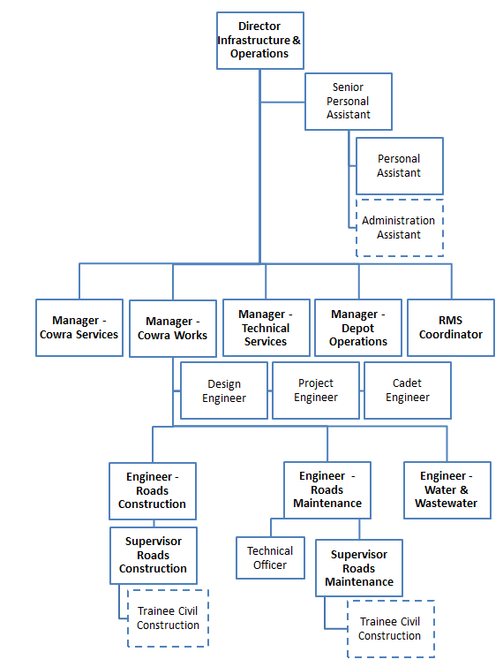

3. RESPONSIBILITIES AND DUTIES

The duties and responsibilities listed here are considered essential to achieving the primary objectives of this job. These duties will be undertaken in such a way that will enable the section to operate in an effective and efficient manner and within budgetary constraints.

- Undertake and complete Certificate II in Civil Construction through TAFE NSW within the 12 month Traineeship.
- Assist with all tasks associated with roads infrastructure maintenance and construction as part of Council’s Works Program.
- Assist in the set-up of form work, kerbing and guttering, site preparation and roadworks.
- Assist in the set up and dismantling of traffic control signage on job sites.
- Perform Traffic Control duties.
- Assist in the set up and dismantling of traffic control signage on job sites.
- Drive and operate items of plant and equipment required to undertake duties, consistent with knowledge, skills and licences held.
- Perform allocated duties utilising initiative, making positive contributions to work quality, productivity, and to work to a timetable, in a cost effective manner.
- Other duties that may arise at the direction of Council’s Works Supervisors, Works Engineers or Team Leaders/Gangers that are consistent with the level of competencies of the position and in line with the principles of multi-skilling, including, but not limited to, traffic control, minor maintenance, manual handling and general laboring.
- Communicate known problems/issues, including but not limited to: hazards, risks, incidents, accidents and near misses in a timely manner to direct supervisor.
- Maintain a high quality or workmanship, safety and environmental protection in all works under your control.
- Ensure tools, equipment and facilities are kept and stored in a clean and tidy condition with all relevant Maintenance & Construction checks carried out as specified and conform to relevant safety standards and guidelines.
- Maintain a sound knowledge of current legislation, standards, policies and guidelines relevant to area of responsibility, and ensures that activities comply with relevant legislation, standards and policies.
- Complete relevant timesheets, log sheets, plant sheets, start up sheets and record information and other paperwork as required by supervisors and Council policies.
- Act in accordance with Council’s Code of Conduct, Safety Policy and other policies as advised.

4. KNOWLEDGE, SKILLS AND ABILITIES

- Authority and accountability: Completion of basic tasks with work closely monitored by the team leader or supervisor.

- Judgement and problem solving: Judgement is limited and coordinated by other workers.

- Specialist knowledge and skills: Specialist knowledge and skills are obtained through on-the-job training and employer-based induction training. Off-the-job training may lead to trade, technical or professional qualifications.

- Management skills: Not required.
- Interpersonal skills: Limited to communications with other staff and possibly, with the public.

- Qualifications and experience: Completion of School Certificate or the Higher School Certificate may be sought. Completion of an appropriate labour market program or similar short-term work/skills experience is desirable.

5. WORK, HEALTH & SAFETY RESPONSIBILITIES

All employees are responsible for Work Health and Safety (WHS) for Council and their duties include:
- Complying with Council’s WHS policies and procedures.
- Working with due diligence and consideration to safeguard their own health and safety and the health and safety of others.
- Reporting any potential hazards, incidents or injuries to their Supervisor and Human Resources within 48 hours.
- Participating in any applicable WHS consultation arrangements.
- Complying with any Return to Work Plan if injured and supporting rehabilitation in the workplace.
- Correctly using all personal protective equipment.
- Complying with emergency and evacuation procedures and site rules if applicable.

6. CONDITIONS OF EMPLOYMENT

Hours
Council’s outdoor staff work a 38 hour week on the basis of a nine day fortnight. Some variation in work hours may be required from time to time to ensure the efficient undertaking of the position.

Performance Appraisal
A performance appraisal will be undertaken on an annual basis utilising performance indicators and include formulation of a career path and training plan.

Policies and Procedures
The employee who occupies this position must comply with Council's Code of Conduct and all other policies and procedures that affect his or her employment.

All other conditions of employment are in accordance with the Local Government (State) Award.

7. ACKNOWLEDGEMENT

I, ......................................................................................... (Print Name) acknowledge that I have read and understand the duties, responsibilities and requirements of this position.

Sign: ……………………………………… Date: ………………………..

This is not a static document. Management reserves the right to review and amend this Position Description in consultation with the position holder as the need arises.

